AOP used for adding features that doesn’t exists in framework (to extend it).

*******************************************************************************************
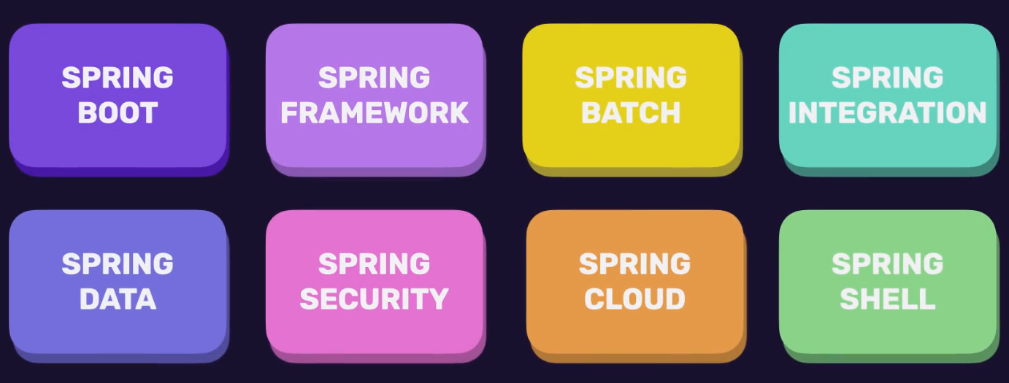
*******************************************************************************************
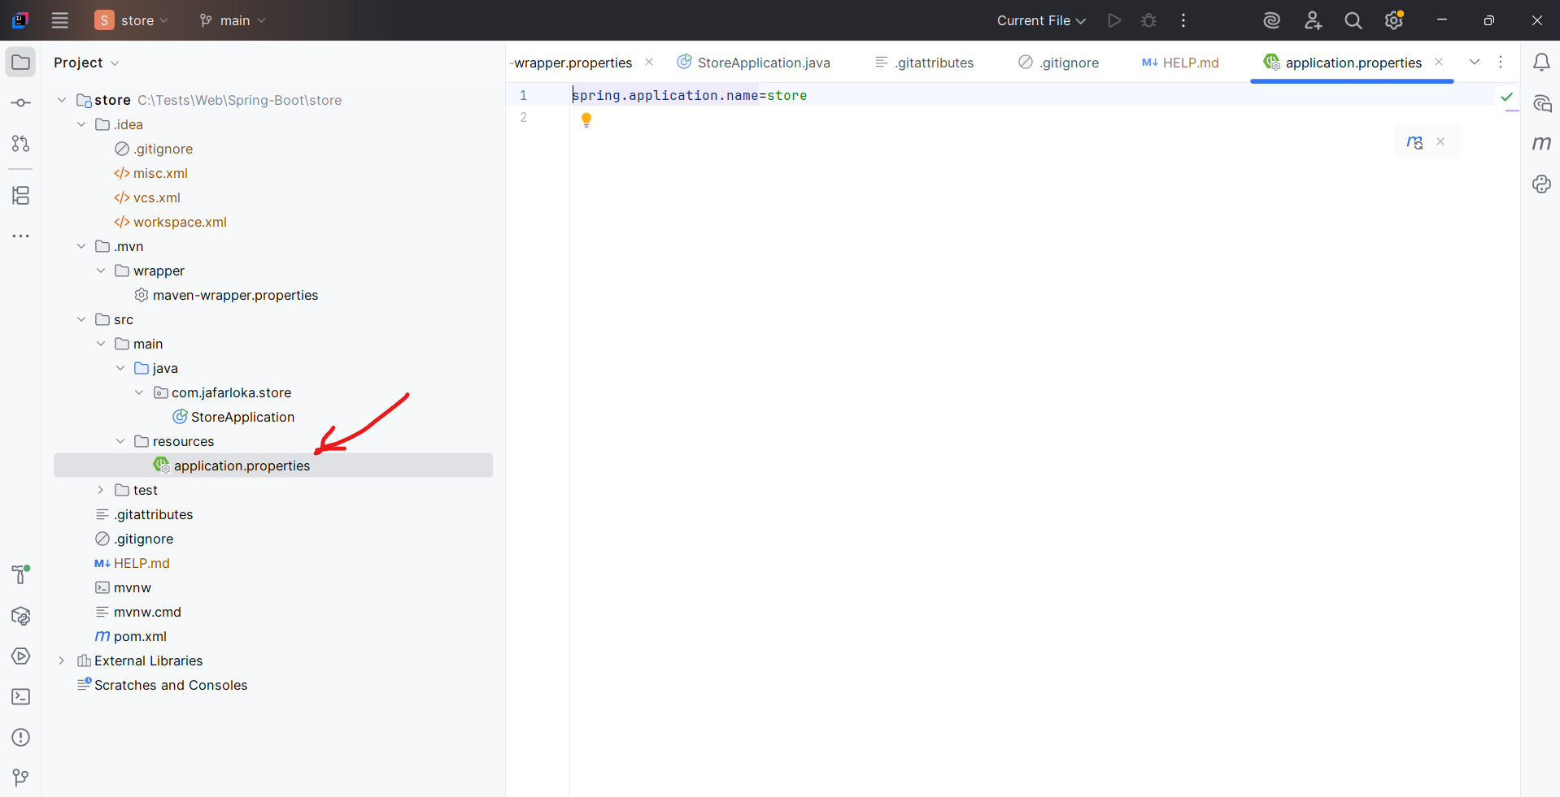
*******************************************************************************************
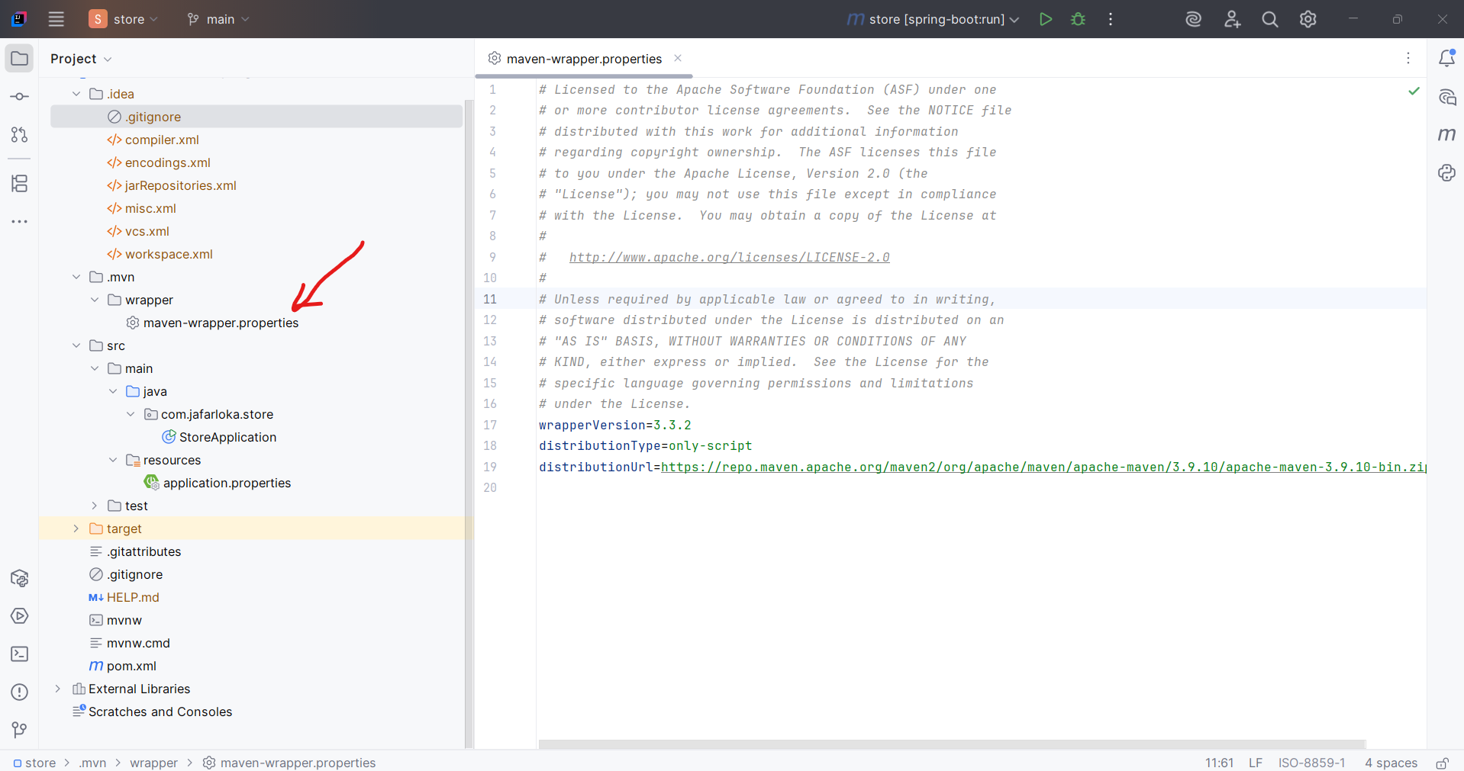

*******************************************************************************************

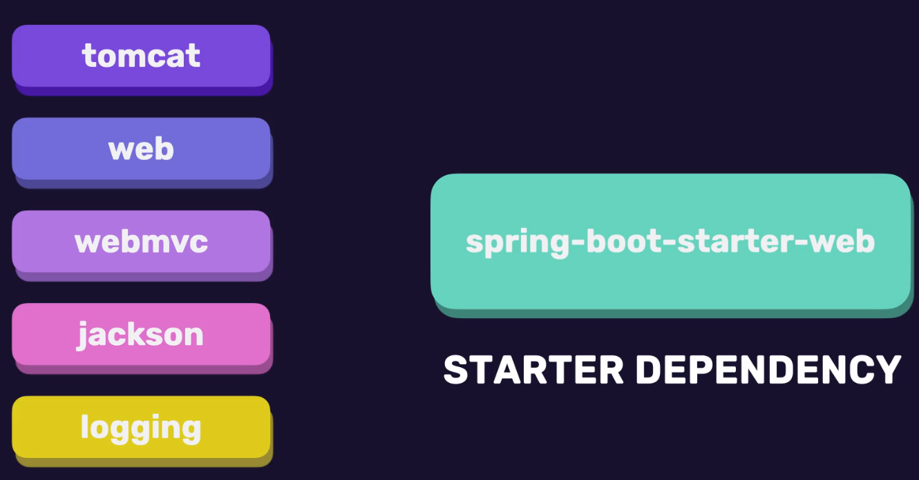
*******************************************************************************************
Maven Central: https://central.sonatype.com/
Here we can search for dependencies like spring-boot-starter-web
*******************************************************************************************
After adding the dependency, may it not found in local machine, so we must download it:
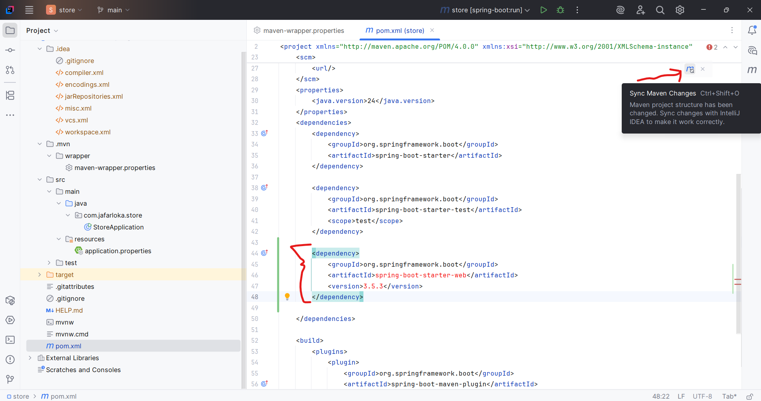
*******************************************************************************************
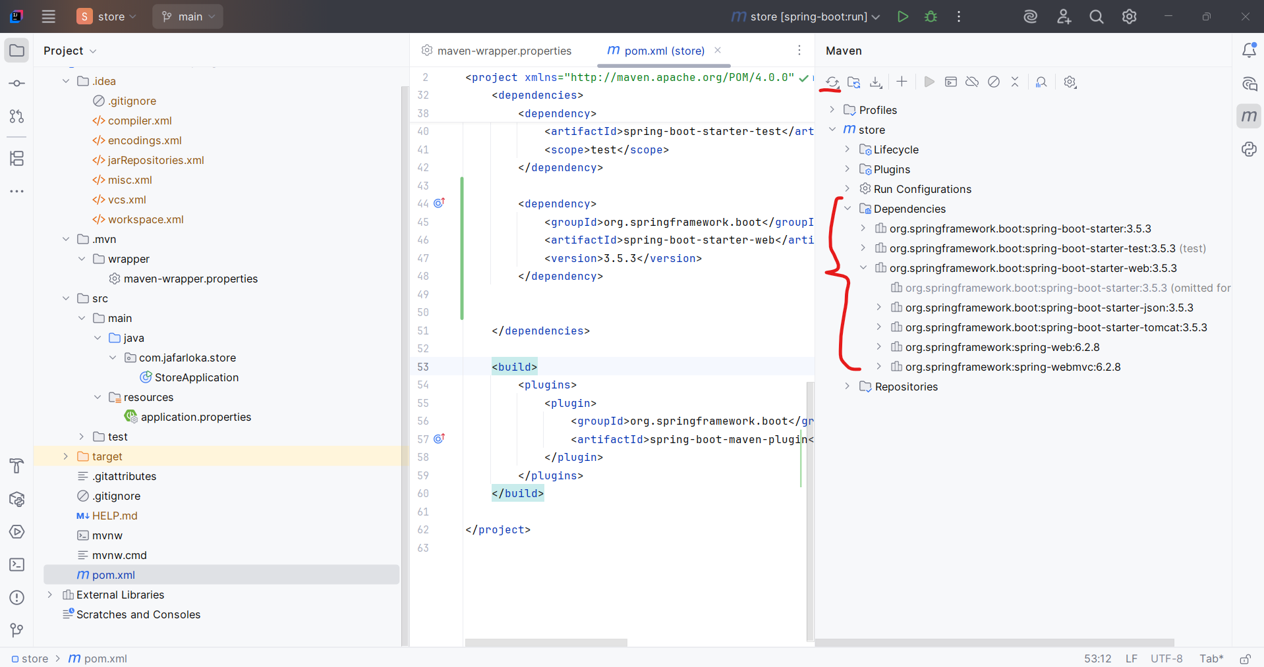
*******************************************************************************************
Always we can delete the version-tag in our dependency in pom.xml file, and then we make the maven and our project determine the best version for our project
*******************************************************************************************
We can run spring boot project using: mvnw spring-boot:run
OR from:
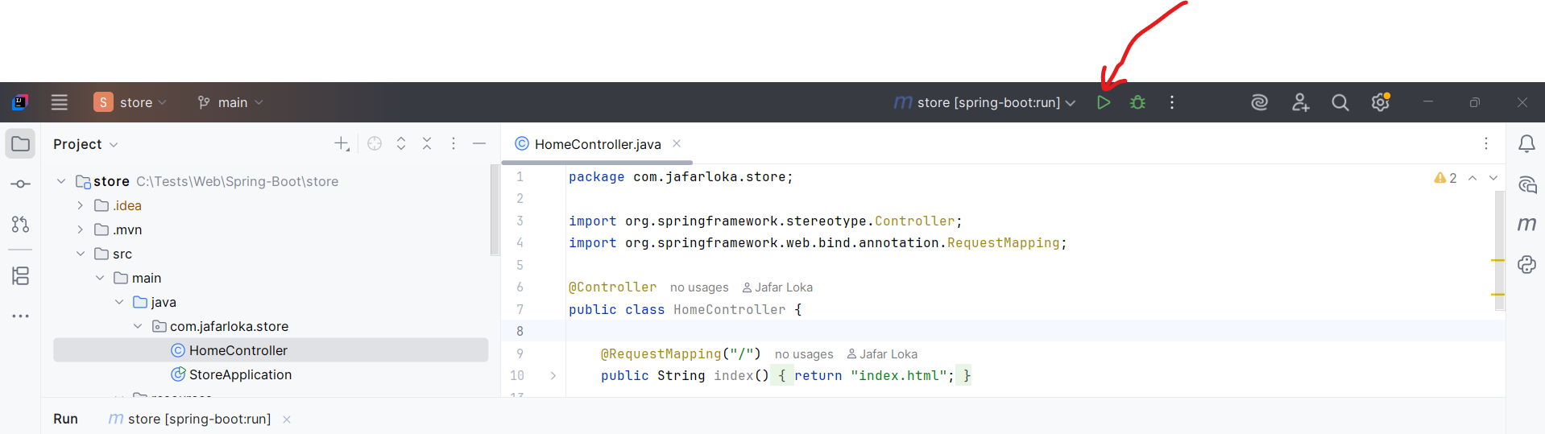
*******************************************************************************************
SHIFT + CTRL + O For searching for file in Intellij IDE
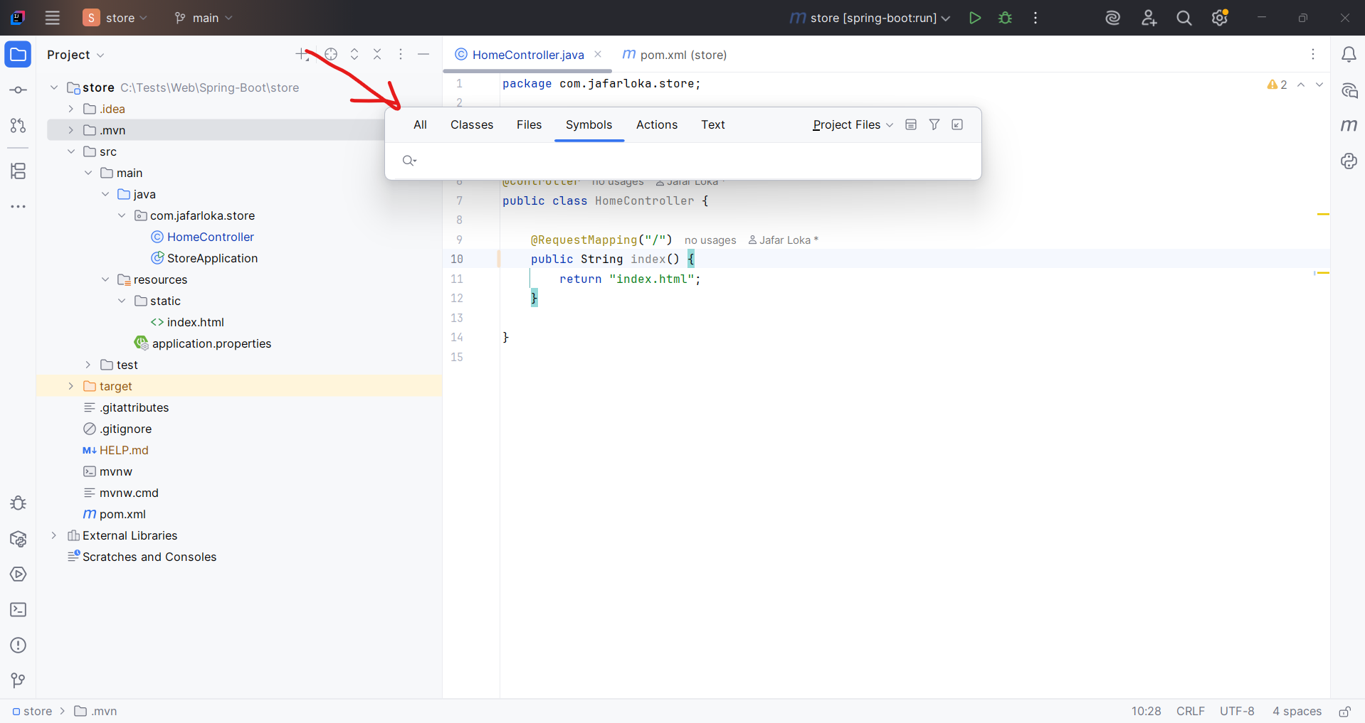
*******************************************************************************************
ALT + 0 Generate dependency
*******************************************************************************************
To define specific configuration, we go to application.properties:
spring.application.name=store
jloka.value=100
----------------------------------------------------------------------------------------
Then to use their value on code, we use Value-annotation, with ${}:
@Value("${spring.application.name}")
private String appName;
@Value("${jloka.value}")
private String value;
*******************************************************************************************
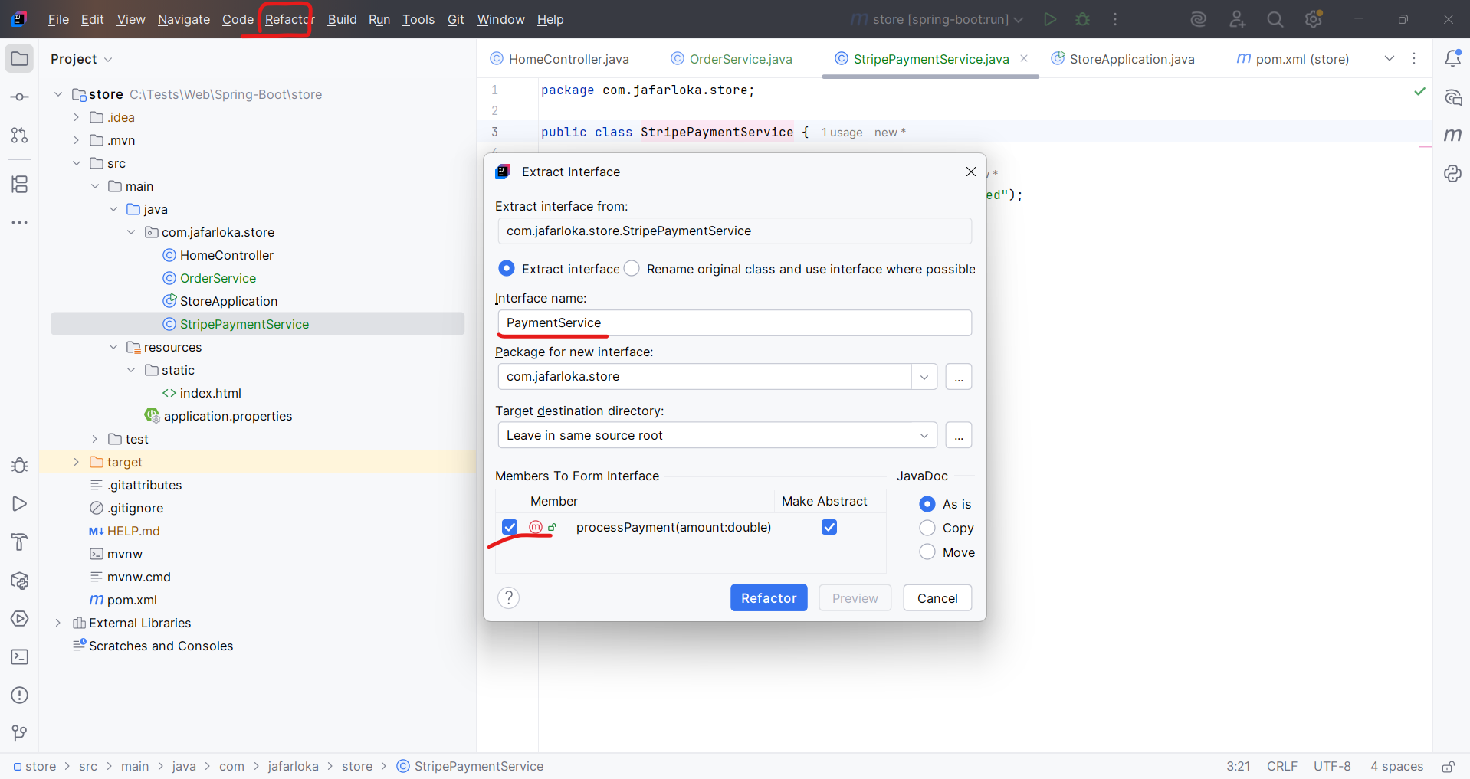
*******************************************************************************************
Note: tight couples mean we have bad service coupling with other, may it can be in small projects, or in projects that have less features in some part of them.
*******************************************************************************************
From solid principle, And OOP:
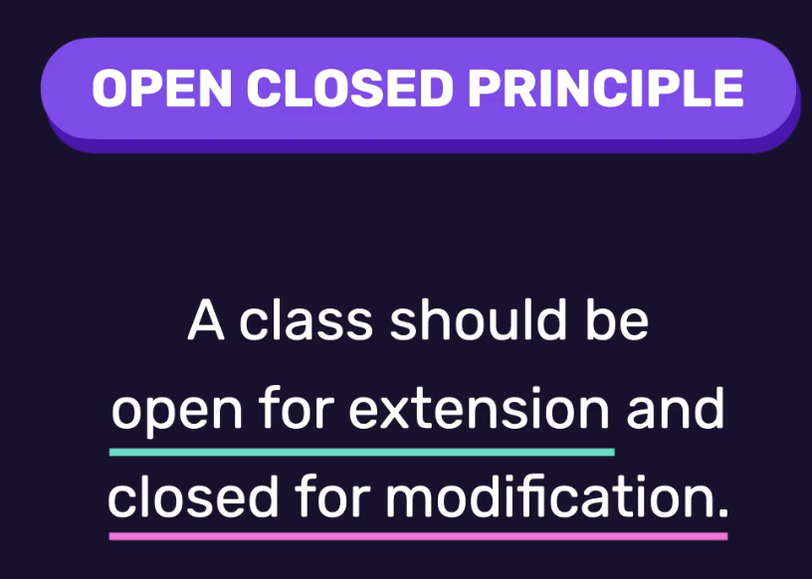
*******************************************************************************************
We can use DI using setter-methods:
public class OrderService {
private PaymentService paymentService;
public OrderService(PaymentService paymentService) {
this.paymentService = paymentService;
}
public void setPaymentService(PaymentService paymentService) {
this.paymentService = paymentService;
}
public void placeOrder() {
paymentService.processPayment(100_000);
}
}
*******************************************************************************************
We can use Generate from Intellij to create the setter methods, or other tasks:
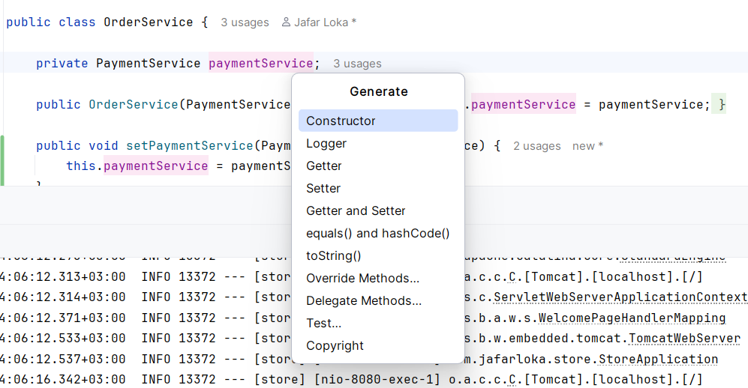
*******************************************************************************************

*******************************************************************************************

IOC Container: set of objects that can be used for DI, each object called BEAN
Bean: Regular java code that used by spring core.
IOC: Inversion Of Control Invert the control of creating objects, and managing dependencies.
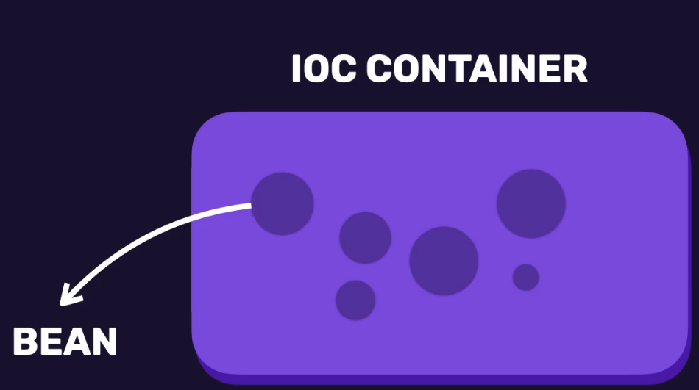
*******************************************************************************************
To make IOC control the DI of OrderService class:
import org.springframework.boot.SpringApplication;
import org.springframework.boot.autoconfigure.SpringBootApplication;
import org.springframework.context.ApplicationContext;
@SpringBootApplication
public class StoreApplication {
public static void main(String[] args) {
ApplicationContext context = SpringApplication.run(StoreApplication.class, args);
context.getBean(OrderService.class);
}
}
-----------------------------------------------------------------------------------

To manage beans inside code:


