Locust makes it easy to run load tests distributed over multiple machines. It is event-based (using gevent), which makes it possible for a single process to handle many thousands of concurrent users. While there may be other tools that are capable of doing more requests per second on a given hardware, the low overhead of each Locust user makes it very suitable for testing highly concurrent workloads.
-------------------------------------------------------------------------------
Even though Locust primarily works with websites/services, it can be used to test almost any system or protocol. Just write a client for what you want to test, or explore some created by the community.
-------------------------------------------------------------------------------
To run the test file: locust -f simple_test.py
To access the dashboard: http://localhost:8089/
-------------------------------------------------------------------------------
Simple test file with 2-tasks:
from locust import HttpUser, task

class HelloWorldUser(HttpUser):
@task
def hello_world(self):
self.client.get('/hello')

@task
def hello_world_02(self):
self.client.get('/world')

-------------------------------------------------------------------------------
To run Locust in headless mode:
locust --headless --users 10 --spawn-rate 1 -H http://your-server.com
-------------------------------------------------------------------------------

import time
from locust import HttpUser, task, between

class QuickStartUser(HttpUser):
wait_time = between(1, 10)

@task
def hello_world(self):
self.client.get("/hello")
self.client.get("/world")

# maximize the chance to choose this task by 3-times
@task(3)
def view_items(self):
for item_id in range(10):
self.client.get(f"/item?id={item_id}", name="/item")
time.sleep(1)

def on_start(self):
self.client.post("/login", json={"username":"foo", "password":"bar"})
-------------------------------------------------------------------------------
HttpUser is not a real browser, and thus will not parse an HTML response to load resources or render the page. It will keep track of cookies, though.
-------------------------------------------------------------------------------
A User’s wait_time method makes it easy to introduce delays after each task execution. If no wait_time is specified, the next task will be executed as soon as one finishes.
-------------------------------------------------------------------------------
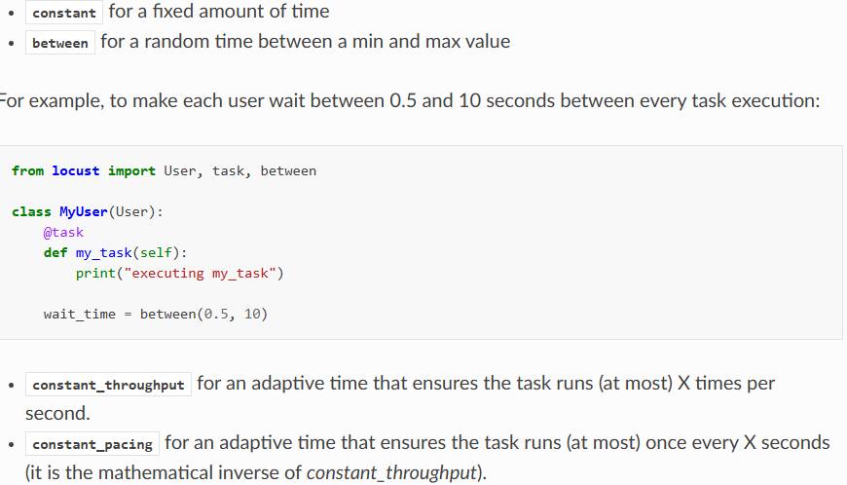
-------------------------------------------------------------------------------
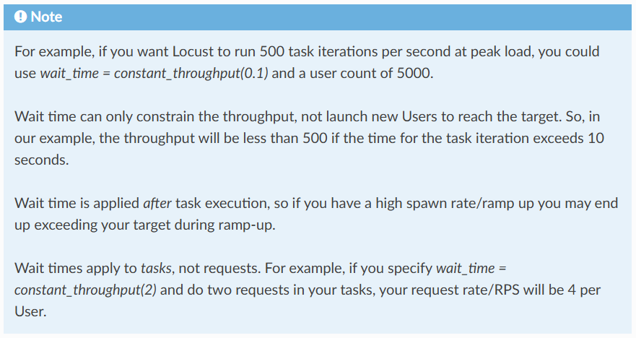
-------------------------------------------------------------------------------
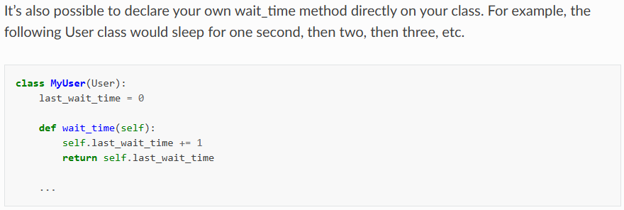
-------------------------------------------------------------------------------
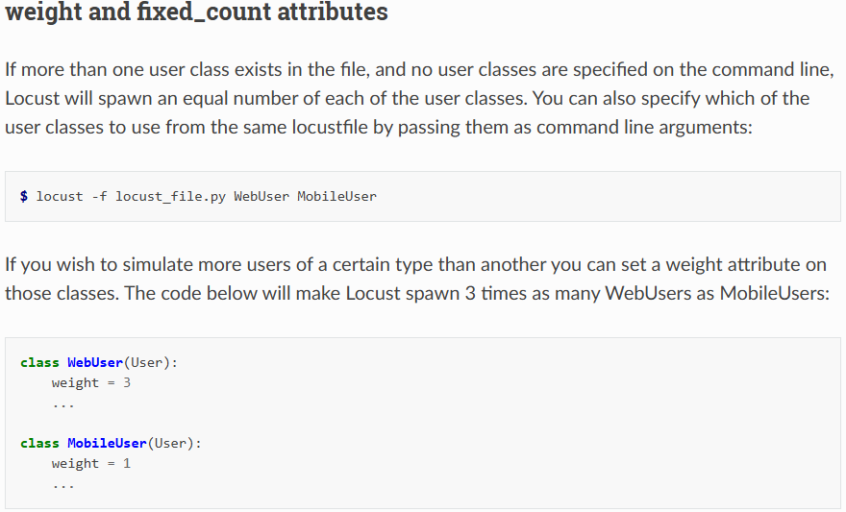
-------------------------------------------------------------------------------
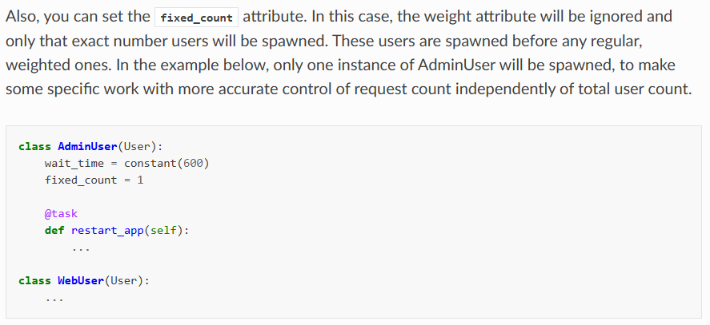
-------------------------------------------------------------------------------
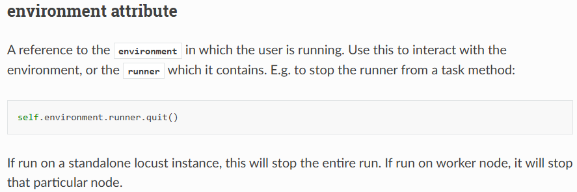
-------------------------------------------------------------------------------
on_start and on_stop methodsℑ
Users (and TaskSets) can declare an on_start method and/or on_stop method. A User will call its on_start method when it starts running, and its on_stop method when it stops running. For a TaskSet, the on_start method is called when a simulated user starts executing that TaskSet, and on_stop is called when the simulated user stops executing that TaskSet (when interrupt() is called, or the user is killed).
-------------------------------------------------------------------------------
When a load test is started, an instance of the User class will be created for each simulated user, and they will start running within their own greenlet. When these users run, they pick tasks that they execute, sleep for a while, and then pick a new task, and so on.
-------------------------------------------------------------------------------


