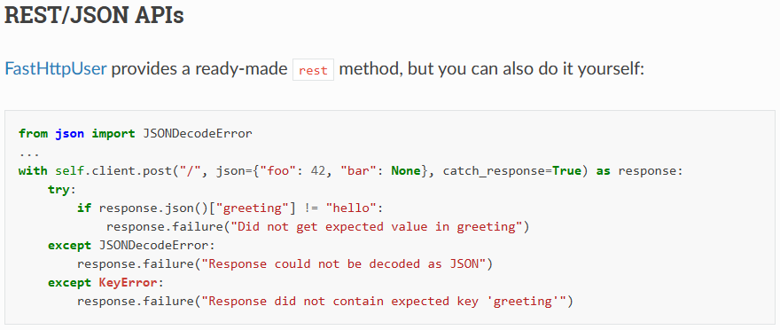
================================================
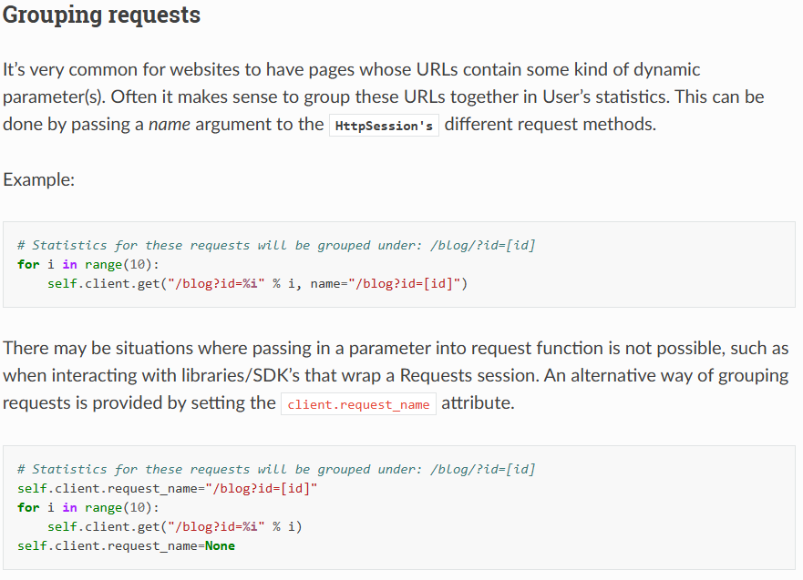
================================================

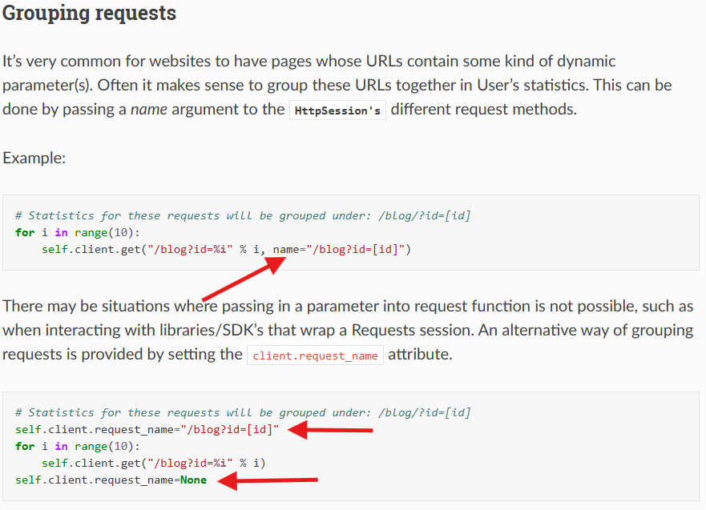
================================================
Very useful feature for grouping requests that are related to the complete checkout workflow in the e-commerce applications:
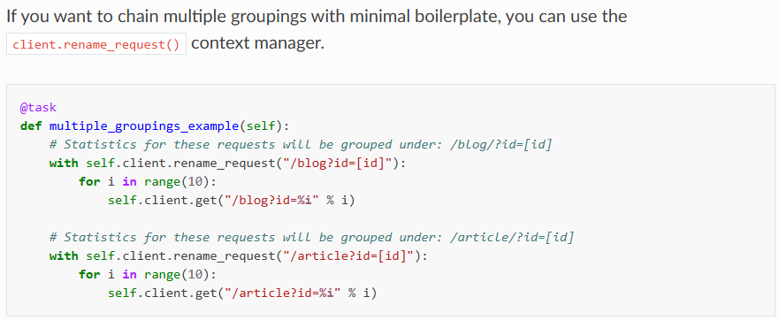
================================================
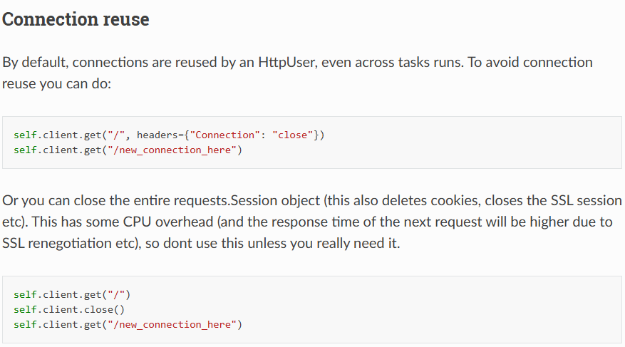
================================================
from locust import HttpUser, task
from urllib3 import PoolManager

class TestConnectionPool(HttpUser):
pool_manager = PoolManager(maxsize=100, block=True)
@task
def get_hello_world(self):
self.client.get('/')
================================================
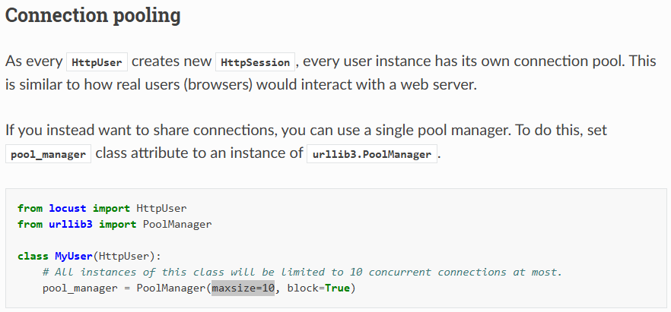
================================================
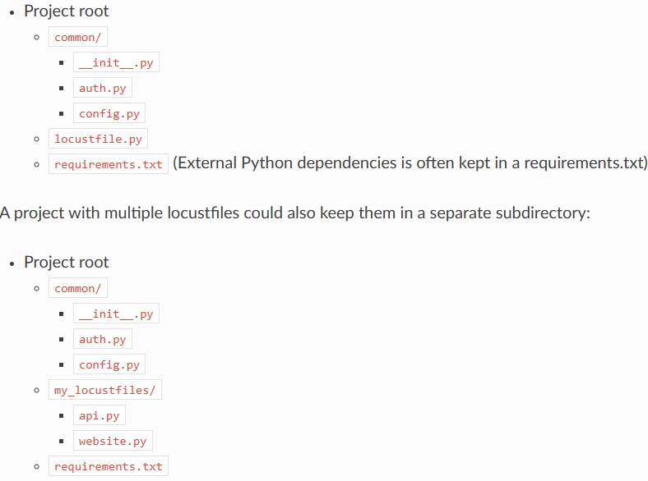
================================================
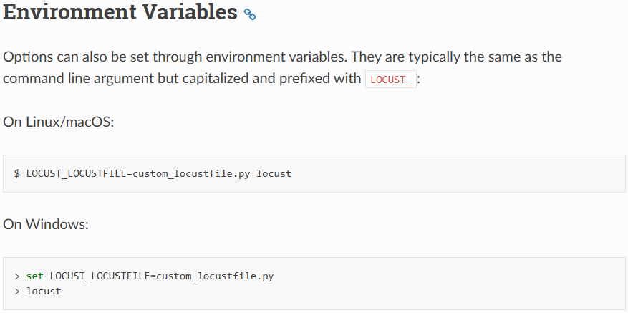
================================================
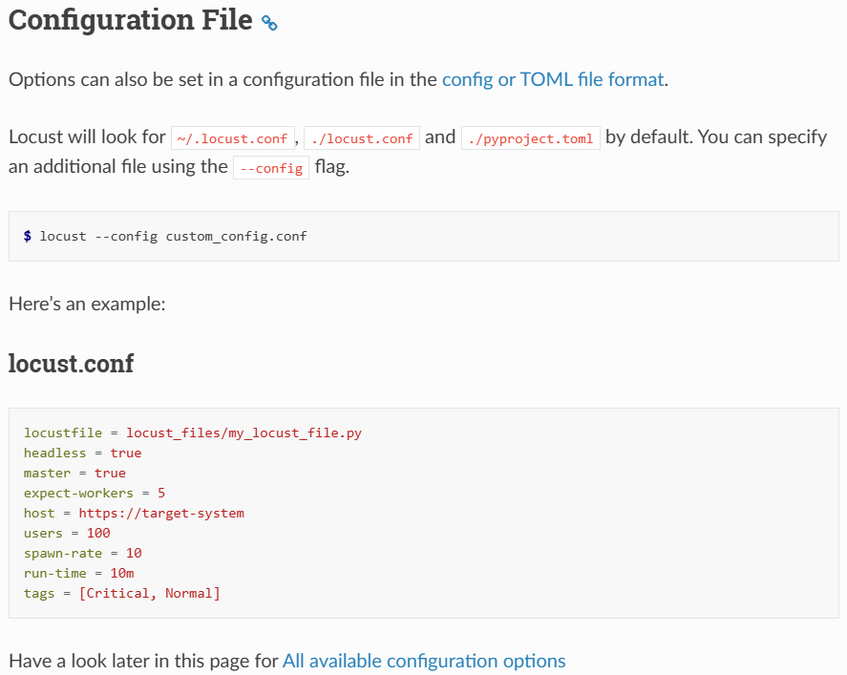
================================================
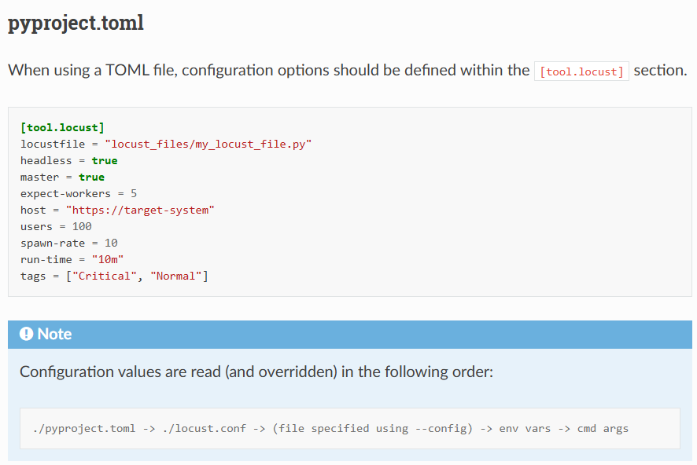
================================================
For all configuration: https://docs.locust.io/en/stable/configuration.html#all-available-configuration-options.
================================================
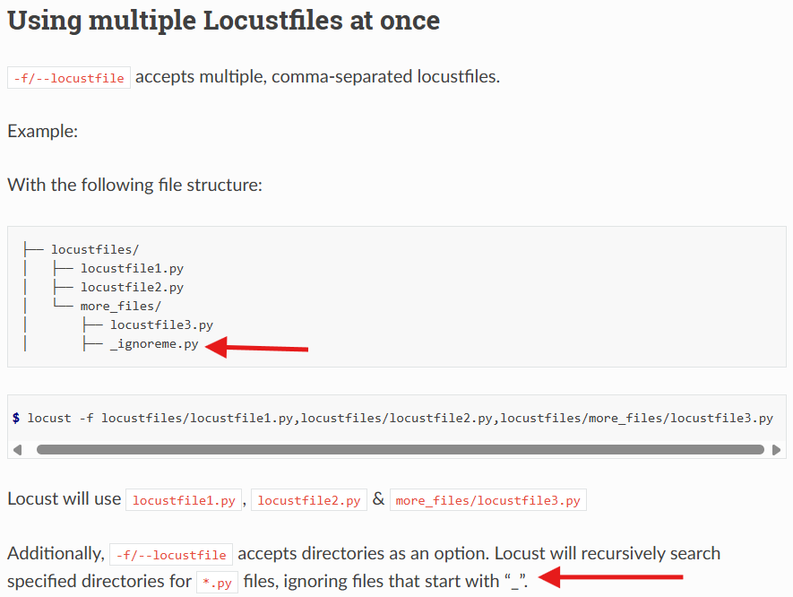
================================================
================================================
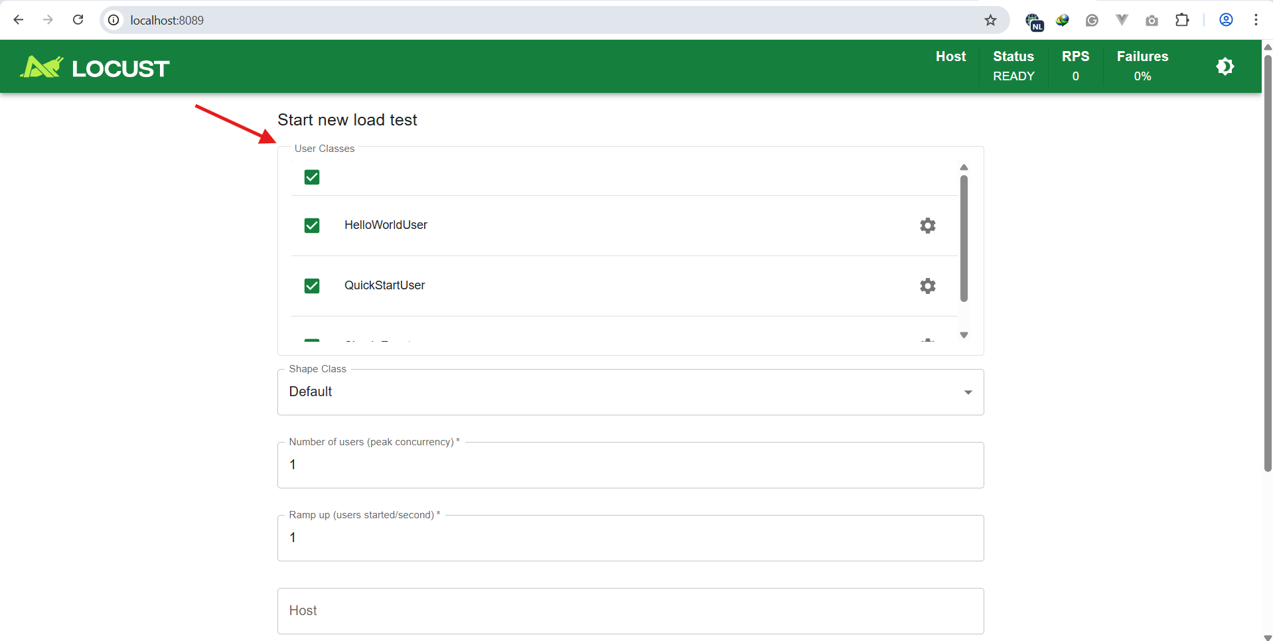
================================================
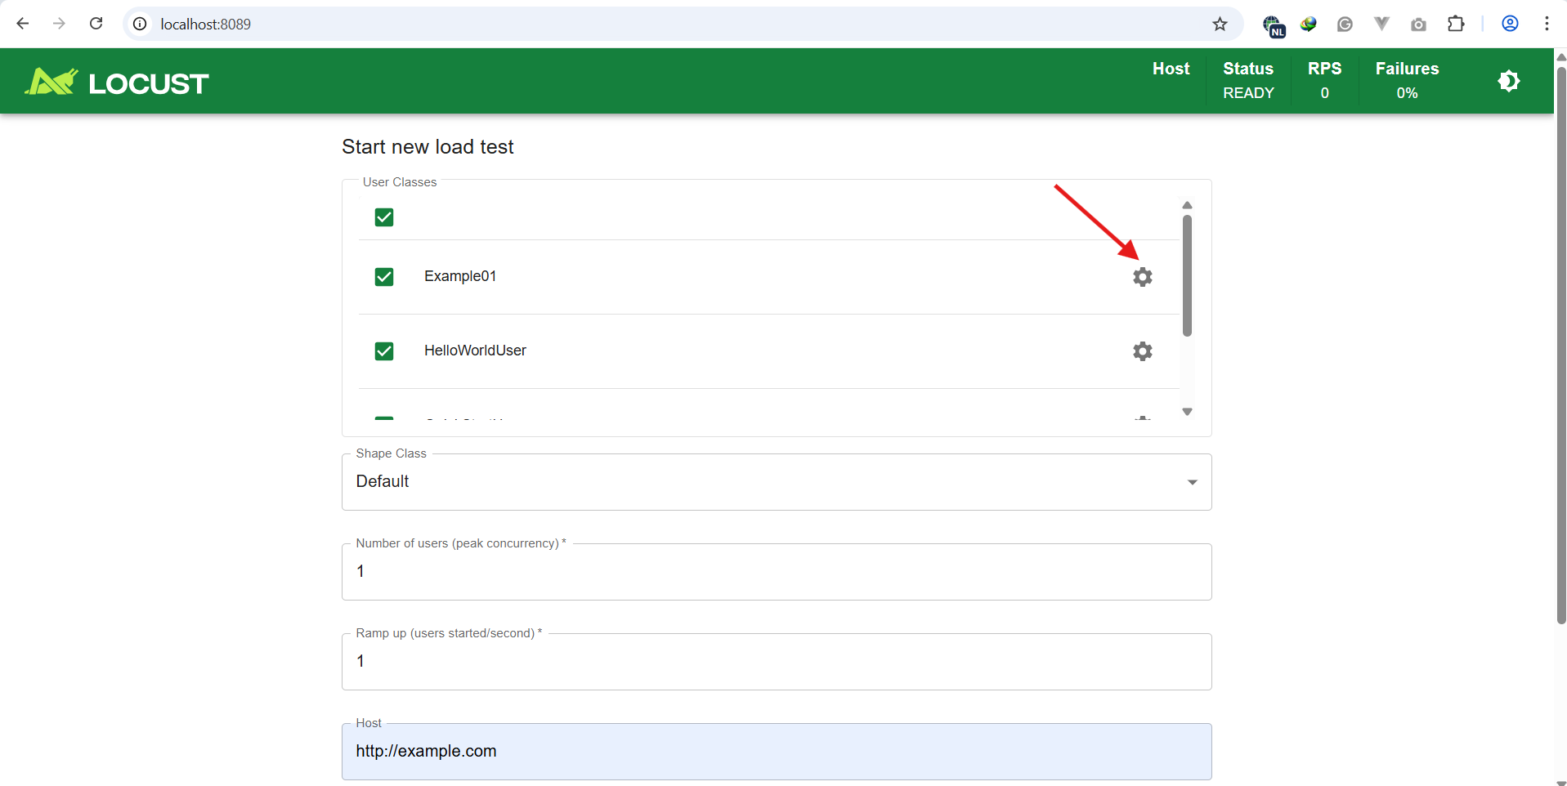
================================================
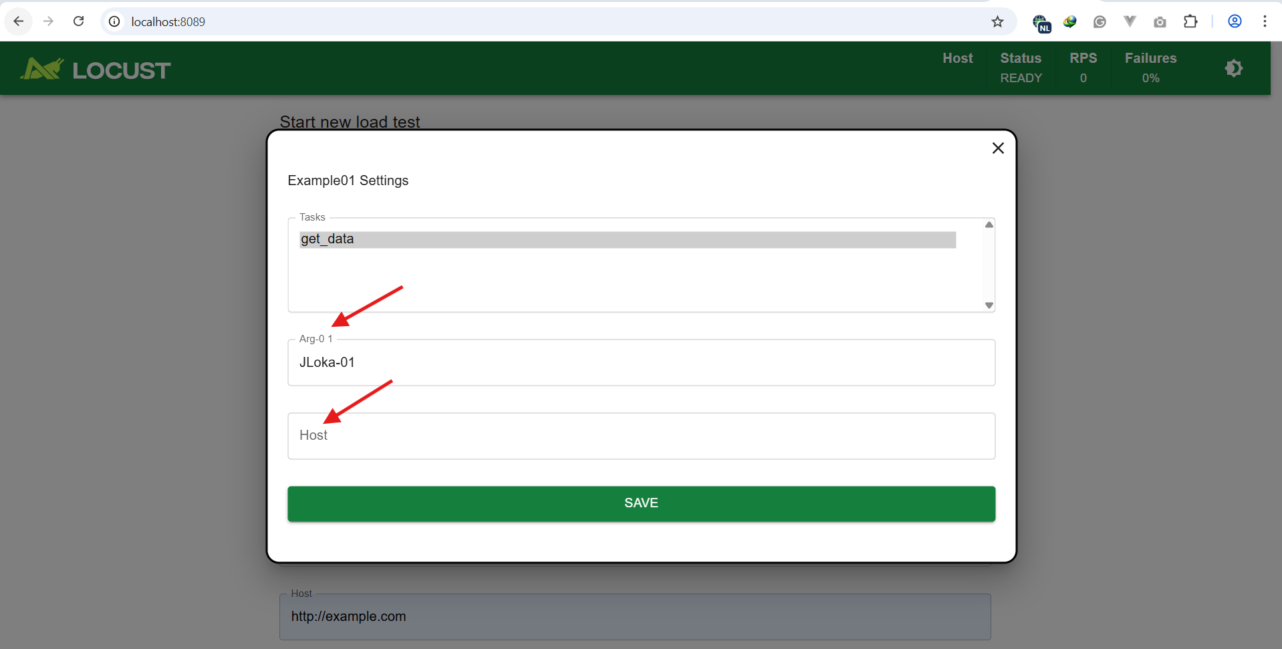
================================================
from locust import task, HttpUser

class Example01(HttpUser):
@task
def get_data(self):
self.client.get("/")

@classmethod
def json(cls):
return {
"host": cls.host,
"arg-01": "JLoka-01"
}
================================================
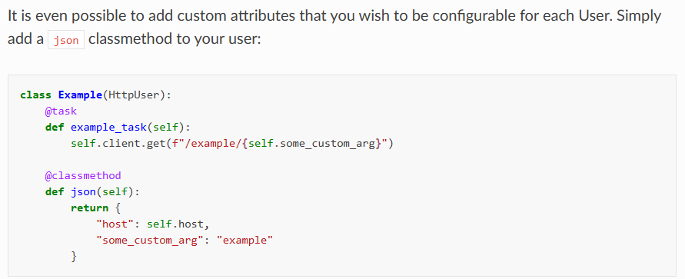
================================================
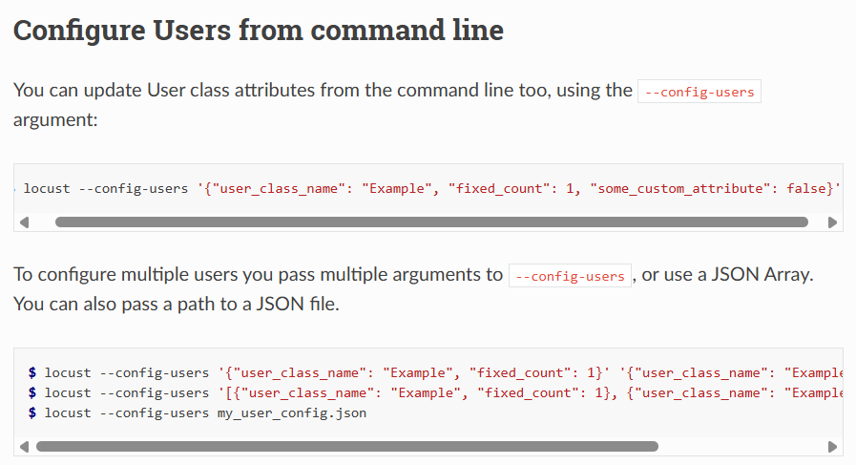
================================================
locust --config-users '{"user_class_name": "Example", "fixed_count": 1, "some_custom_attribute": false}'
locust --config-users '{"user_class_name": "Example", "fixed_count": 1}' '{"user_class_name": "ExampleTwo", "fixed_count": 2}'
locust --config-users '[{"user_class_name": "Example", "fixed_count": 1}, {"user_class_name": "ExampleTwo", "fixed_count": 2}]'
locust --config-users my_user_config.json
================================================
