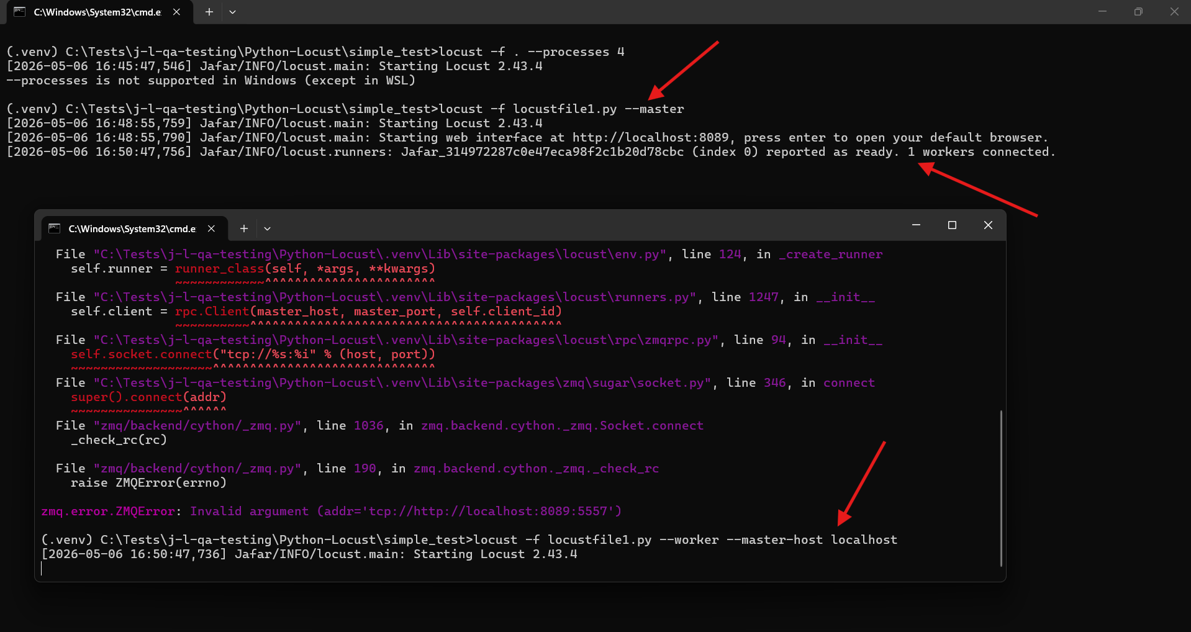
=====================================================
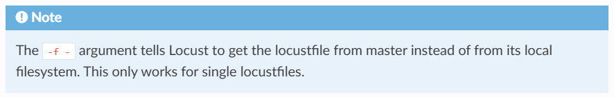
=====================================================
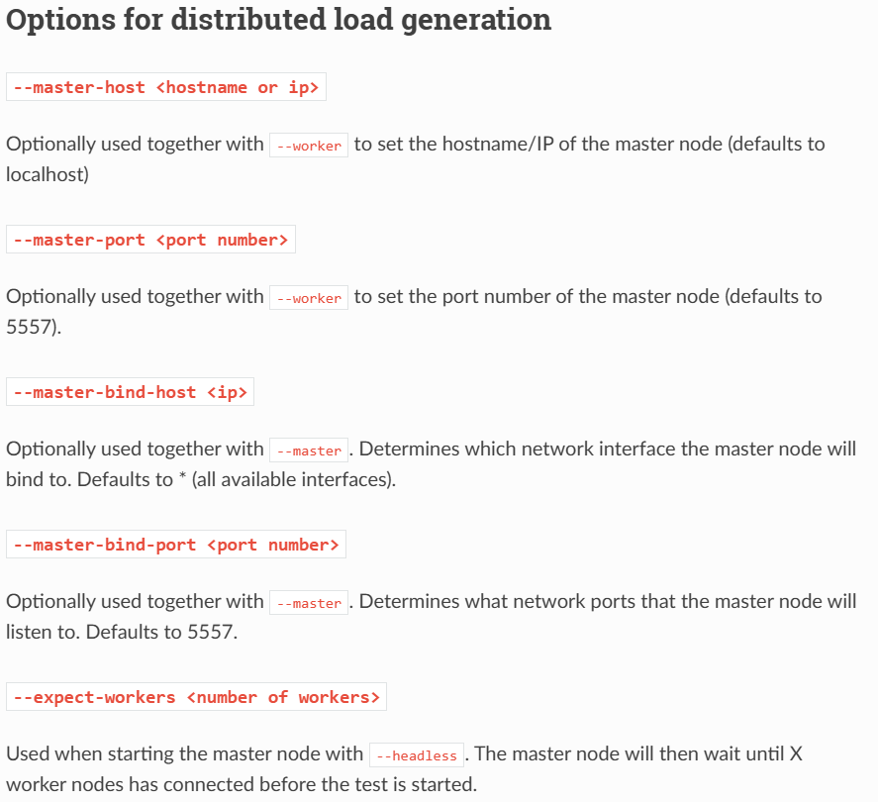
=====================================================
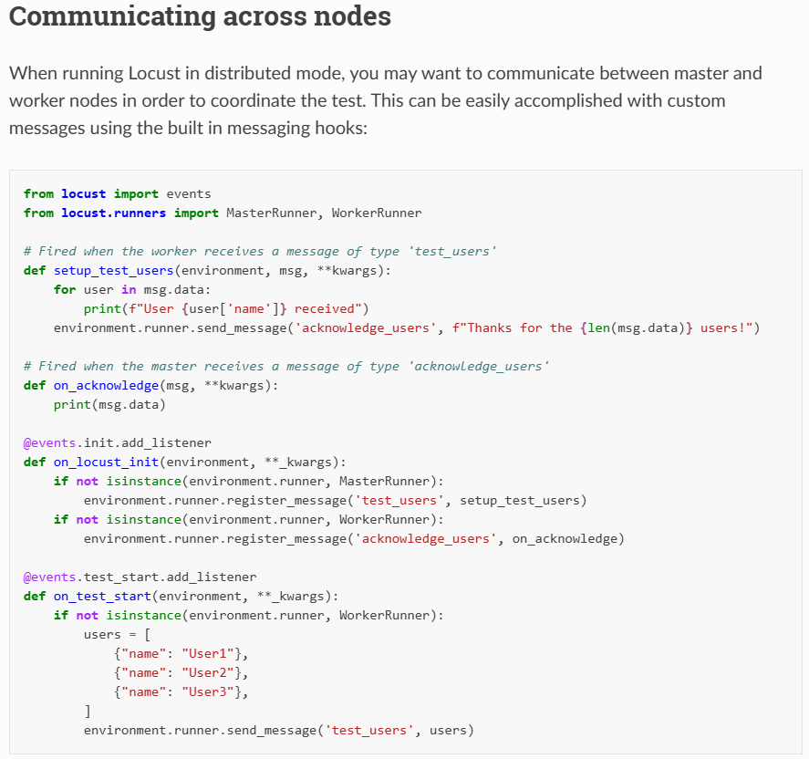
=====================================================

Using the default options while registering a message handler will run the listener function in a blocking way, resulting in the heartbeat and other messages being delayed for the amount of the execution. If you think that your message handler will need to run for more than a second, then you can register it as concurrent. Locust will then make it run in its own greenlet. Note that these greenlets will never be joined.
=====================================================
services:
master:
image: locustio/locust:master
ports:
- "8089:8089"
volumes:
- ./:/mnt/locust
command: -f /mnt/locust/locustfile3.py --master -H http://master:8089

worker:
image: locustio/locust:master
volumes:
- ./:/mnt/locust
command: -f /mnt/locust/locustfile3.py --worker --master-host master
depends_on:
- master

To start a master node and 4 workers using the following command:
docker-compose up --scale worker=4
=====================================================
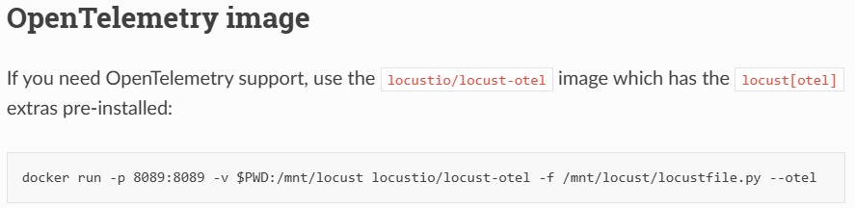
=====================================================
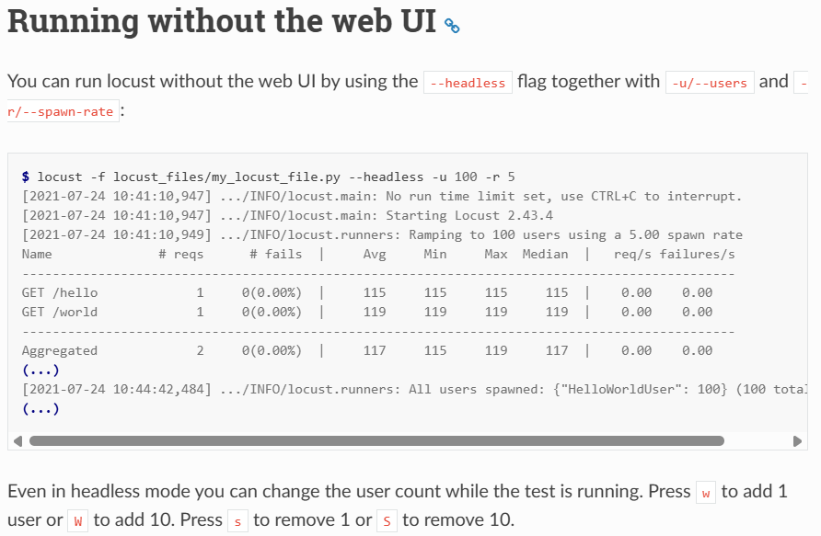
=====================================================
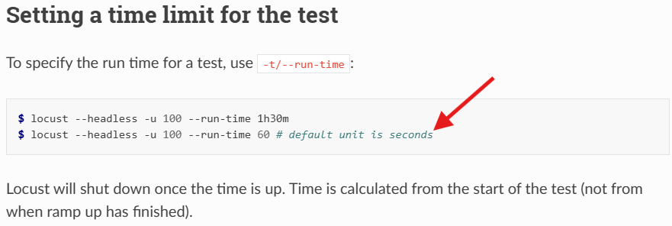
=====================================================
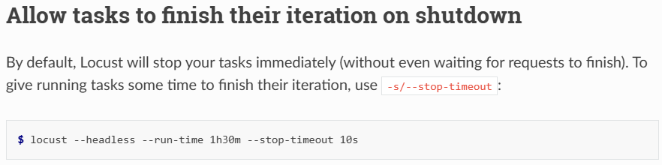
=====================================================
Example about changing the exit code depending on conditions:
Note: 1-> we have a failure
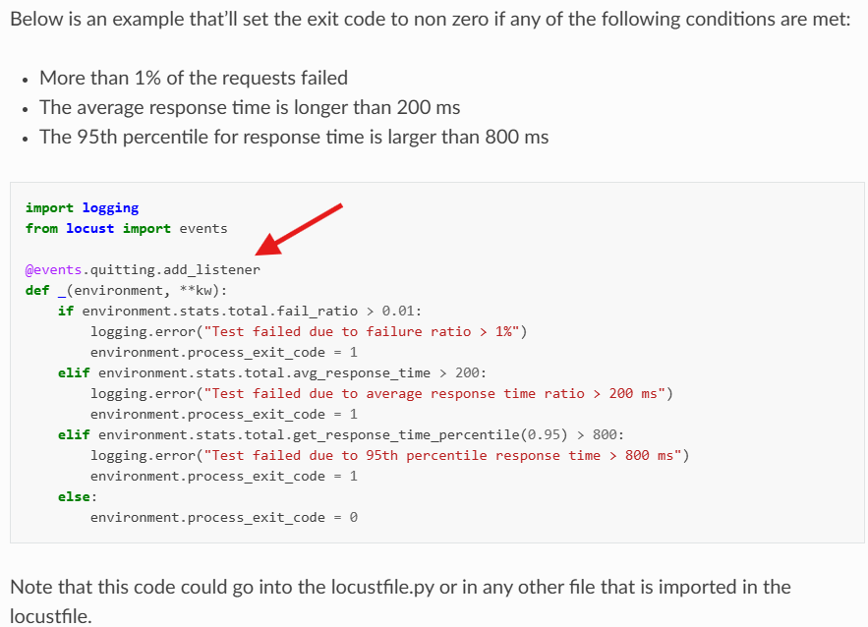
=====================================================
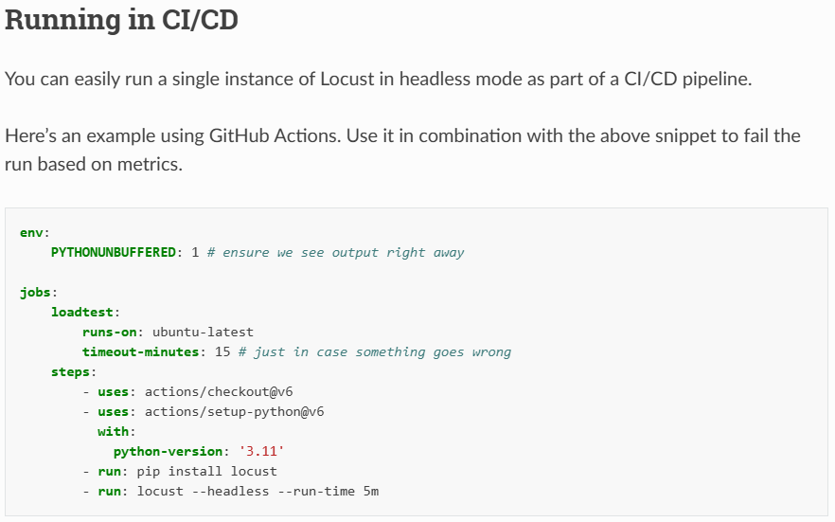
=====================================================
Custom load shapesℑ
Sometimes, a completely custom-shaped load test is required that cannot be achieved by simply setting or changing the user count and spawn rate. For example, you might want to generate a load spike or ramp up and down at custom times. By using a LoadTestShape class, you have full control over the user count and spawn rate at all times.
=====================================================
One further method may be helpful for your custom load shapes: get_current_user_count(), which returns the total number of active users. This method can be used to prevent advancing to subsequent steps until the desired number of users has been reached. This is especially useful if the initialization process for each user is slow or erratic in terms of how long it takes.
=====================================================

The command with csv statistics: locust -f locustfile1.py --headless -u 10 -t25s -r 10 --csv example --csv-full-history -H http://example.com
=====================================================


