Hold the shift key and select the cells to copy, then choose Fill Down to copy the formula to the destination cells.
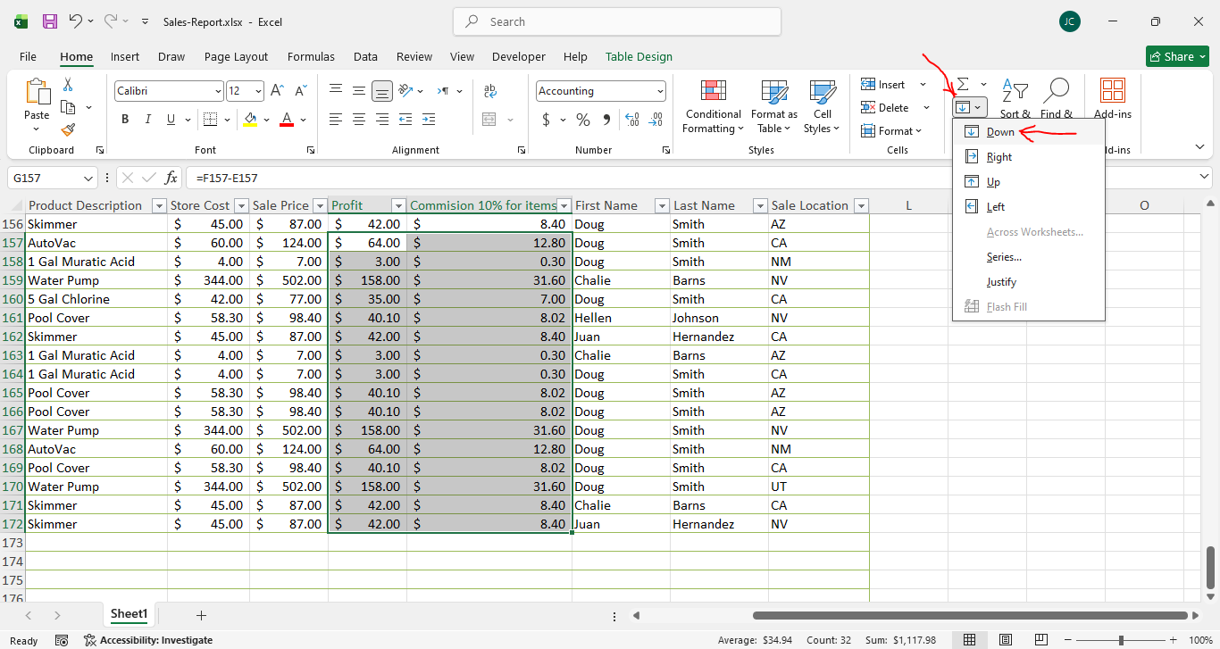
======================================================

To sort the data depending on a specific column:
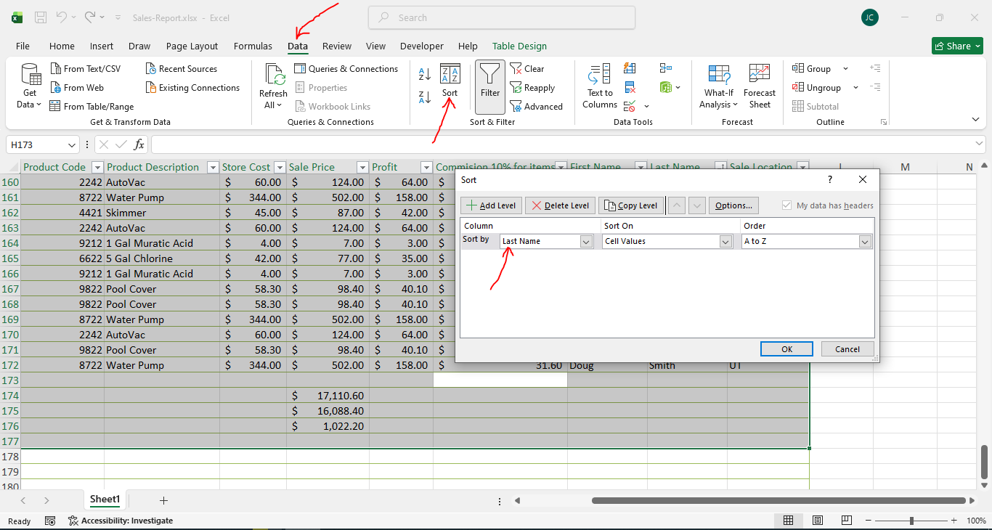
======================================================
To filter the data:
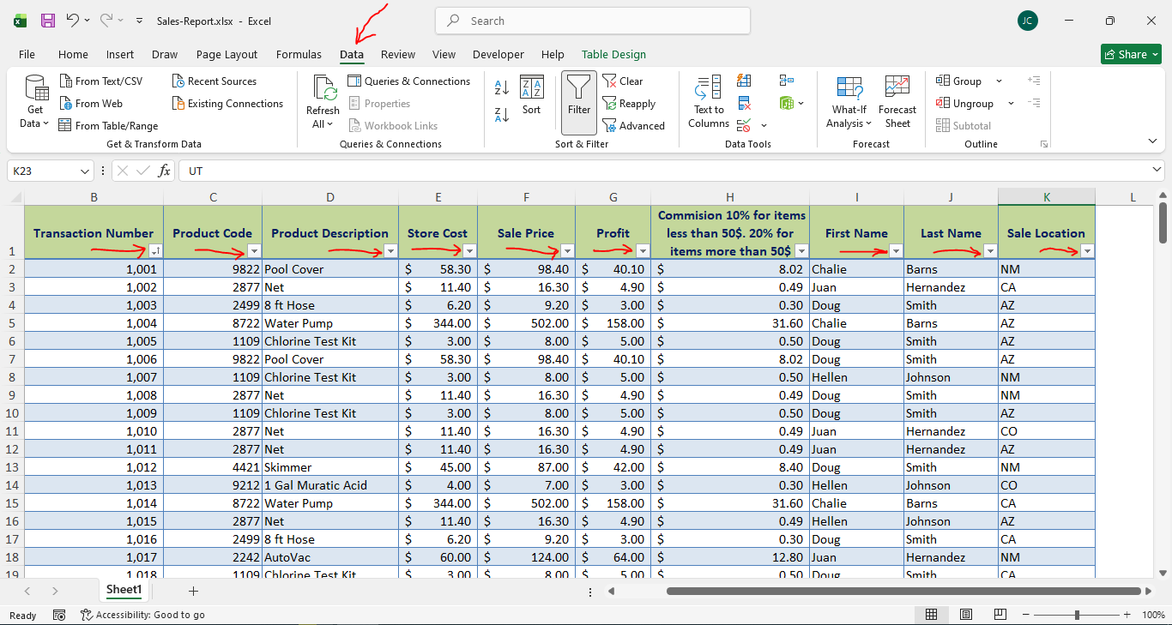
======================================================
Adding a pivot table from a table/range after selecting the data we want:
Note: It prefers to add data from a range; otherwise, blank values will also be included in the pivot table.
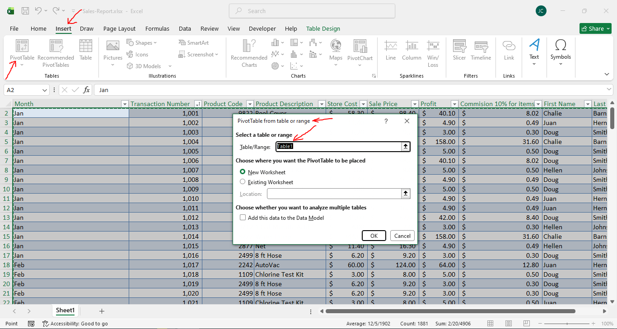
======================================================

The rows and columns for the pivot table:
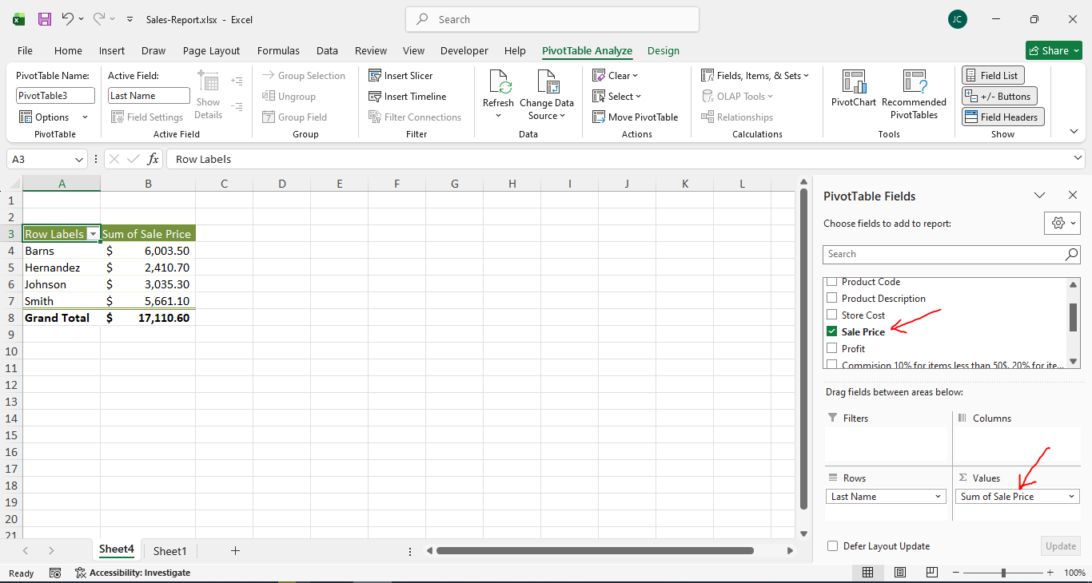
======================================================
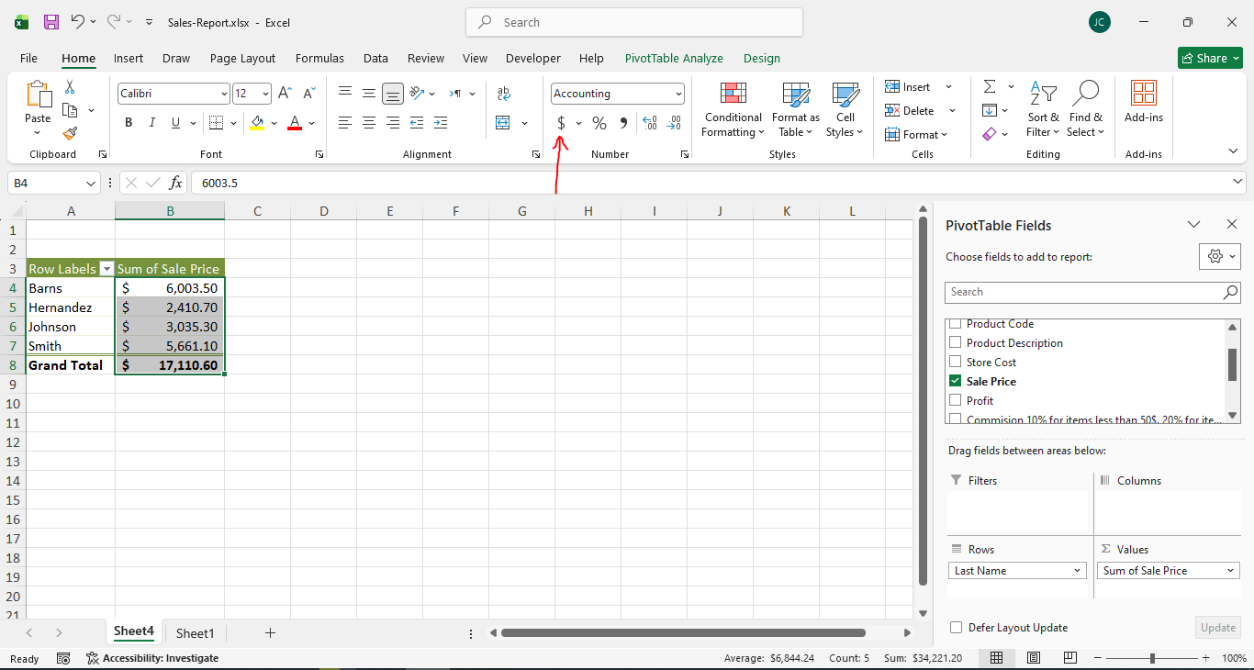
======================================================
To add a pie chart with the data labels:



