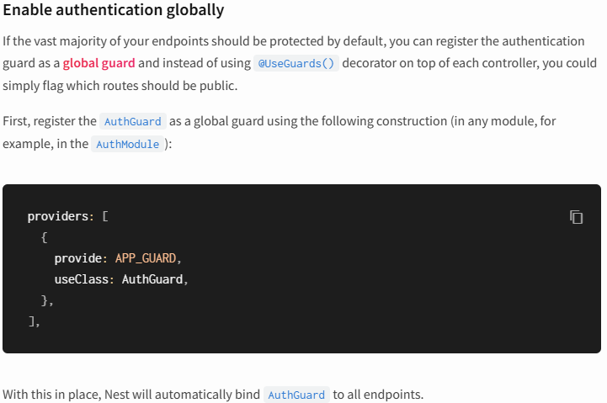
***********************************************************************
import { SetMetadata } from '@nestjs/common';

export const IS_PUBLIC_KEY = 'isPublic'
export const IsPublic = () => SetMetadata(IS_PUBLIC_KEY, true)
***********************************************************************
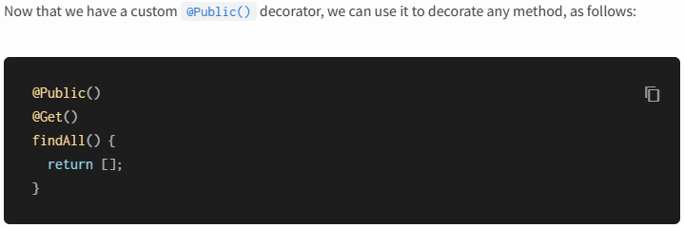
***********************************************************************
And the guard, will be:
import { CanActivate, ExecutionContext, Injectable, UnauthorizedException } from '@nestjs/common';
import { JwtService } from '@nestjs/jwt';
import { Request } from 'express';
import { jwtConstants } from './constants';
import { Reflector } from '@nestjs/core';
import { IS_PUBLIC_KEY } from 'src/public/public.decorator';
@Injectable()
export class AuthGuard implements CanActivate {

constructor(private readonly jwtService: JwtService, private readonly reflector: Reflector){}

async canActivate(
context: ExecutionContext,
): Promise<boolean> {

const isPublic = this.reflector.getAllAndOverride<boolean>(IS_PUBLIC_KEY, [
context.getHandler(),
context.getClass()
])

if(isPublic) {
return true
}

const request = context.switchToHttp().getRequest()
const token = this.extractTokenFromHeaders(request);
if(!token) {
throw new UnauthorizedException()
}

try {
const payload = await this.jwtService.verifyAsync(token, {
secret: jwtConstants.secret,
})
request["user"] = payload
} catch {
throw new UnauthorizedException()
}

return true;
}

extractTokenFromHeaders(request: Request): string|undefined {
const [type, token] = request.headers["authorization"]?.split(' ') ?? []
return type == 'Bearer' ? token : undefined
}
}
***********************************************************************
To use passport with nestjs:
Run command: npm install --save @nestjs/passport passport passport-local
Run command: npm install --save-dev @types/passport-local
***********************************************************************



