Principal Component Analysis (PCA)
**************************************************************************
natural language processing (NLP)
**************************************************************************
Scikit-learn: This stands for "Scientific Toolkit for Machine learning". It is a machine learning library that offers a variety of supervised and unsupervised algorithms, such as regression, classification, dimensionality reduction, cluster analysis, and anomaly detection.
**************************************************************************
The standard process of data analysis
Data analysis refers to investigating the data, finding meaningful insights from it, and drawing conclusions. The main goal of this process is to collect, filter, clean, transform, explore, describe, visualize, and communicate the insights from this data to discover decision-making information. Generally, the data analysis process is comprised of the following phases:
Collecting Data: Collect and gather data from several sources.
Preprocessing Data: Filter, clean, and transform the data into the required format.
Analyzing and Finding Insights: Explore, describe, and visualize the data and find insights and conclusions.
Insights Interpretations: Understand the insights and find the impact each variable has on the system.
Storytelling: Communicate your results in the form of a story so that a layman can understand them.
**************************************************************************
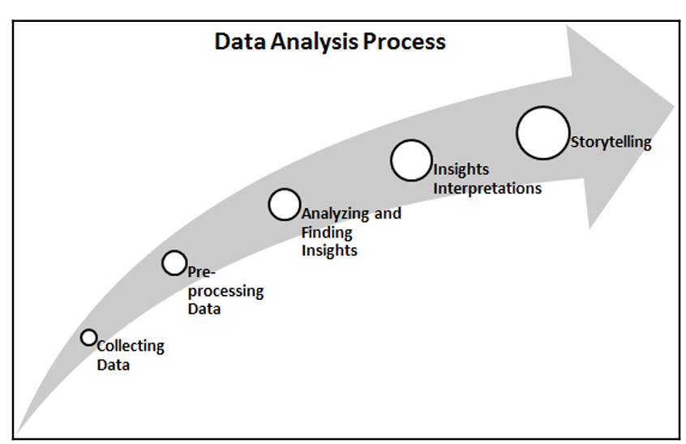
**************************************************************************
The KDD process
The KDD acronym stands for knowledge discovery from data or Knowledge Discovery in Databases. Many people treat KDD as one synonym for data mining. Data mining is referred to as the knowledge discovery process of interesting patterns. The main objective of KDD is to extract or discover hidden interesting patterns from large databases, data warehouses, and other web and information repositories.
**************************************************************************

The KDD process has seven major phases:
Data Cleaning: In this first phase, data is preprocessed. Here, noise is removed, missing values are handled, and outliers are detected.
Data Integration: In this phase, data from different sources is combined and integrated together using data migration and ETL tools.
Data Selection: In this phase, relevant data for the analysis task is recollected.
Data Transformation: In this phase, data is engineered in the required appropriate form for analysis.
Data Mining: In this phase, data mining techniques are used to discover useful and unknown patterns.
Pattern Evaluation: In this phase, the extracted patterns are evaluated.
Knowledge Presentation: After pattern evaluation, the extracted knowledge needs to be visualized and presented to business people for decision-making purposes.
**************************************************************************

SEMMA:
The SEMMA acronym's full form is Sample, Explore, Modify, Model, and Assess. This sequential data mining process is developed by SAS. The SEMMA process has five major phases:
Sample: In this phase, we identify different databases and merge them. After this, we select the data sample that's sufficient for the modeling process.
Explore: In this phase, we understand the data, discover the relationships among variables, visualize the data, and get initial interpretations.
Modify: In this phase, data is prepared for modeling. This phase involves dealing with missing values, detecting outliers, transforming features, and creating new additional features.
Model: In this phase, the main concern is selecting and applying different modeling techniques, such as linear and logistic regression, backpropagation networks, KNN, support vector machines, decision trees, and Random Forest.
Assess: In this last phase, the predictive models that have been developed are evaluated using performance evaluation measures.
**************************************************************************
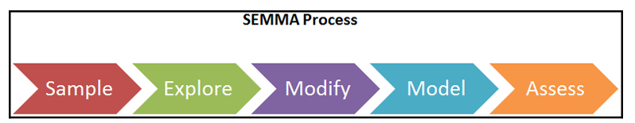
**************************************************************************

CRISP-DM:
CRISP-DM's full form is CRoss-InduStry Process for Data Mining. CRISP-DM is a well-defined, well-structured, and well-proven process for machine learning, data mining, and business intelligence projects. It is a robust, flexible, cyclic, useful, and practical approach to solving business problems. The process discovers hidden valuable information or patterns from several databases. The CRISP-DM process has six major phases:

Business Understanding: In this first phase, the main objective is to understand the business scenario and requirements for designing an analytical goal an initial action plan.
Data Understanding: In this phase, the main objective is to understand the data and its collection process, perform data quality checks, and gain initial insights.
Data Preparation: In this phase, the main objective is to prepare analytics-ready data. This involves handling missing values, outlier detection and handling, normalizing data, and feature engineering. This phase is the most time consuming for data scientists/analysts.
Modeling: This is the most exciting phase of the whole process since this is where you design the model for prediction purposes. First, the analyst needs to decide on the modeling technique and develop models based on data.
Evaluation: Once the model has been developed, it's time to assess and test the model's performance on validation and test data using model evaluation measures such as MSE, RMSE, R-Square for regression and accuracy, precision, recall, and the F1-measure.
Deployment: In this final phase, the model that was chosen in the previous step will be deployed to the production environment. This requires a team effort from data scientists, software developers, DevOps experts, and business professionals.
**************************************************************************

Comparing data analysis and data science:
Data analysis is the process in which data is explored in order to discover patterns that help us make business decisions. It is one of the subdomains of data science. Data analysis methods and tools are widely utilized in several business domains by business analysts, data scientists, and researchers. Its main objective is to improve productivity and profits. Data analysis extracts and queries data from different sources, performs exploratory data analysis, visualizes data, prepares reports, and presents it to the business decision making authorities.

On the other hand, data science is an interdisciplinary area that uses a scientific approach to extract insights from structured and unstructured data. Data science is a union of all terms, including data analytics, data mining, machine learning, and other related domains. Data science is not only limited to exploratory data analysis and is used for developing models and prediction algorithms such as stock price, weather, disease, fraud forecasts, and recommendations such as movie, book, and music recommendations.
**************************************************************************
The data analyst also assesses the quality of the data and handles the issues concerning data acquisition. A data analyst should be proficient in writing SQL queries, finding patterns, using visualization tools, and using reporting tools Microsoft Power BI, IBM Cognos, Tableau, QlikView, Oracle BI, and more.
**************************************************************************
Data scientists are more technical and mathematical than data analysts. Data scientists are research- and academic-oriented, whereas data analysts are more application-oriented. Data scientists are expected to predict a future event, whereas data analysts extract significant insights out of data. Data scientists develop their own questions, while data analysts find answers to given questions. Finally, data scientists focus on what is going to happen, whereas data analysts focus on what has happened so far.
**************************************************************************

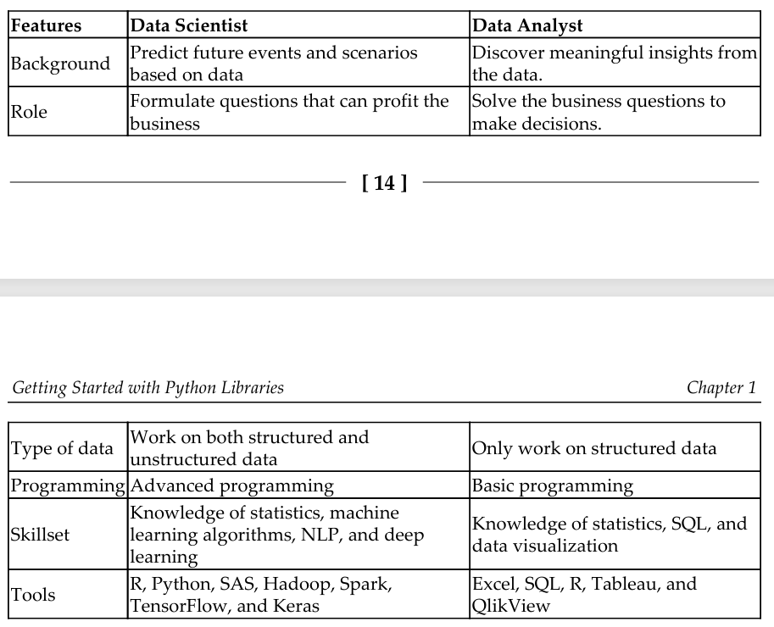
**************************************************************************

The skillsets of data analysts and data scientists
A data analyst is someone who discovers insights from data and creates value out of it. This helps decision-makers understand how the business is performing. Data analysts must acquire the following skills:
Exploratory Data Analysis (EDA): EDA is an essential skill for data analysts. It helps with inspecting data to discover patterns, test hypotheses, and assure assumptions.
Relational Database: Knowledge of at least one of the relational database tools, such as MySQL or Postgre, is mandatory. SQL is a must for working on relational databases.
Visualization and BI Tools: A picture speaks more than words. Visuals have more of an impact on humans and visuals are a clear and easy option for representing the insights. Visualization and BI tools such as Tableau, QlikView, MS Power BI, and IBM Cognos can help analysts visualize and prepare reports.
Spreadsheet: Knowledge of MS Excel, WPS, Libra, or Google Sheets is mandatory for storing and managing data in tabular form.
Storytelling and Presentation Skills: The art of storytelling is another necessary skill. A data analyst should be an expert in connecting data facts to an idea or an incident and turning it into a story.
**************************************************************************

A data scientist has to be a jack of all trades and wear multiple hats, including those of a data analyst, statistician, mathematician, programmer, ML, or NLP engineer. Most people are not skilled enough or experts in all these trades. Also, getting skilled enough requires lots of effort and patience. This is why data science cannot be learned in 3 or 6 months. Learning data science is a journey. A data scientist should have a wide variety of skills, such as the following:
Mathematics and Statistics: Most machine learning algorithms are based on mathematics and statistics. Knowledge of mathematics helps data scientists develop custom solutions.
Databases: Knowledge of SQL allows data scientists to interact with the database and collect the data for prediction and recommendation.
Machine Learning: Knowledge of supervised machine learning techniques such as regression analysis, classification techniques, and unsupervised machine learning techniques such as cluster analysis, outlier detection, and dimensionality reduction.
Programming Skills: Knowledge of programming helps data scientists automate their suggested solutions. Knowledge of Python and R is recommended.
Storytelling and Presentation skills: Communicating the results in the form of storytelling via PowerPoint presentations.
Big Data Technology: Knowledge of big data platforms such as Hadoop and Spark helps data scientists develop big data solutions for large-scale enterprises.
Deep Learning Tools: Deep learning tools such as Tensorflow and Keras are utilized in NLP and image analytics.
**************************************************************************

To create numpy array we can use array, arange:
arange(start,[stop],step)
import numpy as np;

arr = np.array([1, 2, 3, 4, 5])
print(f"The numpy array is: {arr}")

arr = np.arange(1, 11)
print(f"The numpy array using arange: {arr}");
**************************************************************************
Apart from the array() and arange() functions, there are other options, such as zeros(), ones(), full(), eye(), and random(), which can also be used to create a NumPy array, as these functions are initial placeholders.
- zeros(): The zeros()function creates an array for a given dimension with all zeroes.
- ones(): The ones() function creates an array for a given dimension with all ones.
- full(): The full() function generates an array with constant values.
- eyes(): The eye() function creates an identity matrix.
- random(): The random() function creates an array with any given dimension.
**************************************************************************
arr = np.zeros(2)
print(f"The numpy array is: {arr}")
print("\t\t", '-' * 15)

# Create 2x3 array of zeros
arr = np.zeros((2, 3))
print(f"The numpy array is: {arr}")
print("\t\t", '-' * 15)

arr = np.ones(2)
print(f"The numpy array is: {arr}")
print("\t\t", '-' * 15)

# creates 2x2 array of ones
arr = np.ones((2, 2))
print(f"The numpy array is: {arr}")
print("\t\t", '-' * 15)

arr = np.full(2, 2)
print(f"The numpy array is: {arr}")
print("\t\t", '-' * 15)

# creates 2x2 array using 11 as constant
arr = np.full((2, 2), 11)
print(f"The numpy array is: {arr}")
print("\t\t", '-' * 15)

arr = np.eye(4, 3)
print(f"The numpy array is: {arr}")
print("\t\t", '-' * 15)

# create 4x4 identity array
arr = np.eye(4)
print(f"The numpy array is: {arr}")
print("\t\t", '-' * 15)

arr = np.eye(2, 3)
print(f"The numpy array is: {arr}")
print("\t\t", '-' * 15)

arr = np.random.random(3)
print(f"The numpy array is: {arr}")
print("\t\t", '-' * 15)

# creates 3x3 array using random values
arr = np.random.random((3, 3))
print(f"The numpy array is: {arr}")
**************************************************************************
Array features In general, NumPy arrays are a homogeneous kind of data structure that has the same types of items. The main benefit of an array is its certainty of storage size because of its same type of items. A Python list uses a loop to iterate the elements and perform operations on them. Another benefit of NumPy arrays is to offer vectorized operations instead of iterating each item and performing operations on it. NumPy arrays are indexed just like a Python list and start from 0. NumPy uses an optimized C API for the fast processing of the array operations.
**************************************************************************

