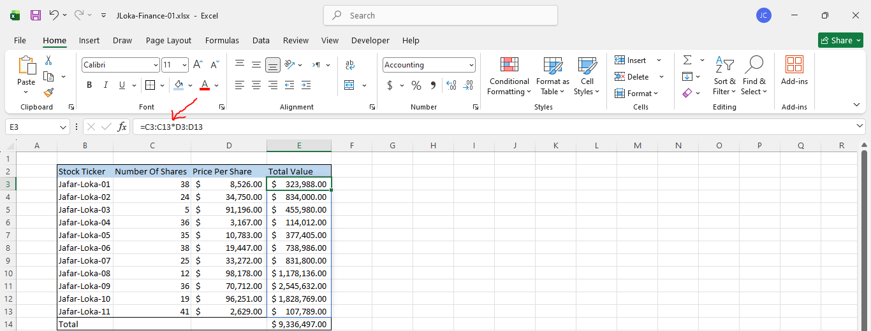
=======================================================
To add data validation for a specific column:
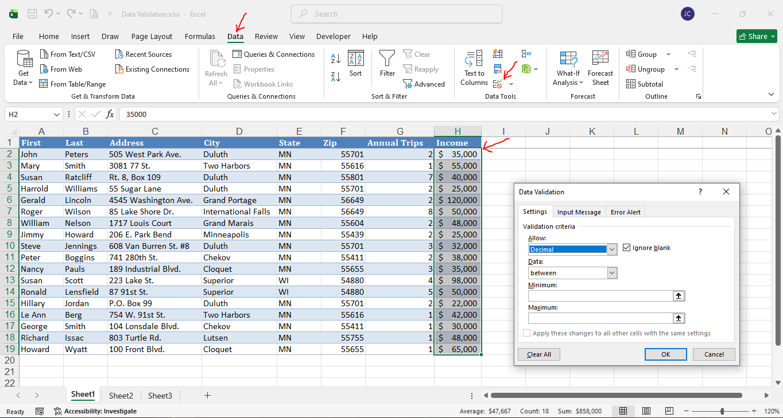
--------------------------------------------------------------------------------------------------

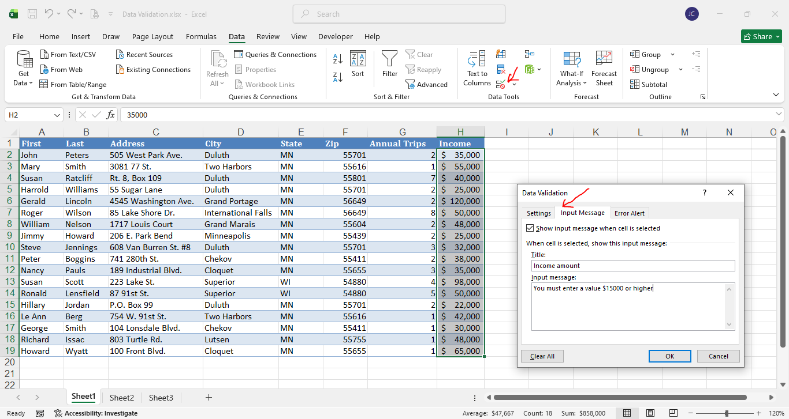
--------------------------------------------------------------------------------------------------
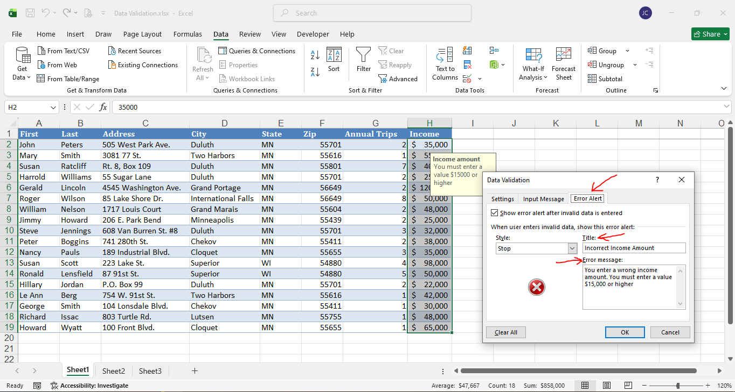
=======================================================

To add current date (CTRL+;) and to add the current time (SHIFT+CTRL+;):
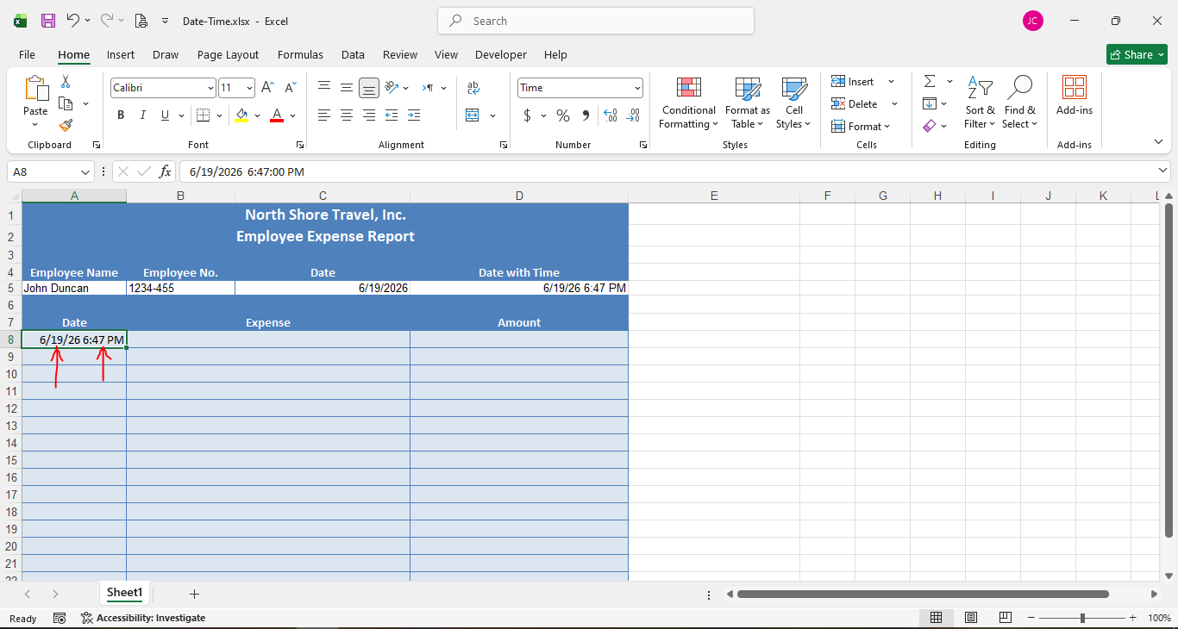
=======================================================
To clear the data validation:
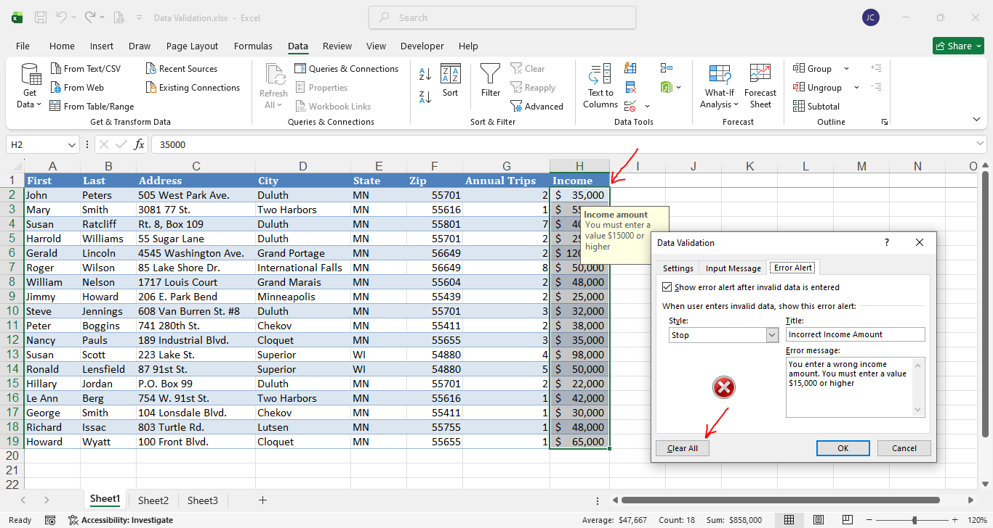
=======================================================
To select the entire column (CTRL + SHIFT + DOWN ARROW):
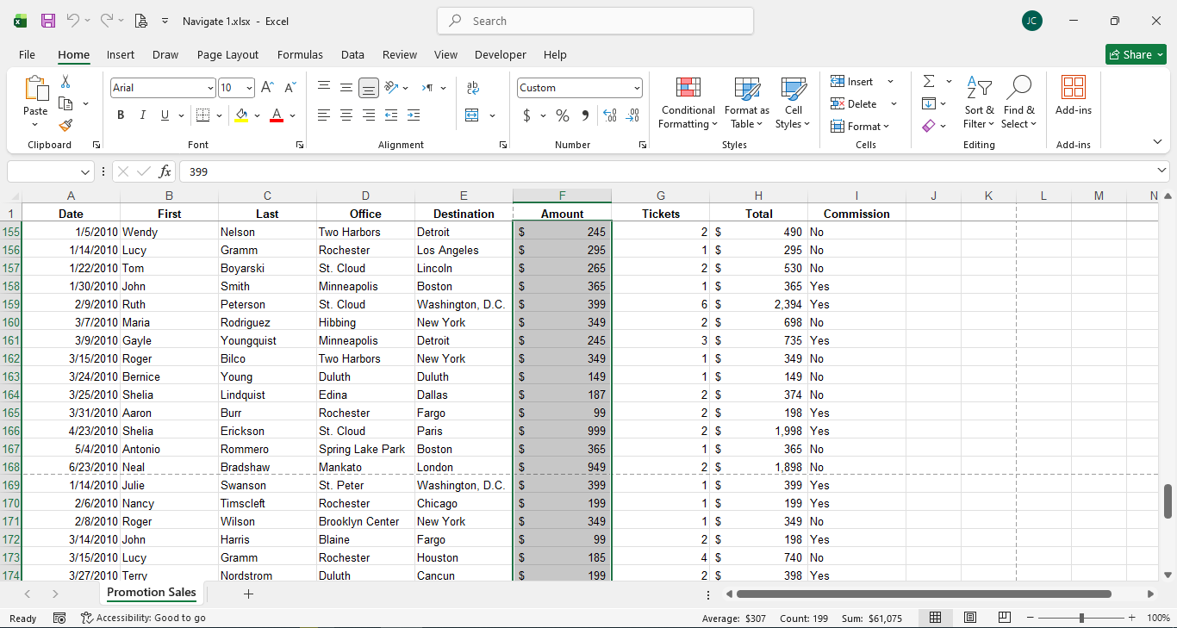
=======================================================
To freeze the top row from the View-Tab:


