To use OrderService Beans using annotation, we can use @component annotation:
import org.springframework.stereotype.Component;
@Component
public class OrderService {
private PaymentService paymentService;
public OrderService(PaymentService paymentService) {
this.paymentService = paymentService;
}
public void setPaymentService(PaymentService paymentService) {
this.paymentService = paymentService;
}
public void placeOrder() {
paymentService.processPayment(100_000);
}
}
--------------------------------------------------------------------------------
Service for classes that encapsulate the logic work
Repository for classes/Interfaces that handle database operations.
Service is alias for Component
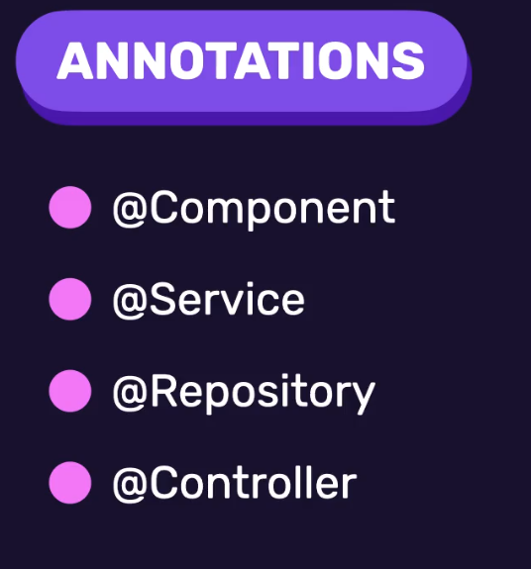
--------------------------------------------------------------------------------

Note 1: we set @Component && @Service for setting the Dependencies that will use
Note 2: if we have multiple constructors, then we must use @Autowired with classes that use @Service or @Component, because Spring prefers to use the default constructor.
Note 3: when we have multiple constructor we must set @Autowired, so Spring Can Handle DI Correct (Not only the default constructor) (If we don’t set it we will get BeanCreationException).
--------------------------------------------------------------------------------
Note: If we have two component with @Component OR @Service, then we will get exception when using the Bean Class that depends on Them.
@Component
public class OrderService {
private PaymentService paymentService;
public OrderService(PaymentService paymentService) {
this.paymentService = paymentService;
}
}
--------------------------------------------------------------------------------
@Service
public class StripePaymentService implements PaymentService {
@Override
public void processPayment(double amount) {
System.out.println("Stripe");
System.out.println("amount: " + amount + " processed");
}
}
--------------------------------------------------------------------------------

@Service
public class PaypalPaymentService implements PaymentService{
@Override
public void processPayment(double amount) {
System.out.println("Paypal");
System.out.println("amount: " + amount + " processed");
}
}
--------------------------------------------------------------------------------
@SpringBootApplication
public class StoreApplication {
public static void main(String[] args) {
ApplicationContext context = SpringApplication.run(StoreApplication.class, args);
OrderService orderService = context.getBean(OrderService.class);
orderService.placeOrder();
}
}
--------------------------------------------------------------------------------
To solve the above problem, we have @Primary @Qualifier
--------------------------------------------------------------------------------
@Primary: Set the default bean
--------------------------------------------------------------------------------
@Qualifier: set the implementation of what we want.
**********************************************************
In This Way we set default value for @Value, if the param not defined in application.properties:
@Value("${not.defined:Hi}")
private String notDefined;
**********************************************************

@Bean: used with method to tell springboot framework it’s Bean producer
**********************************************************
@Configuration: used with class to create configuration classes for our project, so we control the operation of DI (springboot framework will auto load the class when run)
For our classes that we want to create it, we must annotate it with @Component
**********************************************************
Note: when use @Configuration, springboot will always initialize the classes, so to avoid unnecessary of creating objects (this called early or eager initialization), we can use lazy loading
**********************************************************
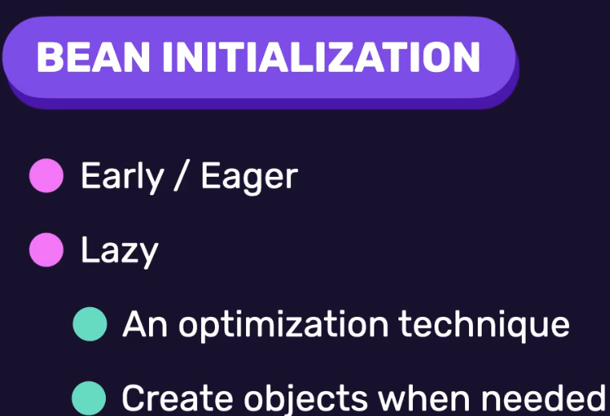
**********************************************************

After comment all code that uses the @Component-classes, this is the output when using eager loading:
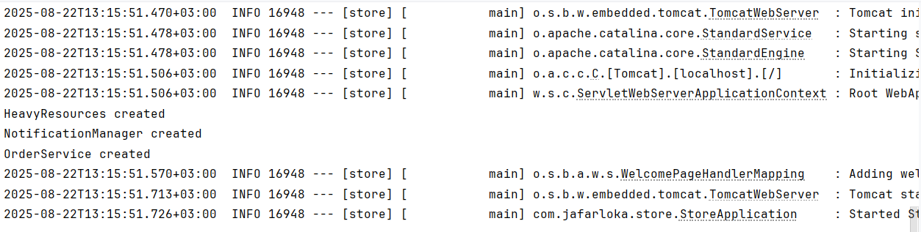
**********************************************************
The default scope for services is singleton, so only one instance of the services will be created, and the constructor will be called only once.
**********************************************************
Prototype scope: will create service for each request, it is useful for services that hold state of info about user activity and that are used temporarily.
Note 1: in this way if we call the service twice using context.getBean, then the constructor will apply twice.
Note 2: if we want to use it, we annotate the class, method (ex: in AppConfig-Class) with @Scope("prototype")
**********************************************************
The other two scopes of bean: request (like asp.net core), session (like asp.net core)
**********************************************************
Bean Lifecycle Hooks: useful when we have many init works that depend on the values of Bean that must be initialized.
**********************************************************
We must use @Autowired carefully, it may make framework call the hooks (PostConstruct Twice).
**********************************************************
This is used inside the orderservice class
@PostConstruct
public void init() {
System.out.println("OrderService PostConstruct");
}
@PreDestroy
public void cleanup() {
System.out.println("OrderService PreDestroyed");
}

To test them:
ConfigurableApplicationContext context = SpringApplication.run(StoreApplication.class, args);
OrderService orderService = context.getBean(OrderService.class);
context.close();
**********************************************************

