Microservice Patterns
Every microservice architecture has challenges such as accessibility, obtaining configuration information, messaging, and service discovery. There are common solutions to these challenges called patterns.
==================================================
API Gateway/BFF
The API Gateway pattern provides a single endpoint for client applications to the microservices assigned to it. API Gateways provide functionality such as routing to microservices, authentication, and load balancing.
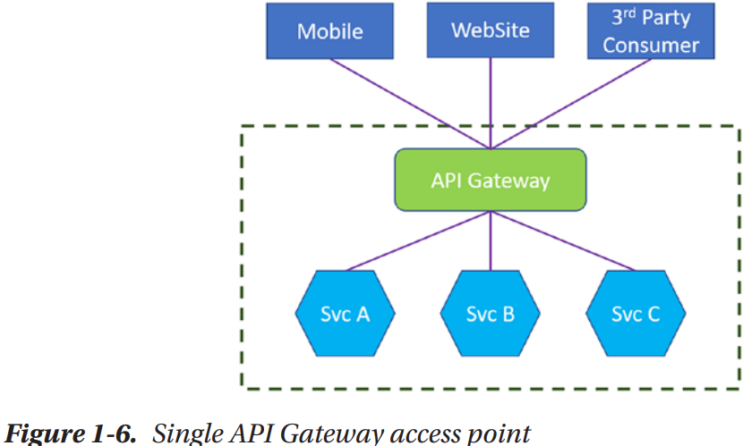
==================================================

At some point, separation should be done to split client applications apart by using multiple API Gateways. Design pattern Backends for Frontends (BFF), helps with this segregation. There are multiple endpoints, but they are designated based on the types of clients being served.
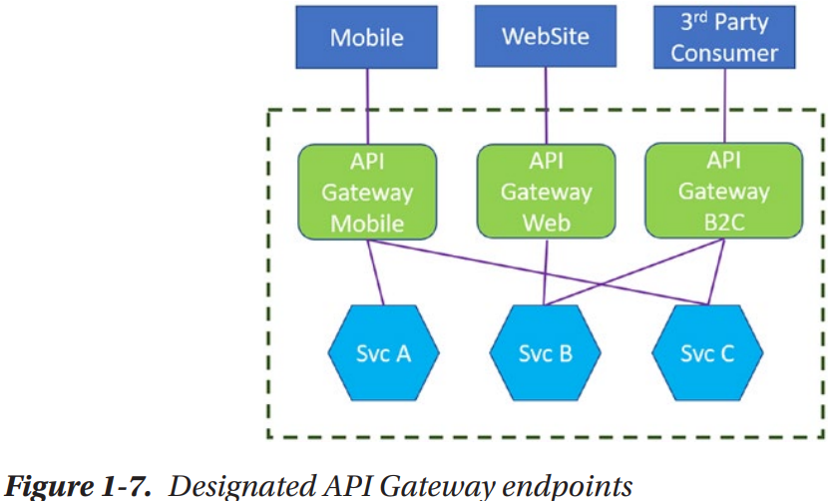
==================================================
External Configuration Store
Nearly all microservices will need configuration information, just like monoliths. With the ability to have many microservices instances, it would be impractical for each instance to have its own configuration files. Updating information across all running instances would be overwhelming. Instead, using the External Configuration Store pattern provides a common area to store configuration information. This means there is one source of the configuration values.
==================================================

