Owned entity types are entity types that are part of the owner and cannot exist without the owner. You can use common one-to-one or one-to-many relationships to model the owned entities, but EF Core provides a more convenient way called owned entity types. You can use the OwnsOne() or OwnsMany() method to define owned entity types, instead of using the HasOne() or HasMany() method.
***********************************************************************
public static class InvoiceModelCreatingExtensions
{
public static void ConfigureInvoice(this ModelBuilder builder)
{
// using Fluent API
builder.Entity<Invoice>(b =>
{
b.ToTable("Invoices");
b.HasKey(i => i.Id);
b.Property(p => p.Id).HasColumnName("Id");
b.Property(p => p.InvoiceNumber).HasColumnName("InvoiceNumber").HasColumnType("varchar(32)").IsRequired();
b.Property(p => p.ContactName).HasColumnName("ContactName").HasMaxLength(32).IsRequired();
b.Property(p => p.Description).HasColumnName("Description").HasMaxLength(256);
b.Property(p => p.Amount).HasColumnName("Amount").HasColumnType("decimal(18,2)").IsRequired();
b.Property(p => p.Amount).HasColumnName("Amount").HasPrecision(18, 2);
b.Property(p => p.InvoiceDate).HasColumnName("InvoiceDate").HasColumnType("datetimeoffset").IsRequired();
b.Property(p => p.DueDate).HasColumnName("DueDate").HasColumnType("datetimeoffset").IsRequired();
b.Property(p => p.Status).HasColumnName("Status").HasMaxLength(16).HasConversion(
v => v.ToString(),
v => (InvoiceStatus)Enum.Parse(typeof(InvoiceStatus), v)
);
// b.HasMany(x => x.InvoiceItems).WithOne(x => x.Invoice).HasForeignKey(x => x.InvoiceId);
b.OwnsMany(p => p.InvoiceItems, a =>
{
a.WithOwner(x => x.Invoice).HasForeignKey(x => x.InvoiceId);
a.ToTable("InvoiceItems");
});
});
}
}
***********************************************************************

When you use the OwnsOne()/WithOwner() methods, you do not need to specify the foreign key property because the owned entity type will be stored in the same table as the owner by default. You can use the ToTable method to specify the table name of the owned entity type.
***********************************************************************
What is the difference between normal one-to-one or one-to-many and owned entity types? There are some differences:
• You cannot create a DbSet property for an owned entity type. You can only use the DbSet property for the owner. That means you do not have any way to access the owned entity type directly. You must access the owned entity type through the owner.
• When you query the owner, the owned entity type will be included automatically. You do not need to use the Include() method to include the owned entity type explicitly.
***********************************************************************
By default, a new DbContext instance is created for each request, which is generally not a problem since it is a lightweight object that does not consume many resources. However, in a high-throughput application, the cost of setting up various internal services and objects for each DbContext instance can add up. To address this, EF Core provides a feature called DbContext pooling, which allows the DbContext instance to be reused across multiple requests.
To enable DbContext pooling, you can replace the AddDbContext() method with the AddDbContextPool() method. This resets the state of the DbContext instance when it is disposed of, stores it in a pool, and reuses it when a new request comes in. By reducing the cost of setting up the DbContext instance, DbContext pooling can significantly improve the performance of your application for high-throughput scenarios.
***********************************************************************
The AddDbContextPool() method takes a poolSize parameter, which specifies the maximum number of DbContext instances that can be stored in the pool. The default value is 1024, which is usually sufficient for most applications. If the pool is full, EF Core will start creating new DbContext instances as needed.
***********************************************************************
Important note:
For most applications, DbContext pooling is not necessary. You should enable DbContext pooling only if you have a high-throughput application. Therefore, before enabling DbContext pooling, it is important to test your application’s performance with and without it to see whether there’s any noticeable improvement.
***********************************************************************
When we call the context.Invoices.FindAsync(id) method for the first time, EF Core will query the database and return the Invoice entity. The second time, EF Core will return the Invoice entity from the context because the Invoice entity is already in the context.
***********************************************************************
But in rare cases, Find() and FindAsync() may return outdated data if the entity is updated in the database after it is loaded into the context.
***********************************************************************
For example, if you use the bulk-update ExecuteUpdateAsync() method, the update will not be tracked by DbContext. Then, if we use Find() or FindAsync() to get the entity from DbContext, you will get the outdated data. In this case, you should use Single() or SingleOrDefault() to get the entity from the database again. In most cases, you can use the Find() or FindAsync() methods to get an entity by its primary key when you are sure the entity is always tracked by the DbContext.
***********************************************************************
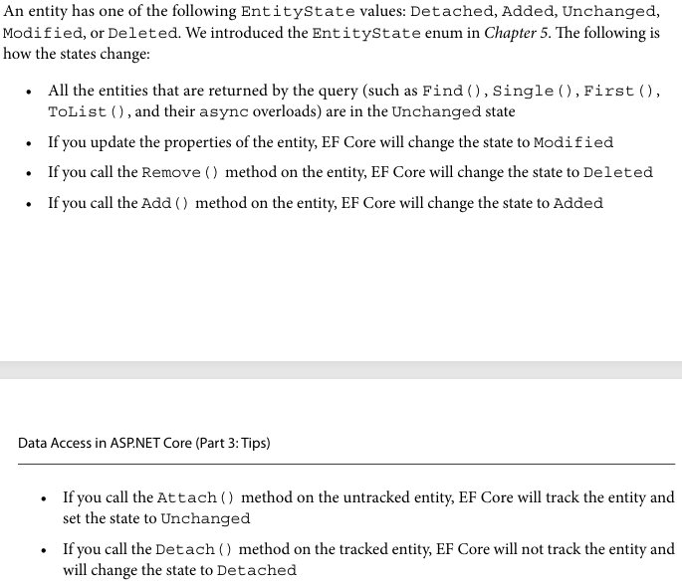
***********************************************************************
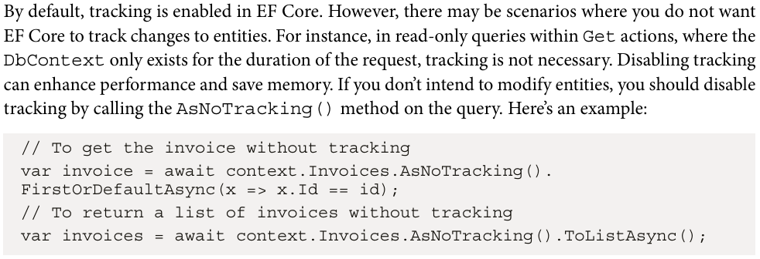
***********************************************************************
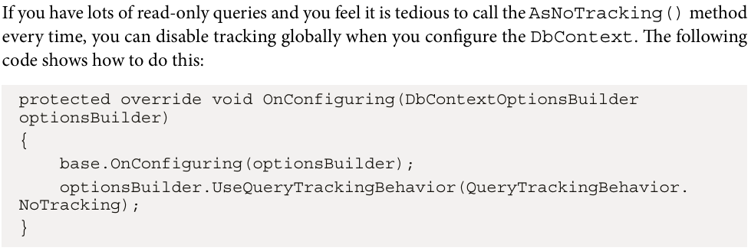
***********************************************************************
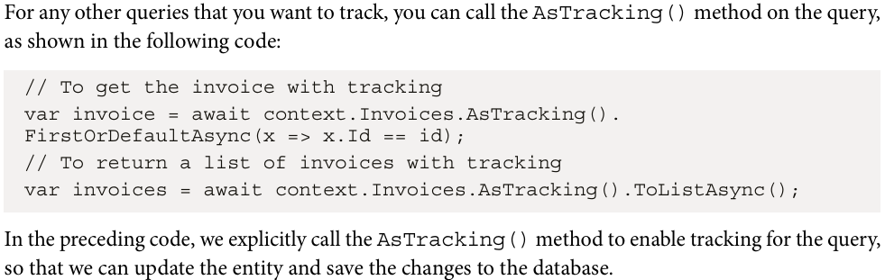
***********************************************************************
If an entity is a keyless entity, EF Core will never track it. Keyless entity types do not have keys defined on them. They are configured by a [Keyless] data annotation or a Fluent API HasNoKey() method. The keyless entity is often used for read-only queries or views.
***********************************************************************
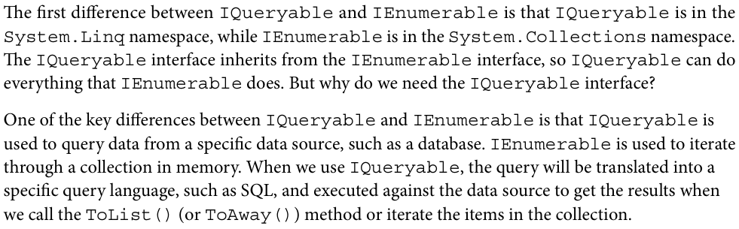
***********************************************************************
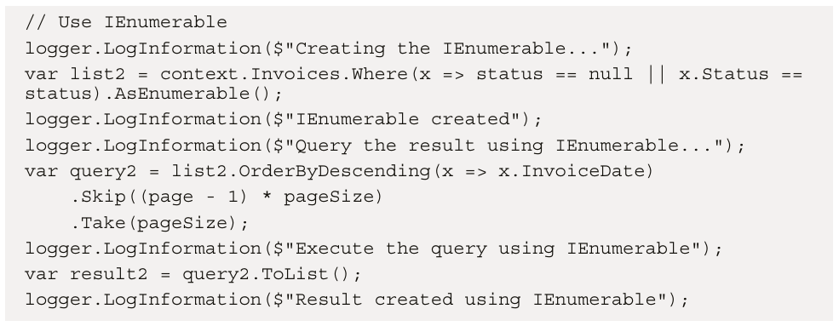
***********************************************************************
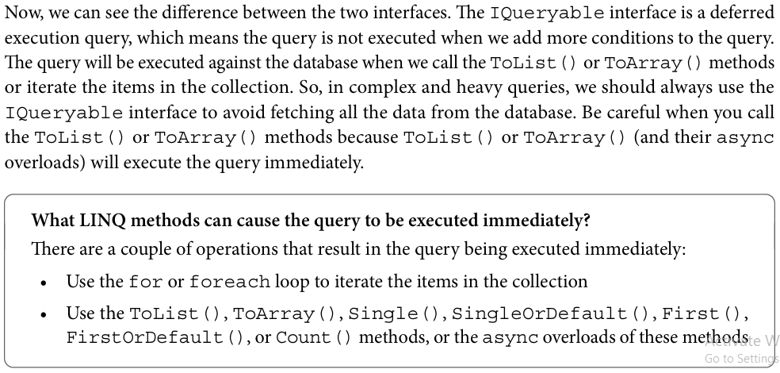
***********************************************************************

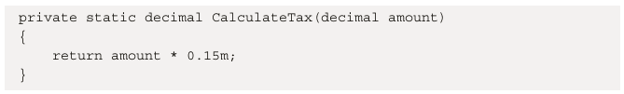
-----------------------------------------------------------------------------------------------------
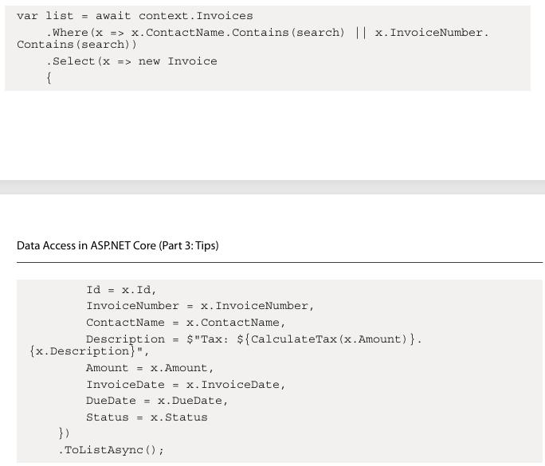
***********************************************************************
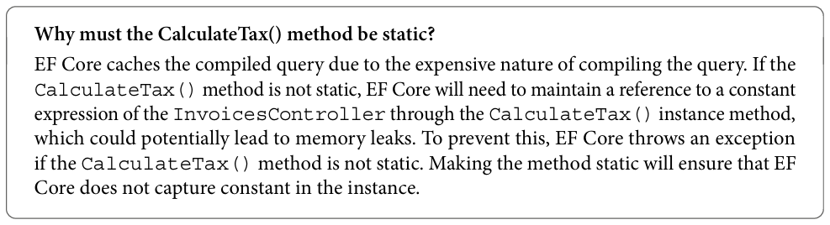
***********************************************************************
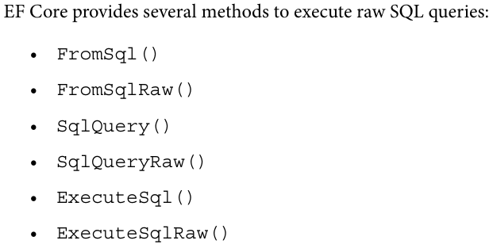
***********************************************************************
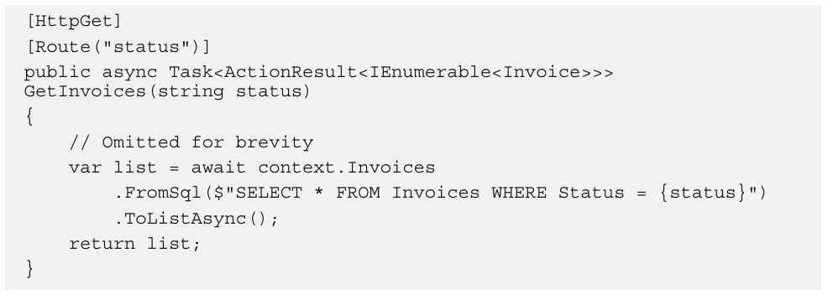
***********************************************************************
The parameter is not inserted into the SQL query directly. Instead, EF Core uses the @p0 parameter placeholder and passes the parameter value to the SQL query. This is called a parameterized query. It is safe to use the parameterized query to avoid SQL injection attacks. So, we do not need to worry about the safety of the FromSql method.
***********************************************************************
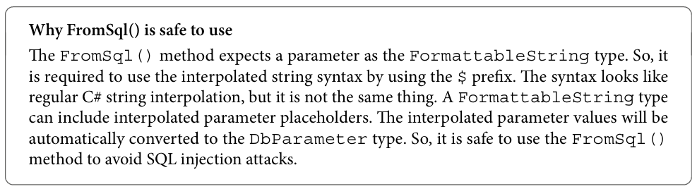
***********************************************************************
Note that the SqlQuery() method is used on the Database property of the DbContext object. It is not available on the DbSet object.



