When a user is authenticated, the user will have a set of claims that are used to store the information about the user. For example, the user can have a claim that specifies the user’s role. So, technically, roles are also claims, but they are special claims that are used to store the roles of the user. We can store other information in the claims, such as the user’s name, email address, date of birth, driving license number, and more. Once we’ve done this, the authorization system can check the claims to determine whether the user is allowed to access the resource. Claim-based authorization provides more granular access control than role-based authorization, but it can be more complex to implement and manage.
*******************************************************************
A claim is a key-value pair. Note that the claim type and value are case-sensitive. You can store the claims in the database or the code. When the user logs in, the claims can be retrieved from the database and added to the token.
*******************************************************************
builder.Services.AddAuthorization(options =>
{
options.AddPolicy("RequireAdministratorRole", policy => policy.RequireRole(AppRoles.Administrator));
options.AddPolicy("RequireVipUserRole", policy => policy.RequireRole(AppRoles.VipUser));
options.AddPolicy("RequireUserRole", policy => policy.RequireRole(AppRoles.User));
options.AddPolicy("RequireUserRoleOrVipUserRole", policy => policy.RequireRole(AppRoles.User, AppRoles.VipUser));
options.AddPolicy(AppAuthorizationPolicies.RequireAccessNumber, policy => policy.RequireClaim(AppClaimTypes.AccessNumber));
options.AddPolicy(AppAuthorizationPolicies.RequireDrivingLicenseNumber, policy => policy.RequireClaim(AppClaimTypes.DrivingLicenseNumber));
// Here we can set multiple values not Russia
options.AddPolicy(AppAuthorizationPolicies.RequireCountry, policy => policy.RequireClaim(ClaimTypes.Country, "Russia", "Syria"));
});
*******************************************************************

The AppClaimTypes:
namespace JLokaAuthentication.Authentication
{
public class AppClaimTypes
{
public const string DrivingLicenseNumber = "DrivingLicenseNumber";
public const string AccessNumber = "AccessNumber";
}
}
*******************************************************************
The Authorization Policies:
namespace JLokaAuthentication.Authentication
{
public static class AppAuthorizationPolicies
{
public const string RequireDrivingLicenseNumber = "RequireDrivingLicenseNumber";
public const string RequireAccessNumber = "RequireAccessNumber";
public const string RequireCountry = "RequireCountry";
}
}
*******************************************************************

To create conditional policy we can use:
builder.Services.AddAuthorization(options =>
{
options.AddPolicy("RequireAdministratorRole", policy => policy.RequireRole(AppRoles.Administrator));
options.AddPolicy("RequireVipUserRole", policy => policy.RequireRole(AppRoles.VipUser));
options.AddPolicy("RequireUserRole", policy => policy.RequireRole(AppRoles.User));
options.AddPolicy("RequireUserRoleOrVipUserRole", policy => policy.RequireRole(AppRoles.User, AppRoles.VipUser));
options.AddPolicy(AppAuthorizationPolicies.RequireAccessNumber, policy => policy.RequireClaim(AppClaimTypes.AccessNumber));
options.AddPolicy(AppAuthorizationPolicies.RequireDrivingLicenseNumber, policy => policy.RequireClaim(AppClaimTypes.DrivingLicenseNumber));
// Here we can set multiple values not Russia
options.AddPolicy(AppAuthorizationPolicies.RequireCountry, policy => policy.RequireClaim(ClaimTypes.Country, "Russia", "Syria"));
options.AddPolicy(AppAuthorizationPolicies.RequireDrivingLicenseAndAccessNumber, policy => policy.RequireAssertion(context =>
{
var hasDrivingLicense = context.User.HasClaim(c => c.Type == AppClaimTypes.DrivingLicenseNumber);
var hasAccessNumber = context.User.HasClaim(c => c.Type == AppClaimTypes.AccessNumber);

return hasDrivingLicense && hasAccessNumber;
}));
});
*******************************************************************
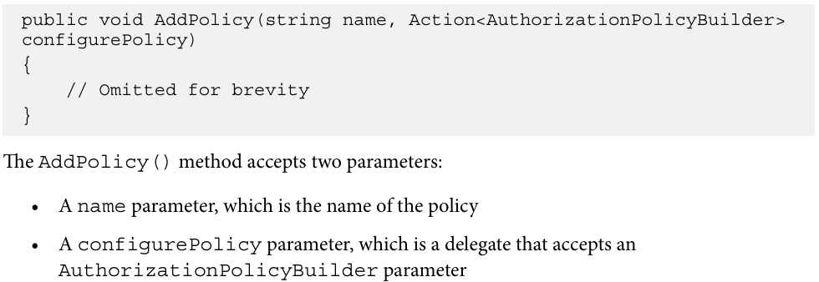
*******************************************************************

[Authorize(Policy = AppAuthorizationPolicies.SpecialPremiumContent)]
[HttpGet("get-premium")]
public IActionResult GetPremium()
{
return NoContent();
}
--------------------------------------------------------
using Microsoft.AspNetCore.Authorization;

namespace JLokaAuthentication.Authentication
{
public class SpecialPremiumContentRequirement : IAuthorizationRequirement
{
public string Country { get; set; } = string.Empty;

public SpecialPremiumContentRequirement(string country)
{
Country = country;
}
}
}
--------------------------------------------------------
using Microsoft.AspNetCore.Authorization;
using System.Security.Claims;

namespace JLokaAuthentication.Authentication
{
public class SpecialPremiumContentAuthorizationHandler: AuthorizationHandler<SpecialPremiumContentRequirement>
{
protected override Task HandleRequirementAsync(AuthorizationHandlerContext context, SpecialPremiumContentRequirement requirement)
{
Console.WriteLine("Executed...");
var hasPremiumAccess = context.User.HasClaim(c => c.Type == AppClaimTypes.Subscription && c.Value == "Premium");
if(!hasPremiumAccess)
{
return Task.CompletedTask;
}
var countryClaim = context.User.FindFirst(c => c.Type == ClaimTypes.Country);
if (countryClaim == null || String.IsNullOrEmpty(countryClaim.ToString()))
{
return Task.CompletedTask;
}

if(countryClaim.Value == requirement.Country)
{
context.Succeed(requirement);
}
return Task.CompletedTask;
}
}
}
--------------------------------------------------------
And in the app builder:
builder.Services.AddAuthorization(options =>
{
options.AddPolicy("RequireAdministratorRole", policy => policy.RequireRole(AppRoles.Administrator));
options.AddPolicy("RequireVipUserRole", policy => policy.RequireRole(AppRoles.VipUser));
options.AddPolicy("RequireUserRole", policy => policy.RequireRole(AppRoles.User));
options.AddPolicy("RequireUserRoleOrVipUserRole", policy => policy.RequireRole(AppRoles.User, AppRoles.VipUser));
options.AddPolicy(AppAuthorizationPolicies.RequireAccessNumber, policy => policy.RequireClaim(AppClaimTypes.AccessNumber));
options.AddPolicy(AppAuthorizationPolicies.RequireDrivingLicenseNumber, policy => policy.RequireClaim(AppClaimTypes.DrivingLicenseNumber));
// Here we can set multiple values not Russia
options.AddPolicy(AppAuthorizationPolicies.RequireCountry, policy => policy.RequireClaim(ClaimTypes.Country, "Russia", "Syria"));
options.AddPolicy(AppAuthorizationPolicies.RequireDrivingLicenseAndAccessNumber, policy => policy.RequireAssertion(context =>
{
var hasDrivingLicense = context.User.HasClaim(c => c.Type == AppClaimTypes.DrivingLicenseNumber);
var hasAccessNumber = context.User.HasClaim(c => c.Type == AppClaimTypes.AccessNumber);

return hasDrivingLicense && hasAccessNumber;
}));
// Adding custom policy implementation
options.AddPolicy(AppAuthorizationPolicies.SpecialPremiumContent, policy =>
{
policy.Requirements.Add(new SpecialPremiumContentRequirement("Russia"));
});
});

builder.Services.AddSingleton<IAuthorizationHandler, SpecialPremiumContentAuthorizationHandler>();
*******************************************************************
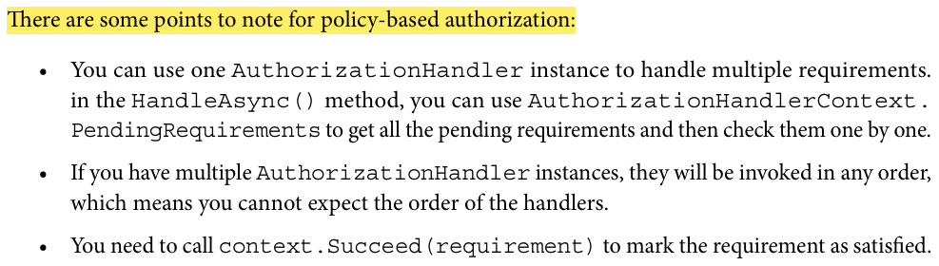
*******************************************************************
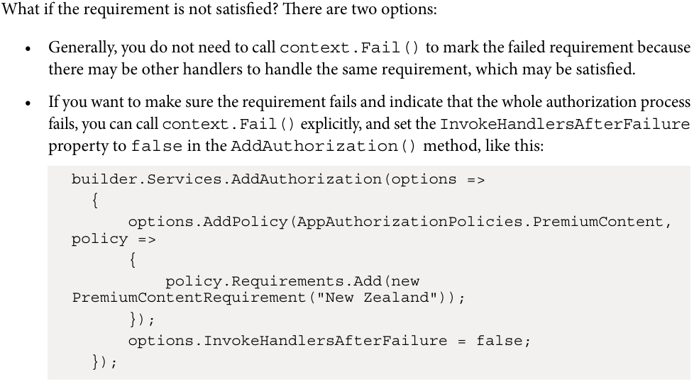
*******************************************************************
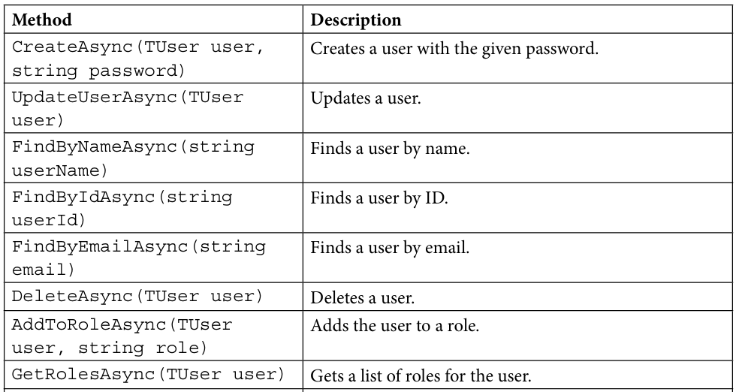
--------------------------------------------------------
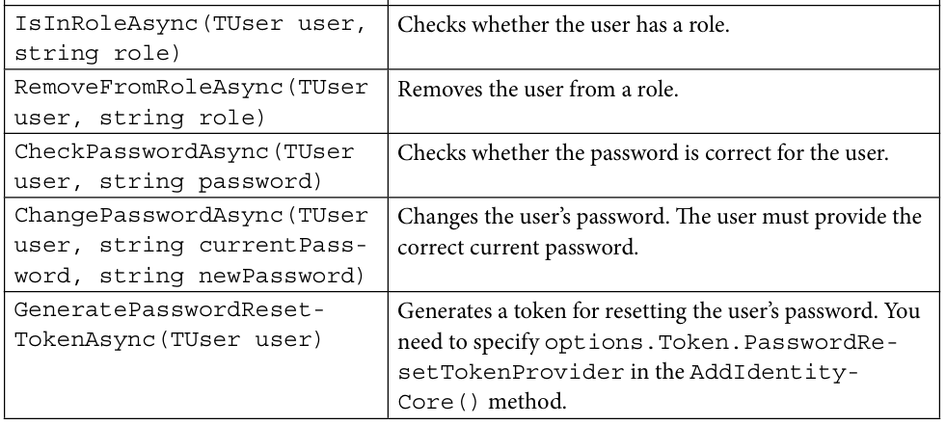
--------------------------------------------------------
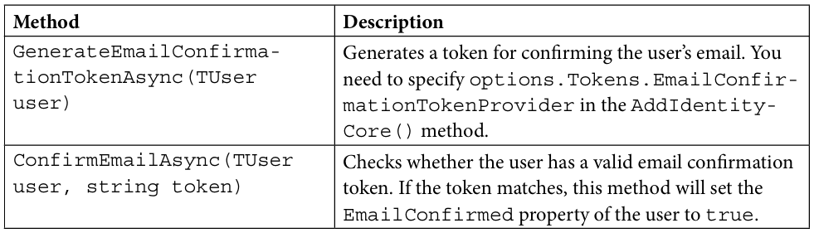
*******************************************************************
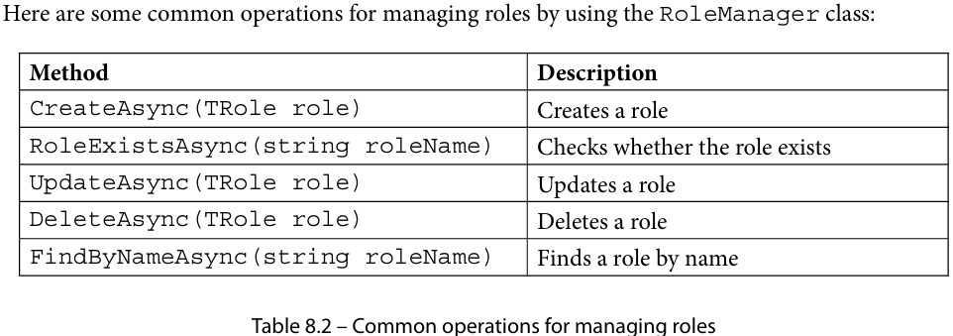
*******************************************************************

These APIs encapsulate the database operations, so we can use them to manage users and roles easily. Some of the methods return a Task object. The IdentityResult object contains a Succeeded property to indicate whether the operation is successful. If the operation is not successful, you can get the error messages by using the Errors property.
*******************************************************************
// Add the identity model and attach to db context
builder.Services.AddIdentityCore<AppUser>()
// this is not added by default
.AddSignInManager() //
// If you use the AddIdentity() method, you do not need to call the AddRoles() method.
// The AddIdentity() method will call the AddRoles() method internally.
.AddRoles<IdentityRole>()
.AddEntityFrameworkStores<AppDbContext>()
.AddDefaultTokenProviders();
--------------------------------------------------------
[HttpPost("login")]
public async Task<IActionResult> Login([FromBody] LoginModel model)
{
// Get the secret in the configuration
// Check if the model is valid
if(ModelState.IsValid)
{
var user = await userManager.FindByNameAsync(model.Username);
if(user != null)
{
//if (await userManager.CheckPasswordAsync(user, model.password))
var result = await signInManager.CheckPasswordSignInAsync(user, model.password, lockoutOnFailure: true);
if (result.Succeeded)
{
var token = GenerateToken(model.Username, user);
return Ok(new { token });
}
}
// If the user is not found, display an error message
ModelState.AddModelError("", "Invalid username or password");
}
return BadRequest(ModelState);
}
*******************************************************************


