After adding the test project to solution:
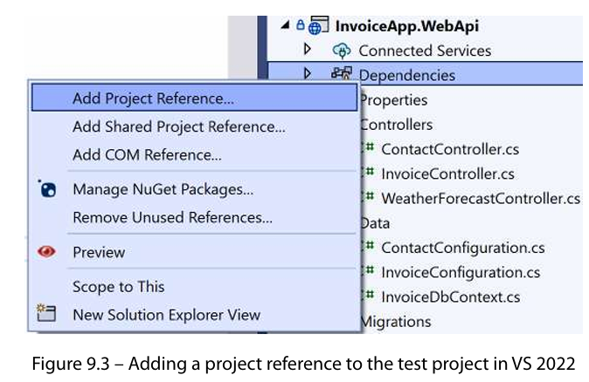
******************************************************************
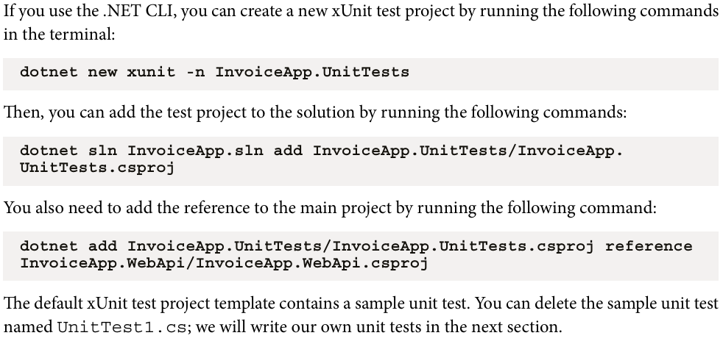
******************************************************************
******************************************************************
The test class is any class that has [Fact]-Annotation:
using InvoiceApp.WebApi;
using InvoiceApp.WebApi.Models;
using InvoiceApp.WebApi.Services;

namespace JLoka.InvoiceApp.UnitTests
{
public class EmailServiceTests
{
[Fact]
public void TestGenerateEmail_Should_Return()
{
var invoiceDate = DateTimeOffset.Now;
var dueDate = invoiceDate.AddDays(30);
var invoice = new Invoice
{
Id = Guid.NewGuid(),
InvoiceNumber = "INV-001",
Amount = 500,
DueDate = dueDate,
Contact = new Contact
{
Id = Guid.NewGuid(),
FirstName = "John",
LastName = "Doe",
Email = "john.doe@example.com"
},
Status = InvoiceStatus.Draft,
InvoiceDate = invoiceDate,
InvoiceItems = new List<InvoiceItem>
{
new()
{
Id = Guid.NewGuid(),
Description = "Item 1",
Quantity = 1,
UnitPrice = 100,
Amount = 100
},
new()
{
Id = Guid.NewGuid(),
Description = "Item 2",
Quantity = 2,
UnitPrice = 200,
Amount = 400
}
}
};

var (to, subject, body) = new EmailService().GenerateInvoiceEmail(invoice);
Assert.Equal(invoice.Contact.Email, to);
Assert.Equal($"Invoice INV-001 for John Doe", subject);
Assert.Equal($"""
Dear John Doe,

Thank you for your business. Here are your invoice details:
Invoice Number: INV-001
Invoice Date: {invoiceDate.LocalDateTime.ToShortDateString()}
Invoice Amount: {invoice.Amount.ToString("C")}
Invoice Items:
Item 1 - 1 x $100.00
Item 2 - 2 x $200.00

Please pay by {invoice.DueDate.LocalDateTime.ToShortDateString()}. Thank you!

Regards,
InvoiceApp
""", body);
}
}
}
******************************************************************
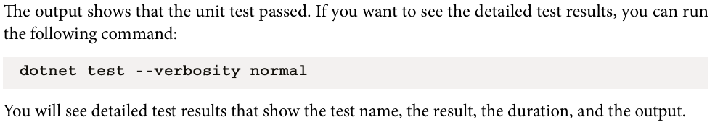
******************************************************************
To Moq the methods in ASP.NET Core we need module named: Moq
******************************************************************

To Mock the functions of interface or virtual members:
[Fact]
public async Task TestSendEmail_SouldSend()
{
// Arrange
var to = "user@example.com";
var subject = "Test Email";
var body = "Hello, this is a test email";

var emailSenderMock = new Mock<IEmailSender>();
object t1 = emailSenderMock.Setup(m => m.SendEmailAsync(It.IsAny<string>(), It.IsAny<string>(), It.IsAny<string>())).Returns(Task.CompletedTask);
//var loggerMock = new Mock<ILogger<IEmailService>>();
//loggerMock.Setup(l => l.Log(It.IsAny<LogLevel>(), It.IsAny<EventId>(), It.IsAny<It.IsAnyType>(),
// It.IsAny<Exception>(), (Func<It.IsAnyType, Exception?, string>)It.IsAny<object>())).Verifiable();
var emailService = new EmailService(emailSenderMock.Object);
// Act
await emailService.SendEmailAsync(to, subject, body);
// Assert
emailSenderMock.Verify(m => m.SendEmailAsync(It.IsAny<string>(), It.IsAny<string>(), It.IsAny<string>()), Times.Once);
}
}
******************************************************************
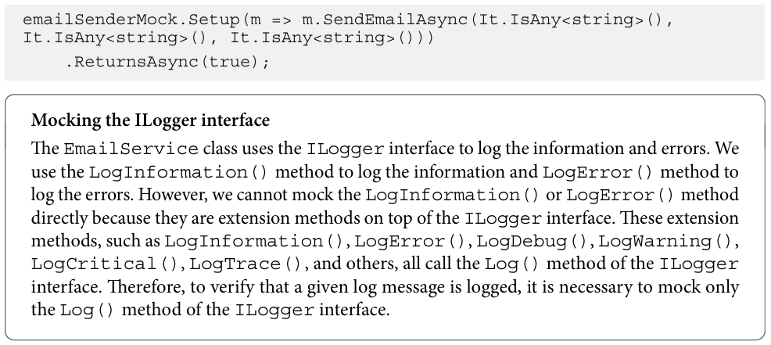
******************************************************************
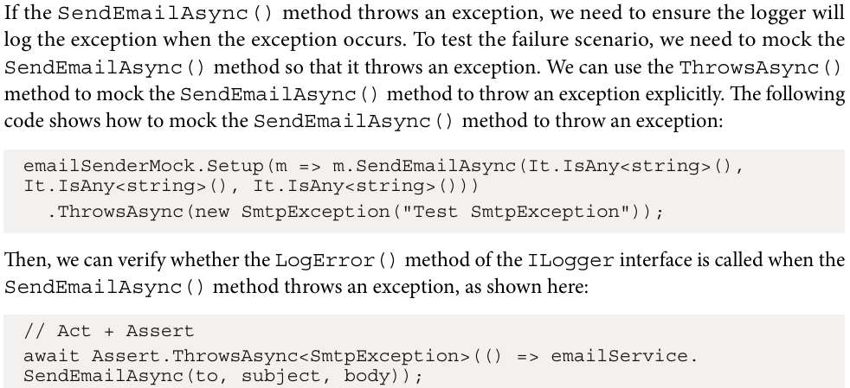
******************************************************************
******************************************************************
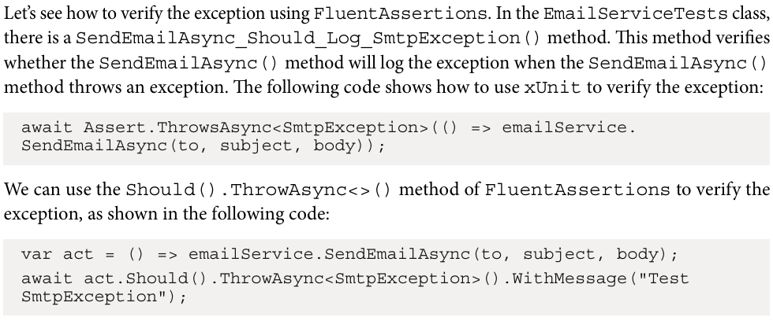
******************************************************************
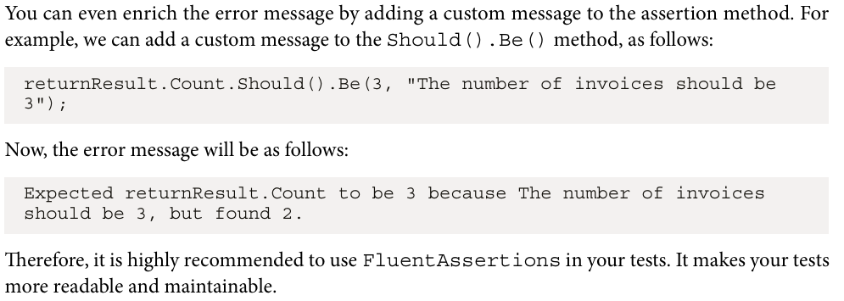
******************************************************************
To create new gRPC service from visual studio:
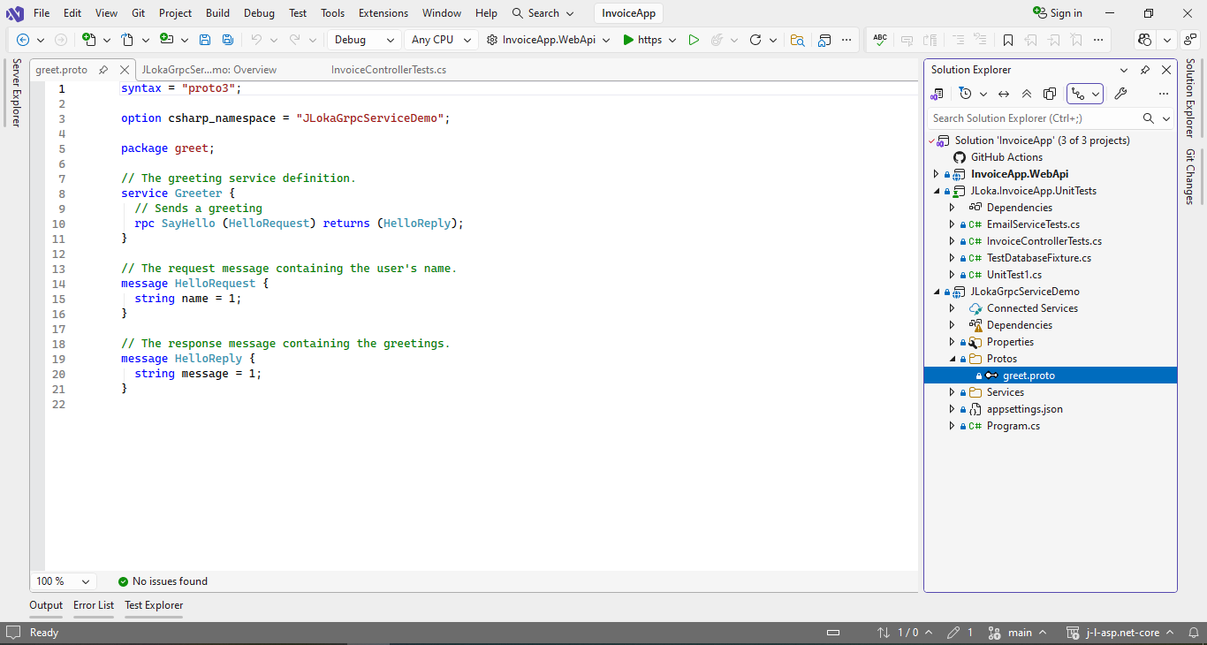
******************************************************************

The greet.proto file is the proto file that defines the gRPC service and messages.
It is the contract of the gRPC service. In the preceding proto file, we define a service named Greeter with a method named SayHello(). The SayHello() method takes a HelloRequest message as input and returns a HelloReply message as output. Both HelloRequest and HelloReply messages have string properties named name and message, respectively.
******************************************************************
We need to check if Google.Protobuf is installed or not, it provides runtime for Protobuf
******************************************************************
The basic service to run with protos is:
using Grpc.Core;
using JLokaGrpcServiceDemo;

namespace JLokaGrpcServiceDemo.Services
{
public class GreeterService : Greeter.GreeterBase
{
private readonly ILogger<GreeterService> _logger;
public GreeterService(ILogger<GreeterService> logger)
{
_logger = logger;
}

public override Task<HelloReply> SayHello(HelloRequest request, ServerCallContext context)
{
return Task.FromResult(new HelloReply
{
Message = "Hello " + request.Name
});
}
}
}
******************************************************************

The service binding for app:
using JLokaGrpcServiceDemo.Services;

var builder = WebApplication.CreateBuilder(args);

// Add services to the container.
builder.Services.AddGrpc();

var app = builder.Build();

// Configure the HTTP request pipeline.
app.MapGrpcService<GreeterService>();
app.MapGet("/", () => "Communication with gRPC endpoints must be made through a gRPC client. To learn how to create a client, visit: https://go.microsoft.com/fwlink/?linkid=2086909");

app.Run();
******************************************************************
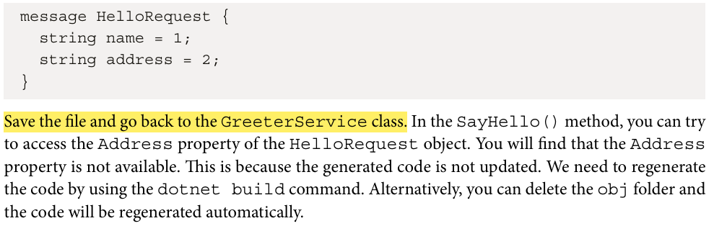
******************************************************************
gRPC is a contract-first framework, meaning that the gRPC service and messages must be defined in a proto file. When we talk about messages, we are talking about the data that is sent between the client and the server. While gRPC messages may be similar to the data model in RESTful APIs, they are not the same. RESTful APIs are centered around resources, and the data model is usually a resource model that can be mapped to one or multiple database tables. In contrast, gRPC is action-based, and the message can be any other type of data model or other message sent between the client and the server. Therefore, gRPC messages may not be exactly mapped to a resource model in RESTful APIs.
******************************************************************
the option csharp_namespace attribute is only used by the C# code generator.
******************************************************************
proto3 does not support GUID and decimal types.
******************************************************************
syntax = "proto3";

option csharp_namespace = "JLokaGrpcServiceDemo.Protos";

message CreateAddressRequest {
string street = 1;
string city = 2;
string state = 3;
string zip_code = 4;
string country = 5;
}
--------------------------------------------------------
The numbers following the field names are called field numbers. Field numbers play an important role in the proto file. These field numbers are used to identify the fields in the message.
--------------------------------------------------------
By using field numbers instead of field names when encoding the message, we can make the gRPC message more compact. This is because numbers are shorter than field names. Additionally, protobuf uses a binary format, which is more compact than plain text formats such as JSON and XML. This further helps reduce the size of the message.
--------------------------------------------------------




