The proto file for contact & invoice:
syntax = "proto3";
import "google/protobuf/duration.proto";
import "google/protobuf/timestamp.proto";
import "google/protobuf/wrappers.proto";

option csharp_namespace = "GrpcDemo";

service Invoice {
rpc CreateAddress(CreateAddressRequest) returns (ActionReply);
rpc AddInvoiceItem(AddInvoiceItemRequest) returns (ActionReply);
rpc UpdateInvoiceDueDate(UpdateInvoiceDueDateRequest) returns (ActionReply);
}

service Contact {
rpc CreateContact(CreateContactRequest) returns (CreateContactResponse);
}

message ActionReply {
bool success = 1;
string message = 2;
}

enum InvoiceStatus {
INVOICE_STATUS_UNKNOWN = 0;
INVOICE_STATUS_DRAFT = 1;
INVOICESTATUS_AWAIT_PAYMENT = 2;
INVOICE_STATUS_PAID = 3;
INVOICE_STATUS_OVERDUE = 4;
}

message CreateAddressRequest {
string street = 1;
string city = 2;
string state = 3;
string zip_code = 4;
string country = 5;
}

message CreateContactRequest {
string first_name = 1;
string last_name = 2;
string email = 3;
string phone = 4;
int32 year_of_birth = 5;
bool is_active = 6;
}

message CreateContactResponse {
string contact_id = 1;
}

message UpdateBatchInvoicesStatusRequest {
repeated string invoice_ids = 1;
InvoiceStatus status = 2;
}

message UpdateInvoicesStatusRequest {
map<string, InvoiceStatus> invoice_status_map = 1;
}

message AddInvoiceItemRequest {
string name = 1;
string description = 2;
google.protobuf.DoubleValue unit_price = 3;
google.protobuf.Int32Value quantity = 4;
google.protobuf.BoolValue is_taxable = 5;
}

message UpdateInvoiceDueDateRequest {
string invoice_id = 1;
google.protobuf.Timestamp due_date = 2;
google.protobuf.Duration grace_period = 3;
}

***********************************************************
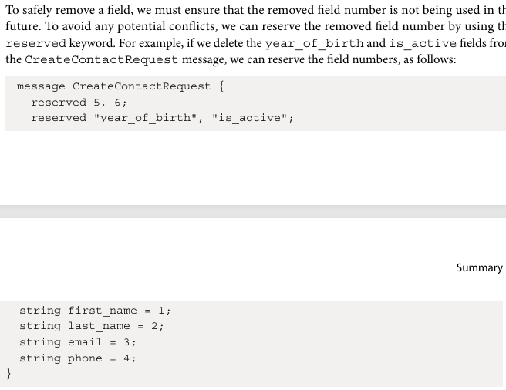
***********************************************************
If we try to use a reserved field number or field name, the gRPC tooling will report an error. Note that the reserved field names should be listed, as well as the reserved field numbers. This ensures that the JSON and text formats are backward compatible. When the field names are reserved, they cannot be placed in the same reserved statement with the field numbers.
***********************************************************
To use ASP.Net Core API with gRPC Service we need to install:
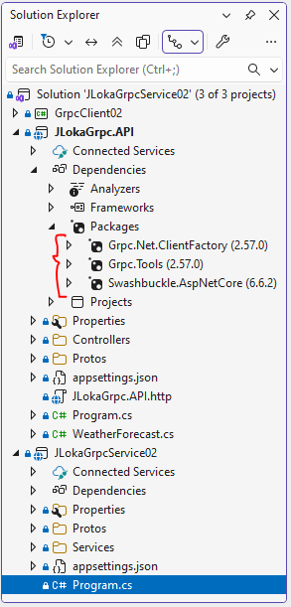
***********************************************************

Then to configure Web API to use the client:
builder.Services.AddGrpcClient<Contact.ContactClient>(x => x.Address = new Uri("https://localhost:7214"));
***********************************************************
And to use it with controller:
using GrpcDemo;
using Microsoft.AspNetCore.Mvc;

namespace JLokaGrpc.API.Controllers
{
[ApiController]
[Route("[controller]")]
public class ContactController (Contact.ContactClient client, ILogger<ContactController> logger) : ControllerBase
{
[HttpPost]
public async Task<IActionResult> CreateContact(CreateContactRequest request)
{
var replay = await client.CreateContactAsync(request);
logger.LogInformation($"Replay is: {replay.ContactId}");
return Ok(replay);
}
}
}
***********************************************************
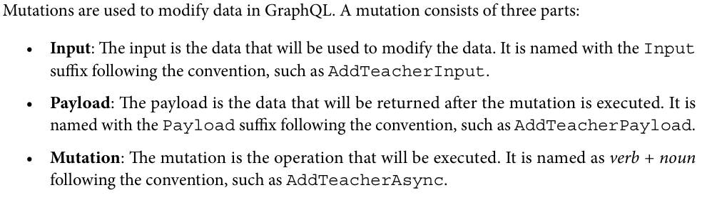
***********************************************************
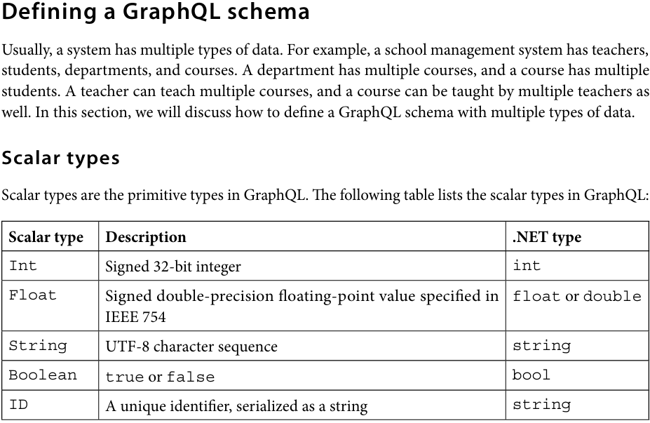
***********************************************************
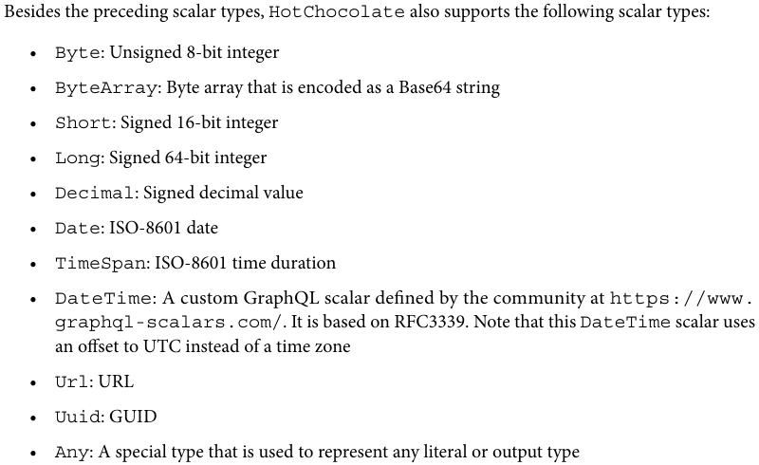
***********************************************************
GraphQL supports enumerations as well. Enumeration types in GraphQL are a special kind of scalar type. They are used to represent a fixed set of values. .NET supports enumeratiopn types very well so that you can use the .NET enum type directly in GraphQL. You can define an enumeration type as follows:
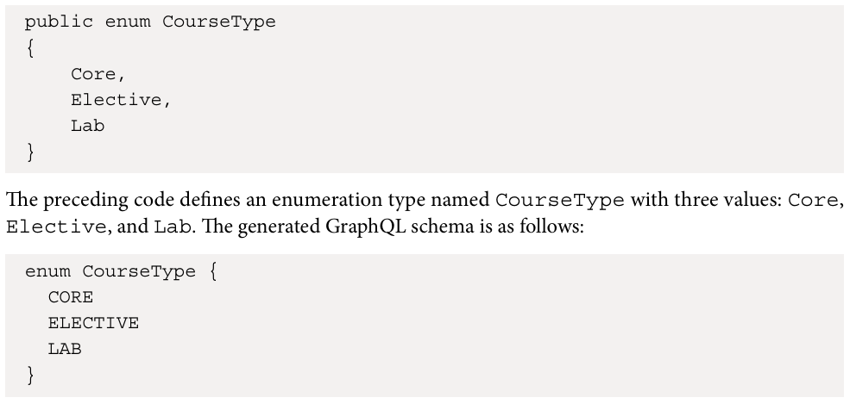
***********************************************************
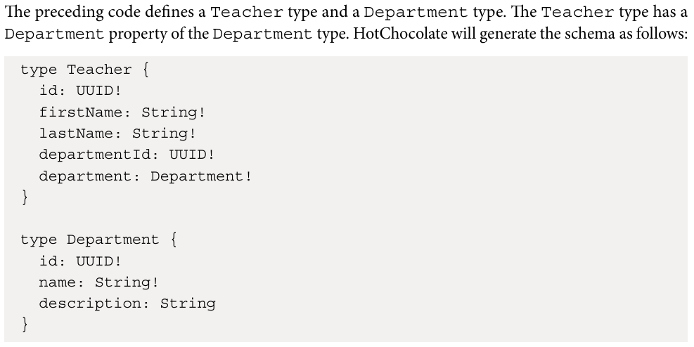
***********************************************************
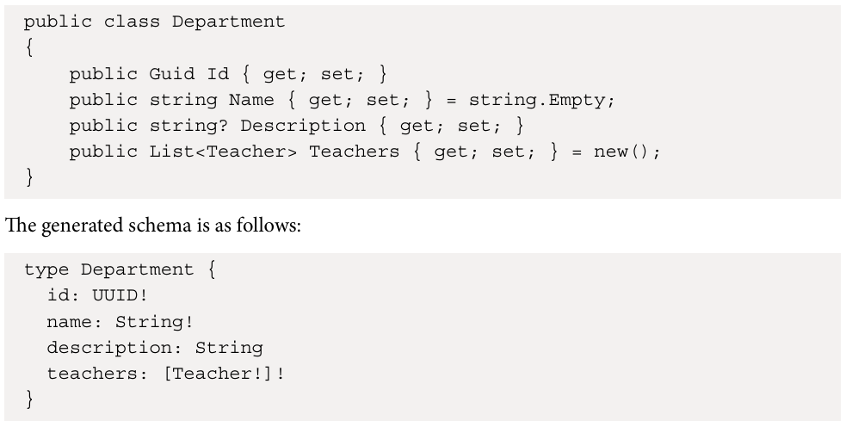
***********************************************************
Every GraphQL service must have a Query type, but may or may not have a Mutation type. So the teachers query is actually a field of the Query type, just like the department field in the teacher type. Mutations work in the same way.
***********************************************************
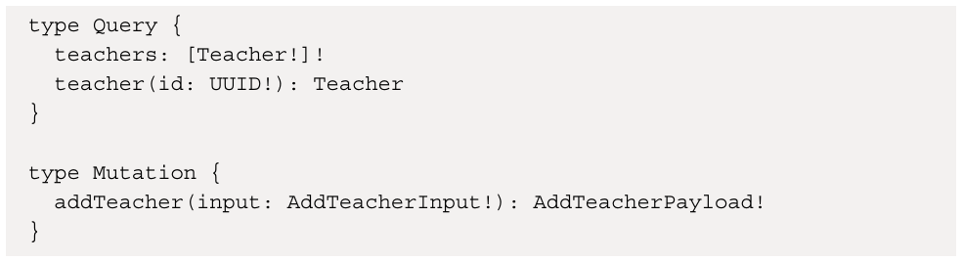
***********************************************************

The query type for getting teacher or teachers:

using JLokaTestGraphQL.Data;
using JLokaTestGraphQL.Models;
using Microsoft.EntityFrameworkCore;

namespace JLokaTestGraphQL.GraphQL.Types;
public class Query
{
public async Task<List<Teacher>> GetTeachers([Service] AppDbContext context) => await context.Teachers.Include(x => x.Department).ToListAsync();

public async Task<Teacher?> GetTeacher(Guid id, [Service] AppDbContext context) => await context.Teachers.FindAsync(id);
}
-----------------------------------------------------
The mutation for add teacher is:
public record AddTeacherInput(string FirstName, string LastName, string Email, string? Phone, string? Bio, Guid departmentId);
-----------------------------------------------------
using JLokaTestGraphQL.Models;

namespace JLokaTestGraphQL.GraphQL.Mutations;
public class AddTeacherPayload
{
public Teacher Teacher { get; }
public AddTeacherPayload(Teacher teacher)
{
Teacher = teacher;
}
}
-----------------------------------------------------

using JLokaTestGraphQL.Data;
using JLokaTestGraphQL.Models;

namespace JLokaTestGraphQL.GraphQL.Mutations;
public class Mutation
{
public async Task<AddTeacherPayload> AddTeacherAsync(AddTeacherInput input, [Service] AppDbContext context)
{
var teacher = new Teacher
{
Id = Guid.NewGuid(),
FirstName = input.FirstName,
LastName = input.LastName,
Email = input.Email,
Phone = input.Phone,
Bio = input.Bio,
DepartmentId = input.departmentId,
};

context.Teachers.Add(teacher);
await context.SaveChangesAsync();
return new AddTeacherPayload(teacher);
}
}
***********************************************************
A resolver is a function that is used to retrieve data from somewhere for a specific field. The resolver is executed when the field is requested in the query. The resolver can fetch data from a database, a web API, or any other data source. It will drill down the graph to retrieve the data for the field. For example, when the department field is requested in the teachers query, the resolver will retrieve the Department object from the database. But when the query does not specify the department field, the resolver will not be executed. This can avoid unnecessary database queries.
***********************************************************

HotChocolate supports three ways to define schemas:
• Annotation-based: The first way is to use the annotation-based approach, which is what we have been using so far. HotChocolate automatically converts public properties and methods to a resolver that retrieves data from the data source following conventions. If a method has a Get prefix or an Async suffix, these prefixes or suffixes will be removed from the name.
• Code-first: This approach allows you to define the schema using explicit types and resolvers. It uses the Fluent API to define the details of the schema. This approach is more flexible when you need to customize the schema.
• Schema-first: This approach allows you to define the schema using the GraphQL schema definition language.
***********************************************************

