For More Visual Output, We Can Add ids-Attribute For Output Formatting Of The Fixture:

@pytest.fixture(params=[(3, 4), [3, 5]], ids=['tuple', 'list'])
def fixture01(request):
return request.param;

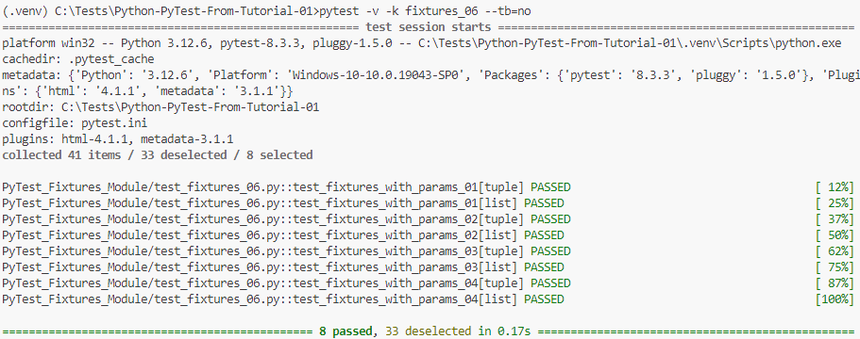
*************************************************************
If We Want To Set Multiple Fixtures With Multiple Params (Like Dictionary):
@pytest.fixture(params=[(3, 4), [3, 5]], ids=['tuple', 'list'])
def fixture01(request):
return request.param;

@pytest.fixture(params=['access'])
def fixture02(request):
return request.param;

def test_fixtures_with_multiple_params_05(fixture01, fixture02):
if(fixture02 == 'access'):
assert fixture01[0];
*************************************************************
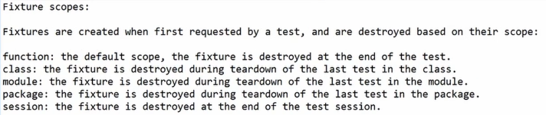
*************************************************************
Note (From Me): The Most Benefit From Passing The Parameters To Test Cases By Command Line, Is That We Control The Test Of Each Environment That We Have.
*************************************************************
Note (To Remember): If We Want To Share Fixtures, We Must Add New File, Called: conftest.py
*************************************************************
To Add New Option To Our PyTest-Framework For Our Test Cases:
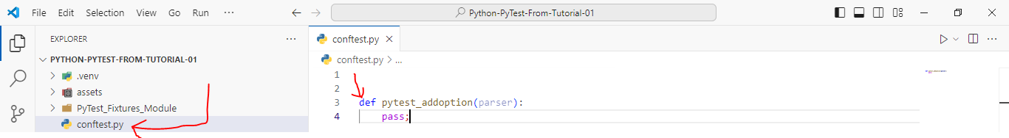
*************************************************************
def pytest_addoption(parser):
parser.addoption("--cmdopt", defaults='QA');
*************************************************************

Then To Get The Command Params:
@pytest.fixture()
def CmdOpt(pytestconfig):
opt = pytestconfig.getoption('cmdopt');
if opt == 'Prod':
f = open(prod_config, 'r');
else:
f = open(QA_config, 'r')
yield f;
f.close();
*************************************************************

