If We Want To Share Our Packages Of Our Projects With Other:
- Run: pip freeze > requirements.txt
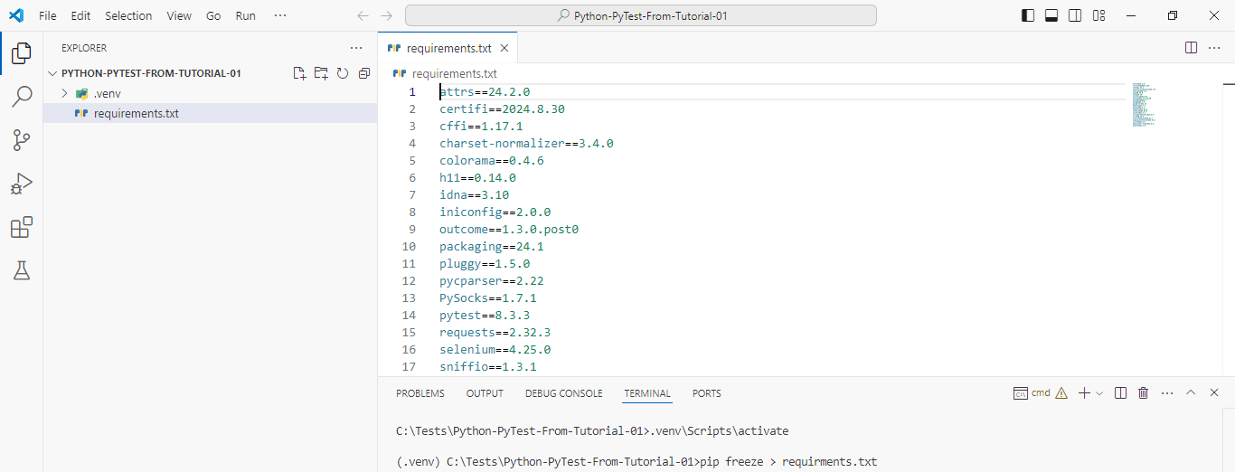
*************************************************
Note 1: We Must Name All Test Modules: test_name_here.py.

Note 2: We Must Name All Test Functions: test_func_name_here.

Note 3: We Must Name All Test Classes: Test<Name_Here>.
*************************************************
To Show The Percentage Of Test Completeness:
- Run: pytest -vv
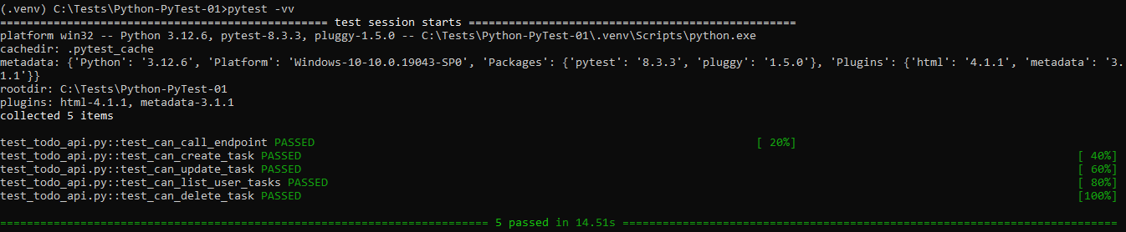
*************************************************
Note 1: In PyTest, We Can Run The Fail Tests Using Arguments.
*************************************************
Understanding Test Outputs :
• --lf, --last-failed : only re-run the failures.
• --ff, --failed-first : to run the failures first and then the rest of the tests.
• Ref doc pytest_cache: https://docs.pytest.org/en/latest/cache.htm
*************************************************
When We Want To Make Test Cases Using Classes:
- The Name Of Class Must Start With Test
- The Class Must Not Contain Constructor: __init__(self)
- The Test Cases (Functions) Must Start With: test_

class TestClass:

def test_t1(self):
assert 1 == 1;

*************************************************

If We Want To Check The Exceptions Using The Test Cases Then We Can Use:
- Import: import pytest.
- Use raises: with pytest.raises(Exception):
- Set The Logic: assert (1/0)

Note 1: In This Way We Can Catch The Exceptions In Run-Time.

def test_t2(self):
with pytest.raises(Exception):
assert (1/0);
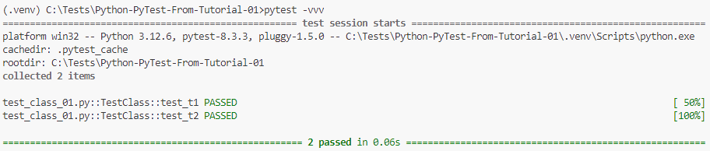
*************************************************
If We Want To Skip Some Of The Tests That We Don’t Want To Run:
- Import: import pytest
- Annotate The Skipped Test With: @pytest.mark.skip(reason='Reason Will Be Here')

@pytest.mark.skip(reason="Skip Reason Will be Here")
def test_skip_test(self):
assert type(1) == int;
*************************************************

Also, We Can Use Conditional Skipping:

Note 1: Here We Must Set The Reason.

@pytest.mark.skipif(sys.version_info.major>=3, reason="No Reason Here")
def test_t1(self):
assert 1 == 1;
*************************************************
If We Want To Skip The Full Module, We Add This At The First Line:
pytestmark = pytest.mark.skipif(sys.platform == 'win32', reason="No Reason Here")

*************************************************
If We Want To Mark The Test Function:
- Import: import pytest
- Add Annotation With Specific Name: @pytest.mark.name_will_be_here
- Create New File: pytest.ini
- Add The Marker Name To It, As Displayed In The Picture.

Note 1: Marker Name Can Be Used Multiple Times In The Same File OR Other Files.

Note 2: Test Function Can Have Multiple Marker Names.
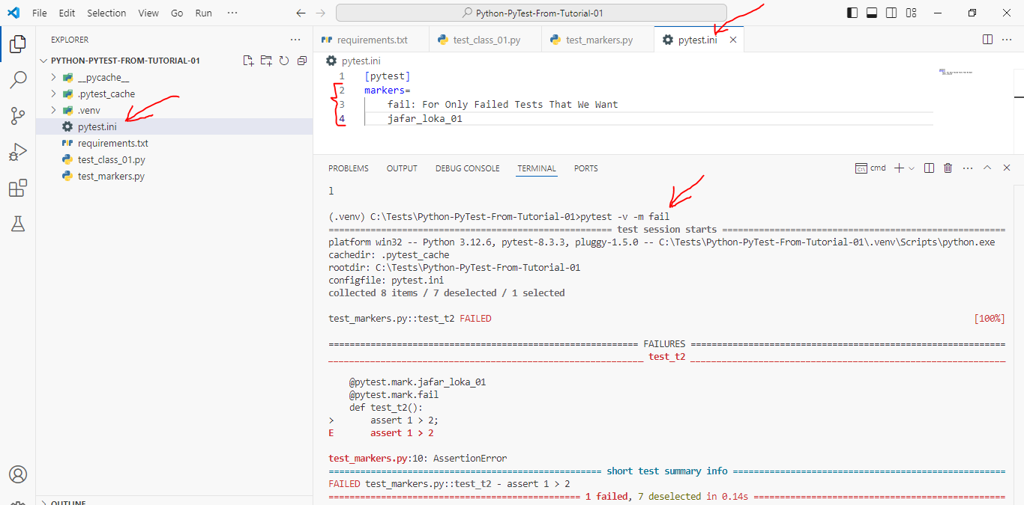
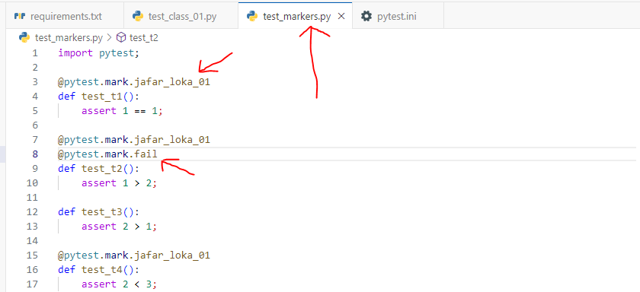
*************************************************

For Markers, We Can Run Tests Using Conditional Statements:
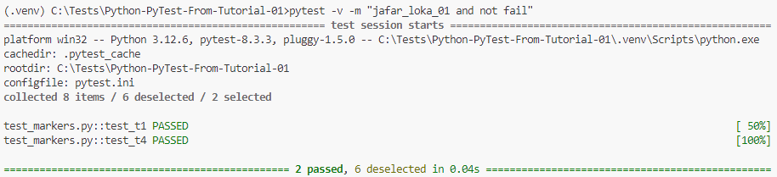
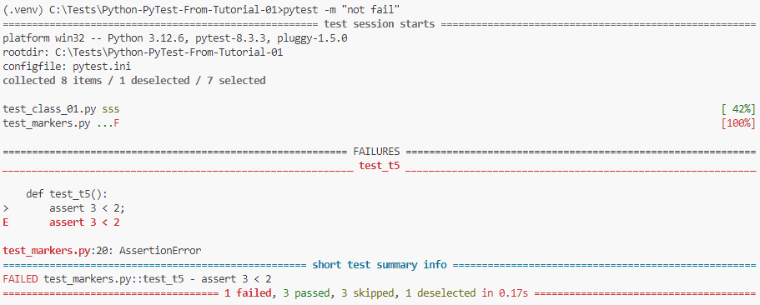
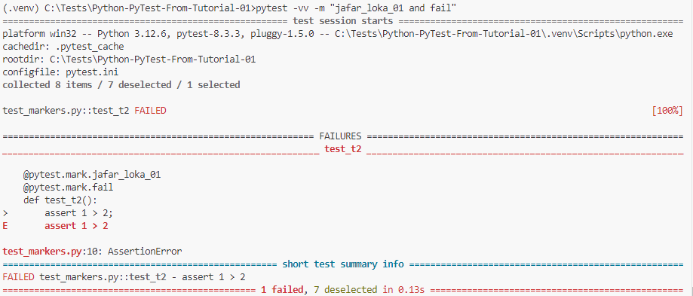
*************************************************
If We Want To Mark The Complete Module With Specific Mark:
- Import: import pytest.
- Add The Line: pytestmark=[…Marks Will Be Here…]
- Create New File: pytest.ini
- Add The Conf. To The pytest.ini-File
- Run The Tests.
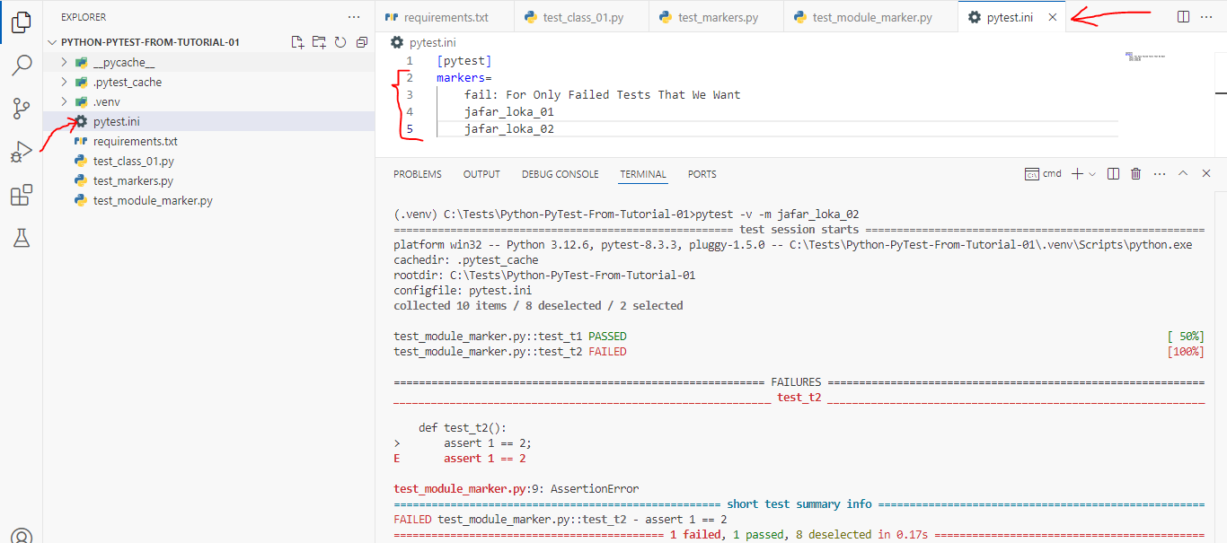
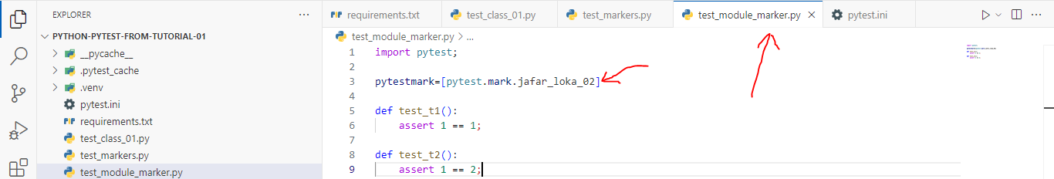
*************************************************
Note: We Must Define The pytest.ini-File At The Root Of The Folder, Else It Will Not Worked.
*************************************************

If We Want To Test Any Function That We Know It Will Fail, Then We Use xfail.

Note: We Use Here The Same Steps.

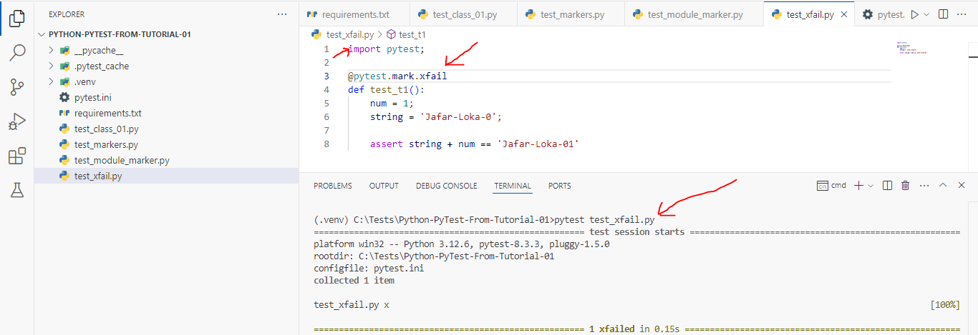
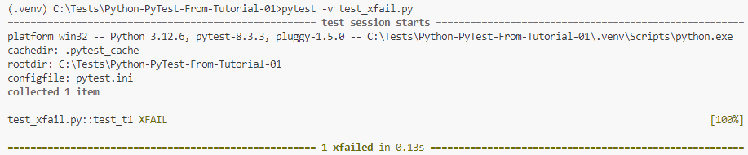
*************************************************
Note: If Any Test Function Marked With xfail, And The Result is Passed, Then The Final Result Of Testing is XPass, Not XFAIL.
*************************************************
Note: We Can Add Reason To xfail-Annotation.
*************************************************
Note: We Can Also Use Conditional Statement With XFail.
*************************************************
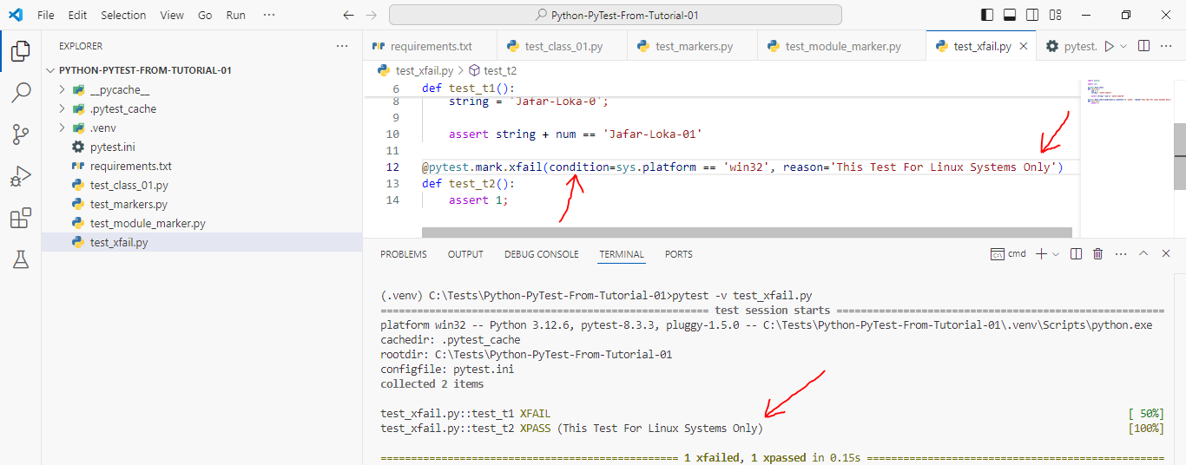
*************************************************
Note: If The Condition Is Not True, Then The Test Will Run As Any Normal Test.
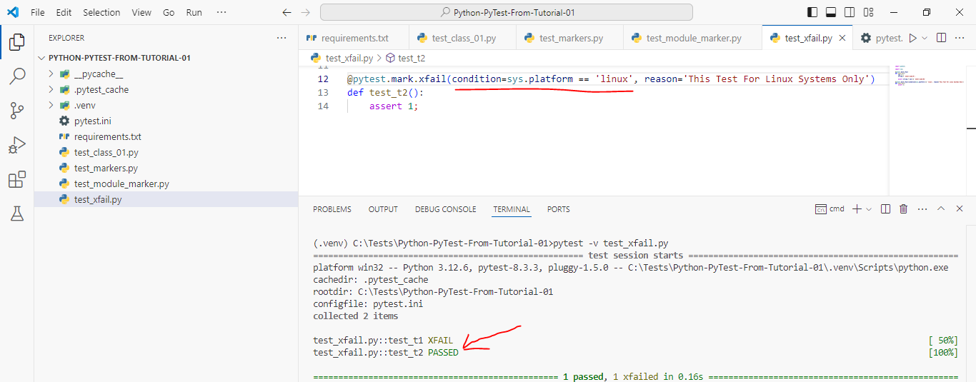
*************************************************
Note 1: We Can Also Add raises To Xfail-Marker Annotation, And it Work As Same As Condition.
*************************************************



