If We Want To Select The Test Cases Based On The File/s Name OR Test Function/s Name, We Can Use -k option:
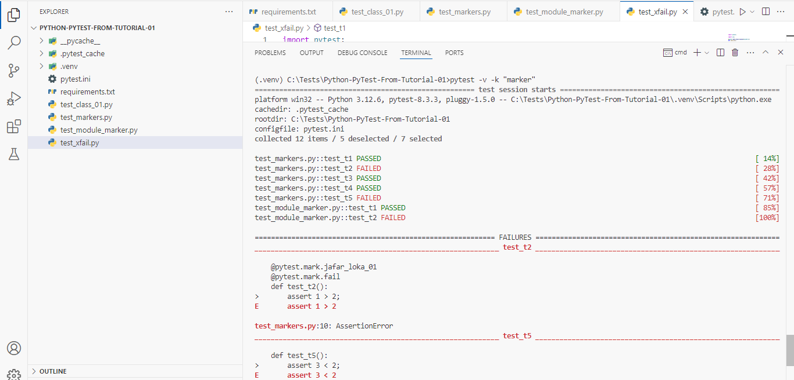
**************************************************************
If We Want To Delete The Error Trace From The Final Result, We Can Use
--tb=no
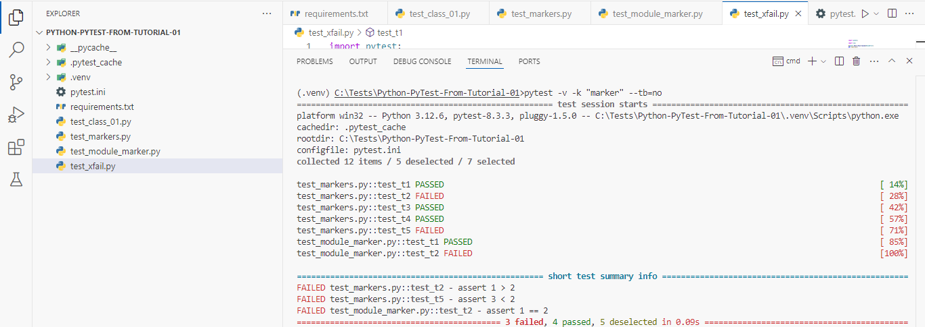
**************************************************************
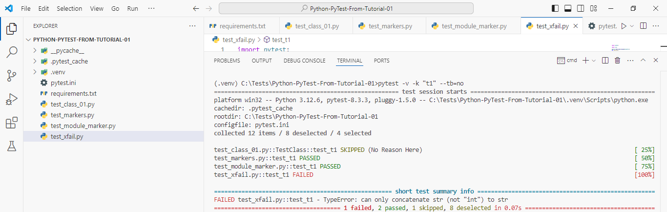
**************************************************************
Note: We Can Use Condition Statements With -k:
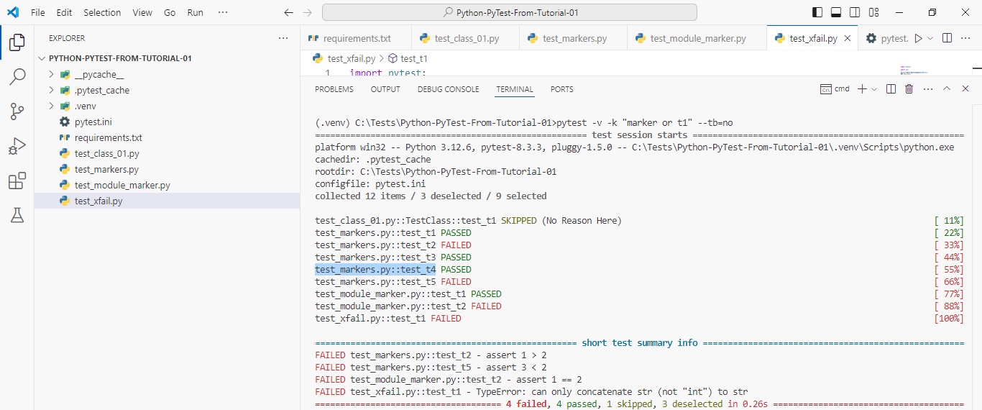
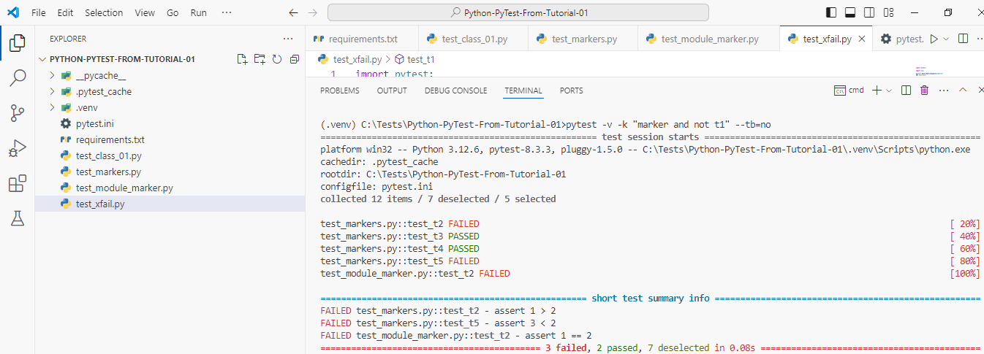
**************************************************************
If We Want To Run The Test Cases, And Stop When First Fail Occur We Can Use -x Option:
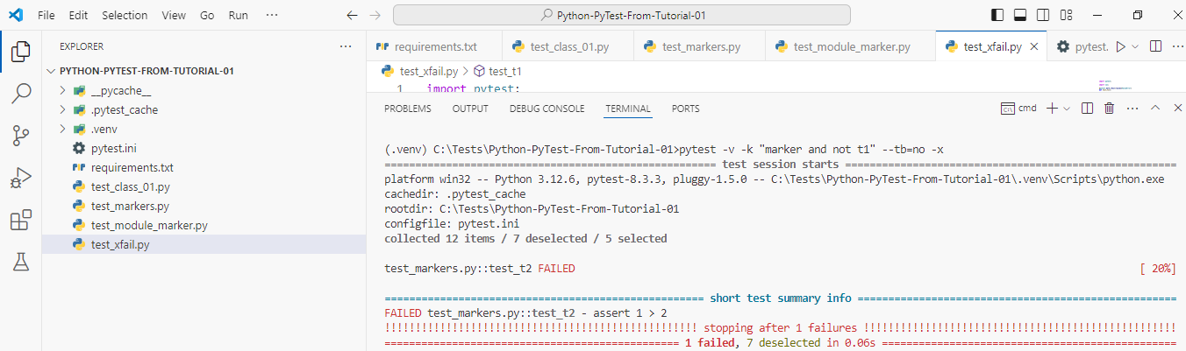
**************************************************************

Also, We Can Set The Maximum Of Failure Times Of Specific Tests, OR The Wall Tests.
Note: Here We Use --maxfail=3.
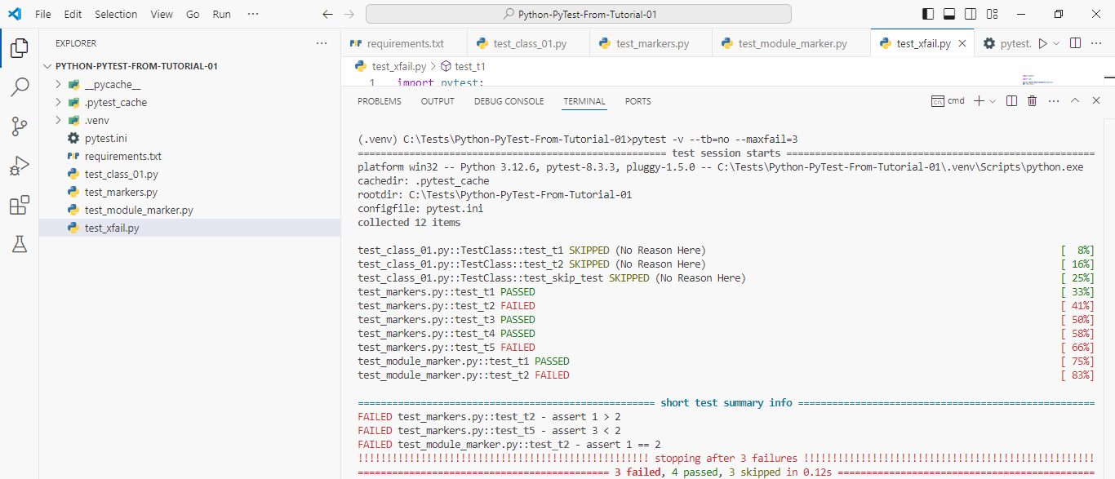
**************************************************************

When We Are Write The Actual Test Scenarios, We Can use -q.
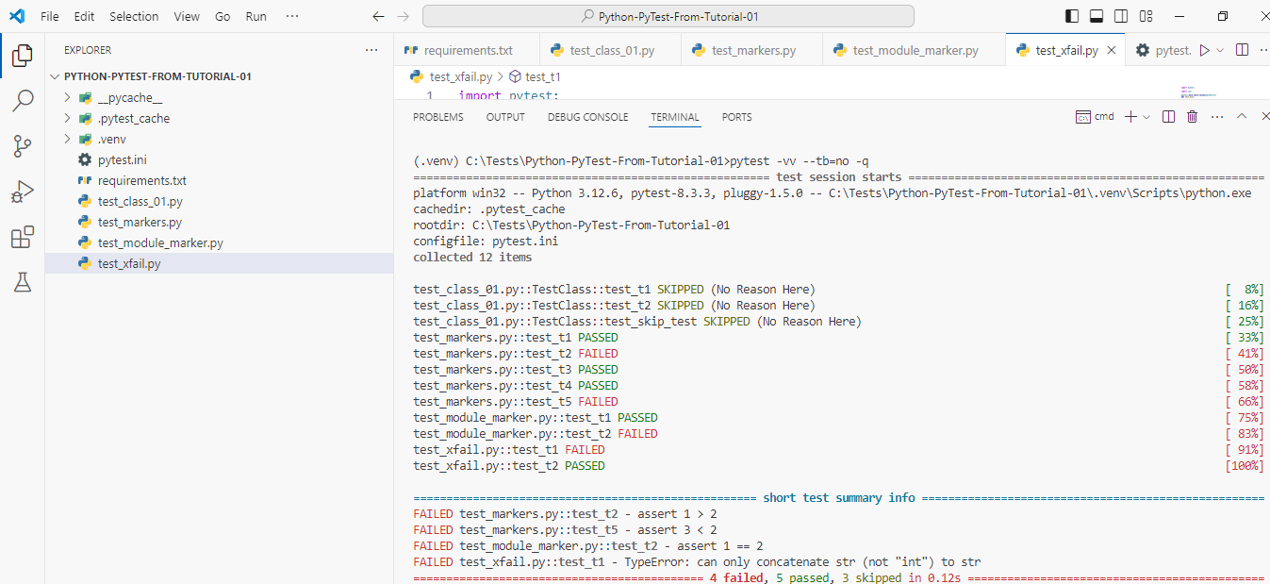
**************************************************************
If We Want To Run The Last Failed Test Cases From PyTest Cache, Then We Can use --lf
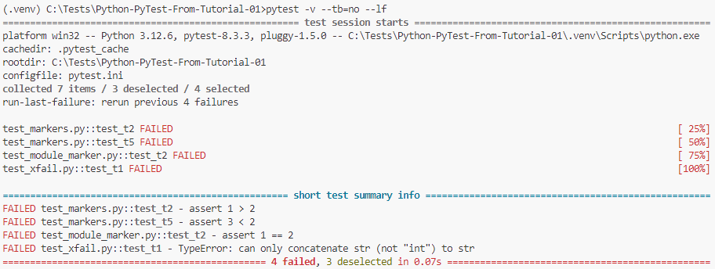
**************************************************************

If We Want To Run The Failed Tests First From Cache, And Then The Other Test Cases, We Can Use --ff
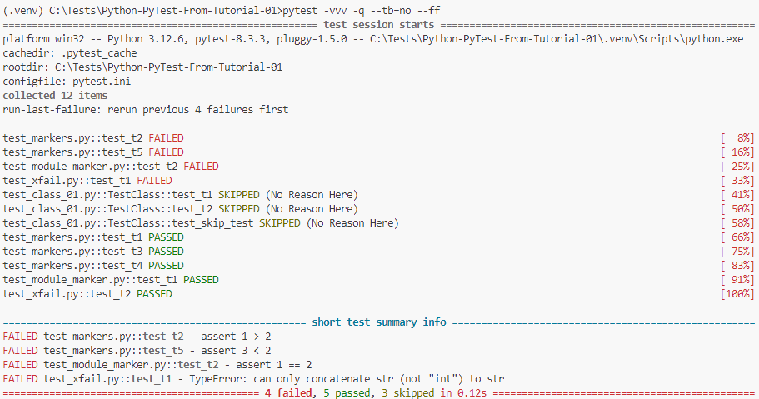
**************************************************************

If We Want To Use Parameters With Our Test Cases:

Note: If We Don’t Set [] For The Arguments (Name And Surname) It Will Be Consider As Error.

import pytest;

@pytest.mark.parametrize(['name', 'surname'], [['Jafar', 'Loka'], ['Test', '01']])
def test_parametrize(name, surname):
print("The Name Is: ", name);
print("The Surname Is: ", surname);

assert name == 'Jafar';
assert surname == 'Loka';
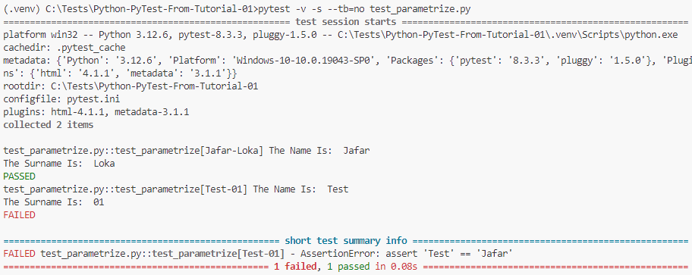
**************************************************************

@pytest.mark.parametrize('number', [55, 45, 35, 75])
def test_numbers(number):
assert number > 50;
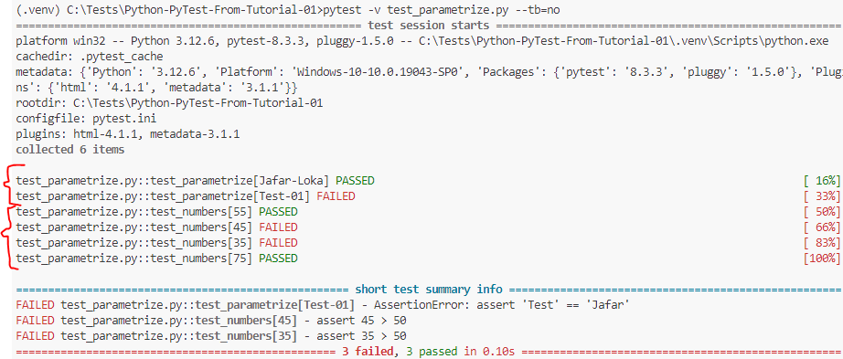
**************************************************************
@pytest.mark.parametrize(["name1", "name2"], [("Jafar", "Loka"), ("Test", "01")])
def test_names(name1, name2):
assert name1 + ' ' + name2 == "Jafar Loka"
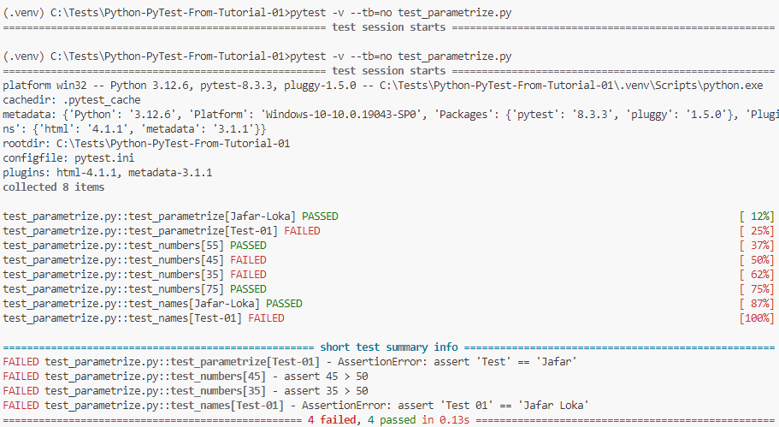
**************************************************************
data=[([2, 3, 4], 'sum', 9), (['4, 5, 6'], 'prod', 256)]

@pytest.mark.parametrize("a,b,c", data)
def test_data(a, b, c):
if b == 'sum':
assert sum(a) == c;
elif b == 'prod':
assert math.prod(a) == c;




