Fixtures: Functions That Run Before (Some Of Them After) The Test Functions.

The Most Value Of Them: Using For DB Initialization, WebDriver Initialization, And …etc.
*************************************************
Note: If We Set The Fixture Inside Any File, It Then Will Run For That File Only.
*************************************************
Note: If We Set Fixtures Inside The conftest.py-File It Will Be Then Available To All Directories And Sub-Directory.
*************************************************
import pytest;

@pytest.fixture()
def setup_names():
print("=" * 15);
print("\n ... Setup From Fixtures ...\n");
print("=" * 15);

return ["Jafar", "Loka", "Jafar-Loka-01"];

def test_len_of_names(setup_names):
assert len(setup_names) == 3;
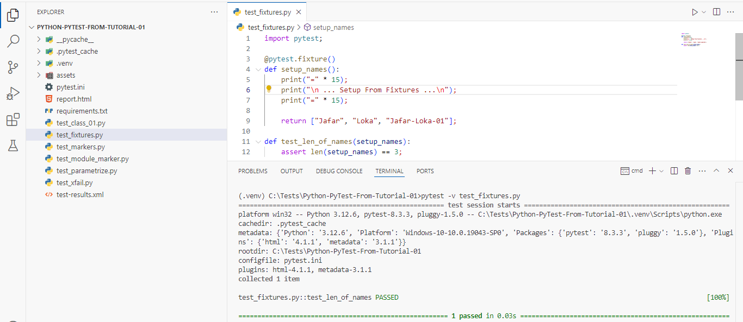
*************************************************
If We Use Fixtures With Markers, Then The Returned Value From Fixtures Can’t Be Used.

We Can Use Fixtures Using Markers, By This Way:
@pytest.mark.usefixtures("setup_names")
def test_use_fixtures():
assert 1 == 1;
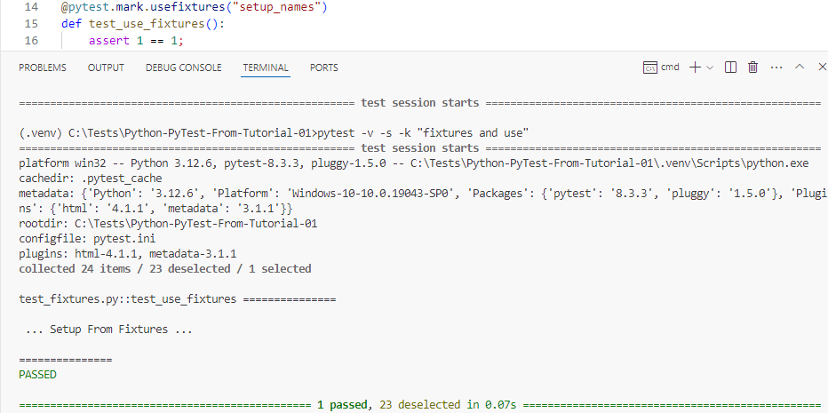
*************************************************

If We Want To Close The:
- Connection To DB.
- The Driver Page.
- The File.
- Any Thing That We Returned From Fixture
Then We Must Use Yield.

days1 = ["Sat", "Sun", "Mon"];
days2 = ["Tue", "Wed", "Thu"];

@pytest.fixture()
def setup_days1():
wk1 = days1.copy();
wk1.append('Fri');
yield wk1;
print("\n After Yield Wk1 \n");

# wk1.clear();
wk1.pop();

def test_wk1(setup_days1):
assert len(setup_days1) == 4;
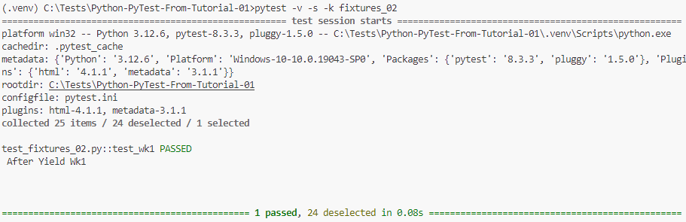
*************************************************

We Can Also, Use Multiple Fixtures For The Same Test:
def test_wk1_wk2(setup_days1, setup_days2):
assert len(setup_days1) + len(setup_days2) == 7;
*************************************************
We Can Use This Way To Handle DB Connection Open, File Open, …etc.
@pytest.fixture()
def setup_days1():
wk1 = days1.copy();
wk1.append('Fri');
yield wk1;
wk1.pop();

@pytest.fixture()
def setup_days2():
wk2 = days2.copy();
yield wk2;
wk2.clear();
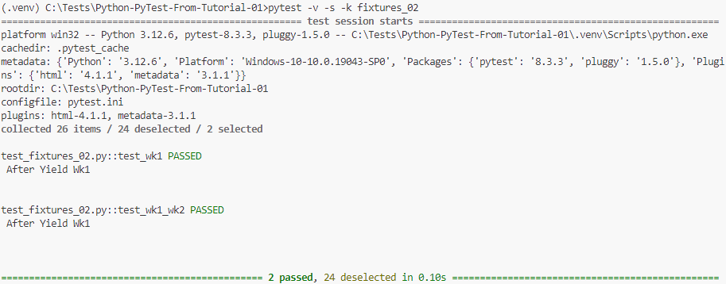
*************************************************

The conftest.py File Used To Share The Fixtures Across The Test Files.
We Can Set Multiple conftest.py Files In All Subdirectories.
It Shouldn’t Import The conftest.py-Files From The Test Files.
The conftest.py File Is Python Module.
*************************************************
Note: If We Used Files Using Fixtures And Generators (Yield), We Must Close Them Before Remove Them From Directories.
*************************************************
To Create Global Variables For Fixtures, To Use Them We Can Use: pytest_configure.py:
def pytest_configure():
pytest.weekdays1 = ['sat', 'sun', 'mon'];
pytest.weekdays2 = ['tue', 'wed', 'thu'];
*************************************************
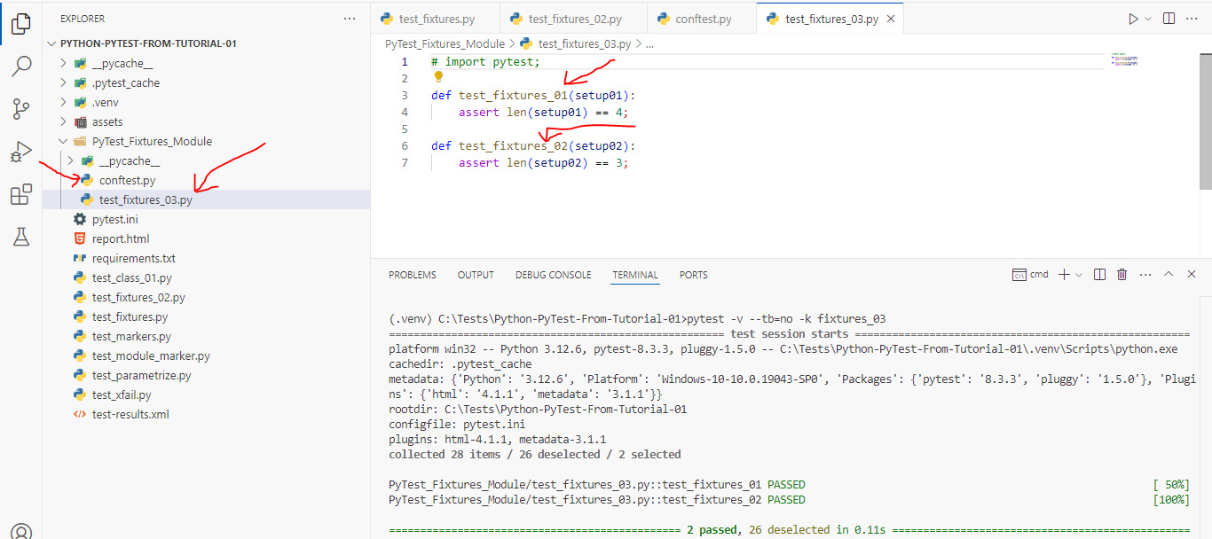
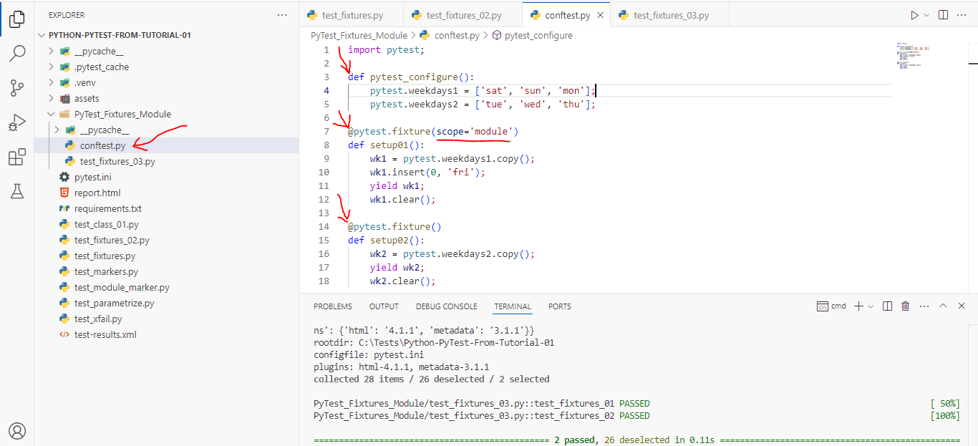
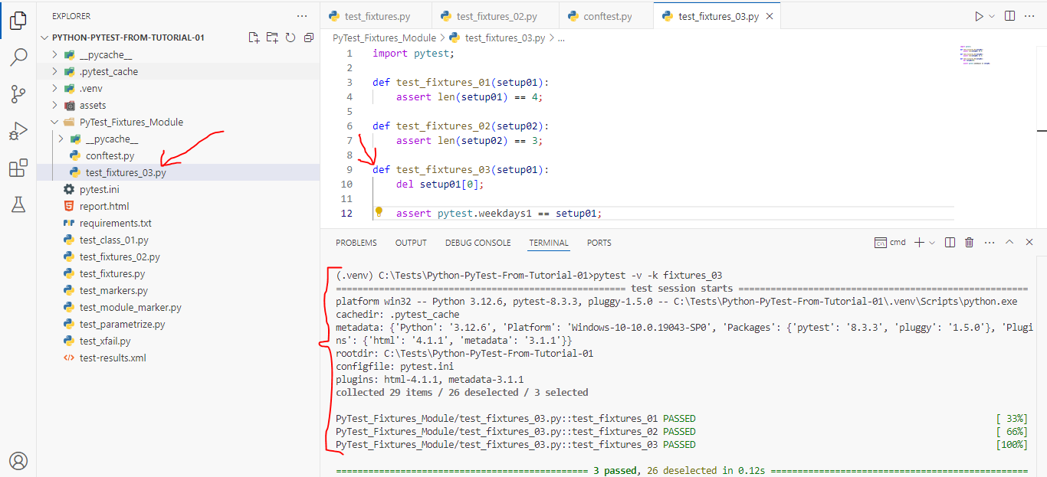
*************************************************
Note: Fixtures Can Be Overridden From Test Module Level.
*************************************************

If We Want To Show The Fixtures That We Use We Can Use: --setup-show With Pytest:
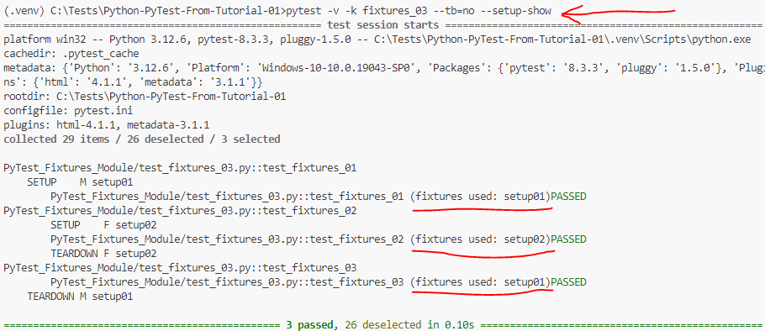
*************************************************
We Can Use Fixtures To Intercept The Test Function Calling:

Note: Here The Months Are Inside The Test Function That Use This Fixture.
@pytest.fixture()
def setup04(request):
months = getattr(request.module, "months");
print("\n The Setup04 Fixture");
print("\n Fixture Scope: ", str(request.scope));
print("\n Calling Function: ", request.function.__name__);
print("\n Calling Module: ", request.module.__name__);
print("\n The Months Of Function Are: ", months);
months.append("April");
yield months;
months.pop();

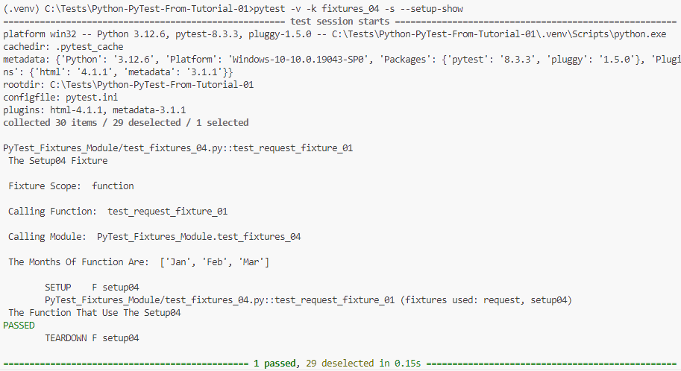

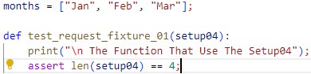
*************************************************
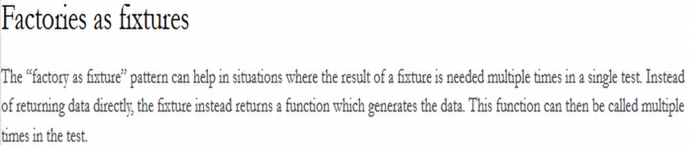
*************************************************

In This Way We Can Define Fixture As Factory:
@pytest.fixture()
def setup05():
def get_structure(name):
if name == 'list':
return [1, 2, 3];
elif name == 'tuple':
return (1, 3, 4);
return get_structure;

And In This Way We Can Call Our Fixture That Used Factory:
def test_fixtures_list_05(setup05):
list = setup05('list');
assert 'list' in str(type(list));

def test_fixtures_tuple_05(setup05):
tuple = setup05('tuple');
assert 'tuple' in str(type(tuple))
*************************************************
Note (From Me): We Can Use Factory As Fixture To Generate The List Of Data That Represent The Test Parametrization Data.
*************************************************
Note: This Function Will Be Called 2-Times, For Each Test Cases:
import pytest;

@pytest.fixture(params=[(3, 4), [3, 5]])
def fixture01(request):
return request.param;
*************************************************



