To create simple decorator: nest g decorator Roles
import { Reflector } from '@nestjs/core';

export const Roles = Reflector.createDecorator<String[]>()

****************************************************
import { CanActivate, ExecutionContext, Injectable } from '@nestjs/common';
import { Reflector } from '@nestjs/core';
import { Observable } from 'rxjs';
import { Roles } from './roles.decorator';

@Injectable()
export class RolesGuard implements CanActivate {
constructor(private readonly reflactor: Reflector) {}

canActivate(
context: ExecutionContext,
): boolean | Promise<boolean> | Observable<boolean> {
const roles = this.reflactor.get(Roles, context.getHandler())
if(!roles) {
return true
}

const request = context.switchToHttp().getRequest()
const t1 = request.headers['roles']
console.log("the roles of the user is: ", t1)
return true;
}
}
****************************************************
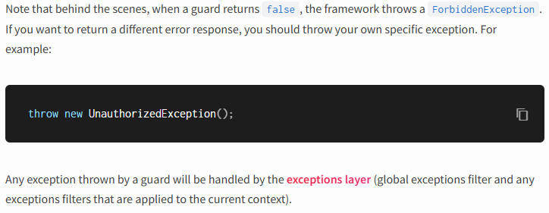
****************************************************
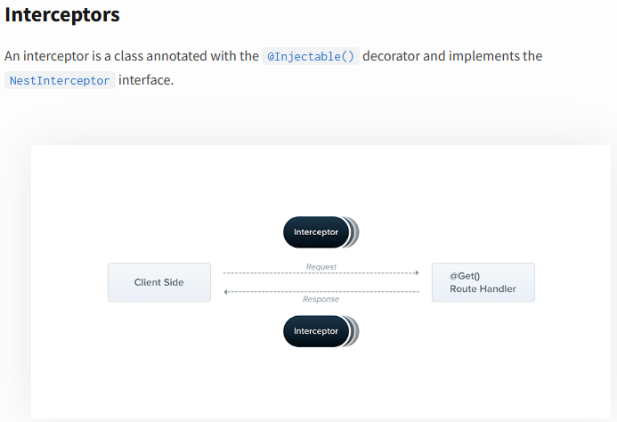
****************************************************
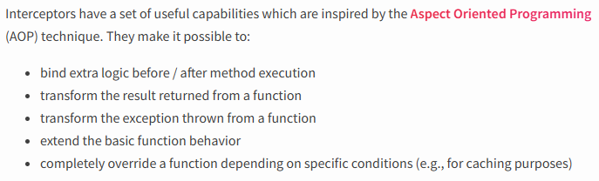
****************************************************
Each interceptor implements the intercept() method, which takes two arguments. The first one is the ExecutionContext instance
****************************************************
The second argument is a CallHandler. The CallHandler interface implements the handle() method, which you can use to invoke the route handler method at some point in your interceptor. If you don't call the handle() method in your implementation of the intercept() method, the route handler method won't be executed at all.
****************************************************
Because the handle() method returns an Observable, we can use powerful RxJS operators to further manipulate the response. Using Aspect Oriented Programming terminology, the invocation of the route handler (i.e., calling handle()) is called a Pointcut, indicating that it's the point at which our additional logic is inserted.
****************************************************

