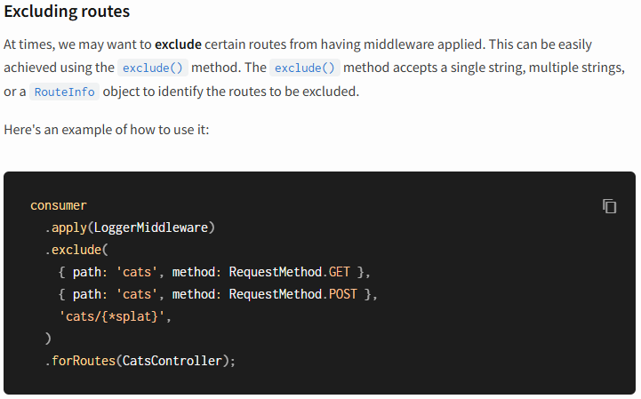
************************************************************************
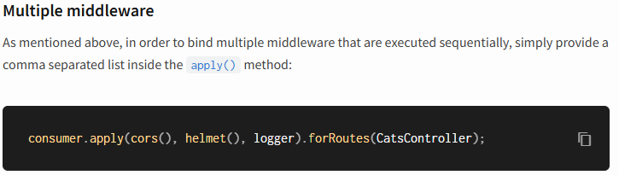
************************************************************************
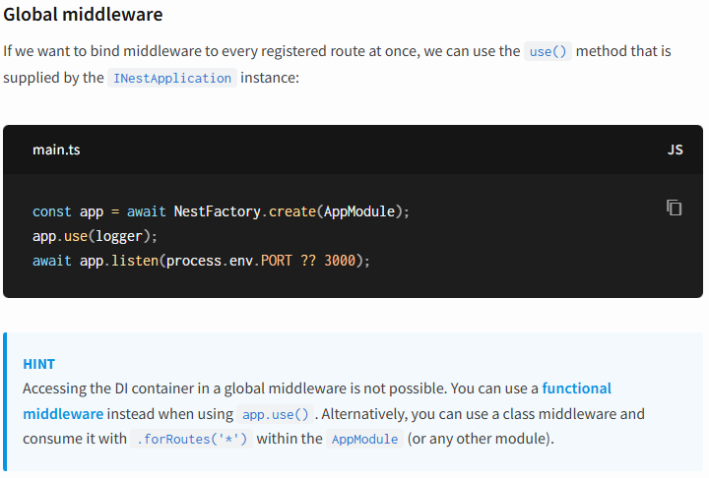
************************************************************************
Nest comes with a built-in exceptions layer which is responsible for processing all unhandled exceptions across an application. When an exception is not handled by your application code, it is caught by this layer, which then automatically sends an appropriate user-friendly response.



