syntax = "proto3";

import "google/protobuf/timestamp.proto";
import "google/protobuf/duration.proto";

option csharp_namespace = "JLokaGrpcService.Protos";

message CreateAddressRequest {
string first_name = 1;
string last_name = 2;
string email = 3;
string phone = 4;
int32 year_of_birth = 5;
bool is_active =6;
}

message UpdateInvoiceDueDateRequest {
string invoice_id = 1;
google.protobuf.Timestamp due_date = 2;
google.protobuf.Duration grace_period = 3;
}
*****************************************************
enum InvoiceStatus {
INVOICE_STATUS_UNKNOWN = 0;
INVOICE_STATUS_DRAFT = 1;
INVOICE_STATUS_AWAIT_PAYMENT = 2;
INVOICE_STATUS_PAID = 3;
INVOICE_STATUS_OVERDUE = 4;
INVOICE_STATUS_CANCELLED = 5;
}
*****************************************************
Every enum type must contain a 0 value, which is the default value and must be placed at the first position.
*****************************************************
Protobuf scalar value types, such as int32, sint32, fixed32, and bool, cannot be null. But in .NET, nullable value types are very common. For example, we can use int? to declare an integer value that can be null. To support nullable value types, protobuf provides some wrapper types, which are defined in the google/protobuf/wrappers.proto file, to support nullable types.
*****************************************************
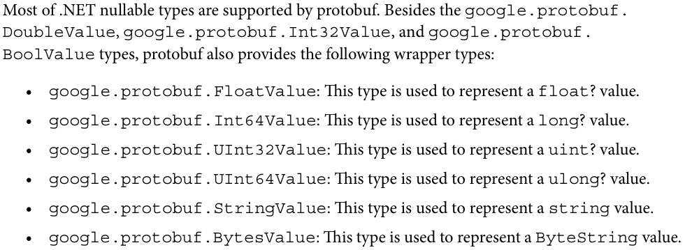
*****************************************************
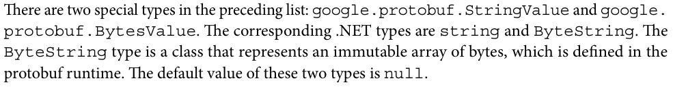
*****************************************************
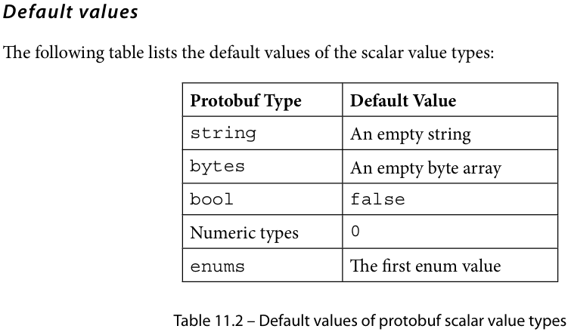
*****************************************************
gRPC supports four types of RPC methods:
- Unary RPC: The client sends a single request message to the server and receives a single response message in return. This type of method is suitable for applications that need single request-response exchanges.
- Server streaming RPC: The client sends a single request message to the server and the server then responds with a stream of response messages. This type of method allows for continuous data exchange between the client and server.
- Client streaming RPC: The client sends a stream request message to the server and the server then responds with a response message. Similar to server streaming RPC, this type of method also allows for a continuous data exchange but the data change is initiated by the client.
- Bidirectional streaming RPC: The client initiates the process by sending a stream request message, to which the server responds with a stream response message. This type of method enables communication between the client and the server to be conducted in both directions.
*****************************************************
message CreateContactRequest {
string first_name = 1;
string last_name = 2;
string email = 3;
string phone = 4;
int32 year_of_birth = 5;
bool is_active =6;
}

message CreateContactResponse {
string contact_id = 1;
}

service ContactService {
rpc CreateContact(CreateContactRequest) returns (CreateContactResponse);
}
*****************************************************

using Grpc.Core;
using JLokaGrpcService.Protos;

namespace JLokaGrpcService.Services
{
public class ContactGrpcService(ILogger<ContactGrpcService> logger): ContactService.ContactServiceBase
{
public override Task<CreateContactResponse> CreateContact(CreateContactRequest request, ServerCallContext context)
{
return Task.FromResult(new CreateContactResponse
{
ContactId = Guid.NewGuid().ToString(),
});
}
}
}
-------------------------------------------------------------------------
// Configure the HTTP request pipeline.
app.MapGrpcService<GreeterService>();
app.MapGrpcService<ContactGrpcService>();
app.MapGet("/", () => "Communication with gRPC endpoints must be made through a gRPC client. To learn how to create a client, visit: https://go.microsoft.com/fwlink/?linkid=2086909");
-------------------------------------------------------------------------
For creating grpc client, we need these modules:
<Project Sdk="Microsoft.NET.Sdk">
<PropertyGroup>
<OutputType>Exe</OutputType>
<TargetFramework>net8.0</TargetFramework>
<ImplicitUsings>enable</ImplicitUsings>
<Nullable>enable</Nullable>
</PropertyGroup>
<!—we need these modules -->
<ItemGroup>
<PackageReference Include="Google.Protobuf" Version="3.23.1" />
<PackageReference Include="Grpc.Net.Client" Version="2.57.0" />
<PackageReference Include="Grpc.Tools" Version="2.57.0">
<PrivateAssets>all</PrivateAssets>
<IncludeAssets>runtime; build; native; contentfiles; analyzers; buildtransitive</IncludeAssets>
</PackageReference>
</ItemGroup>

<ItemGroup>
<ProjectReference Include="..\JLokaGrpcService\JLokaGrpcService.csproj" />
</ItemGroup>

<ItemGroup>
<Protobuf Include="Protos\greet.proto" GrpcServices="Client" />
<Protobuf Include="Protos\jloka.proto" GrpcServices="Client" />
</ItemGroup>
</Project>
-------------------------------------------------------------------------
And the invoice client class:
using Grpc.Net.Client;
using JLokaGrpcService.Protos;

namespace JLokaGrpcClient
{
internal class InvoiceClient
{
public async Task CreateContactAsync()
{
using var channel = GrpcChannel.ForAddress("http://localhost:5077");
// this is from launchSettings.json
var client = new ContactService.ContactServiceClient(channel);
var reply = await client.CreateContactAsync(new CreateContactRequest
{
Email = "john.doe@abc.com",
FirstName = "John",
LastName = "Doe",
IsActive = true,
Phone = "1234567890",
YearOfBirth = 1980
});

Console.WriteLine("Created Contact: " + reply.ContactId);
Console.ReadKey();
}
}
}
-------------------------------------------------------------------------
And to call it, in program.cs:
using JLokaGrpcClient;

Console.WriteLine("Hello, World!");
var contactClient = new InvoiceClient();
await contactClient.CreateContactAsync();
*****************************************************
Once the server starts to send the stream response message, the client cannot send any more messages to the server, unless the server finishes sending the stream response message or the client cancels the RPC call by raising ServerCallContext. CancellationToken.
*****************************************************



