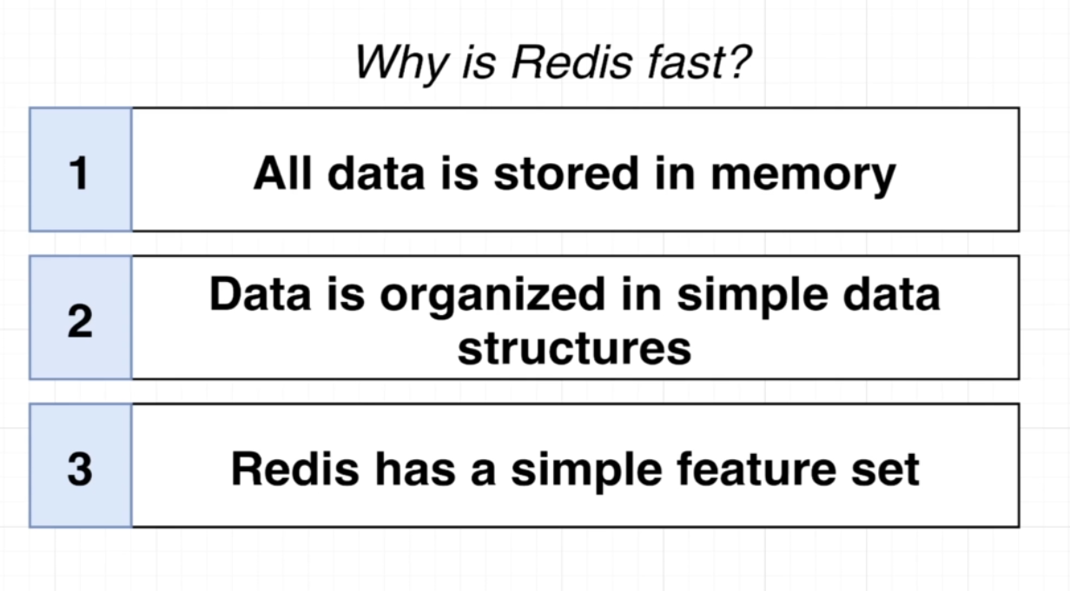
*********************************************************************************
Examples of simple data structure of redis:
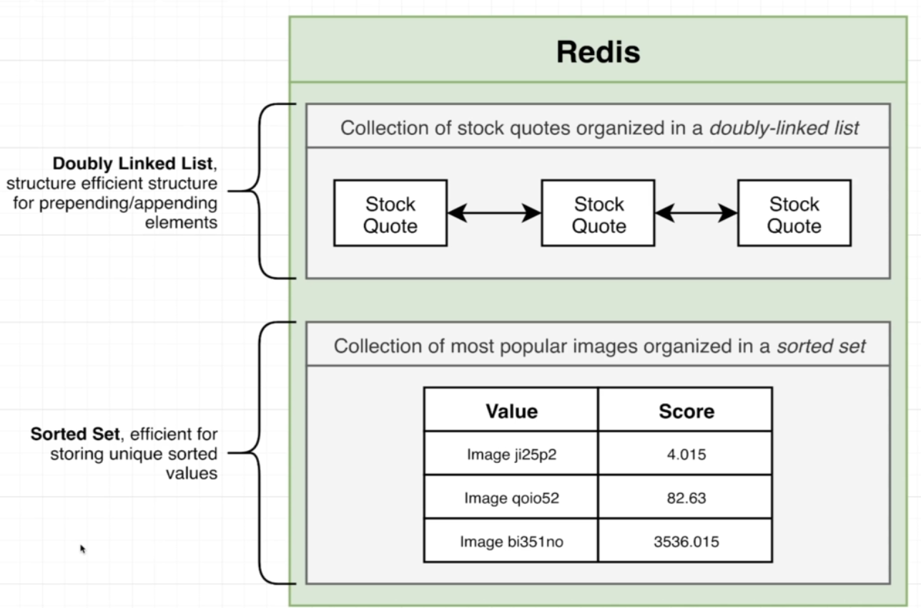
*********************************************************************************

To set basic key, value data in redis, use command: set key value
- Ex1: set jafar loka
- Ex2: set name 'Jafar Loka'
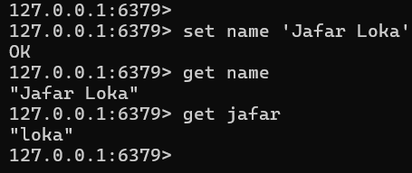
*********************************************************************************
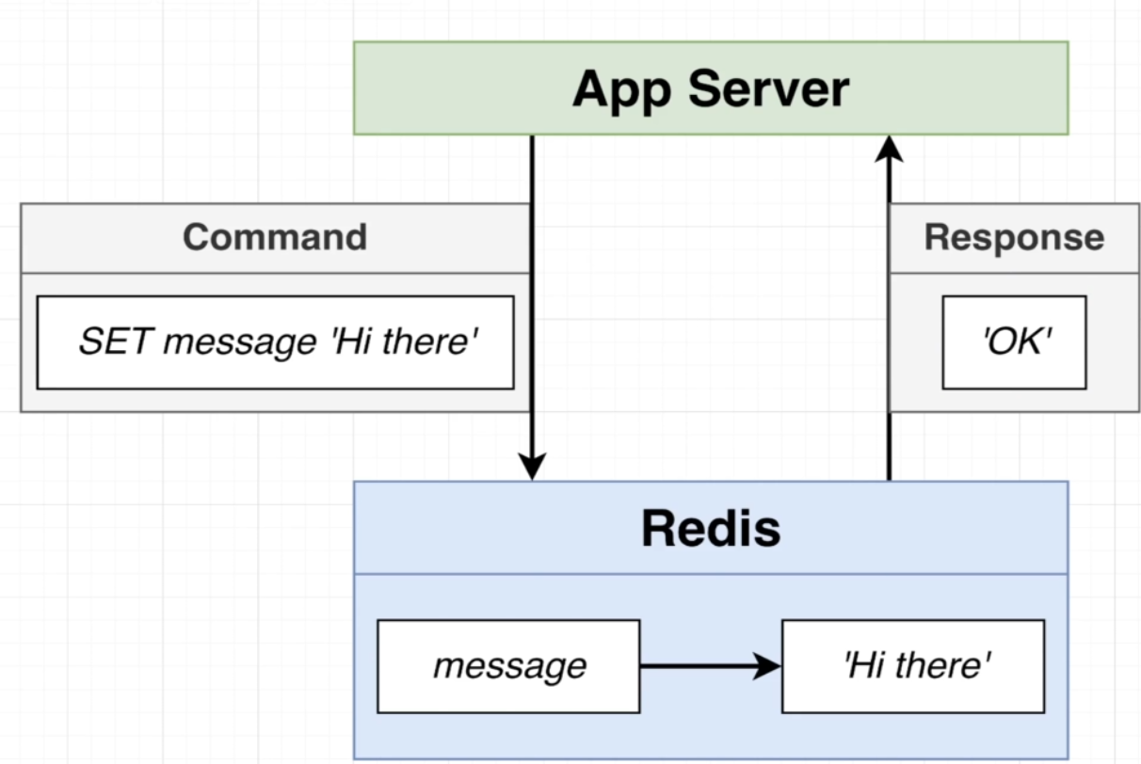
*********************************************************************************
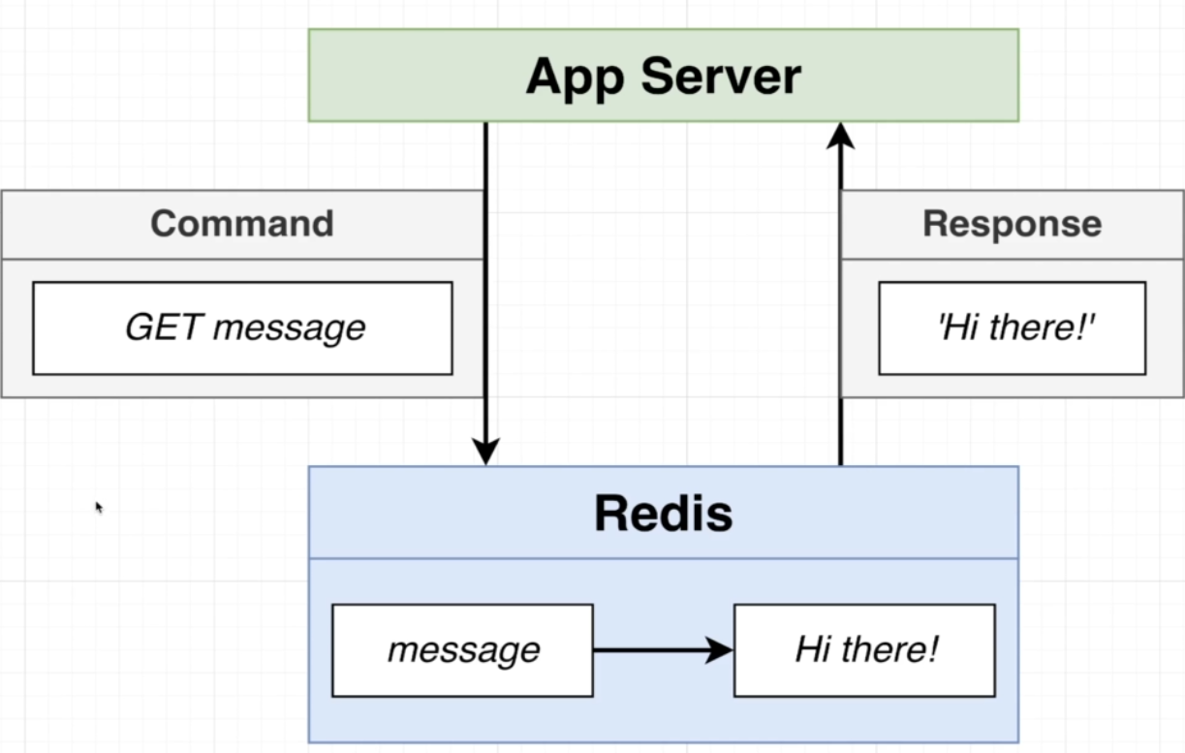
*********************************************************************************
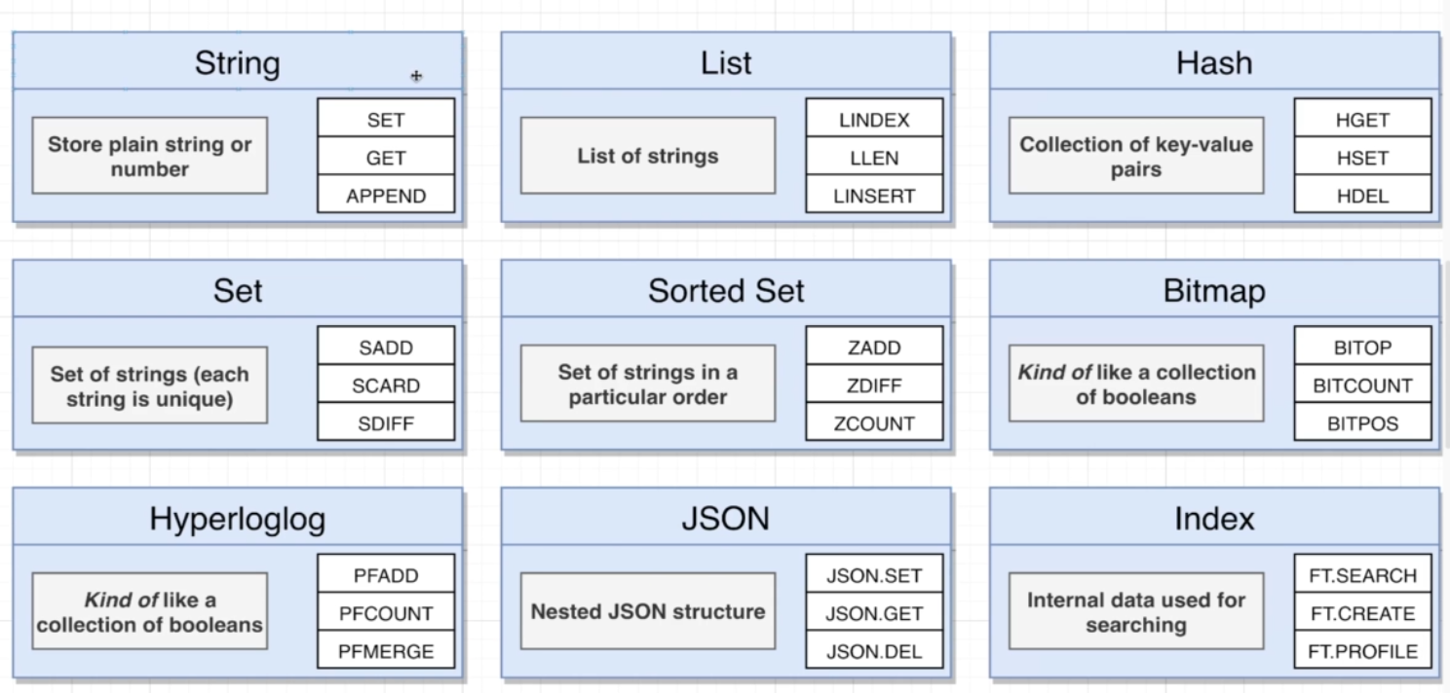
*********************************************************************************
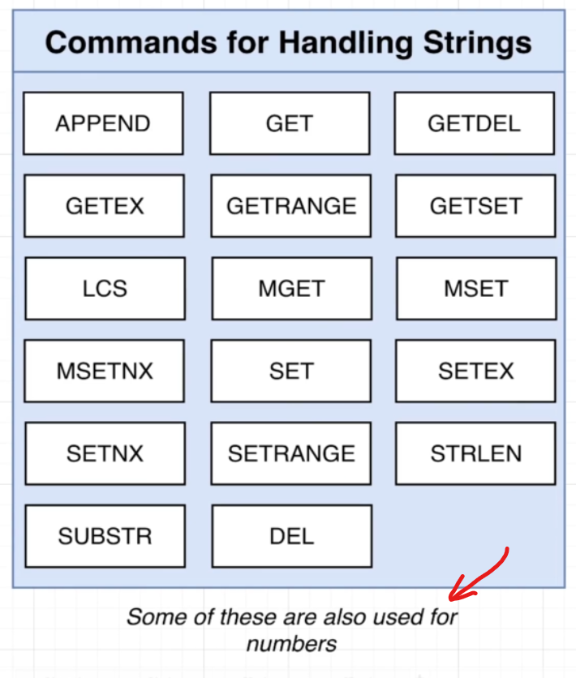
*********************************************************************************
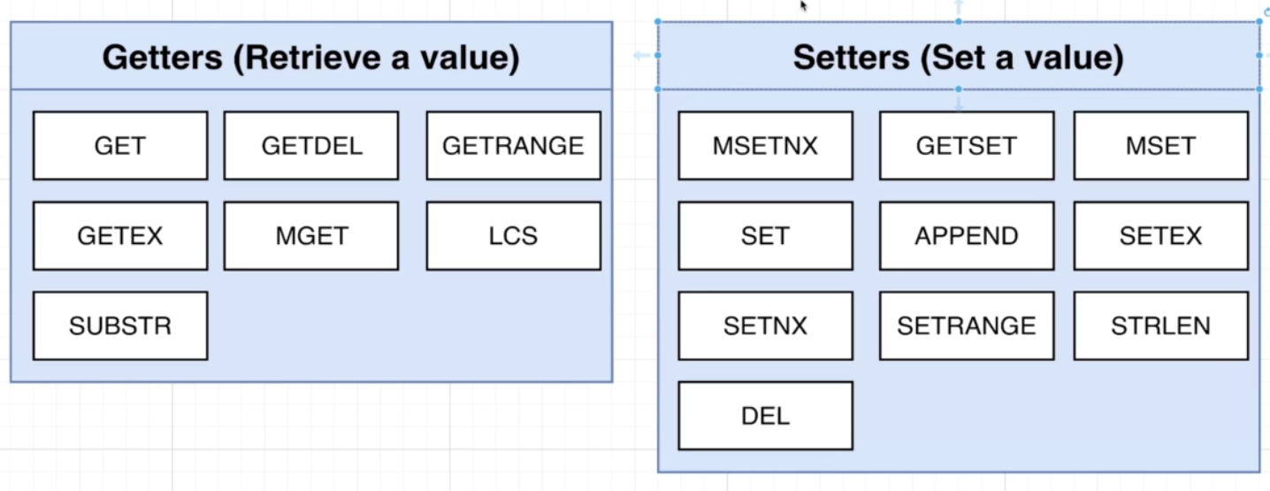
*********************************************************************************
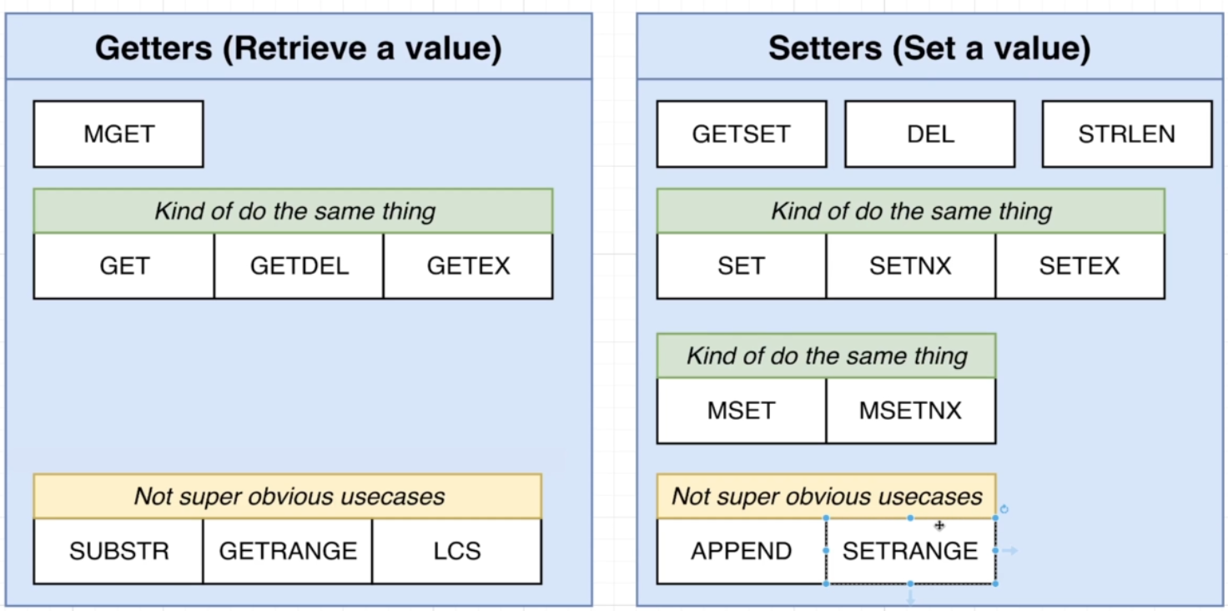
*********************************************************************************
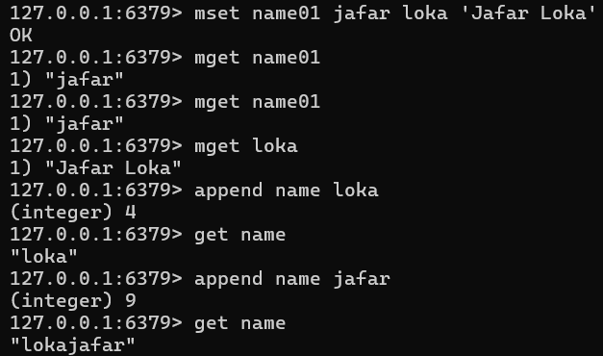
*********************************************************************************
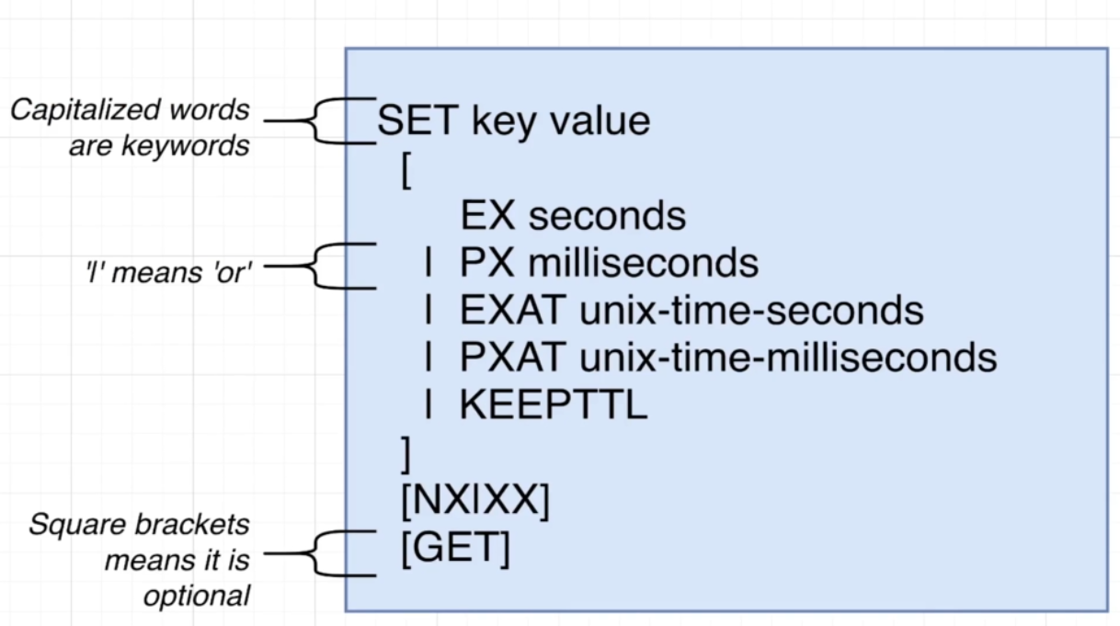
*********************************************************************************

To get the previous value of key, when we execute set command:
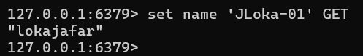
*********************************************************************************
Only set if key is exists:
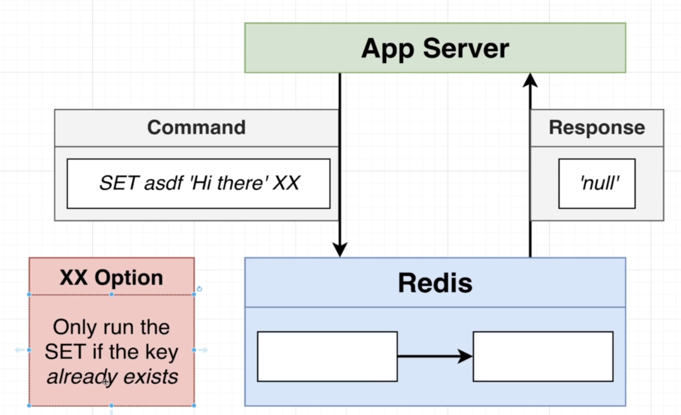
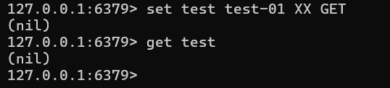
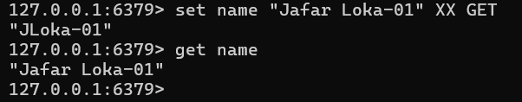
*********************************************************************************
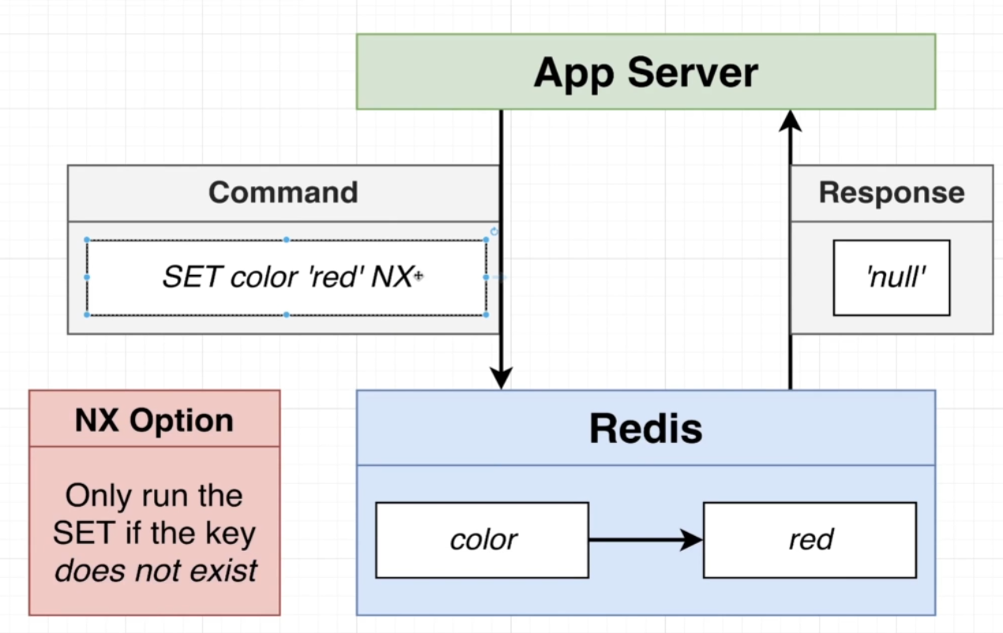
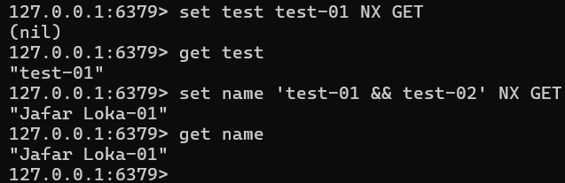
*********************************************************************************
https://redis.io/docs/latest/commands/
*********************************************************************************

To set the TTL value for SET In Seconds we use EX:
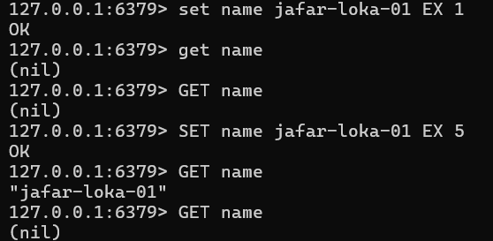
*********************************************************************************
To set the TTL for value in milliseconds, we use PX: 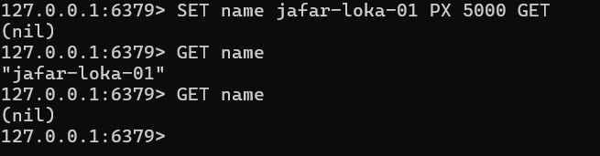
*********************************************************************************
To set the TTL for value depending on date and time (unix time seconds):
*********************************************************************************
Note 1: the SETEX same as SET with EX.
Note 2: the SETNX same as SET with NX.
*********************************************************************************

To add multiple values at once, we use MSET, where M for multiple
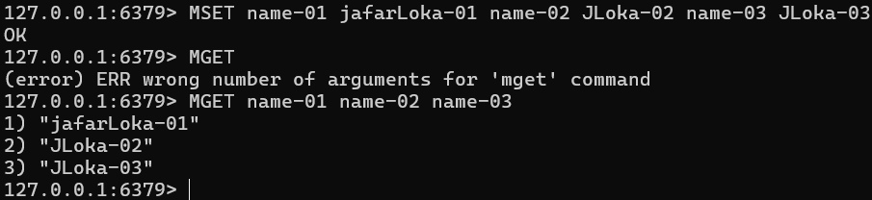
*********************************************************************************
The syntax for SETEX: SETEX name 2 jafar-loka-01
*********************************************************************************
Note: also, we have: MSETNX
*********************************************************************************

