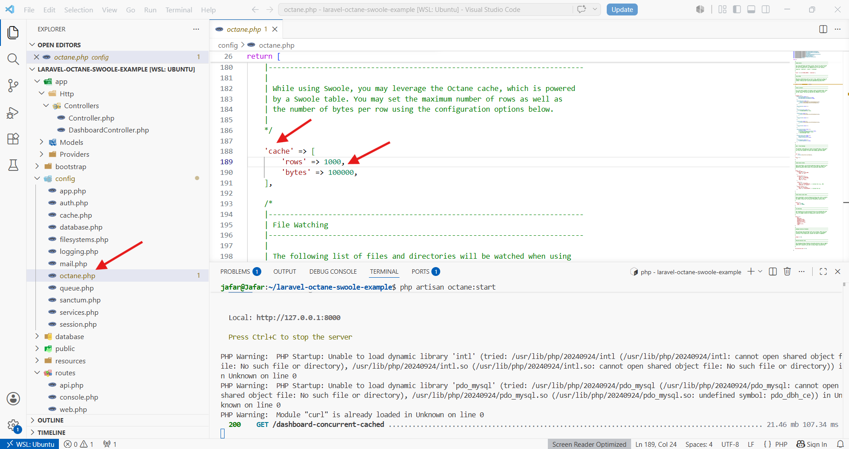
=====================================================

public function indexConcurrentCached()
{
$time = hrtime(true);
[$count, $info, $warning, $alert] = Cache::store('octane')->remember(
key: 'key-event-cache',
ttl: 20,
callback: function () {
return Octane::concurrently([
fn() => Event::count(),
fn() => Event::ofType('INFO')->get(),
fn() => Event::ofType('WARNING')->get(),
fn() => Event::ofType('ALERT')->get(),
]);
}
);

$time = (hrtime(true) - $time) / 1_000_000;
return response()->json([
'count' => $count,
'info' => $info,
'warning' => $warning,
'alert' => $alert,
'totalTime' => $time,
]);
}
=====================================================

