As soon as you deploy an application to Kubernetes, it takes over the daily management of the application. If the application fails, Kubernetes will automatically restart it. If the hardware fails or the infrastructure topology changes so that the application needs to be moved to other machines, Kubernetes does this all by itself. The engineers responsible for operating the system can focus on the big picture instead of wasting time on the details.
=========================================================
It frees application developers from the need to implement infrastructure, related mechanisms in their applications; instead, they rely on Kubernetes to provide them. This includes things like:
- service discovery - a mechanism that allows applications to find other applications and use the services they provide.
- horizontal scaling - replicating your application to adjust to fluctuations in load.
- load-balancing - distributing load across all the application replicas.
- self-healing - keeping the system healthy by automatically restarting failed applications and moving them to healthy nodes after their nodes fail.
- leader election - a mechanism that decides which instance of the application should be active while the others remain idle but ready to take over if the active instance fails.
=========================================================
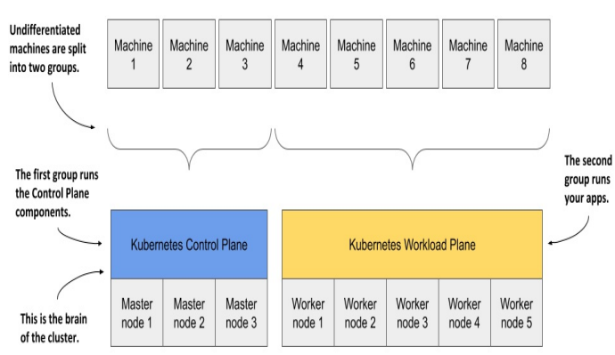
=========================================================
The master nodes will run the Kubernetes Control Plane, which represents the brain of your system and controls the cluster, while the rest will run your applications - your workloads - and will therefore represent the Workload Plane.
=========================================================
The Workload Plane is sometimes referred to as the Data Plane, but this term could be confusing because the plane doesn’t host data but applications. Don’t be confused by the term “plane” either - in this context you can think of it as the “surface” the applications run on.
=========================================================
Non-production clusters can use a single master node, but highly available clusters use at least three physical master nodes to host the Control Plane. The number of worker nodes depends on the number of applications you’ll deploy.
=========================================================
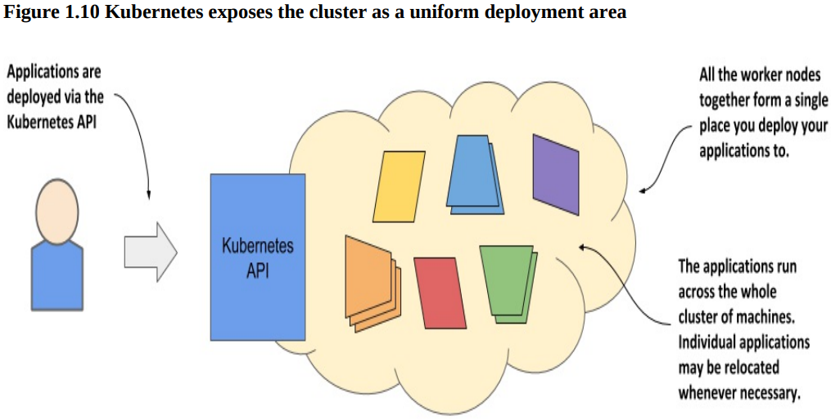
=========================================================
Kubernetes is a self-healing system in that it deals with software errors like the one just described, but it also handles hardware failures. As clusters grow in size, the frequency of node failure also increases. For example, in a cluster with one hundred nodes and a MTBF (mean-time-between-failure) of 100 days for each node, you can expect one node to fail every day.
=========================================================
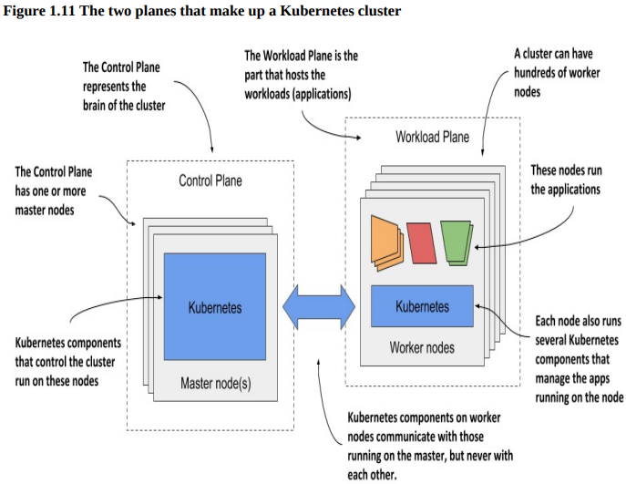
=========================================================
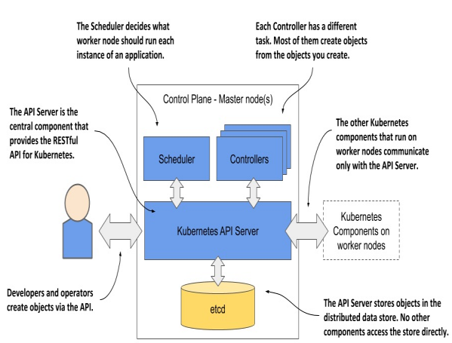
=========================================================
These are the components and their functions:
- The Kubernetes API Server exposes the RESTful Kubernetes API. Engineers using the cluster and other Kubernetes components create objects via this API.
- The etcd distributed datastore persists the objects you create through the API, since the API Server itself is stateless. The Server is the only component that talks to etcd.
- The Scheduler decides on which worker node each application instance should run.
- Controllers bring to life the objects you create through the API. Most of them simply create other objects, but some also communicate with external systems (for example, the cloud provider via its API).
=========================================================
The components of the Control Plane hold and control the state of the cluster, but they don’t run your applications. This is done by the (worker) nodes.
=========================================================
Worker node components:
The worker nodes are the computers on which your applications run. They form the cluster’s Workload Plane. In addition to applications, several Kubernetes components also run on these nodes. They perform the task of running, monitoring and providing connectivity between your applications.
=========================================================

