The container uses its own Process ID namespace; it has its own process tree with its own ID number sequence.
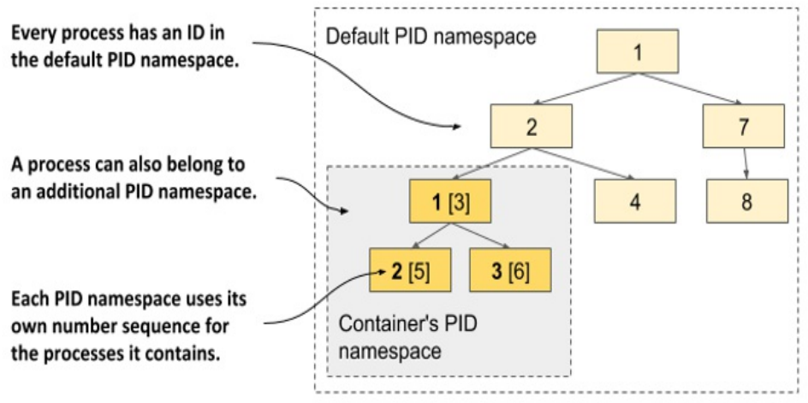
=================================================
Limiting a process’s resource usage with Linux Control Groups Linux
Namespaces make it possible for processes to access only some of the host’s resources, but they don’t limit how much of a single resource each process can consume. For example, you can use namespaces to allow a process to access only a particular network interface, but you can’t limit the network bandwidth the process consumes. Likewise, you can’t use namespaces to limit the CPU time or memory available to a process. You may want to do that to prevent one process from consuming all the CPU time and preventing critical system processes from running properly.
=================================================

The second Linux kernel feature that makes containers possible is called Linux Control Groups (cgroups). It limits, accounts for, and isolates system resources such as CPU, memory, and disk or network bandwidth. When using cgroups, a process or group of processes can only use the allotted CPU time, memory, and network bandwidth. for example. This way, processes cannot occupy resources that are reserved for other processes.
=================================================
Limiting a container’s use of the CPU:
If you don’t impose any restrictions on the container’s use of the CPU, it has unrestricted access to all CPU cores on the host. You can explicitly specify which cores a container can use with Docker’s --cpuset-cpus option. For example, to allow the container to only use cores one and two, you can run the container with the following option:

You can also limit the available CPU time using options --cpus, --cpu-period, --cpu-quota, and --cpu-shares. For example, to allow the container to use only half of a CPU core, run the container as follows:
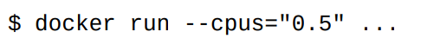
=================================================

Limiting a container’s use of memory:
As with CPU, a container can use all the available system memory, just like any regular OS process, but you may want to limit this. Docker provides the following options to limit container memory and swap usage: --memory, -- memory-reservation, --kernel-memory, --memory-swap, and --memory-swappiness. For example, to set the maximum memory size available in the container to 100MB, run the container as follows (m stands for megabytes):

=================================================
Strengthening isolation between containers:
Linux Namespaces and Cgroups separate the containers’ environments and prevent one container from starving the other containers of compute resources. But the processes in these containers use the same system kernel, so we can’t say that they are really isolated. A rogue container could make malicious system calls that would affect its neighbours.
-------------------------------------------------------------------------------------

