Probability is the study of random events.
=========================================
Statistics is the discipline of using data samples to support claims about populations. Most statistical analysis is based on probability.
=========================================
Computation is a tool that is well-suited to quantitative analysis, and computers are commonly used to process statistics. Also, computational experiments are useful for exploring concepts in probability and statistics.
=========================================
If you have a sample of n values, x_{i}, the mean, µ, is the sum of the values divided by the number of values; in other words.
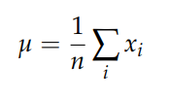
=========================================
The words “mean” and “average” are sometimes used interchangeably, but I will maintain this distinction:
- The “mean” of a sample is the summary statistic computed with the previous formula.
- An “average” is one of many summary statistics you might choose to describe the typical value or the central tendency of a sample.
=========================================
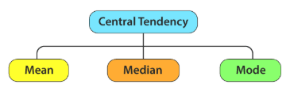
=========================================
Key Measures of Central Tendency:
- Mean: The sum of all values divided by the total number of values. It is the most common measure, but it is sensitive to extreme outliers.
- Median: The exact middle value when data is arranged in ascending or descending order. It is ideal for skewed data because it is not heavily influenced by outliers.
- Mode: The value that appears most frequently in the dataset. It is useful for categorical data or for identifying the most popular option.
=========================================
Variance in statistics measures how far a set of numbers are spread out from their average value (mean). It is the average of the squared differences from the mean, serving as a key indicator of dispersion or volatility in data. A high variance indicates data points are spread far from the mean, while a low variance indicates they are clustered closely.
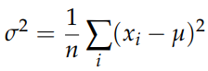
=========================================

In Finance, it measures the risk or volatility of a stock’s returns over time.
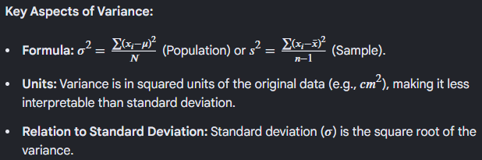
=========================================
The term x_{i} -µ is called the “deviation from the mean,” so variance is the mean squared deviation, which is why it is denoted σ₂. The square root of variance, σ, is called the standard deviation.
=========================================
Regression in statistics is a modeling technique used to analyze the relationship between a continuous dependent variable (target) and one or more independent variables (predictors). It estimates how changes in independent variables affect the dependent variable, enabling prediction, forecasting, and quantifying the impact of variables.
Key Aspects of Regression Analysis
- Purpose: Primarily used for forecasting (e.g., sales, temperature) and determining the strength of predictors.
- Types:
  - Simple Linear Regression: Uses one independent variable to predict a dependent variable by fitting a straight line.
  - Multiple Regression: Uses two or more independent variables to predict a single outcome.
  - Nonlinear/Logistic Regression: Used when data trends are curved or when the outcome is categorical (e.g., yes/no).
-------------------------------------------------------------------------
Common Usage Examples
- Predicting Housing Prices: Using square footage, location, and number of bedrooms to estimate price.
- Sales Forecasting: Analyzing the impact of advertising expenditure on product sales.
- Healthcare Trends: Determining how age and weight influence blood pressure.
- Salary Analysis: Estimating salary based on years of experience and education level.
=========================================
The data of statistics can come from:
- Survey
- Experimental results (like the medicine results)
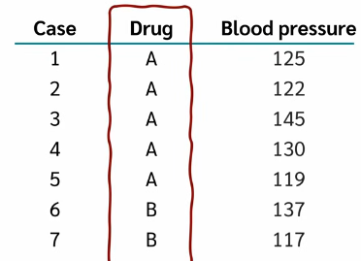
=========================================
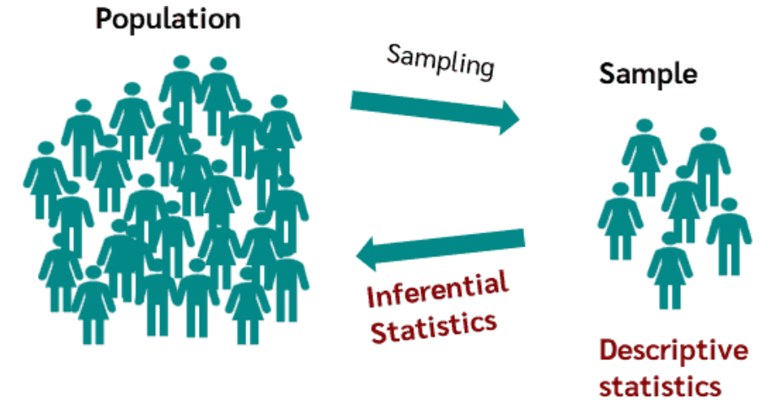
=========================================
The goal of inferential statistics is to infer the unknown parameters of the population from the known parameters of a sample.
=========================================
Therefore, inferential statistics try to infer conclusions that go beyond the immediate data, unlike descriptive statistics. To achieve this, hypothesis tests such as the t-test or analysis of variance are used in inferential statistics.
=========================================
After collecting data, one of the first things to do is to graph the data, calculate the mean, and get an overview of the distributions of the data. This is the task of descriptive statistics.
=========================================
Thus, the goal of descriptive statistics is to gain an overview of the distribution of data sets. Descriptive statistics helps to describe and illustrate data sets.
=========================================
Definition: The term descriptive statistics covers statistical methods for describing data using statistical characteristics, charts, graphics, or tables.
=========================================
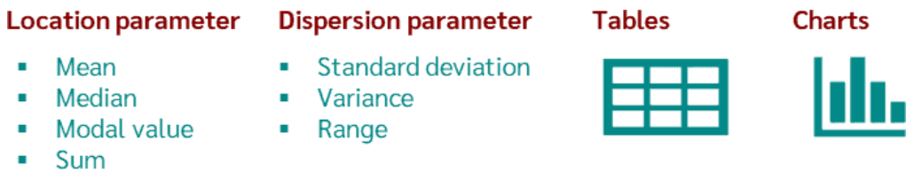
=========================================
Variance and standard deviation are both measures of data spread (dispersion) from the mean, but they differ in units and interpretation.
Variance is the average of squared differences from the mean (units squared), while standard deviation is the square root of variance, returning the measurement to the original data's units.
=========================================
Depending on which question and which measurement scale is available, different key figures, tables, and graphics are used for evaluation. The best known of these are:
- Location parameter: Mean value, median, mode, sum.
- Dispersion parameter: Standard deviation, variance, range.
- Tables: Absolute, relative, and cumulative Frequencies.
- Charts: Histograms, bar charts, box plots, scatter charts, matrix plots.
=========================================

We can say it is used in ML to detect sample clusters.
The first group of descriptive statistics includes location parameters like the mean and mode. They are used to express a central tendency of the data set. They therefore describe where the center of a sample is located or where most of the sample is.
=========================================
Note: we can use it in applications like using the feature engineering.
The second group are measures of dispersion. They provide information about how much the values of a variable in a sample differ from each other. Measures of dispersion can therefore describe how strongly the values of a variable deviate from the mean value: Are the values rather close together, i.e. are they similar, or are they far apart and thus differ greatly? A classic example is the standard deviation.
=========================================
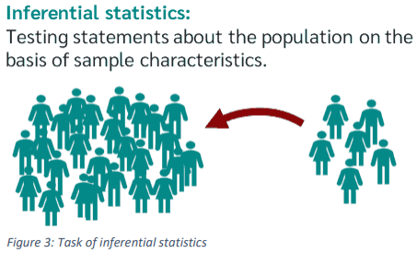
=========================================
Depending on which statement is to be made about the population or which question is to be answered about the population, different statistical methods or hypothesis tests are used.
The best known are the hypothesis tests with which a group difference can be tested, such as the t-test, the chi-square test, or the analysis of variance. Then there are the hypothesis tests with which a correlation of variables can be tested, such as correlation analysis and regression.
=========================================
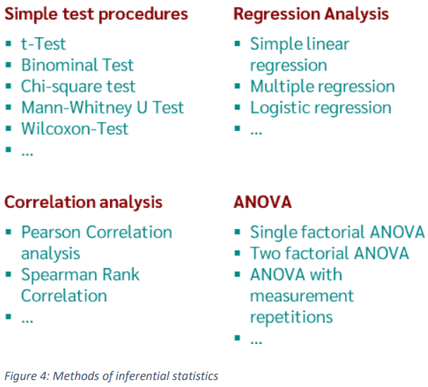
=========================================
Inferential statistics definition
Inferential statistics is a branch of statistics that uses various analytical tools to draw conclusions about the population from sample data. For a given hypothesis about the population, inferential statistics uses a sample and gives an indication of the validity of the hypothesis based on the sample collected.
=========================================

For example, it could be of interest to know if basketball players are larger than the average male population. To test this hypothesis, a t-Test is calculated, the t-test compares the sample mean with the mean of the population.
=========================================



