After we select the chart:
- We can change the bold option.
- We can change the font size option
- And many more

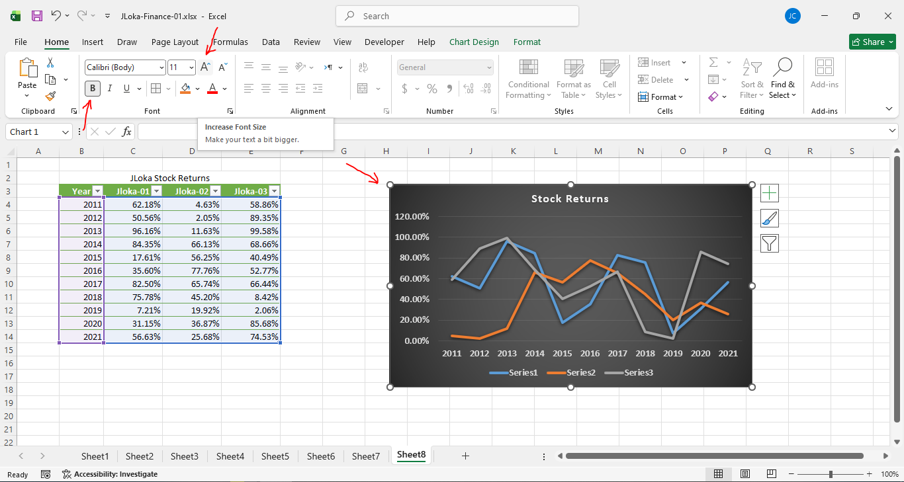
===================================================

We can change the data:
- Select the chart.
- Right click, and choose “Select Data…”

