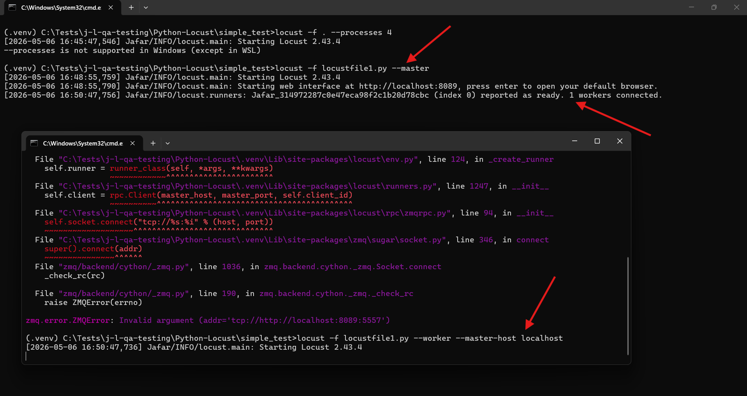
=====================================================
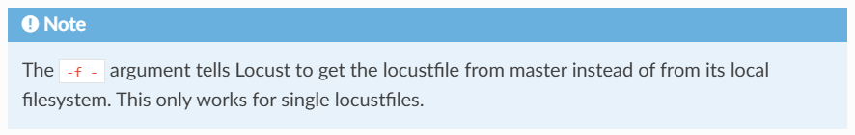
=====================================================
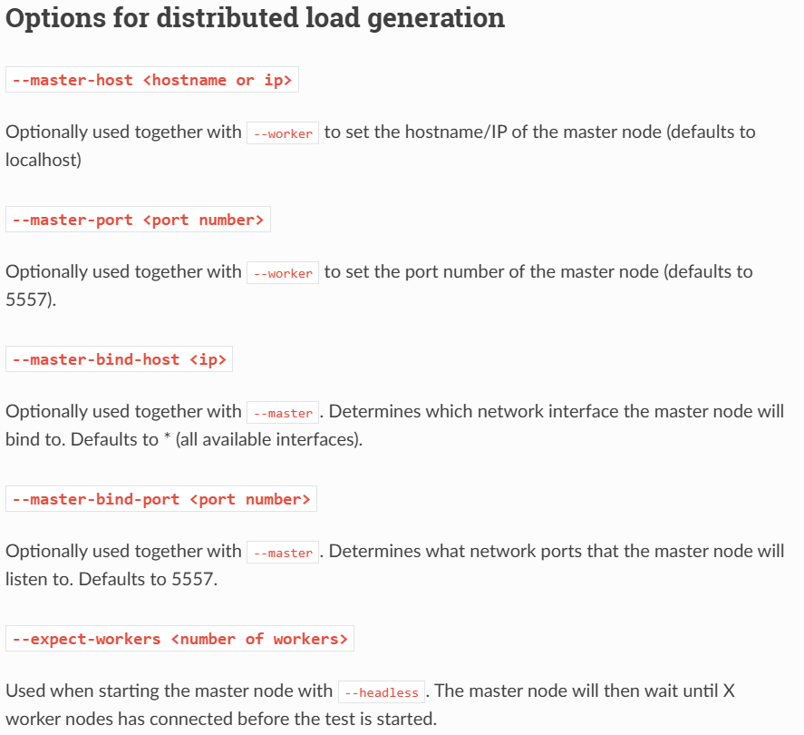
=====================================================
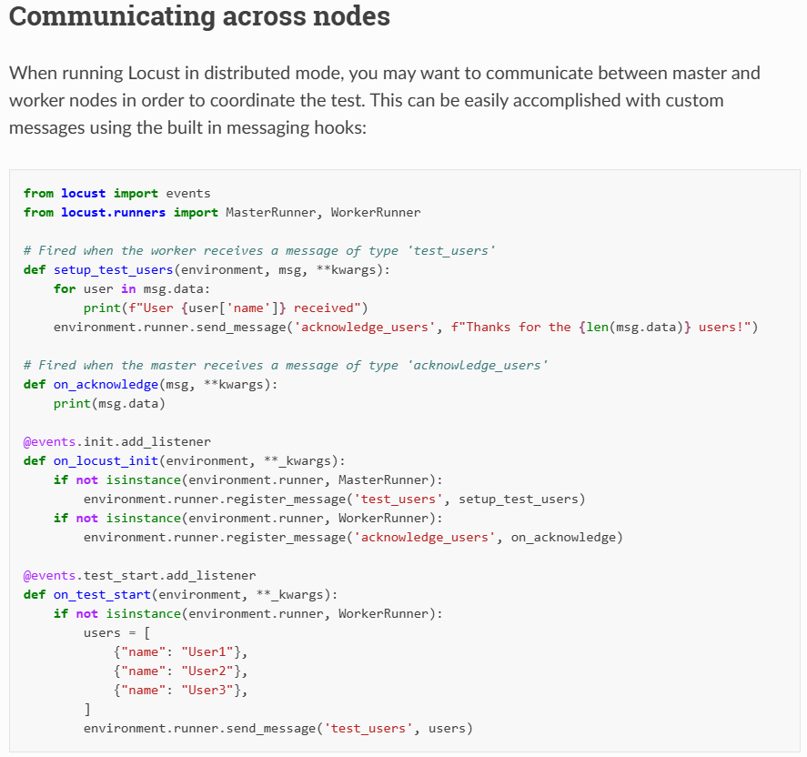
=====================================================

Using the default options while registering a message handler will run the listener function in a blocking way, resulting in the heartbeat and other messages being delayed for the amount of the execution. If you think that your message handler will need to run for more than a second, then you can register it as concurrent. Locust will then make it run in its own greenlet. Note that these greenlets will never be joined.
=====================================================
services:
master:
image: locustio/locust:master
ports:
- "8089:8089"
volumes:
- ./:/mnt/locust
command: -f /mnt/locust/locustfile3.py --master -H http://master:8089

worker:
image: locustio/locust:master
volumes:
- ./:/mnt/locust
command: -f /mnt/locust/locustfile3.py --worker --master-host master
depends_on:
- master

To start a master node and 4 workers using the following command:
docker-compose up --scale worker=4
=====================================================



