Reactive programming is among the major programming paradigms used by developers worldwide. Every programming paradigm solves some problems and has its own advantages. By definition, reactive programming is programming with asynchronous data streams and is based on observer patterns.
======================================================
Data streams are the spine of reactive programming. Everything that may change or happen over time (you don’t know when exactly) is represented as asynchronous streams, such as events, notifications, and messages. Reactive programming is about reacting to changes as soon as they are emitted!
======================================================
To get closer to reactive terminology, instead of listen, we can say observe.
======================================================
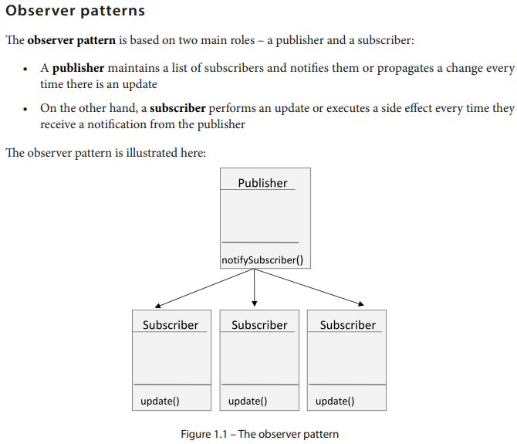
======================================================


======================================================
This leads us to the building blocks of RxJS, which include the following:
• Observables: These are a representation of the asynchronous data streams that notify the observers of any change.
• Observers: These are consumers of the data streams emitted by Observables.
======================================================
RxJS combines the observer pattern with the iterator pattern and functional programming to process and handle asynchronous events. This was a reminder of reactive programming fundamentals, and it is crucial to know when to put a reactive implementation in place and when to avoid it.
======================================================
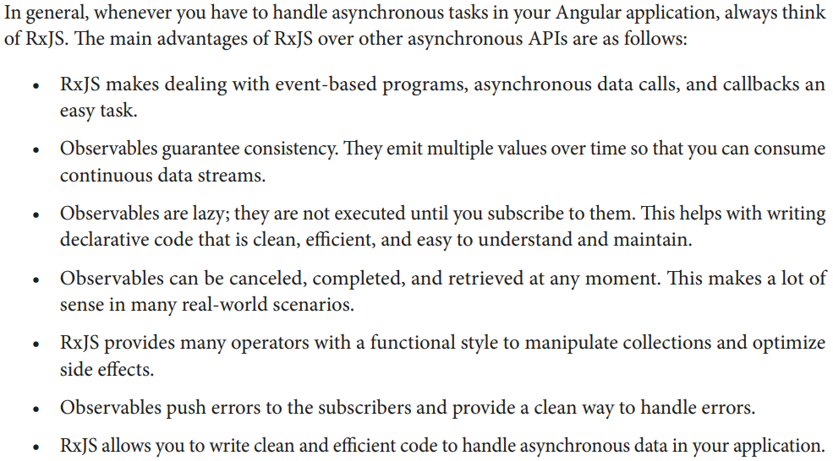
======================================================
Marble diagrams are visual representations of the operator’s execution.
======================================================
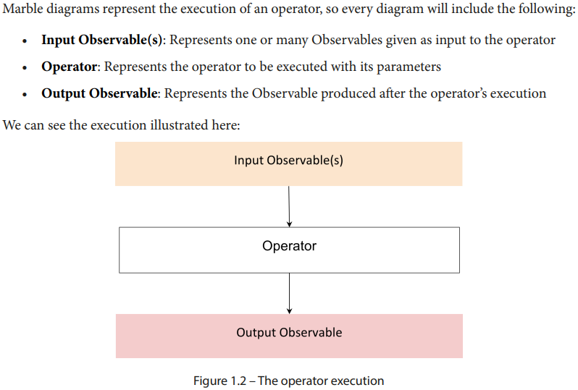
======================================================
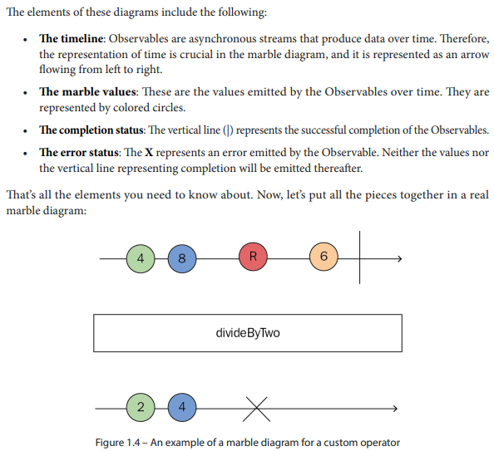
======================================================
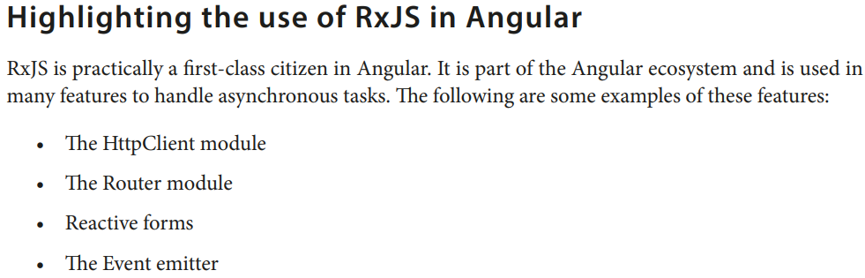
======================================================
RxJS is practically a first-class citizen in Angular. It is part of the Angular ecosystem and is used in many features to handle asynchronous tasks. The following are some examples of these features:
• The HttpClient module.
• The Router module.
• Reactive forms.
• The Event emitter.
======================================================
However, there are a lot of advantages of using Observables over Promises, and the most important ones are listed as follows:
- Observables are cancellable, so you can cancel the HTTP request whenever you want by calling the unsubscribe method.
- You can also retry HTTP requests when an error occurs or an exception is thrown.
======================================================
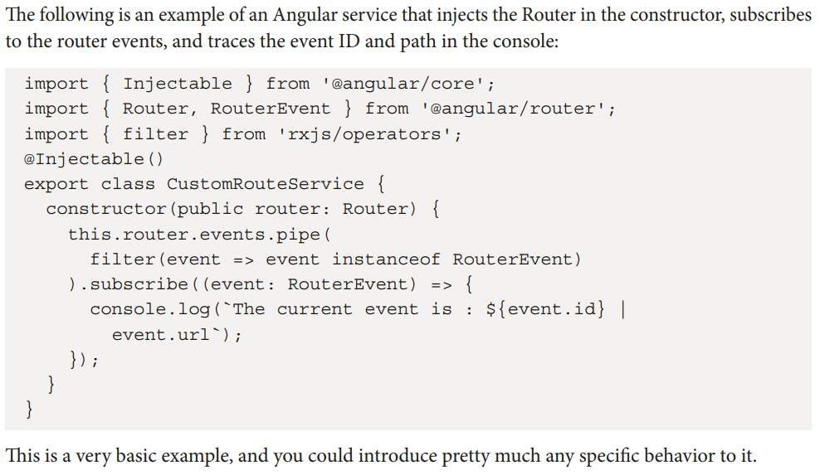
======================================================
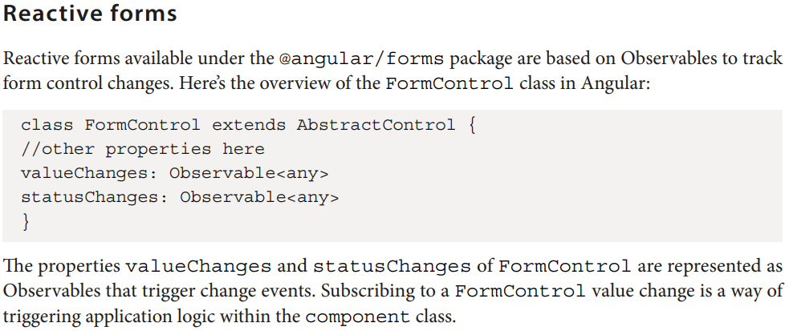
======================================================

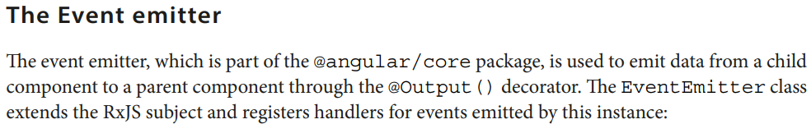
======================================================
The EventEmitter smooths communication between components by allowing one component to emit custom events and another component to listen for and respond to those events. This mechanism plays a crucial role in enabling parent-child communication, sibling communication, and even communication between unrelated components in Angular applications.
======================================================

