For creating event emitting example:
For app.module.ts:
import { Module } from '@nestjs/common';
import { EventEmitterModule } from '@nestjs/event-emitter';
import { AppController } from './app.controller';
import { AppService } from './app.service';
import { UsersModule } from './users/users.module';

@Module({
imports: [UsersModule, EventEmitterModule.forRoot()],
controllers: [AppController],
providers: [AppService],
})
export class AppModule {}
----------------------------------------------------------------------
Then for users.service.ts:
import { Injectable } from '@nestjs/common';
import { EventEmitter2 } from '@nestjs/event-emitter';

@Injectable()
export class UsersService {

constructor(private eventEmitter: EventEmitter2) {}

createUser(name: string, email: string) {
// Simulate user creation
const newUser = { id: Date.now(), name, email };

// Emit 'user.created' event
this.eventEmitter.emit('user.created', newUser);

return newUser;
}
}
----------------------------------------------------------------------

Then for users-created.listener.ts:
import { Injectable, Logger } from '@nestjs/common';
import { OnEvent } from '@nestjs/event-emitter';

@Injectable()
export class UserCreatedListener {
private readonly logger = new Logger(UserCreatedListener.name);

@OnEvent('user.created')
handleUserCreated(user: any) {
// This runs asynchronously by default
this.logger.log(`New user created: ${user.name} <${user.email}>`);

// Example: Send welcome email, update analytics, etc.
}
}
----------------------------------------------------------------------
Then for users.controller.ts:
import { Body, Controller, Post } from '@nestjs/common';
import { UsersService } from './users.service';

@Controller('users')
export class UsersController {
constructor(private usersService: UsersService) {}

@Post()
createUser(@Body() createUserDto: { name: string; email: string }) {
return this.usersService.createUser(createUserDto.name, createUserDto.email);
}
}
----------------------------------------------------------------------
Then for users.module.ts:
import { Module } from '@nestjs/common';
import { UsersService } from './users.service';
import { UsersController } from './users.controller';
import { UserCreatedListener } from './user-create.listener';

@Module({
providers: [UsersService, UserCreatedListener],
controllers: [UsersController]
})
export class UsersModule {}
*************************************************************
To create a Nest application instance, we use the core NestFactory class. NestFactory exposes a few static methods that allow creating an application instance. The create() method returns an application object, which fulfills the INestApplication interface.
*************************************************************
By default, if any error happens while creating the application your app will exit with the code 1. If you want to make it throw an error instead disable the option abortOnError (e.g., NestFactory.create(AppModule, { abortOnError: false })).
*************************************************************
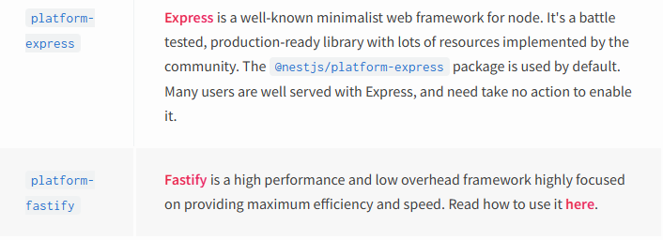
*************************************************************
Whichever platform is used, it exposes its own application interface. These are seen respectively as NestExpressApplication and NestFastifyApplication.
*************************************************************
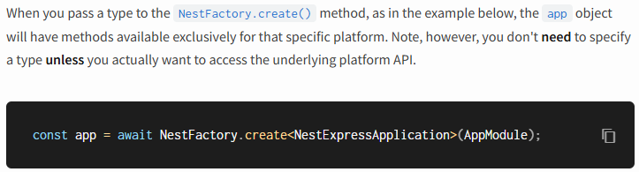
*************************************************************
To speed up the development process (x20 times faster builds), you can use the SWC builder by passing the -b swc flag to the start script, as follows npm run start -- -b swc.
*************************************************************
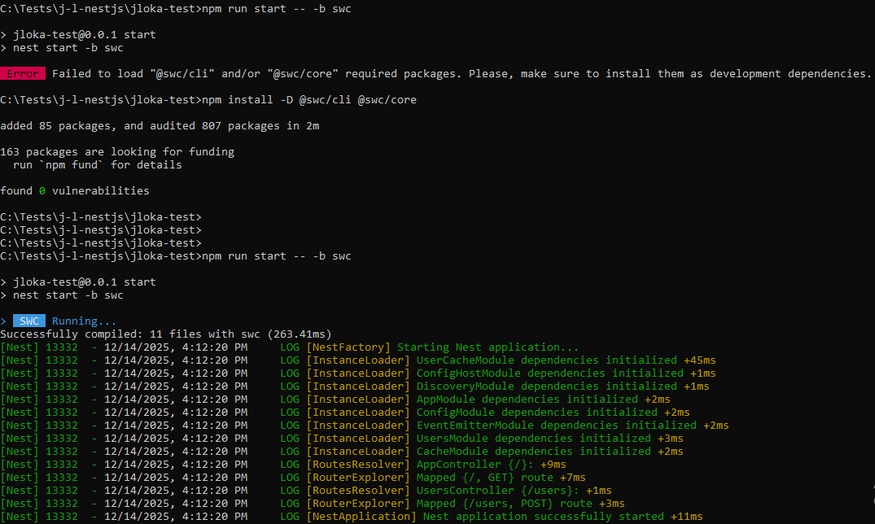
*************************************************************
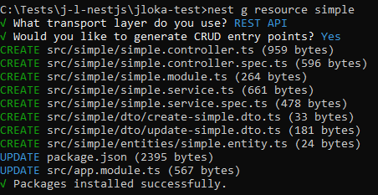
*************************************************************
Controllers are responsible for handling incoming requests and sending responses back to the client.
*************************************************************

The concept that Nest uses two different options for manipulating responses:
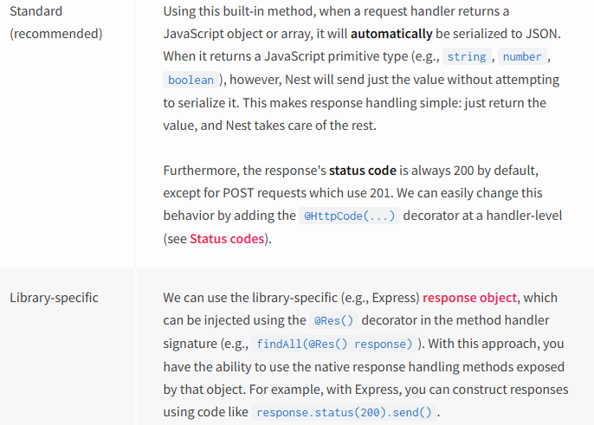
*************************************************************
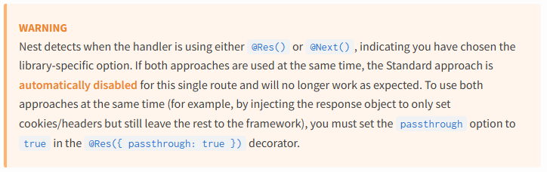
*************************************************************
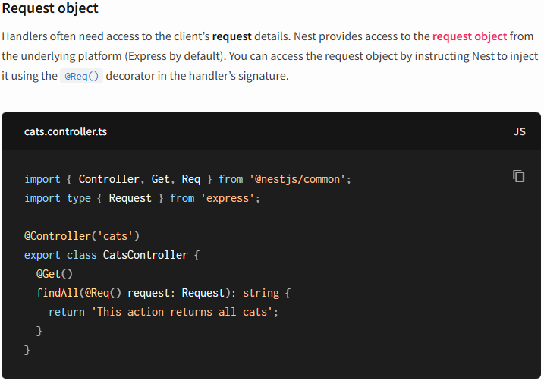
*************************************************************
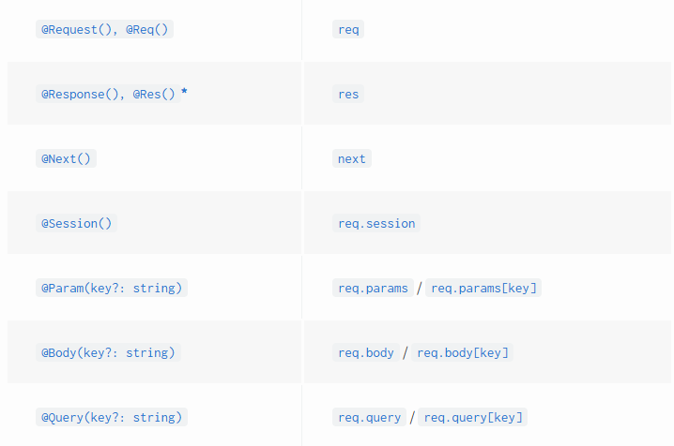
*************************************************************
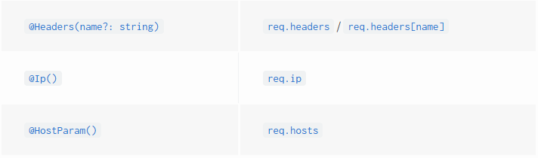
*************************************************************
@Res() is simply an alias for @Response(). Both directly expose the underlying native platform response object interface. When using them, you should also import the typing’s for the underlying library (e.g., @types/express) to take full advantage. Note that when you inject either @Res() or @Response() in a method handler, you put Nest into Library-specific mode for that handler, and you become responsible for managing the response. When doing so, you must issue some kind of response by making a call on the response object (e.g., res.json(...) or res.send(...)), or the HTTP server will hang.
*************************************************************
import { Body, Controller, Get, Post } from '@nestjs/common';
import { UsersService } from './users.service';

@Controller('users')
export class UsersController {
constructor(private usersService: UsersService) {}

@Post()
createUser(@Body() createUserDto: { name: string; email: string }) {
return this.usersService.createUser(createUserDto.name, createUserDto.email);
}

// in this way we can use supported way to paths: *, by adding *path where path is the prefix
// here the path is $
@Get('/loka/*$')
getLoka() {
return "My name is: Jafar Loka";
}
}
*************************************************************

This approach works on both Express and Fastify. However, with the latest release of Express (v5), the routing system has become more strict. In pure Express, you must use a named wildcard to make the route work—for example, abcd/*splat, where splat is simply the name of the wildcard parameter and has no special meaning. You can name it anything you like. That said, since Nest provides a compatibility layer for Express, you can still use the asterisk (*) as a wildcard.
*************************************************************
When it comes to asterisks used in the middle of a route, Express requires named wildcards (e.g., ab{*splat}cd), while Fastify does not support them at all.
*************************************************************
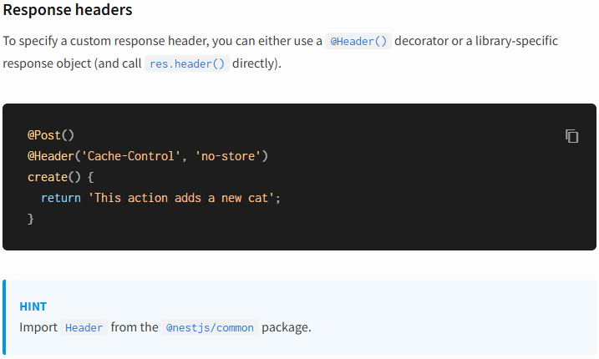
*************************************************************
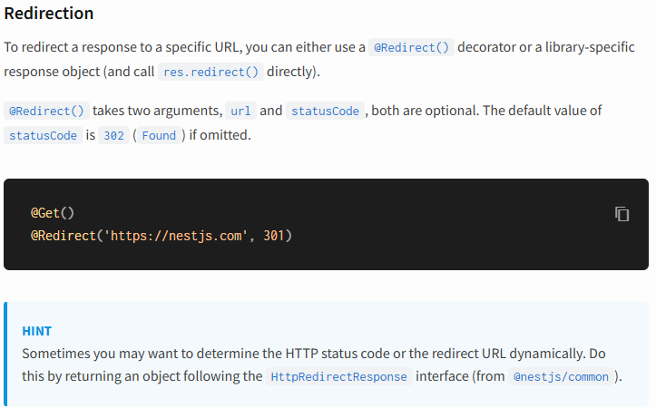
*************************************************************
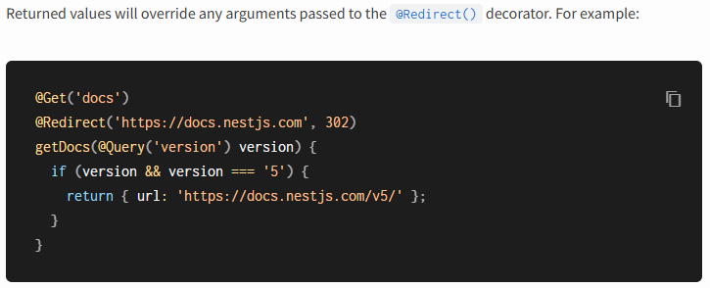
*************************************************************
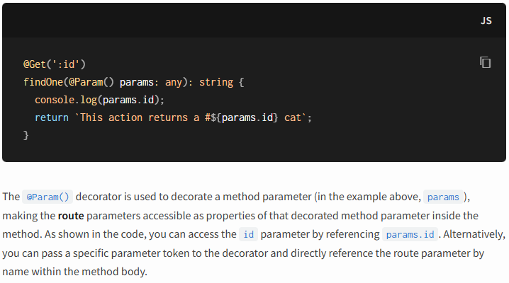
*************************************************************
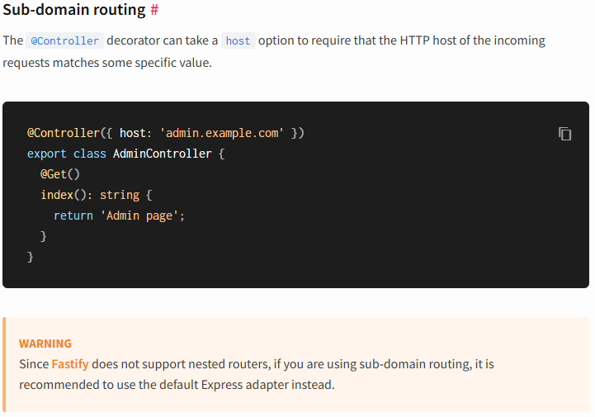
*************************************************************
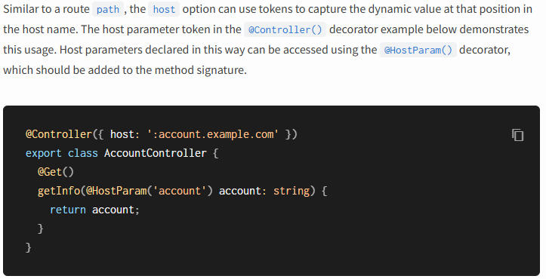
*************************************************************
Nest, nearly everything is shared across incoming requests. This includes resources like the database connection pool, singleton services with global state, and more. It's important to understand that Node.js doesn't use the request/response Multi-Threaded Stateless Model, where each request is handled by a separate thread. As a result, using singleton instances in Nest is completely safe for our applications.
*************************************************************
There are specific edge cases where having request-based lifetimes for controllers may be necessary. Examples include per-request caching in GraphQL applications, request tracking, or implementing multi-tenancy.
*************************************************************

