This value must be string, from docker compose:

***********************************************************
In this way we define the services for docker compose, that we want to run:
Note: the name/s of services can be anything.
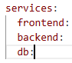
***********************************************************
To set the location of Dockerfile, for docker-compose file, we can use build:
services:
frontend:
build: ./frontend
backend:
build: ./backend
db:
***********************************************************
To define the image of service, instead of build:
db:
image: mongo:4.0-xeniel
***********************************************************

To define the env-variables:
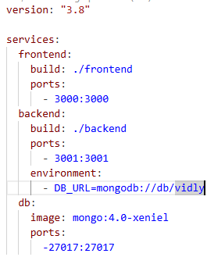
***********************************************************
Also, we can use object notation for env-variables:
Note: in this way we don’t use = we use :
environment:
DB_URL: mongodb://db/vidly
***********************************************************

To define the volumes (vidly can be any name for volume):
Note: we need to define the name of volume inside the docker-compose file
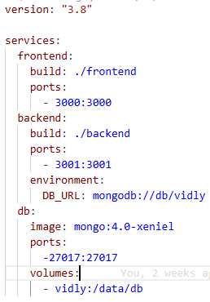
***********************************************************

When we use volumes inside any service of docker-compose.yml file we must declare it, so; we can set volumes outside any service (services and volumes in the same level).
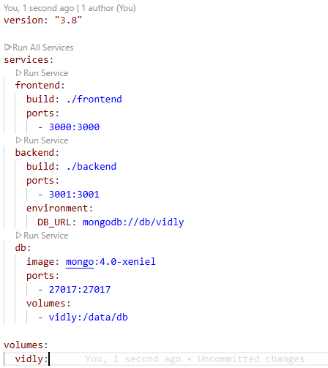
***********************************************************
If we have issues when building images with docker-compose, then we can use --no-cache
***********************************************************
To show the docker compose services that are relevant to application: docker-compose ps
***********************************************************
In docker-compose.yml-file, we don’t need to define version-attribute any more
***********************************************************
The default network driver is: bridge on Linux and NAT on windows.
***********************************************************

To list all networks from docker: docker network ls
***********************************************************
To check the connection between containers:
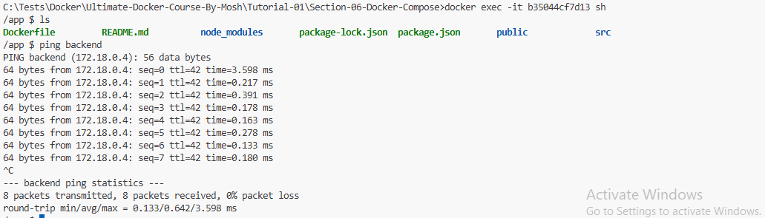
***********************************************************
To display the logs of docker-compose services: docker-compose logs
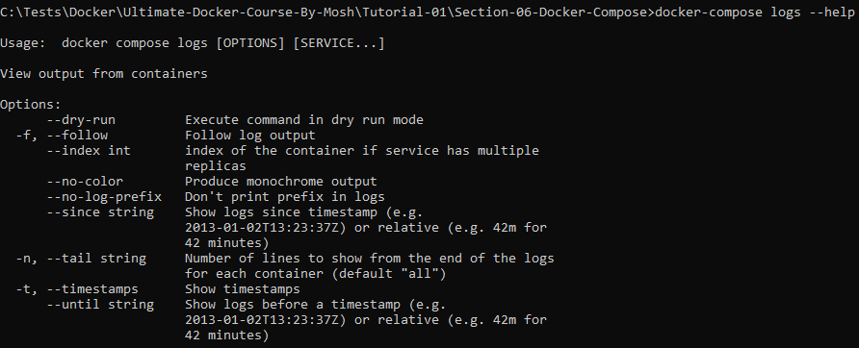
***********************************************************
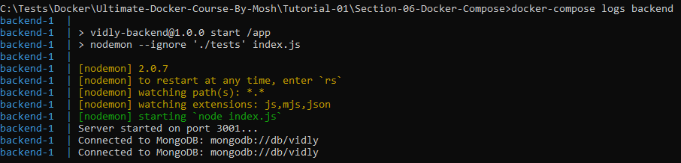
***********************************************************
When building production images, we must separate the stages of building using AS-keyword in docker file, so we separate the building stage from production stage.
***********************************************************
When building production app using docker:
- Remove all un-important volumes from docker-compose
- Set the restart-policy to on-failure or unless-stopped (the preferred solution is: unless-stopped)
- Secure db from un authorized accesses
- For production Stage (from previous note) we can use server images to serve the build optimized version of our app (like: nginx-image)
- For running app from docker-file we should use entrypoint instead of CMD due to restart-policy
- When using custom docker file, set the context of file path. Like . to current path
***********************************************************
When using custom docker file, and custom docker-compose file, for build-tag we must define the context and Dockerfile
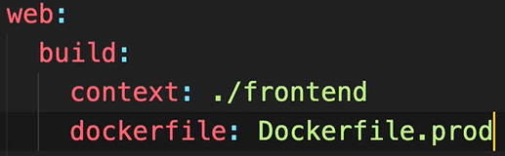
***********************************************************
To add tag in docker-compose, we can use image-tag:
Ex image: jloka:1.0.0
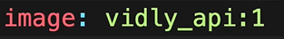
***********************************************************

The complete docker-compose file including the test service:
services:
frontend:
build: ./frontend
ports:
- 3000:3000

backend:
build: ./backend
ports:
- 3001:3001
environment:
DB_URL: mongodb://db/vidly
command: ./docker-entrypoint.sh
db:
image: mongo
ports:
- 27017:27017
volumes:
- vidly:/data/db
test:
image: jloka_01-backend
volumes:
- ./backend:/app
command: npm test
depends_on:
- backend
environment:
DB_URL: mongodb://db/vidly
volumes:
vidly:
***********************************************************

The content of docker-entrypoint.sh is:
#!/bin/sh

echo "Waiting for MongoDB to start..."
./wait-for db:27017

echo "Migrating the database..."
npm run db:up

echo "Starting the server..."
npm start
***********************************************************

