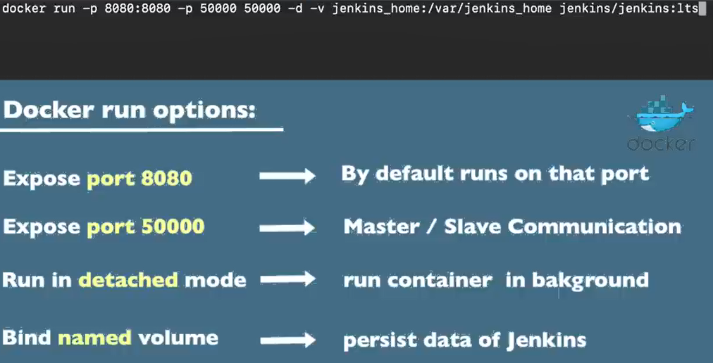
************************************************************
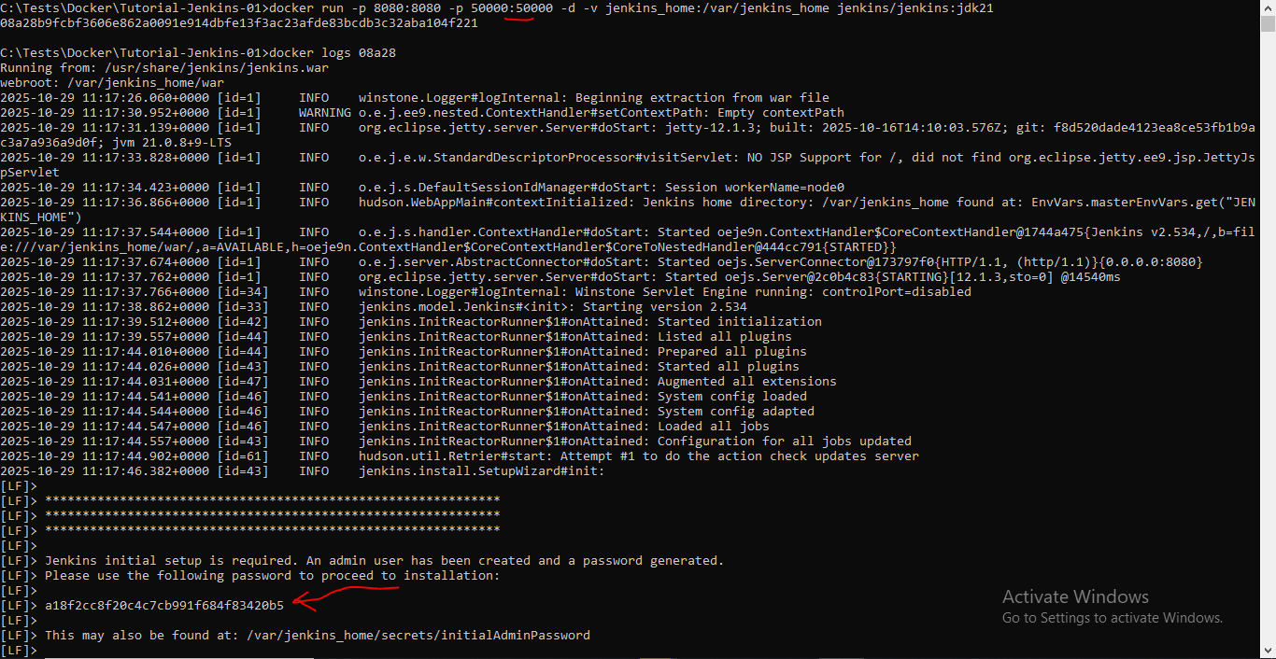
************************************************************

Then we can go to: localhost:8080
************************************************************
Then we choose to install the suggested plugins
************************************************************
Then we create new admin user
************************************************************
Then we start Jenkins:
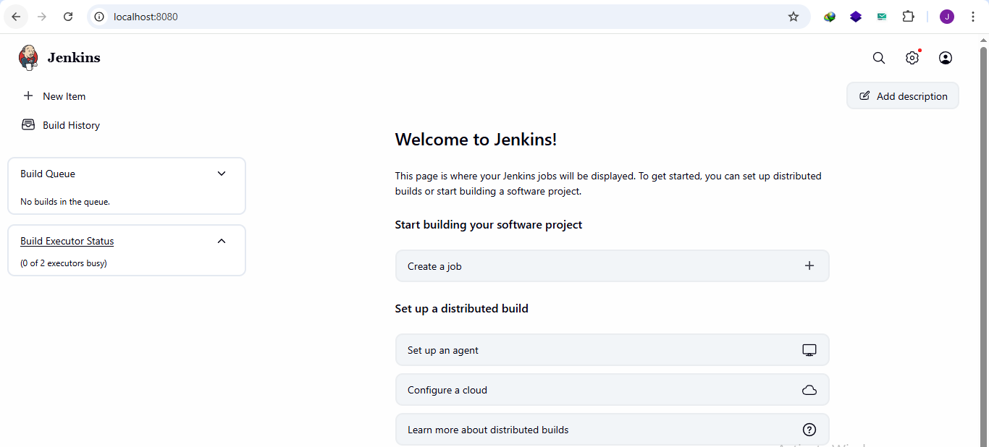
************************************************************
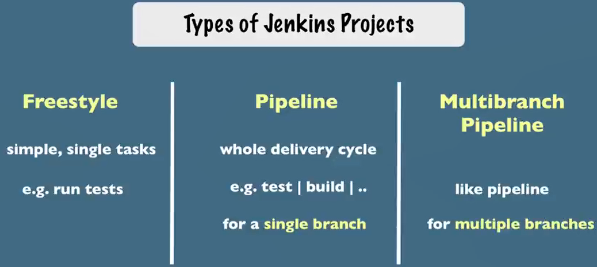
************************************************************
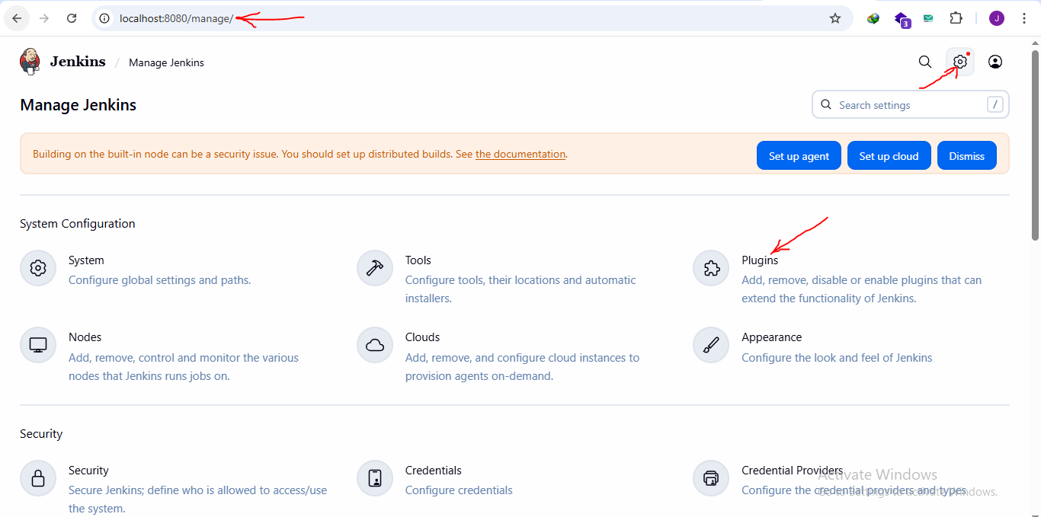
************************************************************
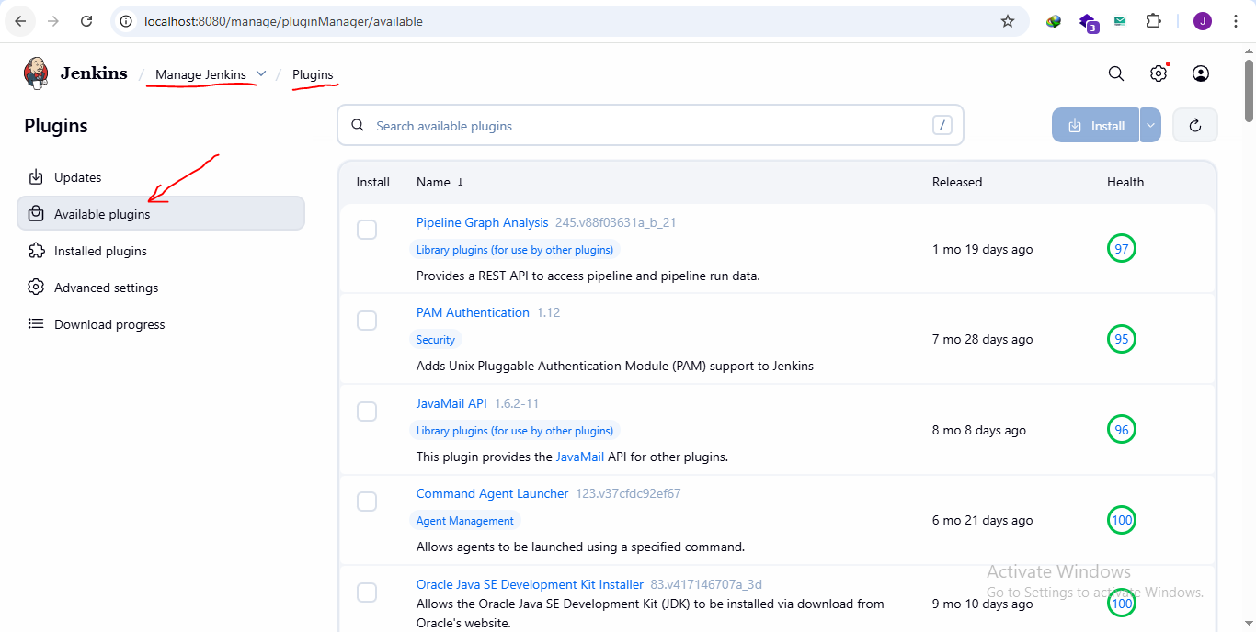
************************************************************

************************************************************
To create multibranch pipeline we create new item with name and select multibranch pipeline:
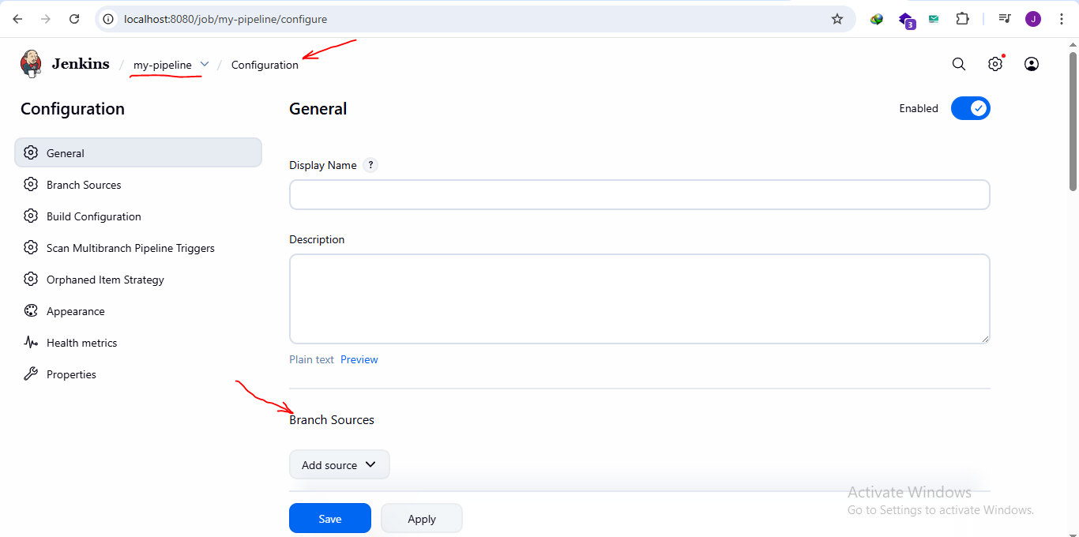
************************************************************
For branches we select by name with Regular expression, where RE from java
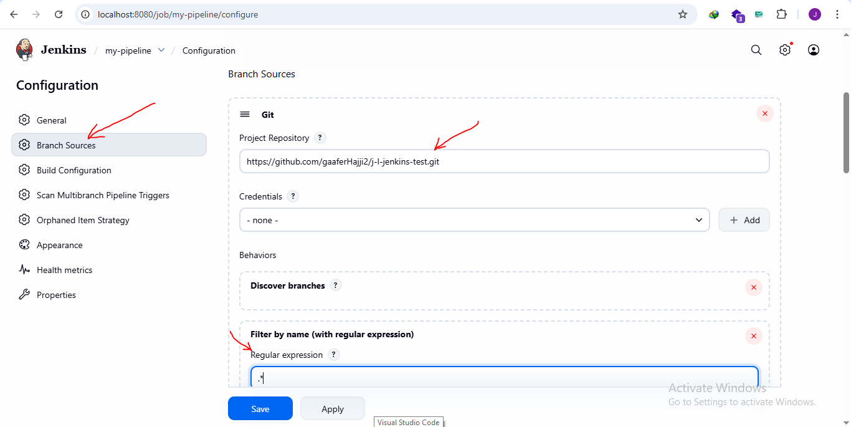
************************************************************

To add new credentials for Jenkins for our pipeline:
- From settings we select credentials and select system, then we select global credentials, then we add new ones:
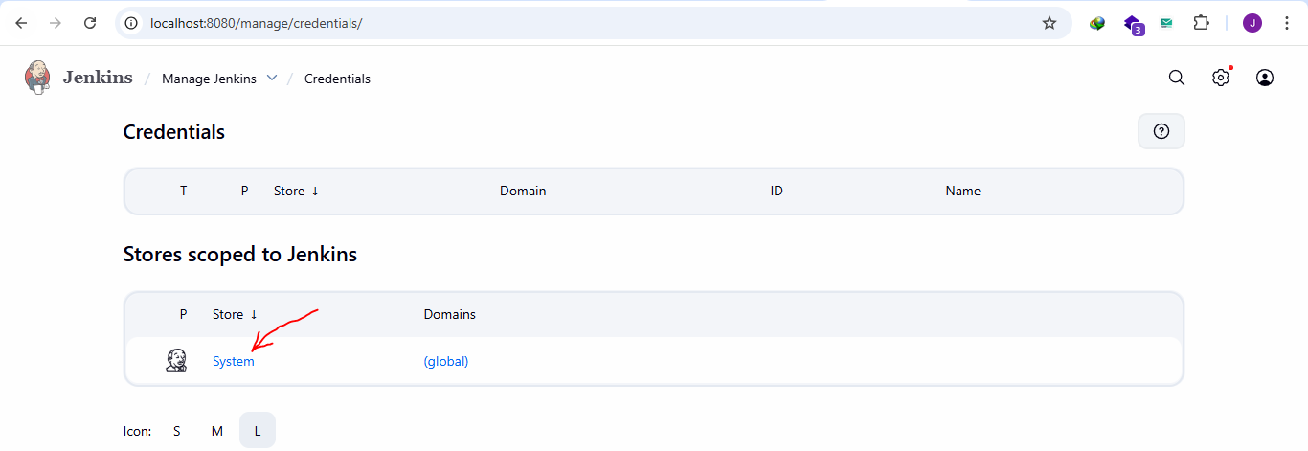
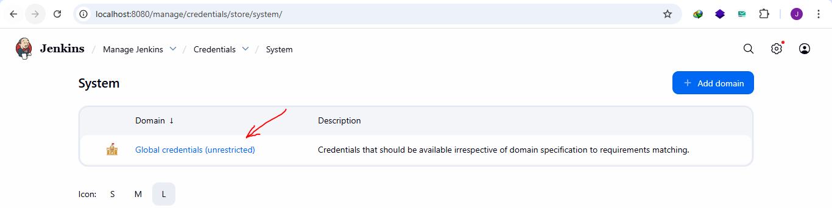
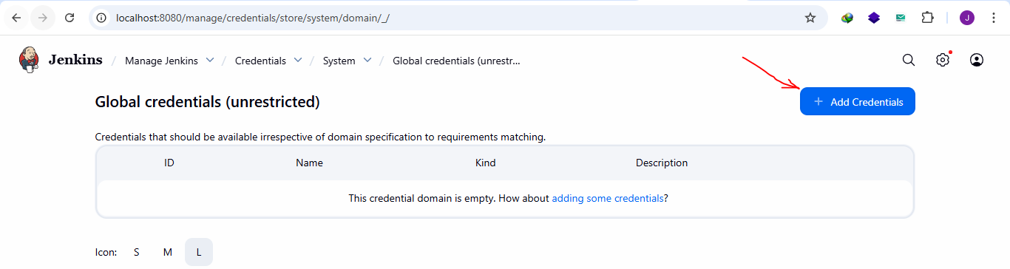
************************************************************
The system will not be available for pipelines
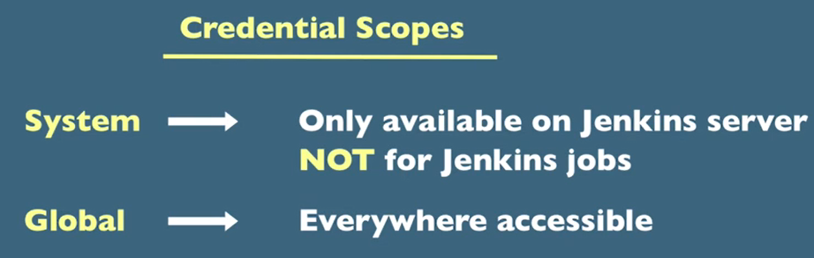
************************************************************
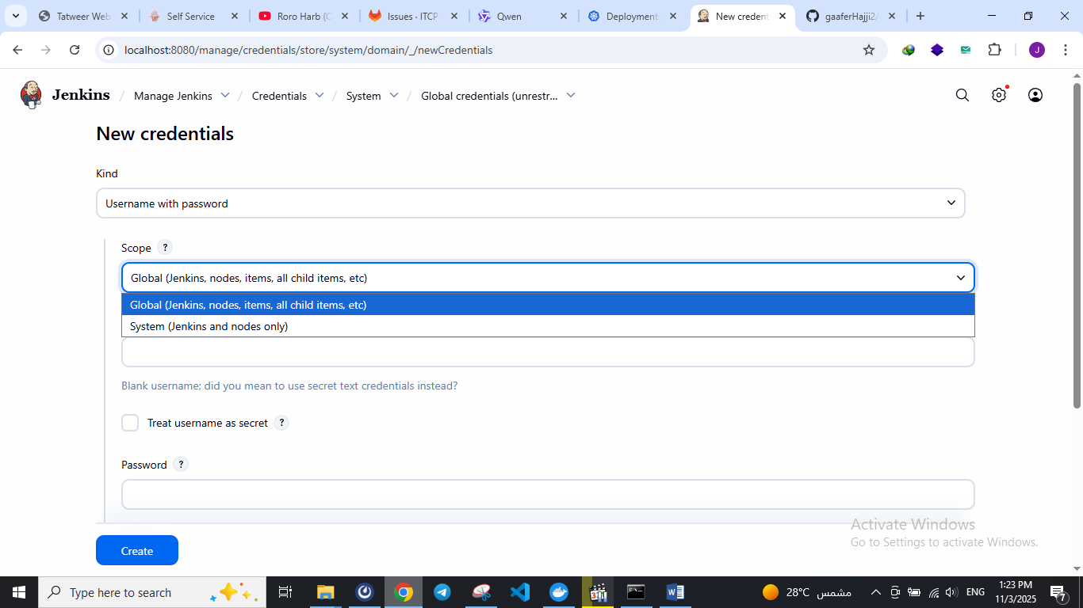
************************************************************

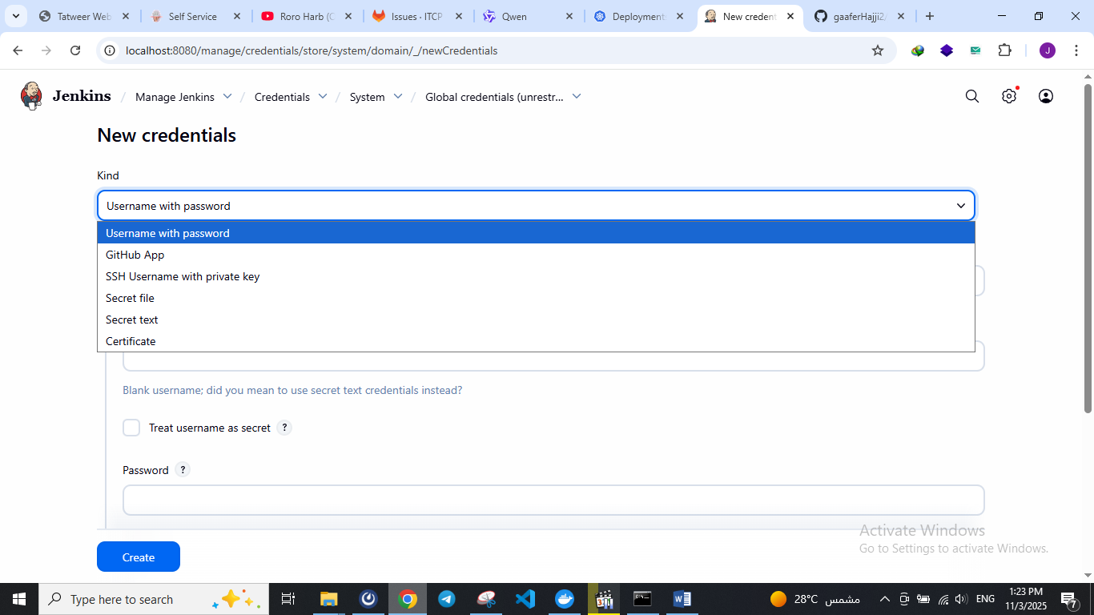
************************************************************

************************************************************

************************************************************
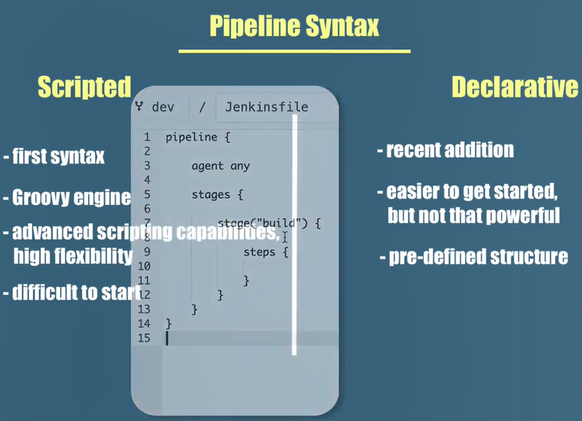
************************************************************
Note: pipeline and agent in declarative way are the similar to node {} in groovy script
************************************************************
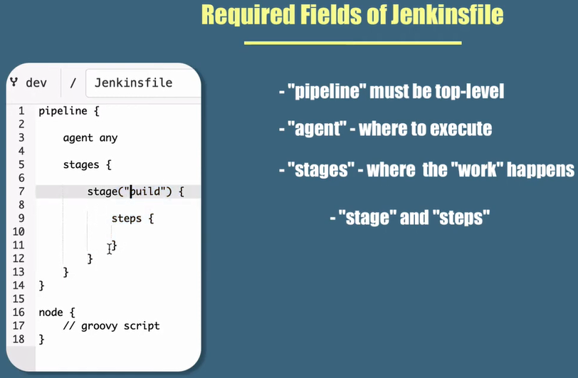
************************************************************

Example about basic Jenkinsfile:
pipeline {
agent any
stages {
stage("build") {
steps {
echo 'building the application...'
}
}
stage("test") {
steps {
echo 'testing the application...'
}
}
stage("deploy") {
steps {
echo 'deploying the application...'
}
}
}
}
************************************************************

