After we re-run the pipeline of Jenkins:
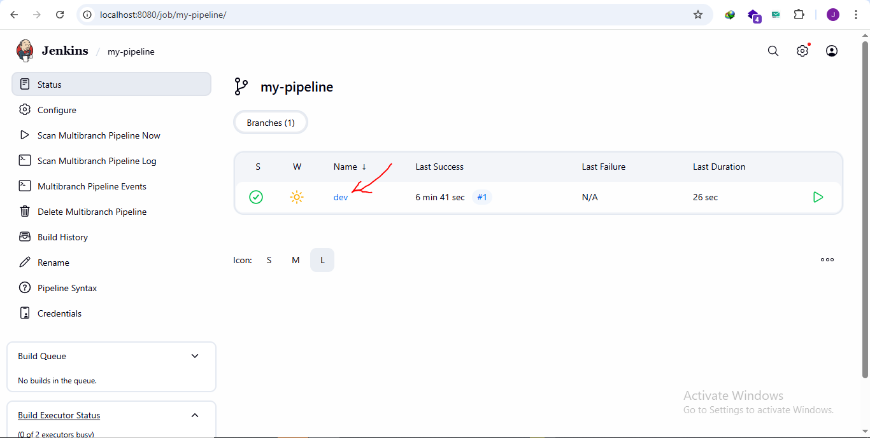
**********************************************************
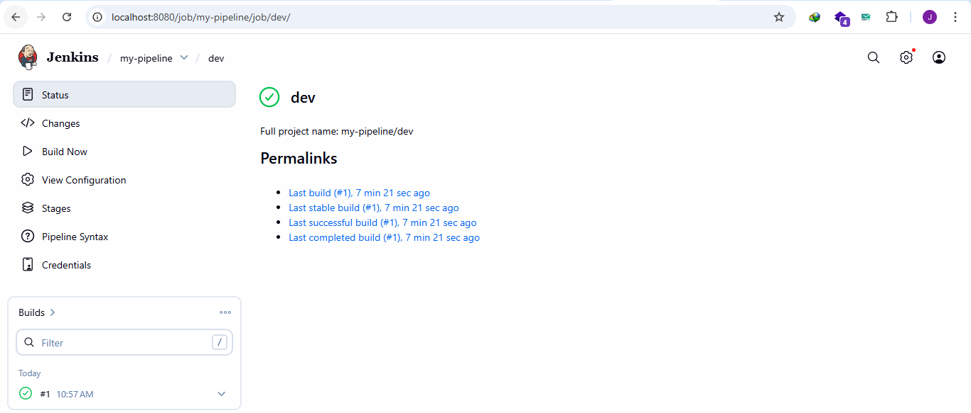
**********************************************************
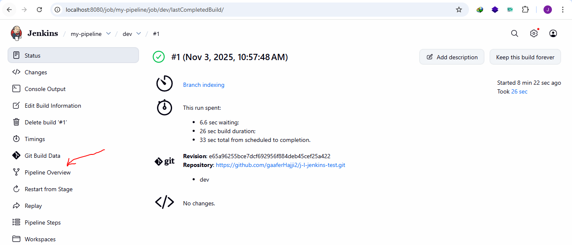
**********************************************************
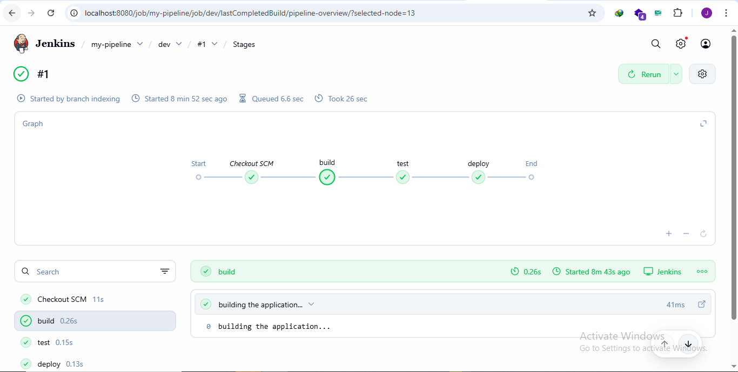
**********************************************************

To test changes in Jenkinsfile from Jenkins machine, we use Replay from pipeline:
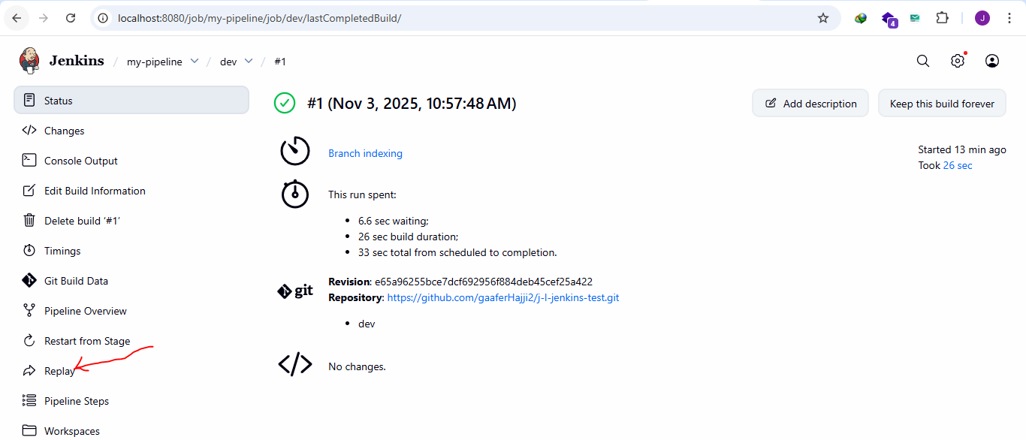
**********************************************************
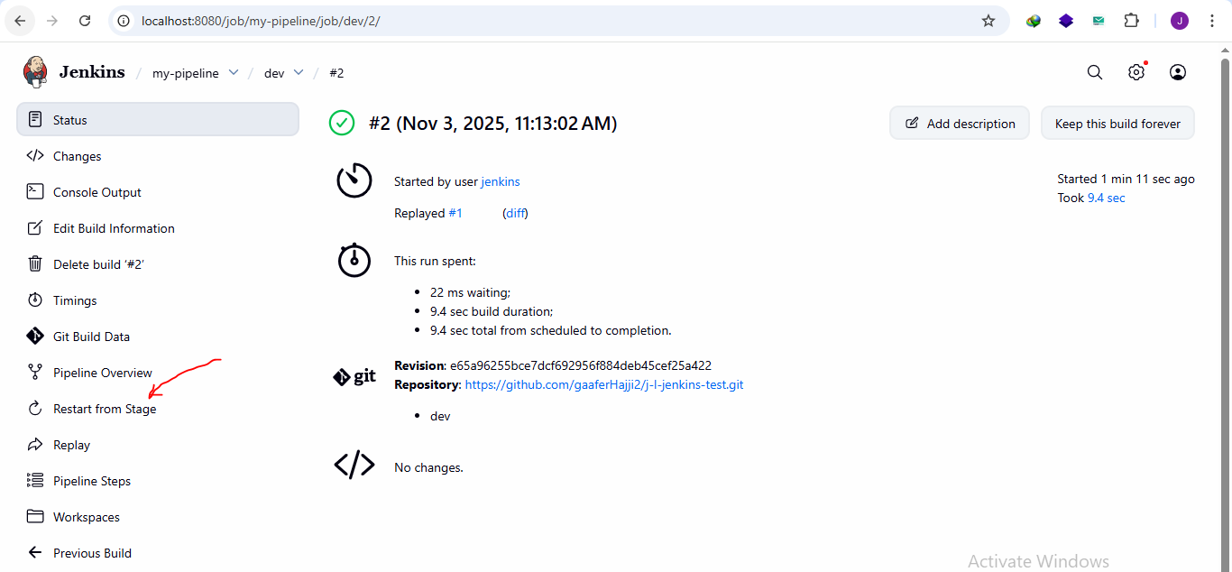
**********************************************************
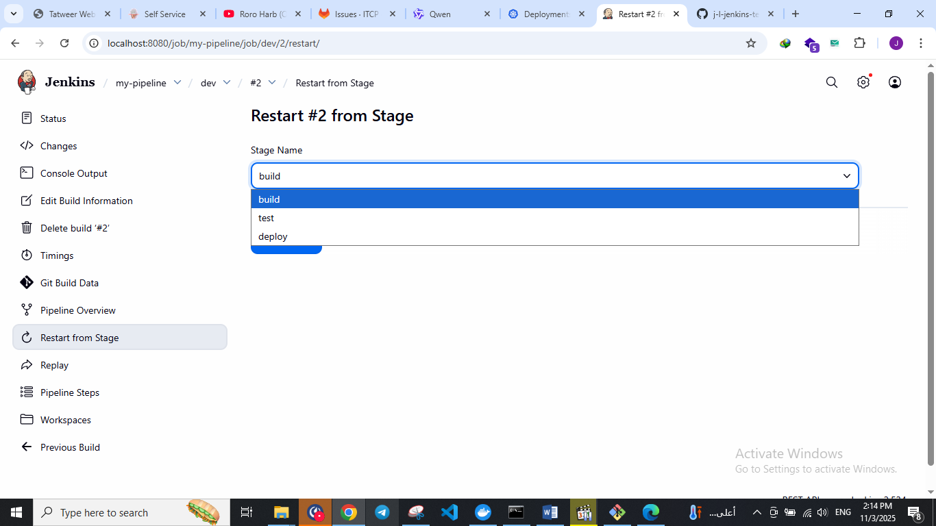
**********************************************************

pipeline {
agent any
stages {
stage("build") {
steps {
echo 'building the application...'
script {
def test = 2 + 2 > 3 ? 'cool' : 'not cool'
echo test
}
}
}

stage("test") {
steps {
echo 'testing the application...'
}
}

stage("deploy") {
steps {
echo 'deploying the application...'
}
}
}
}
**********************************************************
To poll the changes from Jenkins to github:
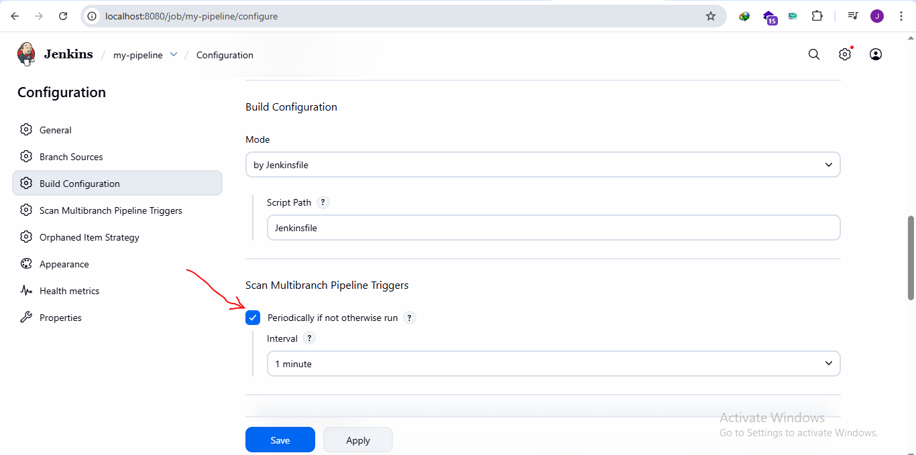
**********************************************************
The other way to check the changes in github by using push notification, but it is not always works, especially if the Jenkins server stops
**********************************************************
The perfect way is to use both ways (poll and push notifications)
**********************************************************

To configure any tool in Jenkins, from manage Jenkins configure tools:
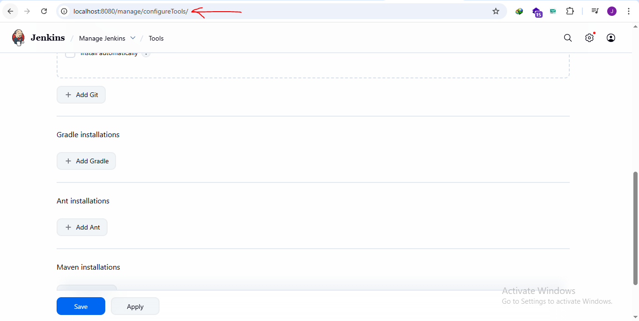
**********************************************************
If we have btn with: Add … that means we must configure it first
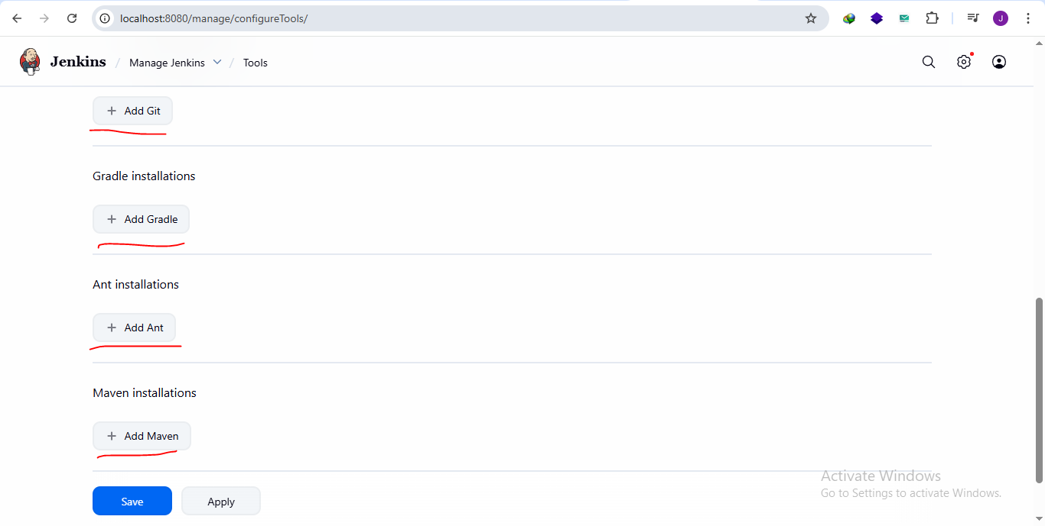
**********************************************************

For Gradle we only need to set the name and installation version:
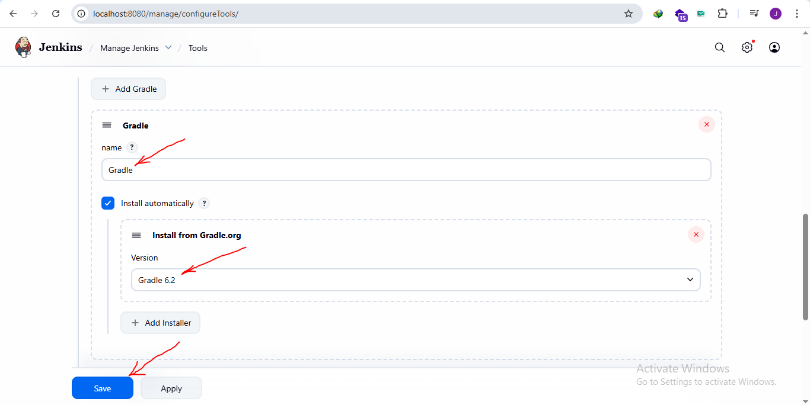
**********************************************************
After installing node.js from plugin manager, we go to configuration to config it:
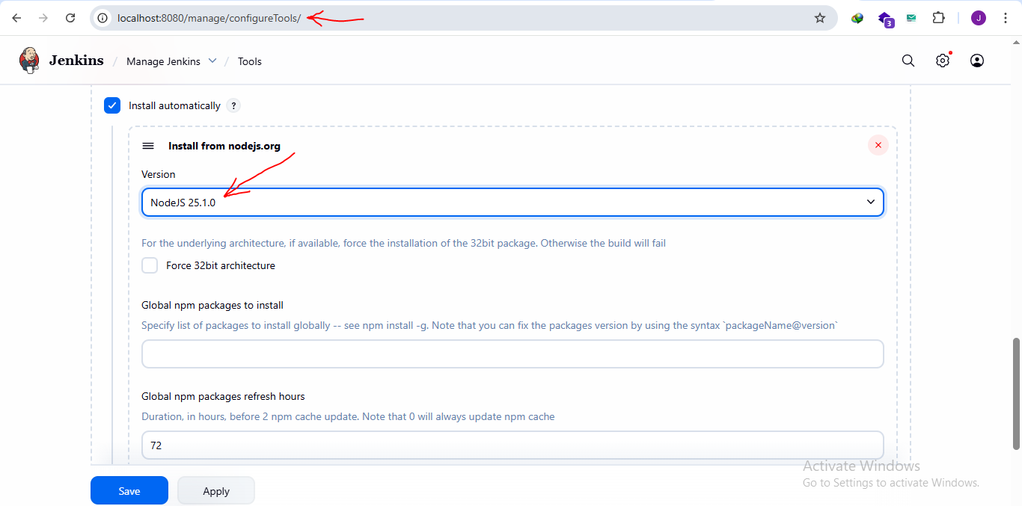
**********************************************************

For 1 && 2 They are called wrappers.
For node.js build tools that we install it from plugins; it’s called: nodejs
For gradle build tools that we install it from plugins; it’s called: withGradle
For 3 it is the name of installation from the configuration:
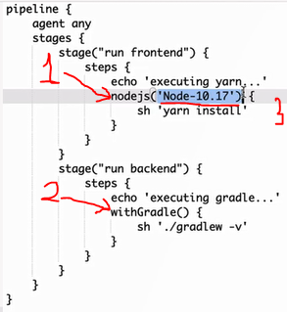
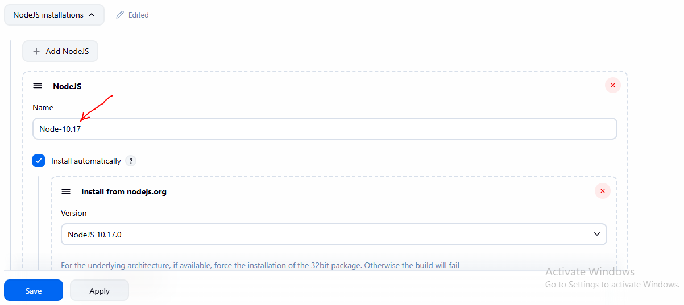
**********************************************************

To build without wrappers, we use tools:



