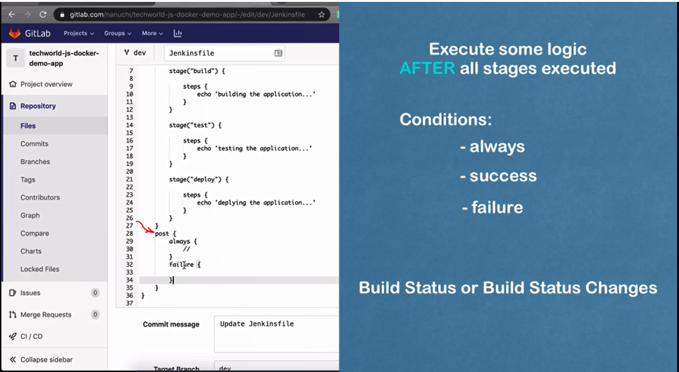
***********************************************************
To define condition for stage, we can use when:
stage("test") {
when {
expression {
BRANCH_NAME == 'dev'
}
}
steps {
echo 'testing the application...'
}
}
***********************************************************
http://localhost:8080/env-vars.html/
***********************************************************
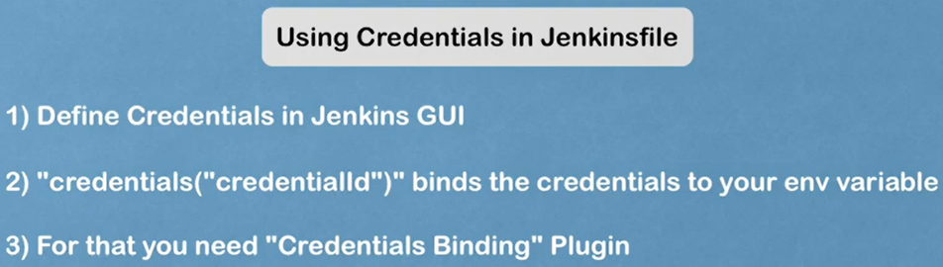
***********************************************************
environment {
NEW_VERSION = '1.3.0'
SERVER_CREDENTIALS = credentials('global')
}
***********************************************************

To use with Credentials-Wrapper:
stage("deploy") {
steps {
echo 'deploying the application...'
withCredentials([usernamePassword(credentialsId: 'JLoka', usernameVariable: 'MY_USERNAME', passwordVariable: 'MY_PASSWORD')]) {
sh 'echo "Username: $MY_USERNAME"'
sh 'echo "Password: $MY_PASSWORD"'
}
}
}
***********************************************************
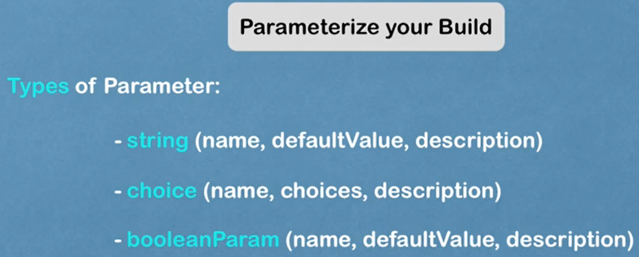
***********************************************************

parameters {
string(name: 'jloka_01', defaultValue: '', description: 'simple parameter-01')
choice(name: 'jloka_02', choices: ['1.1.0', '1.2.0', '1.3.0'], description: 'simple parameter-02')
booleanParam(name: 'jloka_03', defaultValue: true, description: 'simple parameter-03')
}
***********************************************************
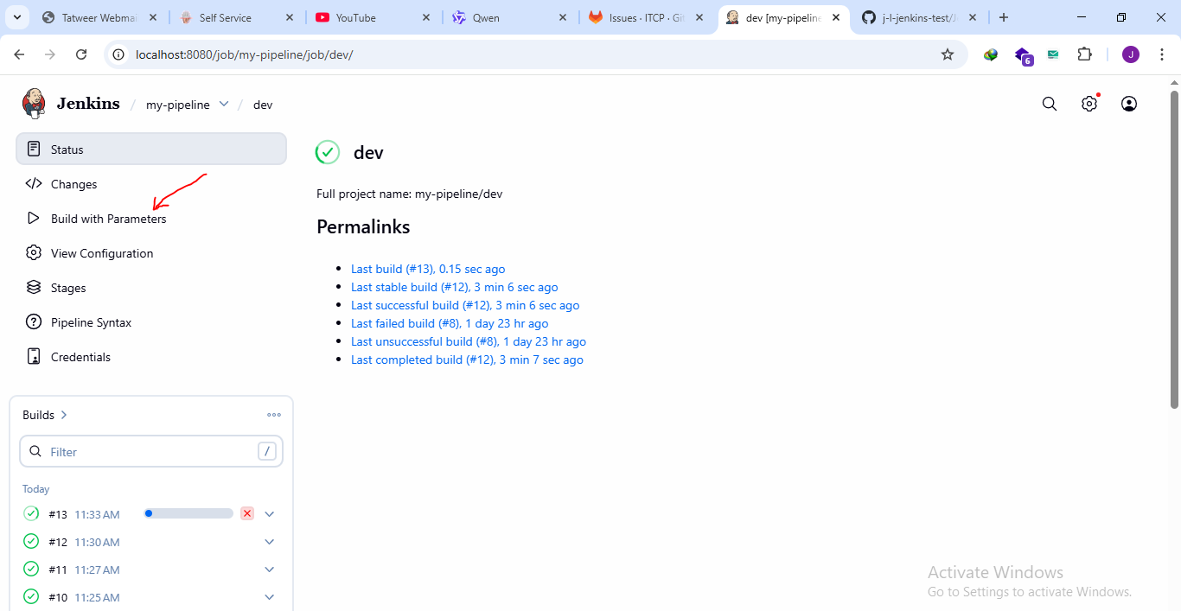
***********************************************************

The complete Jenkins file:
pipeline {
agent any

environment {
NEW_VERSION = '1.3.0'
}

parameters {
string(name: 'jloka01', defaultValue: 'JLoka-01', description: 'simple parameter-01')
choice(name: 'jloka02', choices: ['1.1.0', '1.2.0', '1.3.0'], description: 'simple parameter-02')
booleanParam(name: 'jloka03', defaultValue: true, description: 'simple parameter-03')
}

stages {
stage("build") {
steps {
echo 'building the application...'
echo "building version ${NEW_VERSION}"
echo "The jloka_01 is: ${params.jloka01}"
echo "The jloka_02 is: ${params.jloka02}"
echo "The jloka_03 is: ${params.jloka03}"
}
}

stage("test") {
when {
expression {
BRANCH_NAME == 'dev' || BRANCH_NAME == 'master'
}
}
steps {
echo 'testing the application...'
}
}

stage("deploy") {
steps {
echo 'deploying the application...'
// withCredentials([usernamePassword(credentialsId: 'JLoka', usernameVariable: 'MY_USERNAME', passwordVariable: 'MY_PASSWORD')]) {
// sh 'echo "Username: $MY_USERNAME"'
// sh 'echo "Password: $MY_PASSWORD"'
// }
}
}
}
}
***********************************************************

