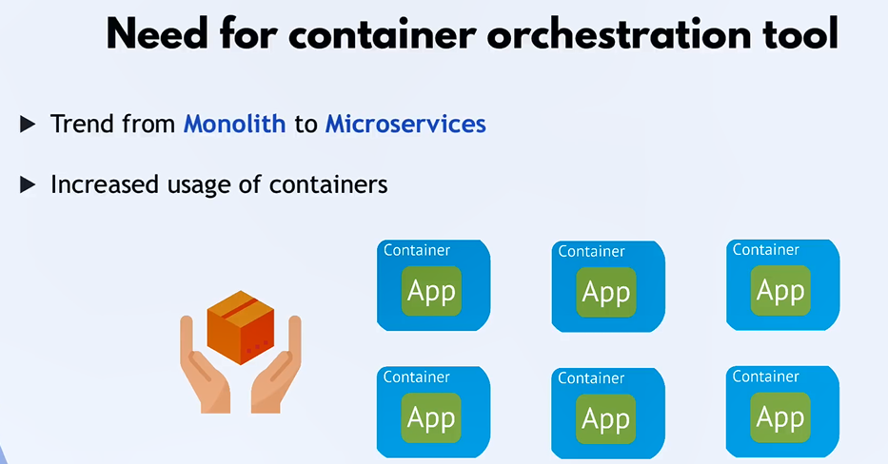
*******************************************************
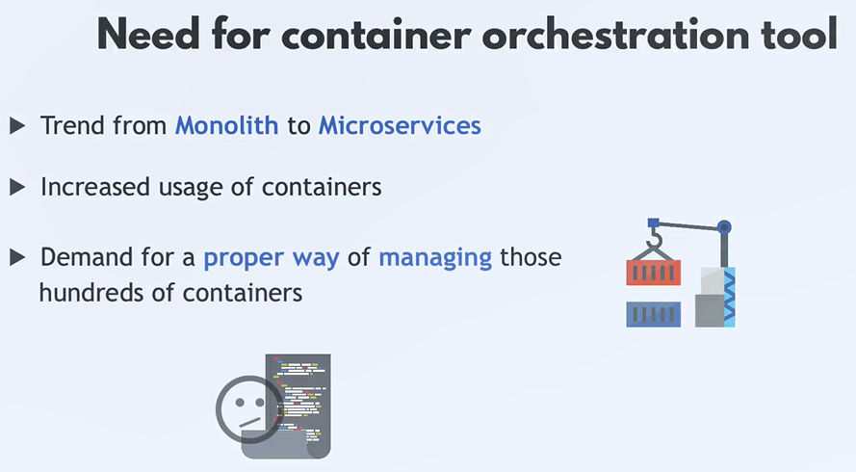
*******************************************************
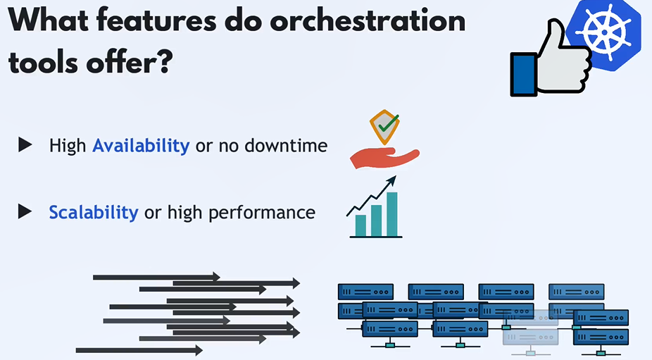
*******************************************************

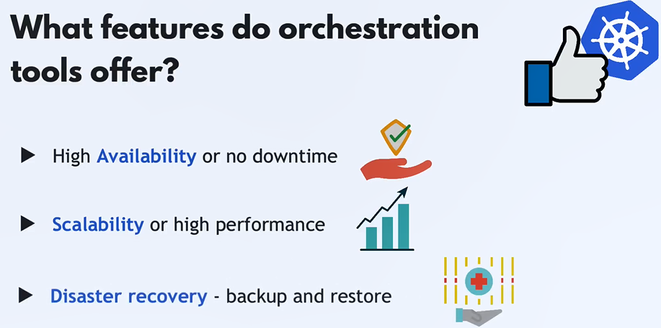
*******************************************************
Kubernetes contains one master node, and other nodes (workers) that can connect to master
*******************************************************
Note: Kubelet is program that make the nodes in the cluster reach to each other, and it’s responsible of running the applications inside the nodes (from me: we can imagine it as replica of app with API Gateway)
*******************************************************
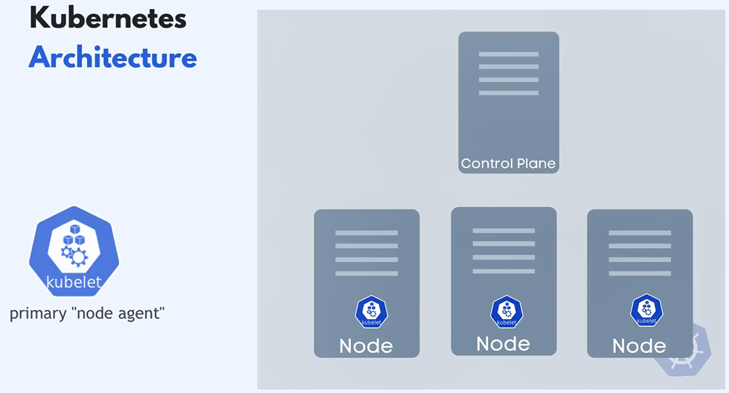
*******************************************************
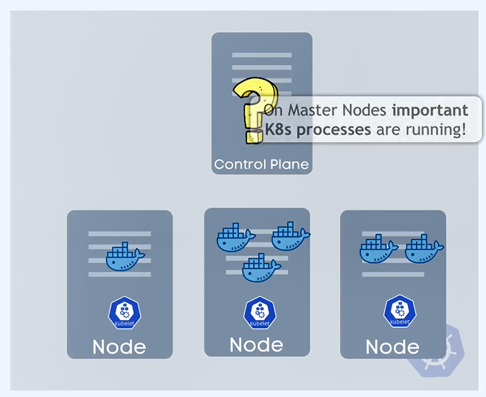
*******************************************************
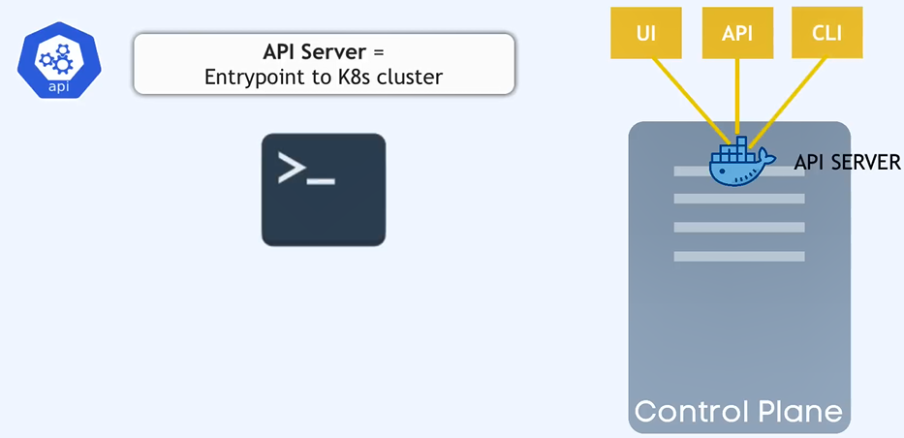
*******************************************************
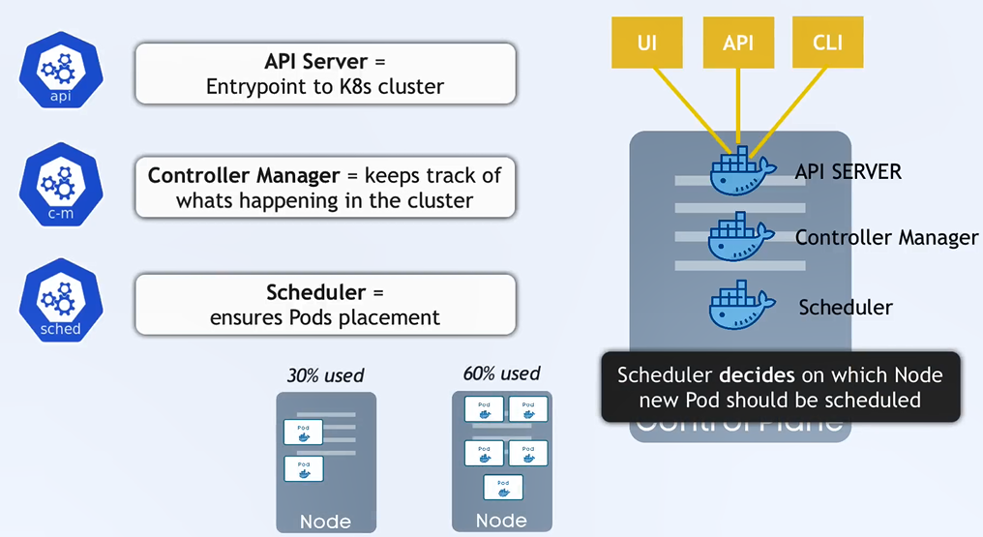
*******************************************************
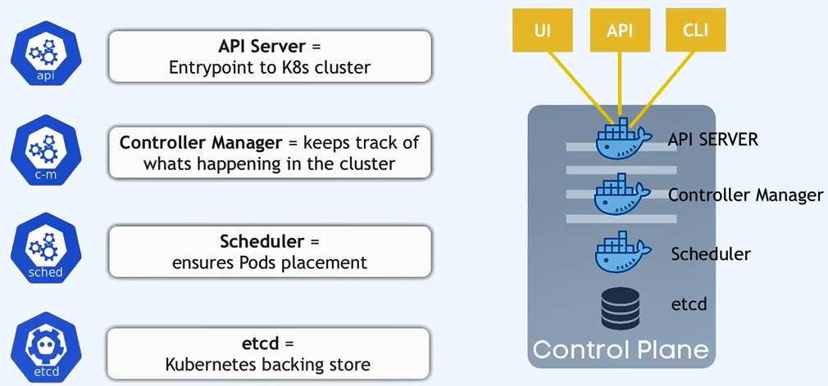
*******************************************************
Virtual Network: allow nodes to talk to each other
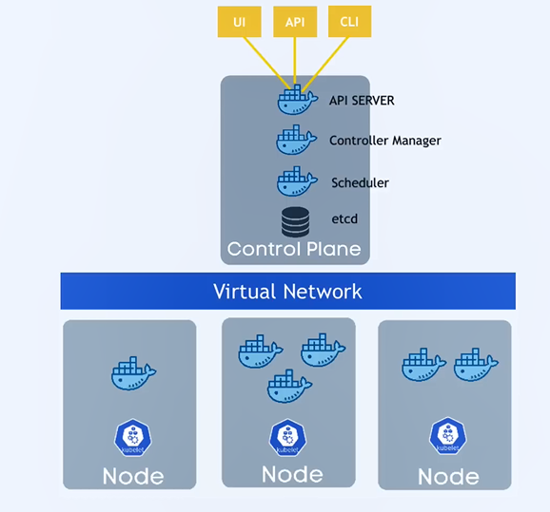
*******************************************************
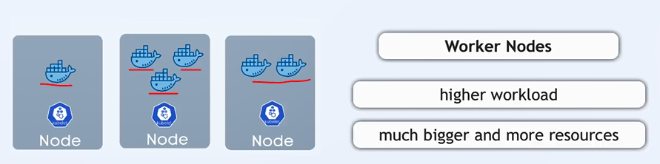
*******************************************************
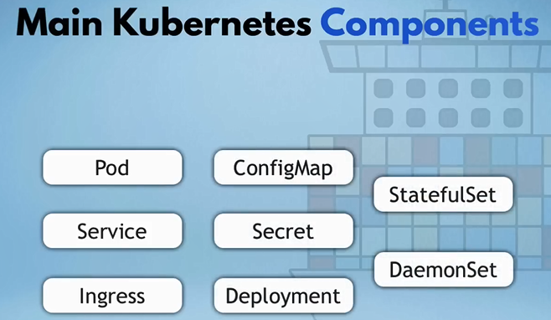
*******************************************************
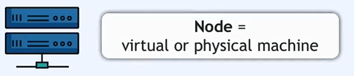
*******************************************************
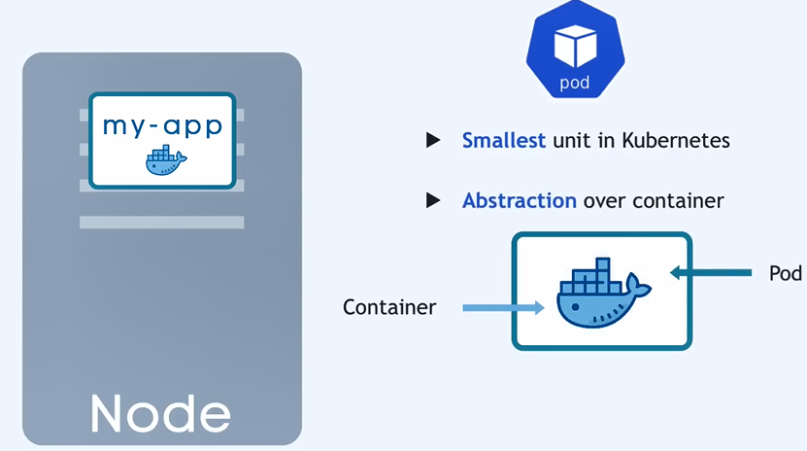
*******************************************************
Not the container, the pod get its own ip-addr:
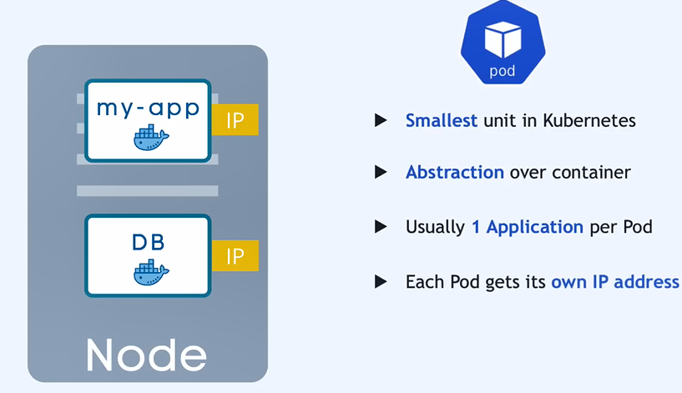
*******************************************************

If any pod is dying for any reason then new ip-addr will assigned:
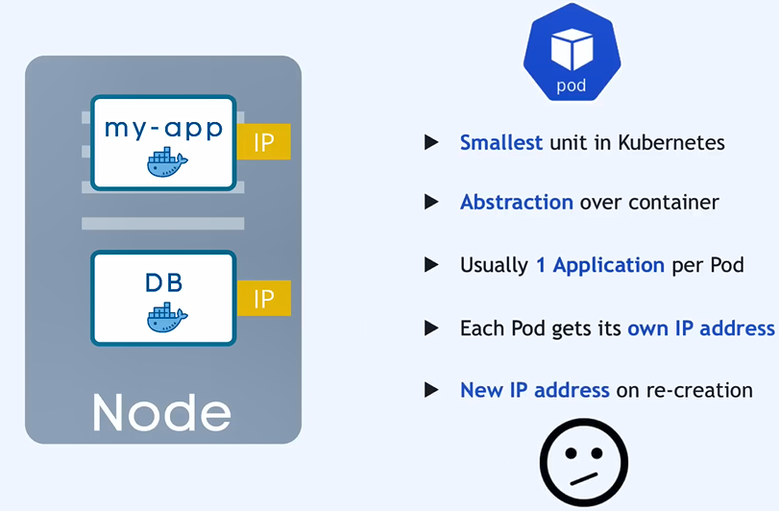
*******************************************************
To solve the previous problem we use services (even if the pod die the service will still have the same ip-addr):
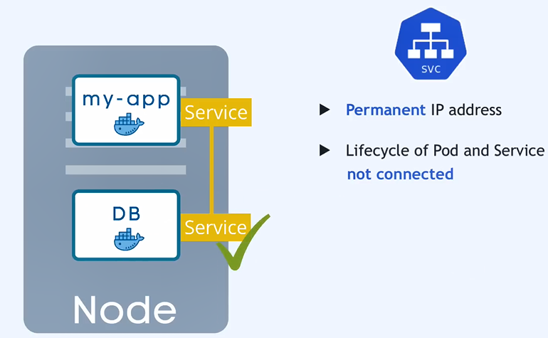
*******************************************************
External service: the service that open the communication with external resources (ex: from node/cluster to our browser)
*******************************************************
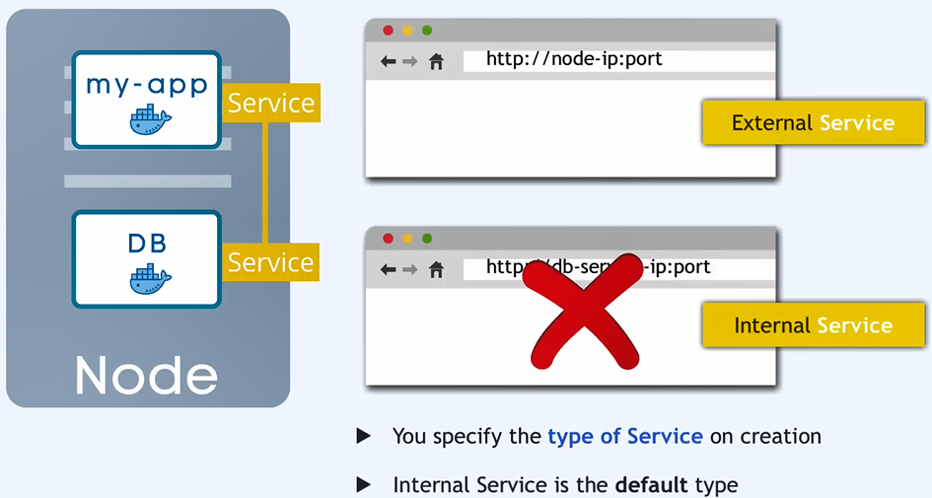
*******************************************************
Ingress: like service but it routes the request then call the right service
*******************************************************
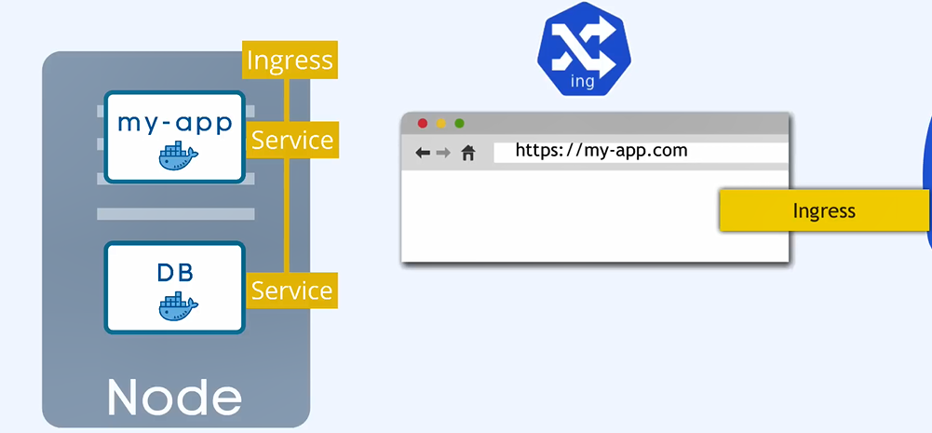
*******************************************************
The main advantages of services is to make the pods communicate with each other
*******************************************************
The advantages of ConfigMap in kubernetes is when we change the configurations of our app, we don’t need to rebuild our image from start
*******************************************************
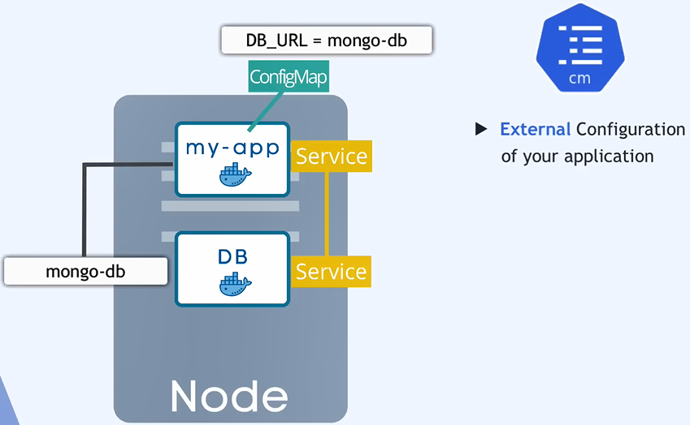
*******************************************************
To store secret data we can use Secret, but it store them as base64, not in encrypted way, we must enable the encryption, and we must enable RBAC
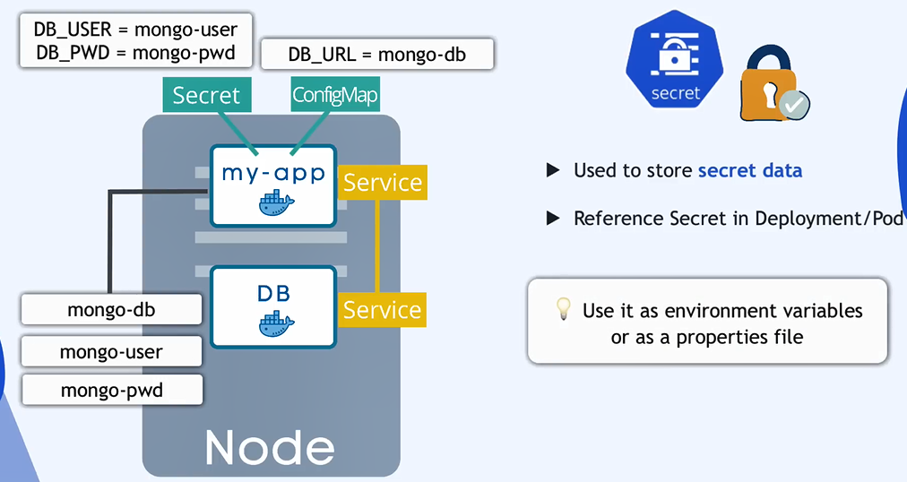
*******************************************************
The another problem of pod is, when the pod restart it will loss the data
*******************************************************



