The advantage of using distributed systems or microservices with containers is that we have many replicas of our app, so if one of them is crashed or down, the others will still handle the requests of users
***************************************************************
The other advantage of service that it contains load balancer
***************************************************************
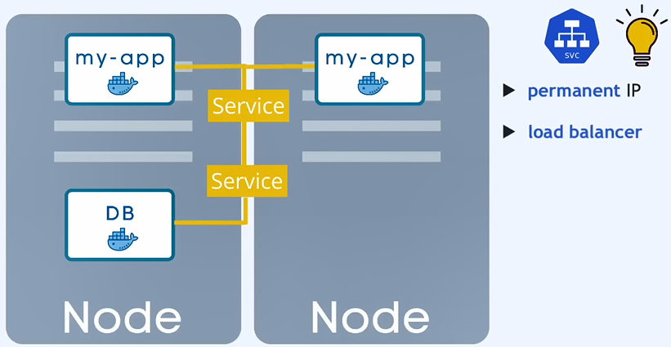
***************************************************************
This blueprint called deployment, they are abstractions of Pod
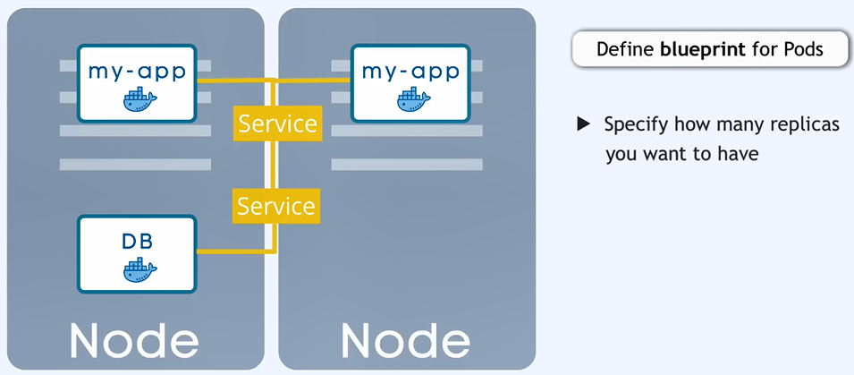
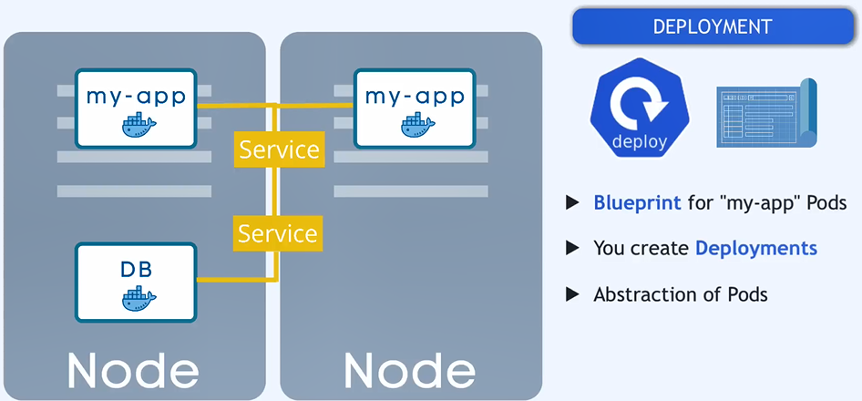
***************************************************************
We can’t replicate the DB using deployments, because it has its state (data with volume):

***************************************************************
The solution for previous is:
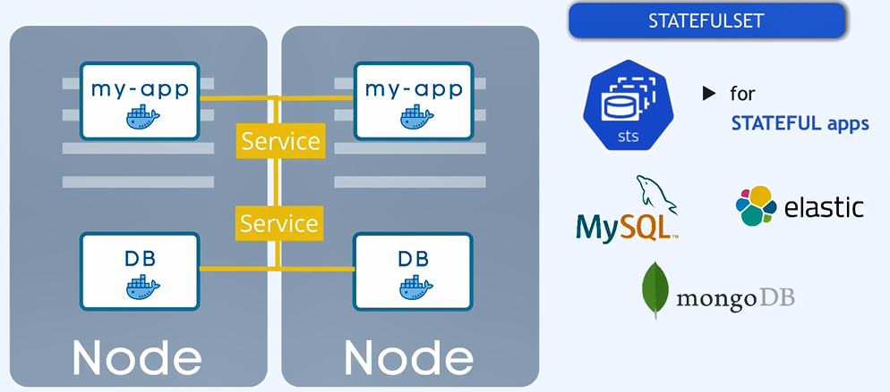
***************************************************************
But the deployment for DB in same cases may not be easy
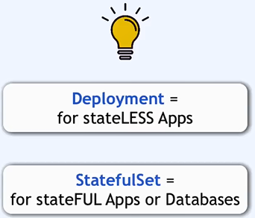
***************************************************************

If one of the replicas die, then:

***************************************************************
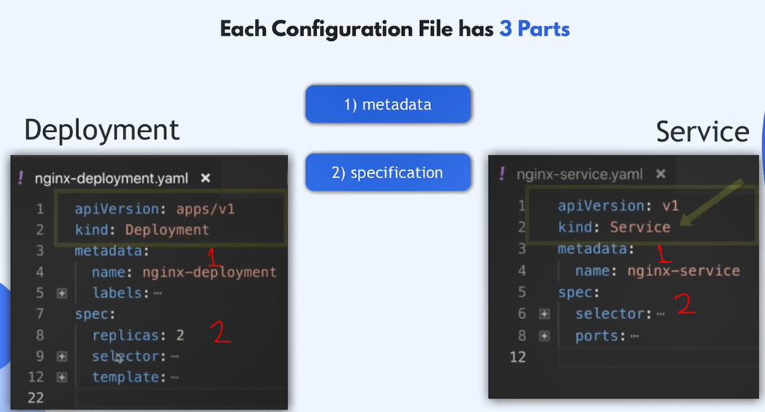
***************************************************************
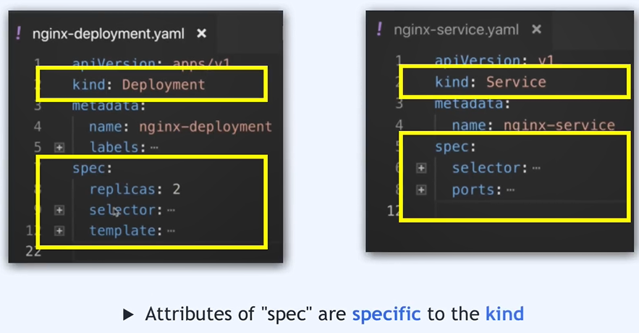
***************************************************************
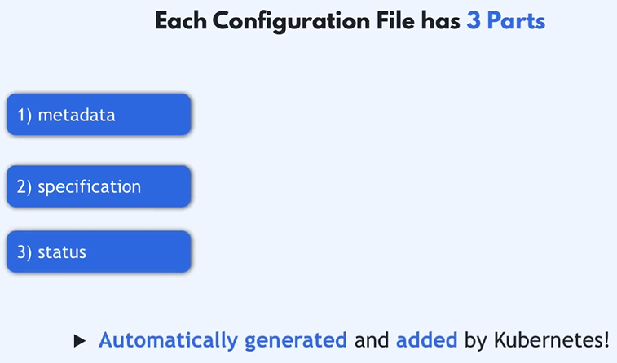
***************************************************************
For status, kubernetes will always check the desired && actual status:
- Then we have choice of the desired = actual then it will still works
- Else, kubernetes will try to solve the problem.
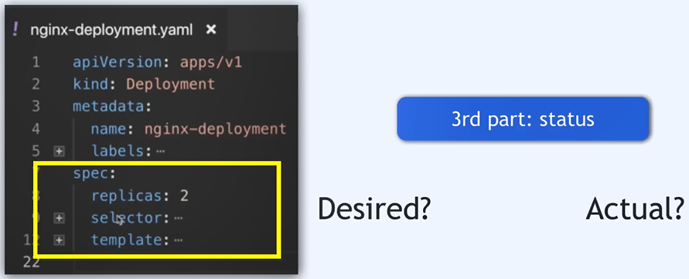
***************************************************************
Kubernetes save the important data (like status) in etcd (key/value store)
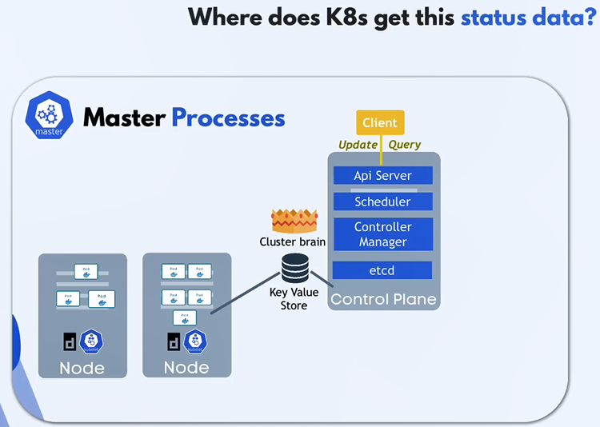
***************************************************************
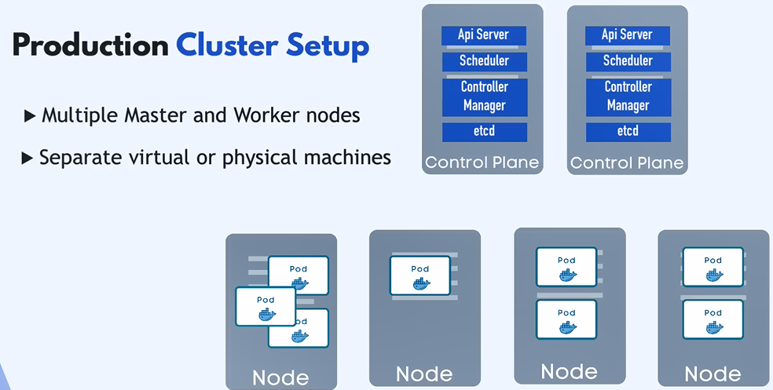
***************************************************************
In test environment the master && worker processes are running on the same node:
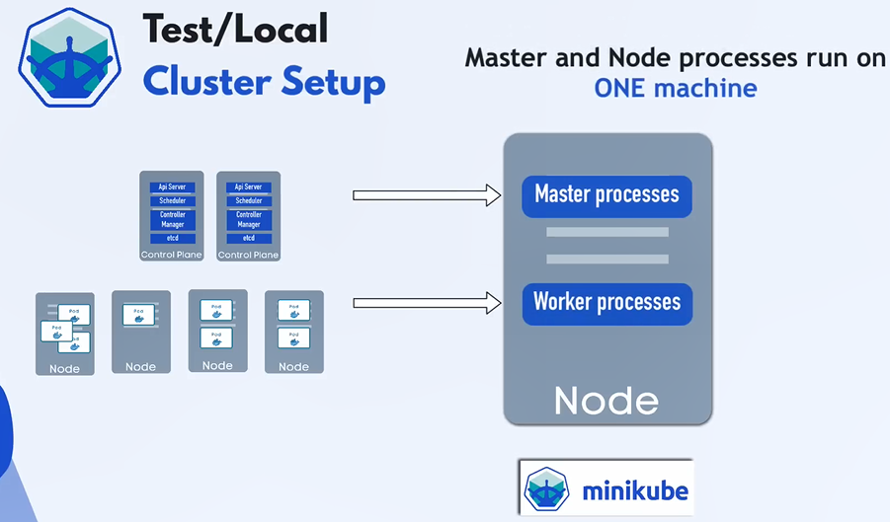
***************************************************************

The main entry for kubernetes cluster is Api Server:
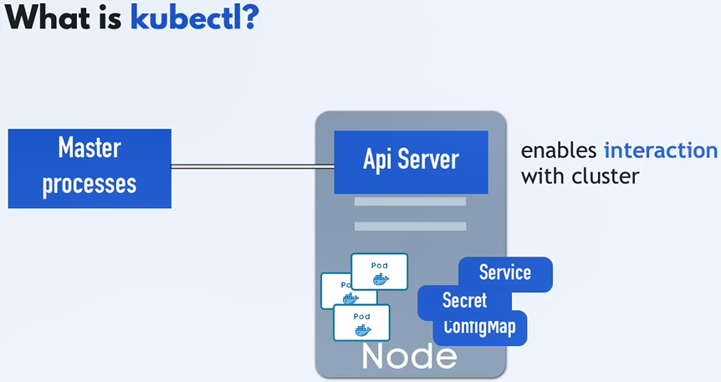
***************************************************************
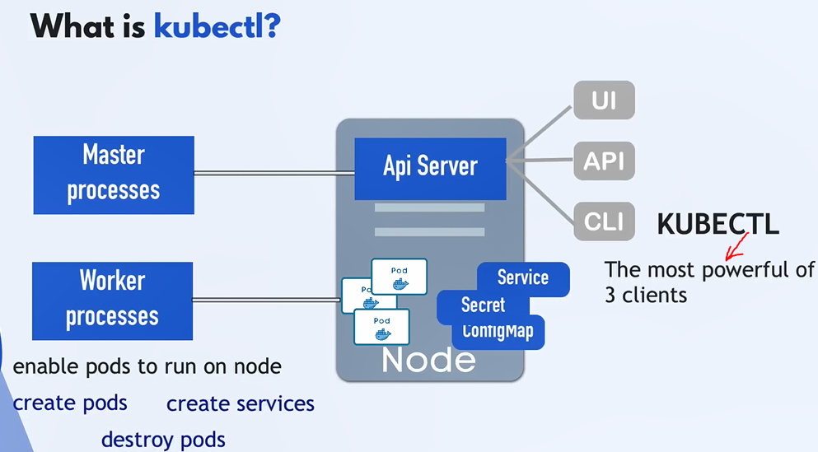
***************************************************************
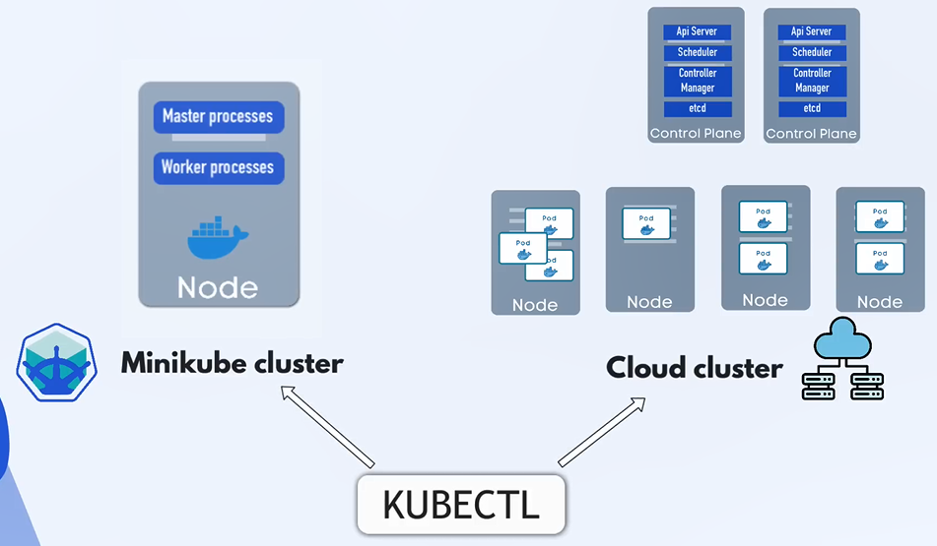
***************************************************************
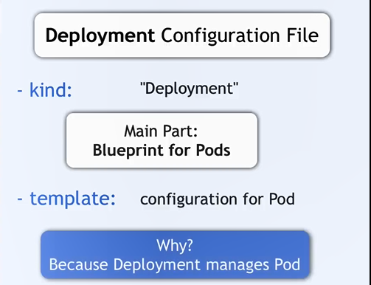
***************************************************************
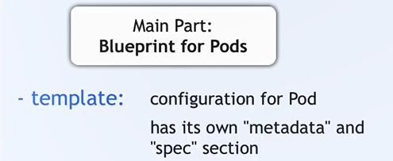
***************************************************************
For spec in template we may have multiple containers per pod, but we usually have one main app per pod:


