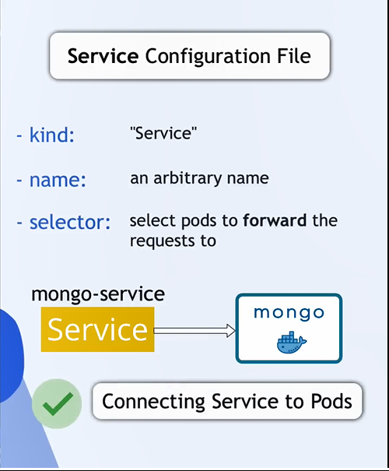
*******************************************************
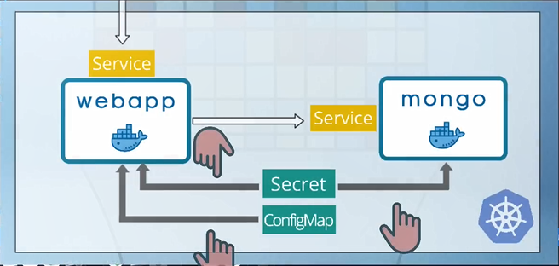
*******************************************************
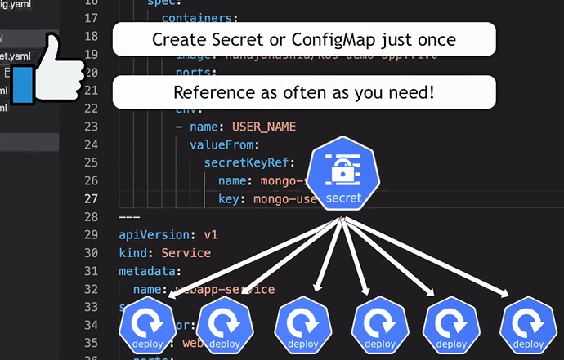
*******************************************************

To configure ConfigMap in kubernetes:
apiVersion: v1
kind: ConfigMap
metadata:
name: mongo-config
data:
mongo-url: mongo-service # where mongo-service is the name of service that will mongodb use it

-------------------------------------------------------------------------------
To configure Secret in Kubernetes:
apiVersion: v1
kind: Secret
metadata:
name: mongo-secret
data:
mongo-user: bW9uZ291c2Vy
mongo-password: bW9uZ29wYXNzd29yZA==
-------------------------------------------------------------------------------

To configure db deployment with service:
apiVersion: apps/v1
kind: Deployment
metadata:
name: mongo-deployment
# For deployment labels are optional
labels:
app: mongo
spec:
replicas: 1
selector:
# All pods that have the same label are belong to this deployment
matchLabels:
app: mongo
# this is pod template the has label: mongo
template:
metadata:
# for pod the labels are required
labels:
app: mongo
spec:
containers:
# this will create pods with mongo:latest image
- name: mongo
image: mongo:latest
ports:
- containerPort: 27017
resources: # this from qwen.ai
requests:
memory: "256Mi"
cpu: "100m"
limits:
memory: "512Mi"
cpu: "500m"
env:
- name: MONGO_INITDB_ROOT_USERNAME
valueFrom:
secretKeyRef:
name: mongo-secret
key: mongo-user
- name: MONGO_INITDB_ROOT_PASSWORD
valueFrom:
secretKeyRef:
name: mongo-secret
key: mongo-password
volumeMounts: # this from qwen.ai
- name: mongo-storage
mountPath: /data/db
volumes: # this from qwen.ai
- name: mongo-storage
emptyDir: {}

---
apiVersion: v1
kind: Service
metadata:
# To remember only: this is the name of service that match the mongo-config
name: mongo-service
spec:
selector:
app: mongo
ports:
- protocol: TCP
port: 27017
targetPort: 27017

-------------------------------------------------------------------------------
To configure web app deployment and service:
apiVersion: apps/v1
kind: Deployment
metadata:
name: webapp-deployment
# For deployment labels are optional
labels:
app: webapp
spec:
replicas: 1
selector:
# All pods that have the same label are belong to this deployment
matchLabels:
app: webapp
# this is pod template the has label: webapp
template:
metadata:
# for pod the labels are required
labels:
app: webapp
spec:
containers:
- name: webapp
image: nanajanashia/k8s-demo-app:v1.0
ports:
- containerPort: 3000
resources: # this is from qwen.ai
requests:
memory: "256Mi"
cpu: "100m"
limits:
memory: "512Mi"
cpu: "500m"
env:
- name: USERNAME
valueFrom:
# In this way we ref from secret
secretKeyRef:
name: mongo-secret
key: mongo-user
- name: USER_PWD
valueFrom:
secretKeyRef:
name: mongo-secret
key: mongo-password
- name: DB_URL
valueFrom:
# In this way we ref from map
configMapKeyRef:
name: mongo-config
key: mongo-url
---
apiVersion: v1
kind: Service
metadata:
name: webapp-service
spec:
type: NodePort # in this way we make this service external service,
# so we can reach to it from external host
selector:
app: webapp
ports:
- protocol: TCP
port: 3000
targetPort: 3000
nodePort: 30100
-------------------------------------------------------------------------------
NodePort: Must be between 30000 && 32767



