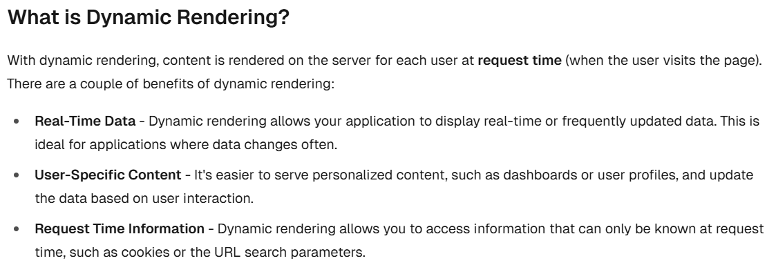
==================================================
With dynamic rendering, your application is only as fast as your slowest data fetch.
==================================================
Streaming is a data transfer technique that allows you to break down a route into smaller "chunks" and progressively stream them from the server to the client as they become ready.
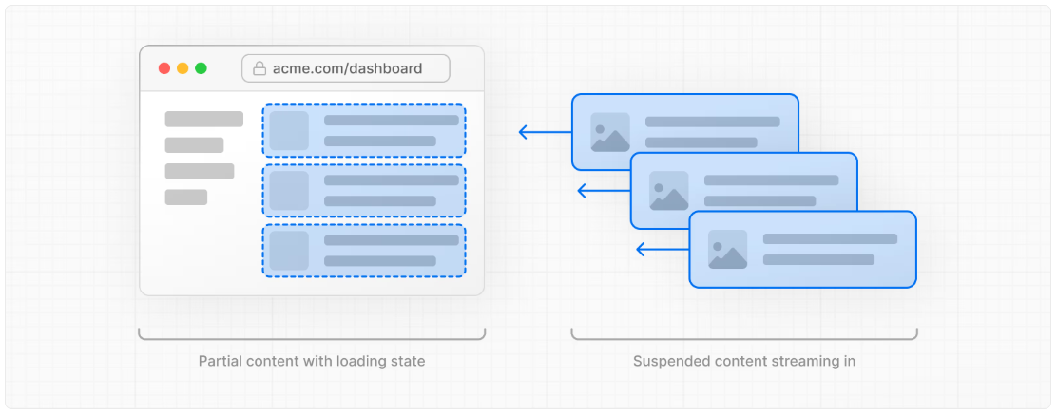
==================================================
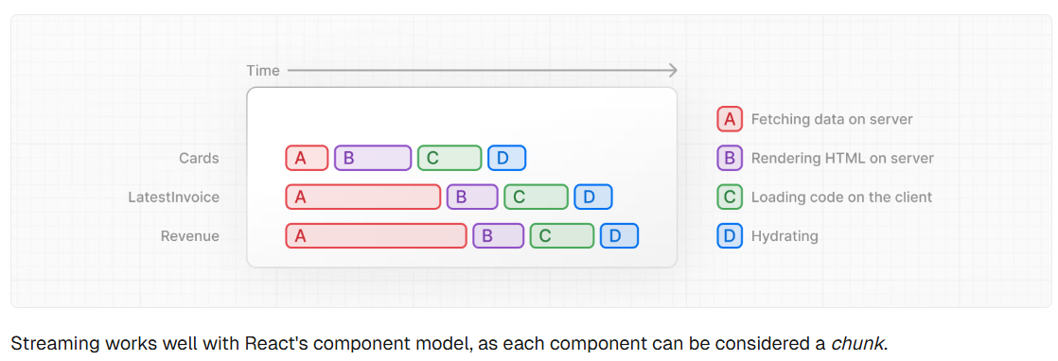
==================================================
There are two ways you implement streaming in Next.js:
- At the page level, with the loading.tsx file (which creates <Suspense> for you).
- At the component level, with <Suspense> for more granular control.
==================================================
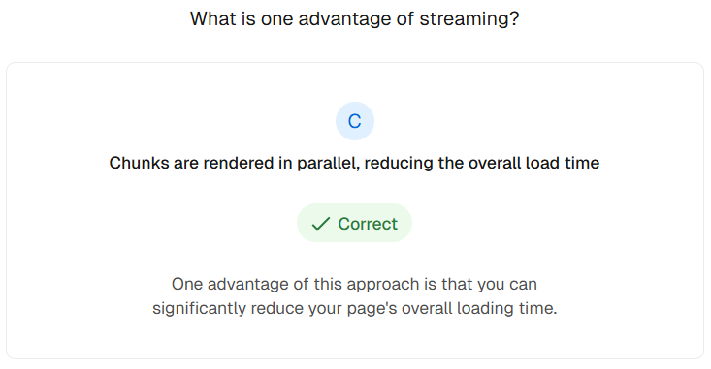
==================================================
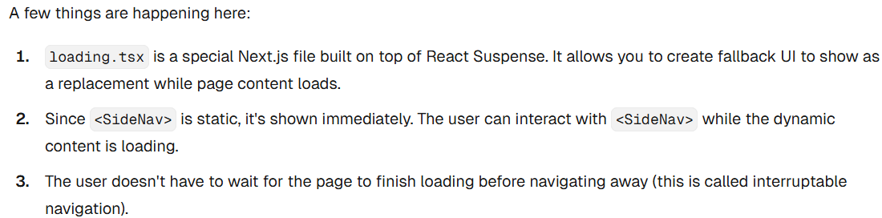
------------------------------------------------------------------------------------
export default function Loading() {
return <div>Loading...</div>;
}
==================================================
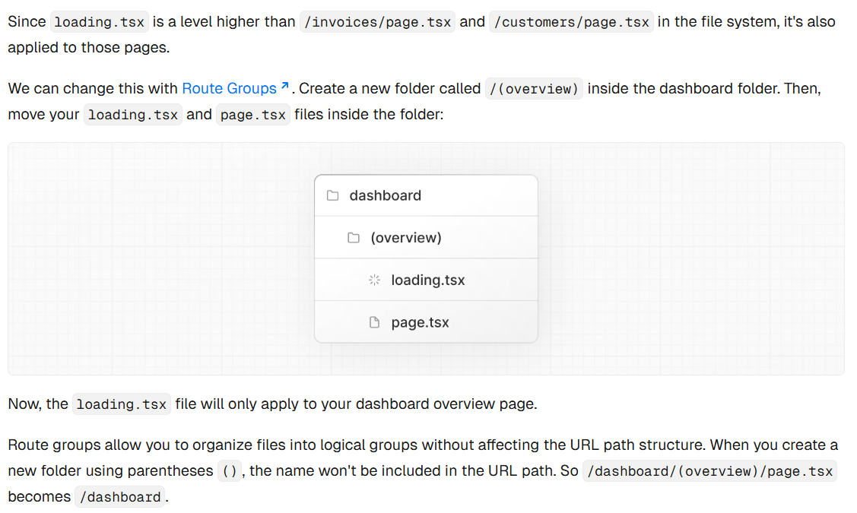
==================================================

Here, you're using a route group to ensure loading.tsx only applies to your dashboard overview page. However, you can also use route groups to separate your application into sections (e.g. (marketing) routes and (shop) routes) or by teams for larger applications.
==================================================
Suspense allows you to defer rendering parts of your application until some condition is met (e.g. data is loaded). You can wrap your dynamic components in Suspense. Then, pass it a fallback component to show while the dynamic component loads.
==================================================

