After adding the test project to solution:
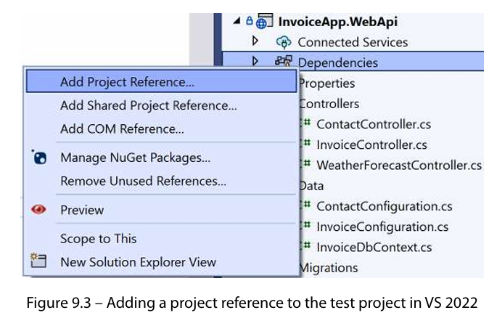
******************************************************************
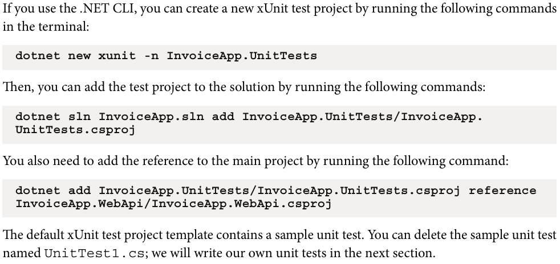
******************************************************************
******************************************************************
The test class is any class that has [Fact]-Annotation:
using InvoiceApp.WebApi;
using InvoiceApp.WebApi.Models;
using InvoiceApp.WebApi.Services;

namespace JLoka.InvoiceApp.UnitTests
{
public class EmailServiceTests
{
[Fact]
public void TestGenerateEmail_Should_Return()
{
var invoiceDate = DateTimeOffset.Now;
var dueDate = invoiceDate.AddDays(30);
var invoice = new Invoice
{
Id = Guid.NewGuid(),
InvoiceNumber = "INV-001",
Amount = 500,
DueDate = dueDate,
Contact = new Contact
{
Id = Guid.NewGuid(),
FirstName = "John",
LastName = "Doe",
Email = "john.doe@example.com"
},
Status = InvoiceStatus.Draft,
InvoiceDate = invoiceDate,
InvoiceItems = new List<InvoiceItem>
{
new()
{
Id = Guid.NewGuid(),
Description = "Item 1",
Quantity = 1,
UnitPrice = 100,
Amount = 100
},
new()
{
Id = Guid.NewGuid(),
Description = "Item 2",
Quantity = 2,
UnitPrice = 200,
Amount = 400
}
}
};

var (to, subject, body) = new EmailService().GenerateInvoiceEmail(invoice);
Assert.Equal(invoice.Contact.Email, to);
Assert.Equal($"Invoice INV-001 for John Doe", subject);
Assert.Equal($"""
Dear John Doe,

Thank you for your business. Here are your invoice details:
Invoice Number: INV-001
Invoice Date: {invoiceDate.LocalDateTime.ToShortDateString()}
Invoice Amount: {invoice.Amount.ToString("C")}
Invoice Items:
Item 1 - 1 x $100.00
Item 2 - 2 x $200.00

Please pay by {invoice.DueDate.LocalDateTime.ToShortDateString()}. Thank you!

Regards,
InvoiceApp
""", body);
}
}
}
******************************************************************



