By selecting the cell and pressing the small button, and dragging to the desired cells, the target cells will be filled automatically with values.
In this way, we can fill the cells automatically with numbers, days, dates, etc.
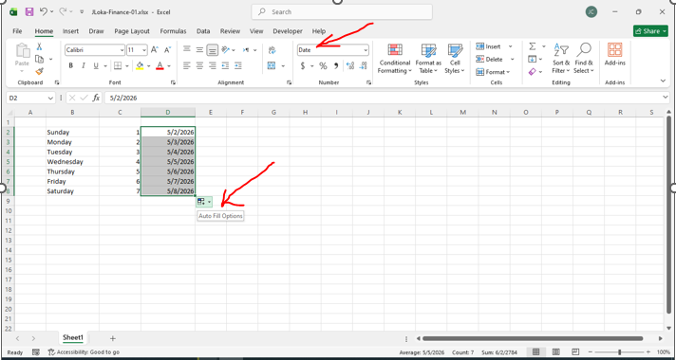
================================================
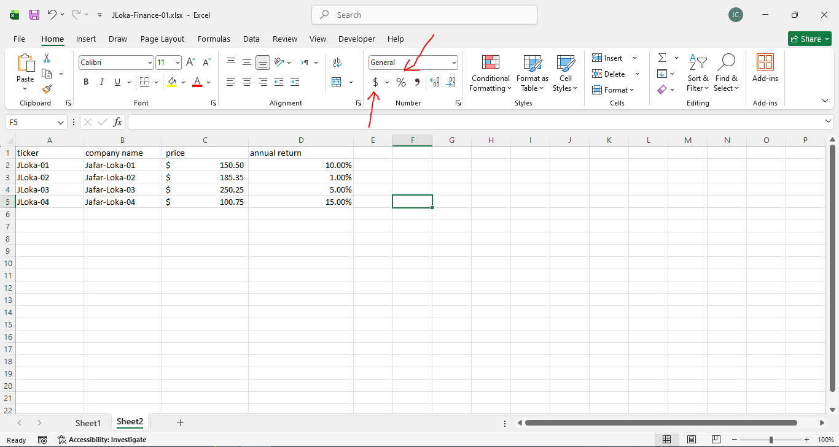
================================================
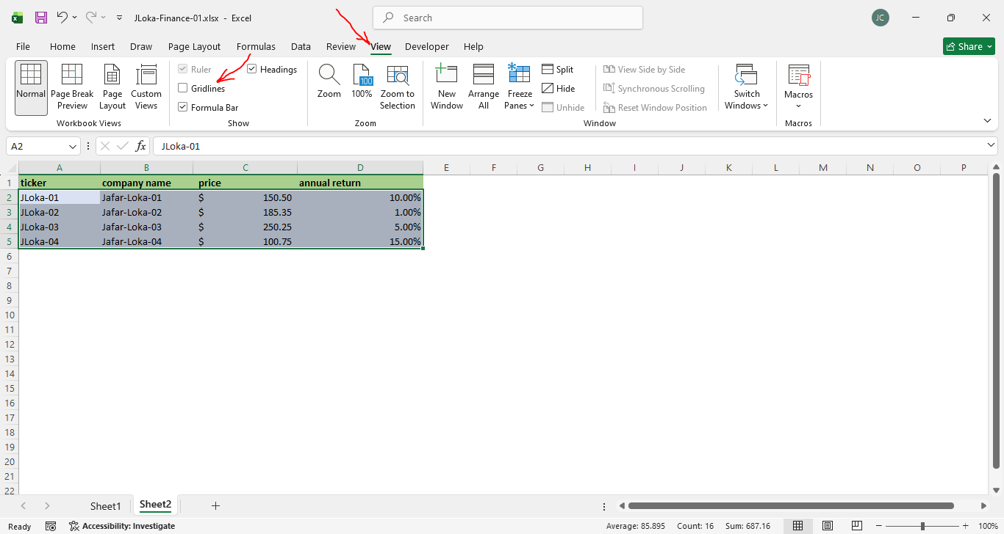
================================================
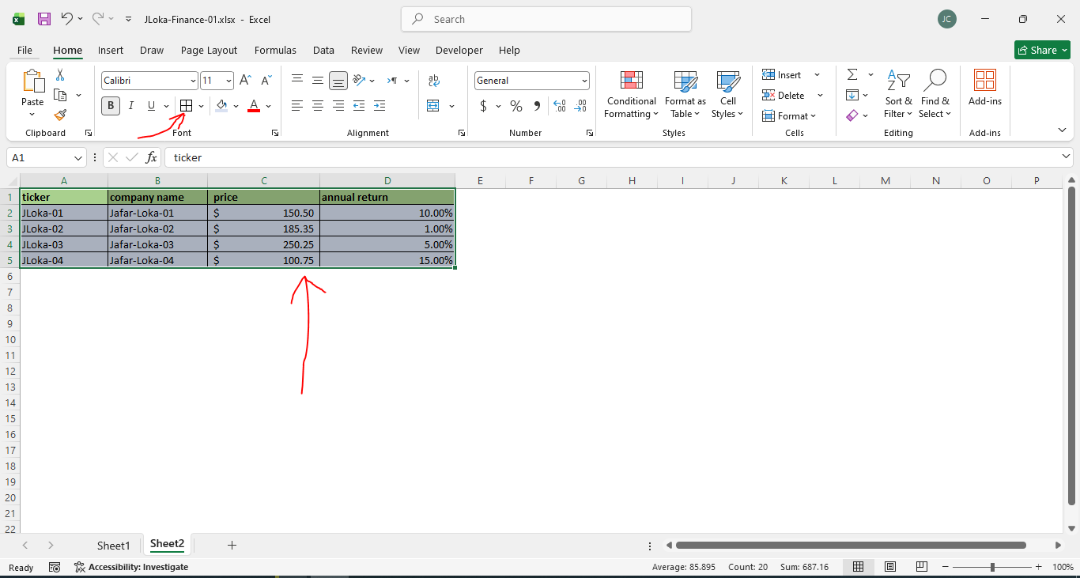
================================================
To insert a new function formula:



