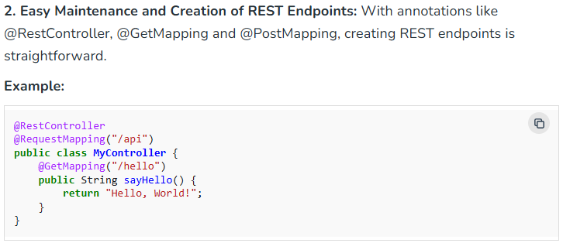
**************************************************************
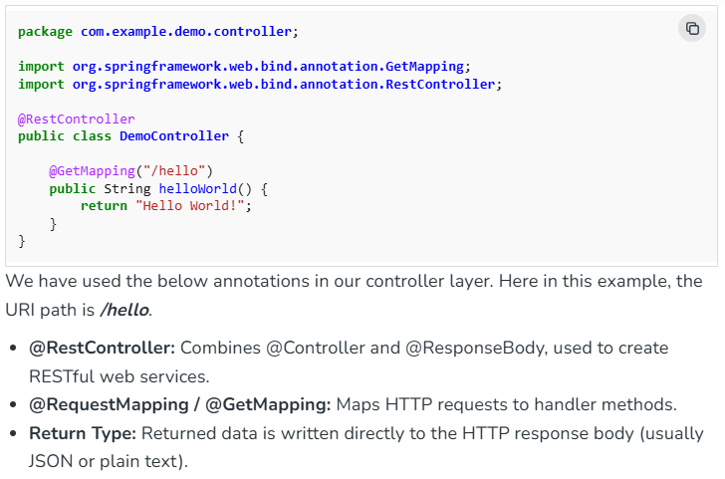
**************************************************************

Simple example about request param:
package com.jloka.jloka;

import org.springframework.boot.SpringApplication;
import org.springframework.boot.autoconfigure.SpringBootApplication;
import org.springframework.web.bind.annotation.RestController;
import org.springframework.web.bind.annotation.GetMapping;
import org.springframework.web.bind.annotation.RequestParam;

@SpringBootApplication
@RestController
public class JlokaApplication {

public static void main(String[] args) {
SpringApplication.run(JlokaApplication.class, args);
}

@GetMapping("/hello")
public String getMethodName(@RequestParam(name="name", defaultValue = "World") String name) {
return String.format("Hello %s!", name);
}
}
**************************************************************
Jackson is included by default by the web starter.
<dependencies>
<dependency>
<groupId>org.springframework.boot</groupId>
<artifactId>spring-boot-starter-web</artifactId>
</dependency>

<dependency>
<groupId>org.springframework.boot</groupId>
<artifactId>spring-boot-starter-test</artifactId>
<scope>test</scope>
</dependency>
</dependencies>
**************************************************************

The Greeting object must be converted to JSON. Thanks to Spring’s HTTP message converter support, you need not do this conversion manually. Because Jackson is on the classpath, Spring’s JacksonJsonHttpMessageConverter is automatically chosen to convert the Greeting instance to JSON.
-----------------------------------------------------------------------------------------
Greeting.java:
package com.jloka.jloka.resources;

public record Greeting(long id, String content) { }
-----------------------------------------------------------------------------------------
package com.jloka.jloka.controllers;

import java.util.concurrent.atomic.AtomicLong;
import org.springframework.web.bind.annotation.RestController;
import com.jloka.jloka.resources.Greeting;
import org.springframework.web.bind.annotation.GetMapping;
import org.springframework.web.bind.annotation.RequestParam;

@RestController
public class GreetingController {
private static final String template = "Hello, %s!";
private final AtomicLong counter = new AtomicLong();

@GetMapping("/greeting")
public Greeting greeting(@RequestParam(defaultValue = "World") String name) {
return new Greeting(counter.incrementAndGet(), template.formatted(name));
}
}
-----------------------------------------------------------------------------------------



