Core Web Vitals (CWV)
*********************************************************
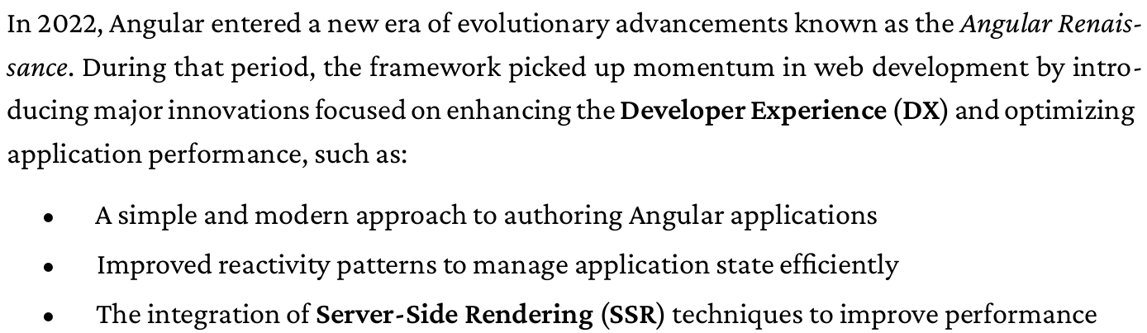
*********************************************************
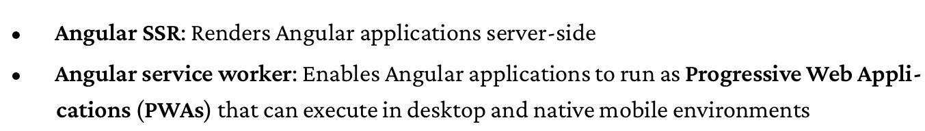
*********************************************************
Note 1 (To Remember): SSR Server Side Rendering
Note 2 (To Remember): SSG Static Side Generation
*********************************************************
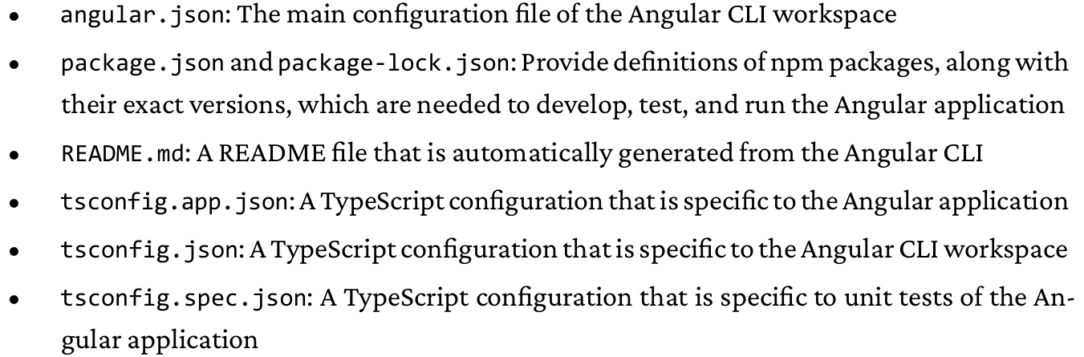
*********************************************************

The new version of angular, remove component from name of files:
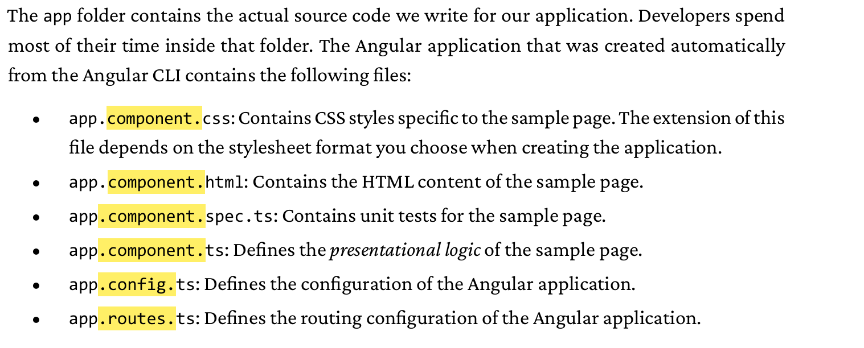
*********************************************************
Components:
The files whose names start with app.component constitute an Angular component.
A component in Angular controls part of a web page by orchestrating the interaction of the presentational logic with the HTML content of the page, called a template.
Each Angular application has a main HTML file, named index.html, that exists inside the src folder and contains the following
HTML element:
<body>
<app-root></app-root>
</body>
*********************************************************
When the Angular CLI builds an Angular application, it parses the index.html file and identifies HTML tags inside the element. An Angular application is always rendered inside the element and comprises a tree of components. When the Angular CLI finds a tag that is not a known HTML element, such as, it starts searching through the components of the application tree.
*********************************************************
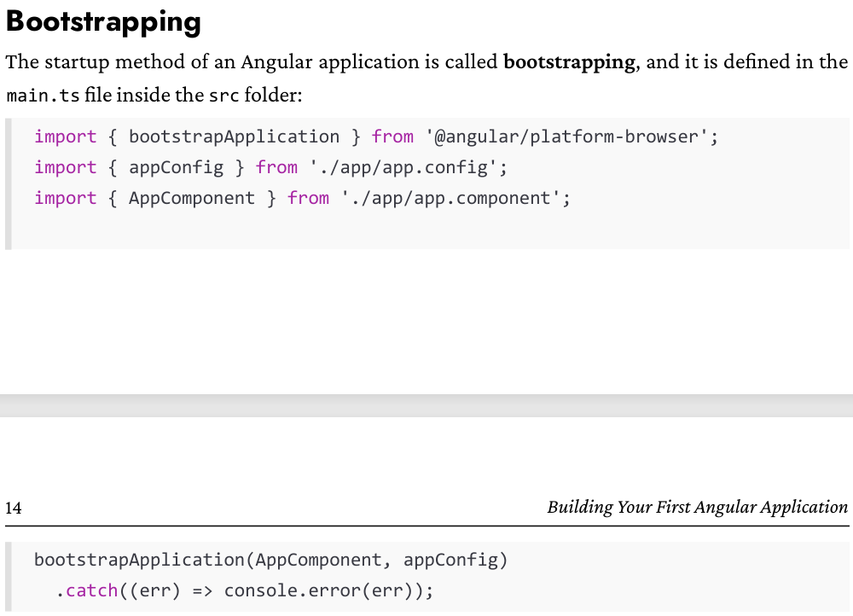
*********************************************************

The main task of the bootstrapping file is to define the component that will be loaded at application startup. It calls the bootstrapApplication method, passing AppComponent as a parameter to specify the starting component of the application. It also passes the appConfig object as a second parameter to specify the configuration that will be used in the application startup. The application configuration is described in the app.config.ts file
*********************************************************
import { ApplicationConfig, provideBrowserGlobalErrorListeners, provideZoneChangeDetection } from '@angular/core';
import { provideRouter } from '@angular/router';

import { routes } from './app.routes';

export const appConfig: ApplicationConfig = {
providers: [
provideBrowserGlobalErrorListeners(),
provideZoneChangeDetection({ eventCoalescing: true }),
provideRouter(routes)
]
};
*********************************************************
The appConfig object contains a providers property to define services provided throughout the Angular application.
*********************************************************
One of the most useful features of the component tree is that we can alter the value of a component property and inspect how the component template behaves.
*********************************************************

import { Component, signal } from '@angular/core';
import { RouterOutlet } from '@angular/router';

@Component({
selector: 'app-root',
imports: [RouterOutlet],
templateUrl: './app.html',
styleUrl: './app.css'
})
export class App {
protected readonly title = signal('hello-world');
protected readonly description = "My Name is Jafar Loka";
}
*********************************************************
In the app.html:
<h1>Hello, {{ title() }}</h1>
<h2>{{ description }}</h2>
*********************************************************
For each component we create and we want to use it inside other component, we must declare it inside the imports-array of the other component:
import { Component, signal } from '@angular/core';
import { RouterOutlet } from '@angular/router';
import { ProductList } from "./product-list/product-list";

@Component({
selector: 'app-root',
imports: [RouterOutlet, ProductList],
templateUrl: './app.html',
styleUrl: './app.css'
})
export class App {
protected readonly title = signal('hello-world');
protected readonly description = "My Name is Jafar Loka";
}
*********************************************************

To define attributes for our tag, we use attr and define the value in .ts-component-file:
- For html file:
<p>product-list works!</p>
<div>title: {{ title() }}</div>
<p [attr.data-title]="dataTitle">Testing</p>
<p [attr.data-test]="'test'">For testing Only</p>
@if(products.length > 0 ) {
<p>products: {{ products.length }}</p>
<ul class="pill-group">
@for (product of products; track product.id) {
<li class="pill">{{product.title}}</li>
}
</ul>
} @else {
<p>No products found!!!</p>
}
- For ts file:
import { Component, signal } from '@angular/core';
import { Product } from './product';

@Component({
selector: 'app-product-list',
imports: [],
templateUrl: './product-list.html',
styleUrl: './product-list.css'
})
export class ProductList {
protected readonly title = signal('product list page')
protected readonly dataTitle = 'test'
products: Product[] = [
{title: 'JLoka-01', id: 1},
{title: 'JLoka-02', id: 2},
{title: 'JLoka-03', id: 3},
{title: 'JLoka-04', id: 4},
{title: 'JLoka-05', id: 5},
];
}

----------------------------------------------------------------------
Or we can use 'value-here':
<p>product-list works!</p>
<div>title: {{ title() }}</div>
<p [attr.data-title]="dataTitle">Testing</p>
<p [attr.data-test]="'test'">For testing Only</p>
*********************************************************
The track property, which keeps track of data changes. In our case, the track property defines the property name of the product variable that will be used to keep track of every item in the products array.
*********************************************************
Refactor using @empty:
<p>product-list works!</p>
<div>title: {{ title() }}</div>
<p [attr.data-title]="dataTitle">Testing</p>
<p [attr.data-test]="'test'">For testing Only</p>
<p>products: {{ products.length }}</p>
<ul class="pill-group">
@for (product of products; track product.id) {
<li class="pill">{{product.title}}</li>
} @empty {
<p>No products found!!!</p>
}
</ul>
*********************************************************
The other form of for-loop:
@for (product of products; track product.id; let variable=property) {}
Where property can be:
• $count: Indicates the number of items in the array
• $index: Indicates the index of the item in the array
• $first/$last: Indicates whether the current item is the first or last one in the array
• $even/$odd: Indicates whether the index of the item in the array is even or odd
*********************************************************

To bind events:
<p>product-list works!</p>
<div>title: {{ title() }}</div>
<p [attr.data-title]="dataTitle">Testing</p>
<p [attr.data-test]="'test'">For testing Only</p>
<p>products: {{ products.length }}</p>
<ul class="pill-group">
@for (product of products; track product.id) {
<li class="pill" (click)="selectedProduct = product">{{product.title}}</li>
} @empty {
<p>No products found!!!</p>
}
</ul>

@if(selectedProduct) {
<p>The Selected Product is: {{ selectedProduct.title }}</p>
}
------------------------------------------------------------------------------------------
import { Component, signal } from '@angular/core';
import { Product } from './product';

@Component({
selector: 'app-product-list',
imports: [],
templateUrl: './product-list.html',
styleUrl: './product-list.css'
})
export class ProductList {
protected readonly title = signal('product list page')
protected readonly dataTitle = 'test'
protected selectedProduct: Product | undefined;
products: Product[] = [
{title: 'JLoka-01', id: 1},
{title: 'JLoka-02', id: 2},
{title: 'JLoka-03', id: 3},
{title: 'JLoka-04', id: 4},
{title: 'JLoka-05', id: 5},
];
}
*********************************************************

For using product-detail for product list using input-directive:
import { Component, input } from '@angular/core';
import { Product } from '../product-list/product';

@Component({
selector: 'app-product-detail',
imports: [],
templateUrl: './product-detail.html',
styleUrl: './product-detail.css'
})
export class ProductDetail {
product = input<Product>();
}
------------------------------------------------------------------------------------------
@if(product()) {
<p style="font-weight: bold;">Product Selected: {{product()!.title}}</p>
}
------------------------------------------------------------------------------------------
For product list:
import { Component, signal } from '@angular/core';
import { Product } from './product';
import { ProductDetail } from '../product-detail/product-detail';

@Component({
selector: 'app-product-list',
imports: [ProductDetail],
templateUrl: './product-list.html',
styleUrl: './product-list.css'
})
export class ProductList {
protected readonly title = signal('product list page')
protected readonly dataTitle = 'test'
protected selectedProduct: Product | undefined;
products: Product[] = [
{title: 'JLoka-01', id: 1},
{title: 'JLoka-02', id: 2},
{title: 'JLoka-03', id: 3},
{title: 'JLoka-04', id: 4},
{title: 'JLoka-05', id: 5},
];
}
------------------------------------------------------------------------------------------
<p>product-list works!</p>
<div>title: {{ title() }}</div>
<p [attr.data-title]="dataTitle">Testing</p>
<p [attr.data-test]="'test'">For testing Only</p>
<p>products: {{ products.length }}</p>
<ul class="pill-group">
@for (product of products; track product.id) {
<li class="pill" (click)="selectedProduct = product">{{product.title}}</li>
} @empty {
<p>No products found!!!</p>
}
</ul>

<app-product-detail [product]="selectedProduct"></app-product-detail>

*********************************************************

