From EF Core 7.0, we can use the ExecuteUpdate() and ExecuteDelete() methods to update or delete data. Note that these two methods do not involve the entity tracking feature. So, once you call these two methods, the changes will be executed immediately. There is no need to call the SaveChanges() method.
*******************************************************************
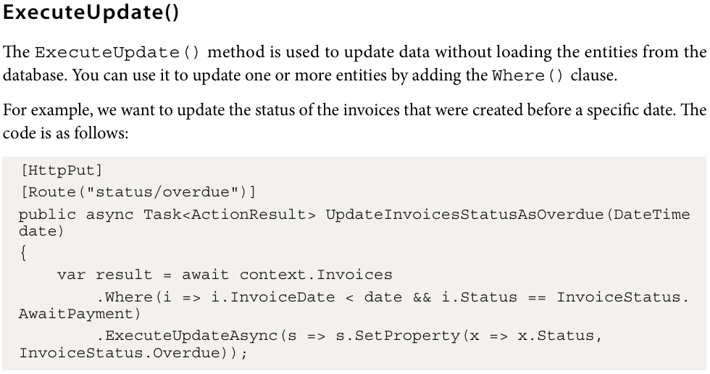
*******************************************************************
This query can update multiple invoices at the same time. It does benefit from the strong type support but has the same efficiency as the raw SQL query. If we need to update more than one property, you can use the SetProperty() method multiple times:
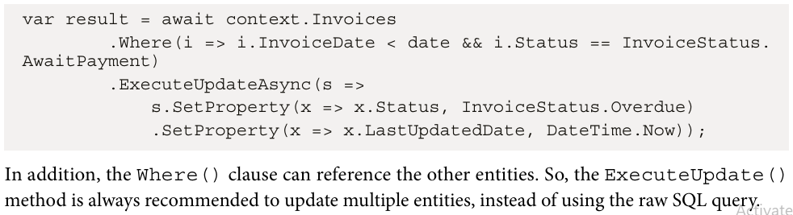
*******************************************************************
*******************************************************************
An API endpoint can be called by multiple clients at the same time. If the endpoint updates data, the data may be updated by another client before the current client completes the update. When the same entity is updated by multiple clients, it can cause a concurrency conflict, which may result in data loss or inconsistency, or even cause data corruption.
*******************************************************************
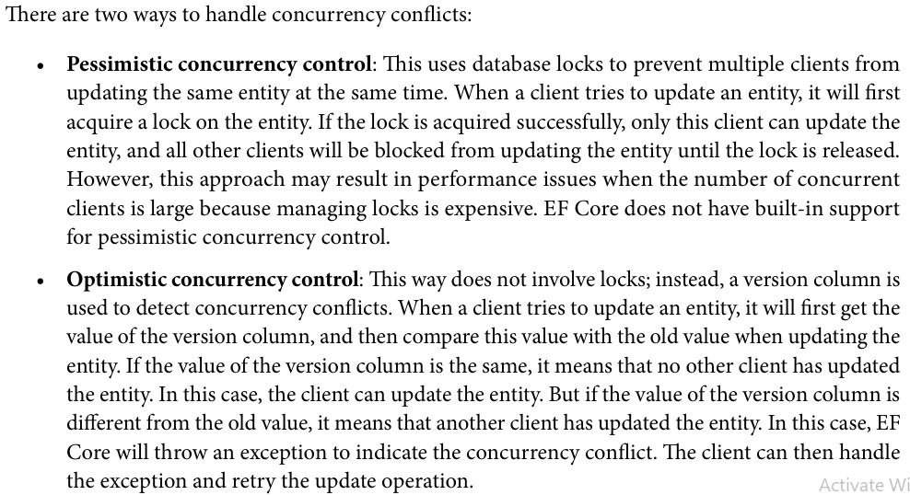
*******************************************************************

One of problems when handling multiple requests in the same time:
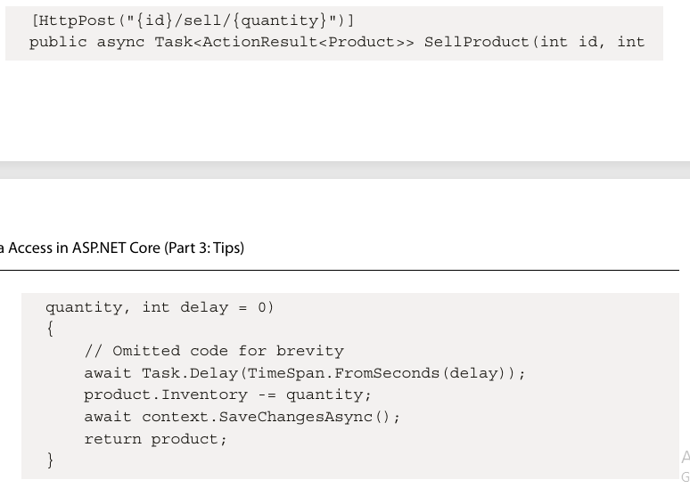
*******************************************************************
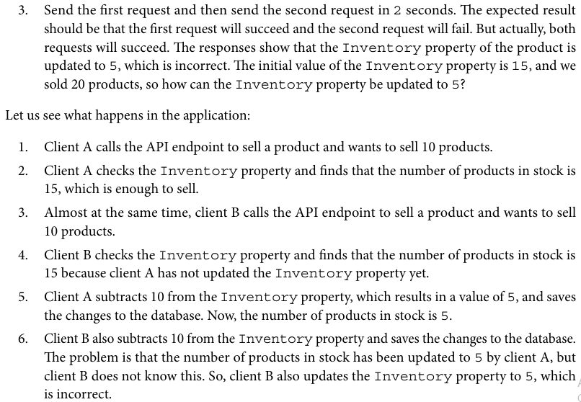
*******************************************************************
To solve this problem, EF Core provides optimistic concurrency control. There are two ways to use optimistic concurrency control:
• Native database-generated concurrency token
• Application-managed concurrency token
*******************************************************************
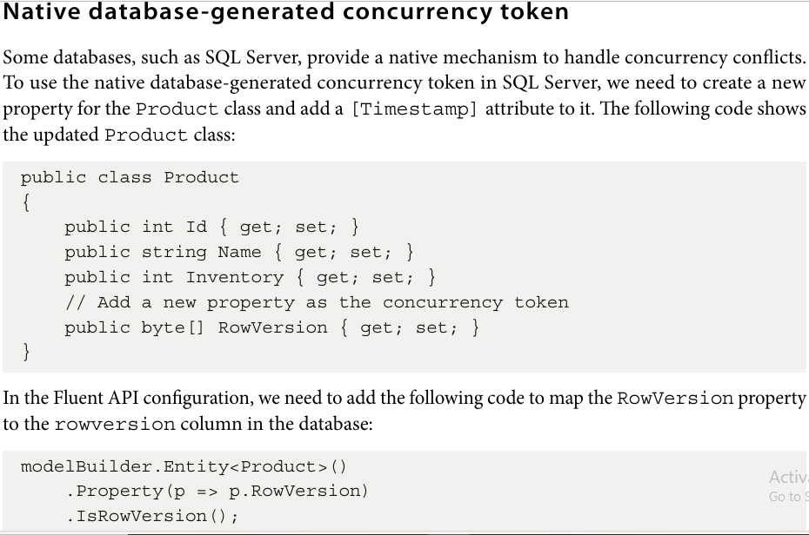
*******************************************************************
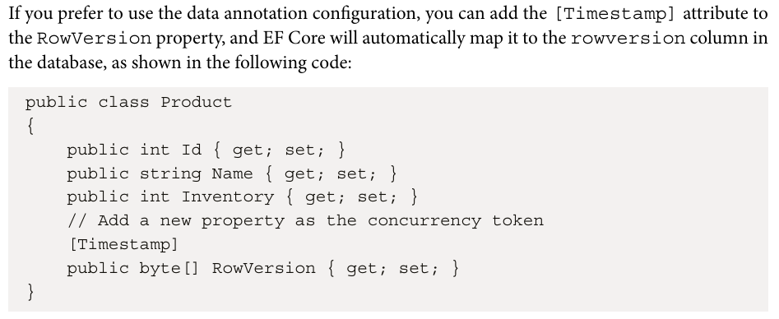
*******************************************************************

By using concurrency control, EF Core not only checks the ID of the entity but also checks the value of the rowversion column. If the value of the rowversion column is not the same as the value in the database, it means that the entity has been updated by another client, and the current update operation should be aborted.
*******************************************************************
Note that the rowversion column type is available for SQL Server, but not for other databases, such as SQLite. Different databases may have different types of concurrency tokens, or may not support the concurrency token at all.
*******************************************************************
Application-managed concurrency token
If the database does not support the built-in concurrency token, we can manually manage the concurrency token in the application. Instead of using the rowversion column, which can be automatically updated by the database, we can use a property in the entity class to manage the concurrency token and assign a new value to it every time the entity is updated.
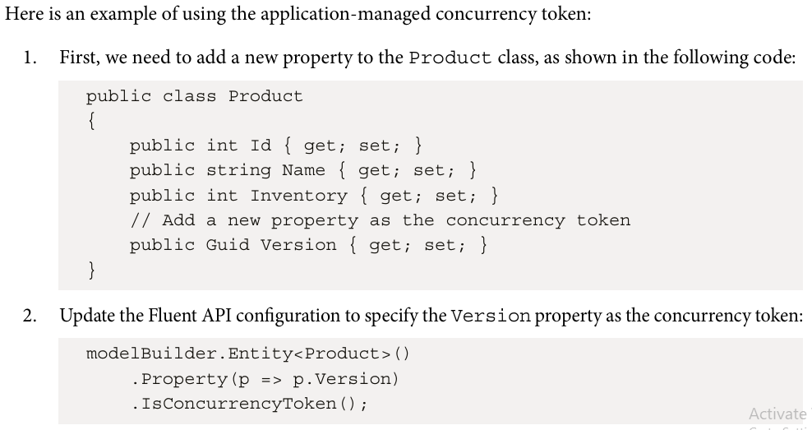
*******************************************************************
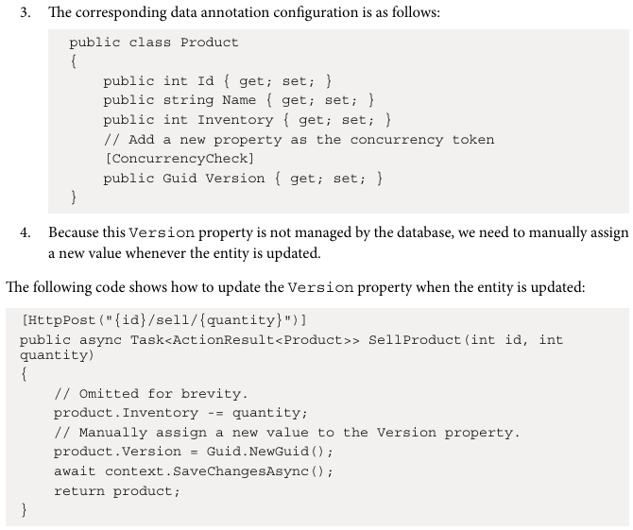
*******************************************************************
Sometimes we need to work with an existing database. In this case, we need to create the entity classes and DbContext from the existing database schema. This is called database-first or reverse engineering. This is useful when we want to migrate an existing application to EF Core.
*******************************************************************
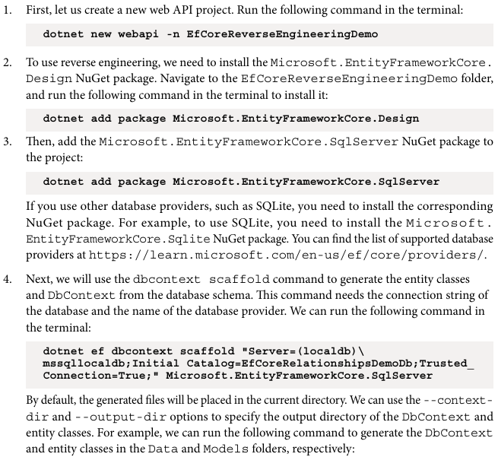
*******************************************************************
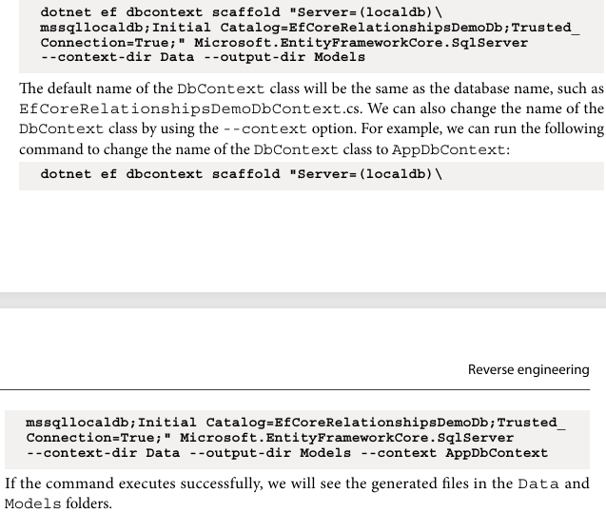
*******************************************************************
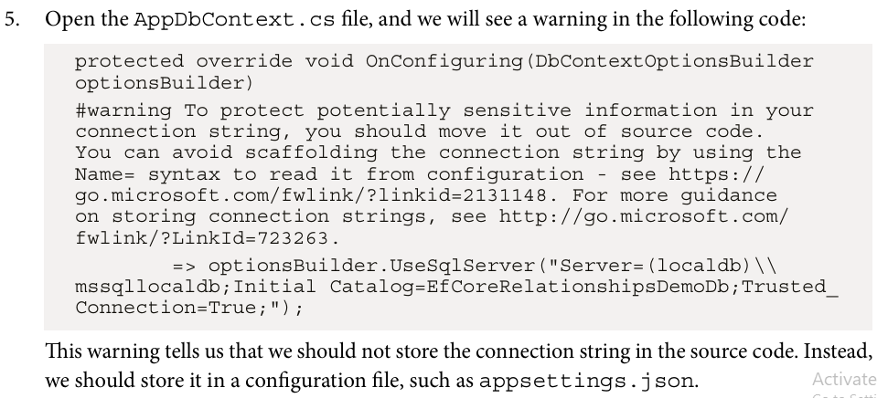
*******************************************************************
Some models or properties may not be represented correctly in the database. For example, if your models have inheritance, the generated code will not include the base class because the base class is not represented in the database. Also, some column types may not be able to be mapped to the corresponding CLR types. For example, the Status column in the Invoice table is of the nvarchar(16) type, which will be mapped to the string type in the generated code, instead of the Status enum type.
*******************************************************************

