The persistence context is created when the transaction starts and cleared when the transaction ends.
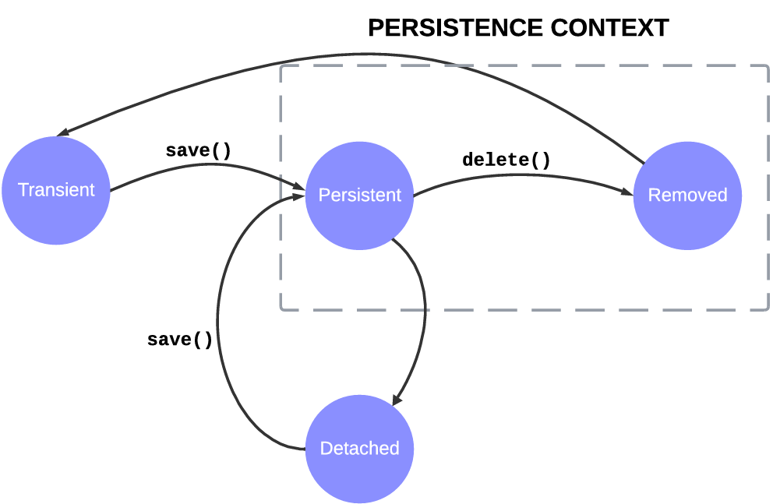
===========================================
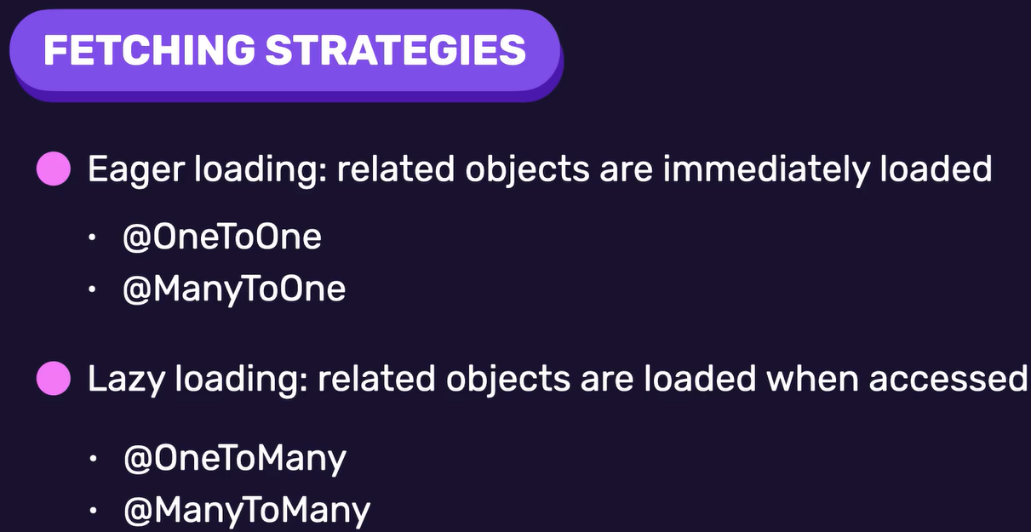
===========================================
We must set the fetch strategy on the owner side:
Note: The strategy only affects the owner entity, not the entity being mapped.
public class Profile {
@Id
@GeneratedValue(strategy = GenerationType.IDENTITY)
@Column(nullable = false, name = "id")
private Long id;
@Column(nullable = false, name = "bio")
private String bio;
@Column(nullable = false, name = "phone_number")
private String phoneNumber;
@Column(nullable = false, name = "date_of_birth")
private LocalDate dateOfBirth;
@Column(nullable = false, name = "loyalty_points")
private int loyaltyPoints;
// The @MapsId tells the framework to use the foreign and primary as the join column key.
@OneToOne(fetch = FetchType.LAZY)
@JoinColumn(name = "id")
@MapsId
@ToString.Exclude
private User user;
}
===========================================
To track the user object from the profile object that uses FetchType.LAZY, we must use @Transactional-annotation.



