import 'package:flutter_bloc/flutter_bloc.dart';
import 'package:flutter_bloc_example/models/todo_model.dart';

class TodoCubit extends Cubit<List<Todo>> {
TodoCubit() : super([]);

void addTodo(String name) {
final todo = Todo(name: name, createdAt: DateTime.now());
// [emit] does nothing if the [state] being emitted is equal to the current [state].
emit([...state, todo]);
}
}
=====================================================
import 'package:flutter_bloc/flutter_bloc.dart';
import 'package:flutter_bloc_example/bloc/counter_event.dart';

class CounterBloc extends Bloc<CounterEvent, int> {
CounterBloc() : super(0) {
on<CounterIncrement>((event, emit) => increment(event, emit));
on<CounterDecrement>((event, emit) => decrement(event, emit));

// on<CounterIncrement>(increment);
}

void increment(CounterIncrement event, Emitter<int> emit) {
// Here we can't use emit of the main class like cubit,
// because we have multiple events to listen to them
emit(state + 1);
}

void decrement(CounterDecrement event, Emitter<int> emit) {
emit(state - 1);
}
}
=====================================================
abstract class CounterEvent {}

final class CounterIncrement extends CounterEvent {}

final class CounterDecrement extends CounterEvent {}
=====================================================

return MultiBlocProvider(
providers: [
BlocProvider(create: (_) => CounterCubit()),
BlocProvider(create: (_) => CounterBloc()),
],
child: MaterialApp(
title: 'Flutter Demo',
debugShowCheckedModeBanner: false,
theme: ThemeData(colorScheme: .fromSeed(seedColor: Colors.deepPurple)),
home: const MyHomePage(title: 'Flutter Demo Home Page'),
),
);
=====================================================
BlocBuilder<CounterBloc, int>(
// bloc: context.read<CounterCubit>(),
// bloc: context.read<CounterBloc>(),
builder: (context, counter) {
return Text(
'$counter',
style: Theme.of(context).textTheme.headlineMedium,
);
},
),
=====================================================
BlocBuilder<TodoCubit, List<Todo>>(
builder: (context, state) {
return ListView.builder(
itemCount: state.length,
itemBuilder: (BuildContext context, int index) {
final item = state[index];
return ListTile(
title: Text(item.name),
trailing: Text(item.createdAt.toIso8601String()),
);
},
);
},
),
=====================================================

To define the structure of the project using the Feature Design:
- We define the bloc where state management logic resides.
- We define the data that contains the:
  - The data provider that calls the APIs endpoints.
  - The repository that uses the data provider.
- The model that contains the data representation for the request and response.
- The presentations that contain the screens and widgets of our application.
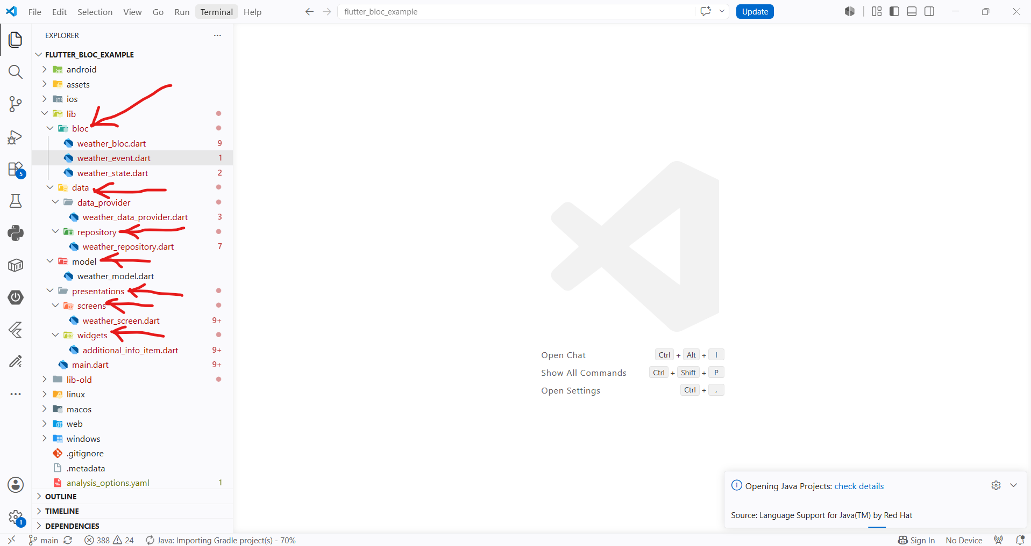
=====================================================
To define the logic using the bloc state management we define:
- The events of the logic.
- The states of the logic.
- The bloc of the logic that combine the events with the states.
=====================================================

To build the events we can use classes:
@immutable
sealed class WeatherEvent {}

final class WeatherFetched extends WeatherEvent {}
----------------------------------------------------------------------------------------

To build the states that represents the flow of the logic:
@immutable
sealed class WeatherState {}

final class WeatherInitial extends WeatherState {}

final class WeatherSuccess extends WeatherState {
final WeatherModel weatherModel;
WeatherSuccess({required this.weatherModel});
}

final class WeatherFailure extends WeatherState {
final String error;
WeatherFailure({required this.error});
}

final class WeatherLoading extends WeatherState {}
----------------------------------------------------------------------------------------

To use the states and events with the bloc:
class WeatherBloc extends Bloc<WeatherEvent, WeatherState> {
final WeatherRepository weatherRepository;
WeatherBloc({required this.weatherRepository}) : super(WeatherInitial()) {
on<WeatherFetched>(onWeatherFetched);
}

void onWeatherFetched(
WeatherFetched event,
Emitter<WeatherState> emit,
) async {
emit(WeatherLoading());
try {
final weather = await this.weatherRepository.getCurrentWeather(
"Damascus",
);
emit(WeatherSuccess(weatherModel: weather));
} catch (e) {
emit(WeatherFailure(error: e.toString()));
}
}
}
=====================================================
The simple data provider:
class WeatherDataProvider {
Future<String> getCurrentWeather(String cityName) async {
try {
final res = await http.get(
Uri.parse(
'https://api.openweathermap.org/data/2.5/forecast?q=$cityName&APPID=$openWeatherAPIKey',
),
);

return res.body;
} catch (e) {
throw e.toString();
}
}
}
=====================================================

The simple data repository
class WeatherRepository {
final WeatherDataProvider weatherDataProvider;

WeatherRepository({required this.weatherDataProvider});

Future<WeatherModel> getCurrentWeather(String cityName) async {
try {
final body = await this.weatherDataProvider.getCurrentWeather(cityName);
final data = jsonDecode(body);

if (data['cod'] != '200') {
throw 'An unexpected error occurred';
}
debugPrint("The data is: ${data['list'][0]}");
return WeatherModel.fromJson(data['list'][0]);
} catch (e) {
throw e.toString();
}
}
}
=====================================================

To use the repository with the bloc, we can use The RepositoryProvider & BlocProvider:
class MyApp extends StatelessWidget {
const MyApp({super.key});

@override
Widget build(BuildContext context) {
// Note: We have also MultiRepositoryProvider
return RepositoryProvider(
create: (context) =>
WeatherRepository(weatherDataProvider: WeatherDataProvider()),
child: BlocProvider(
create: (context) =>
WeatherBloc(weatherRepository: context.read<WeatherRepository>()),
child: MaterialApp(
debugShowCheckedModeBanner: false,
theme: ThemeData.dark(useMaterial3: true),
home: const WeatherScreen(),
),
),
);
}
}
=====================================================

