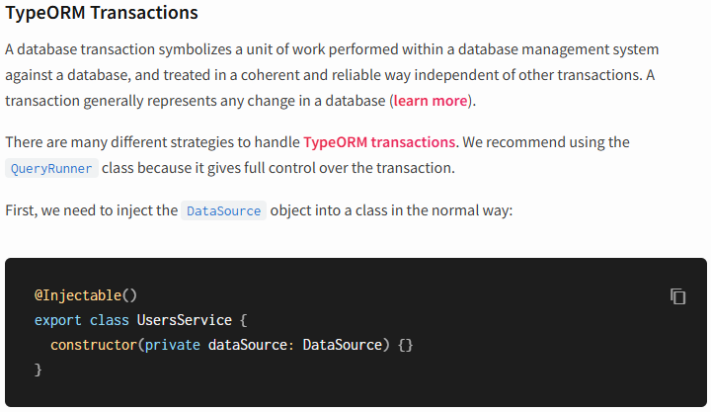
*******************************************************
import { Injectable } from '@nestjs/common';
import { InjectRepository } from '@nestjs/typeorm';
import { User } from './user.entity';
import { DataSource, DeleteResult, Repository } from 'typeorm';

@Injectable()
export class UsersService {

constructor(
@InjectRepository(User) private userRepository: Repository<User>,
private dataSource: DataSource
) {}

async findAll():Promise<User[]> {
return this.userRepository.find()
}

async findOne(id: number) :Promise<User | null> {
return this.userRepository.findOneBy({ id })
}

async remove(id: number): Promise<DeleteResult> {
return this.userRepository.delete(id)
}

async createMany(users: User[]) {
const queryRunner = this.dataSource.createQueryRunner()
await queryRunner.connect()
await queryRunner.startTransaction()
try {
await queryRunner.manager.save(users[0])
await queryRunner.manager.save(users[1])
await queryRunner.commitTransaction()
} catch (e) {
await queryRunner.rollbackTransaction()
} finally {
await queryRunner.release()
}
}
}
*******************************************************



