To use Laravel Octane with Swoole, we need to install this package: composer require laravel/Octane
To install the PHP Swoole extension: sudo apt install php8.4-openswoole
Then, we need to activate the extension in the php.ini file.
===============================================================
To start the Octane server: php artisan Octane:start --host 0.0.0.0
===============================================================
To define a repeated task in the app service provider:
Octane::tick('caching-query', function () {
Log::info('caching-query.', ['timestamp' => now()]);
$time = hrtime(true);

$count = Event::count();
$eventsInfo = Event::ofType('INFO')->get();
$eventsWarning = Event::ofType('WARNING')->get();
$eventsAlert = Event::ofType('ALERT')->get();

$time = (hrtime(true) - $time) / 1_000_000;
$result = [
'count' => $count,
'eventsInfo'=> $eventsInfo,
'eventsWarning' => $eventsWarning,
'eventsAlert'=> $eventsAlert,
'cached_time' => $time,
];
Cache::store('Octane')->put('cached-result-tick', $result);
})->seconds(60)->immediate();
===============================================================
Note (From me): if the user defines the Octane concurrent function inside the Octane tick, an error will appear.
===============================================================

To use the Octane concurrent function with the cache in Laravel:
Route::get('/httpcall/parallel', function () {
$time = hrtime(true);
[$sentenceJson, $nameJson] =Cache::store('Octane')->remember(
'key-checking',20, function () {
return Octane::concurrently([
fn() => Http::get('http://127.0.0.1:8000/api/sentence')->json(),
fn() => Http::get('http://127.0.0.1:8000/api/name')->json(),
]);
}
);
$time = hrtime(true) - $time;

return response()->json(
array_merge(
$sentenceJson,
$nameJson,
['time_ms' => $time / 1_000_000]
)
);
});
===============================================================
To create Octane table for caching:
Route::get('/table-create', function () {
// Getting the table instance
$table = Octane::table('my-table');
// looping 1..90 creating rows with fake() helper
for ($i = 1; $i <= 90; $i++) {
$table->set(
$i,
[
'uuid' => fake()->uuid(),
'name' => fake()->name(),
'age' => fake()->numberBetween(18, 99),
'value' => fake()->randomFloat(2, 0, 1000)
]
);
}
return "Table created!";
});
-------------------------------------------------------

And in the Octane config file:
'tables' => [
'example:1000' => [
'name' => 'string:1000',
'votes' => 'int',
],
'my-table:100' => [
'uuid' => 'string:36',
'name' => 'string:1000',
'age' => 'int',
'value' => 'float',
],
'cache' => [
'key' => 'string:256',
'value' => 'string:2048576', // Increase this (e.g., 1MB)
'expiration' => 'int:8',
],
'request_context' => [
'key' => 'string:256',
'value' => 'string:2048576', // Increase this too
],
],
===============================================================
Route::get('/table-get/', function () {
$table = Octane::table('my-table');
$row = $table->get(1);
return $row;
});
-------------------------------------------------------
Route::get('/table-get-all', function () {
$table = Octane::table('my-table');
$rows = [];
foreach ($table as $key => $value) {
$rows[$key] = $table->get($key);
}
//Add the table row count as the first row
$rows[0] = count($table);
return $rows;
});
-------------------------------------------------------

Route::get('/metrics', function () {
$server = App::make(Swoole\Http\Server::class);
return $server->stats();
});
===============================================================
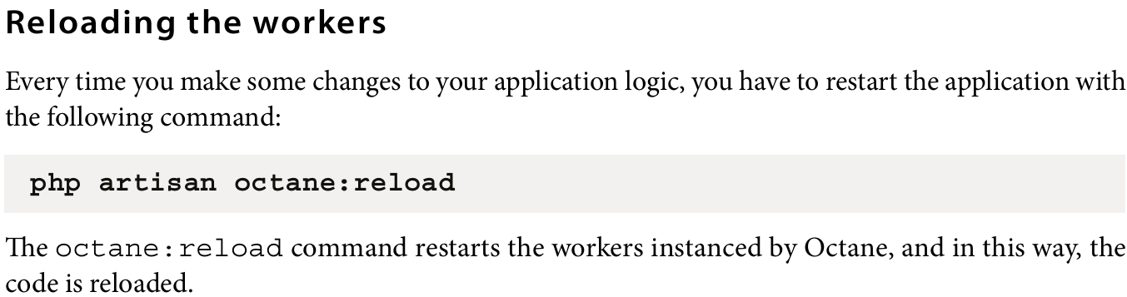

===============================================================
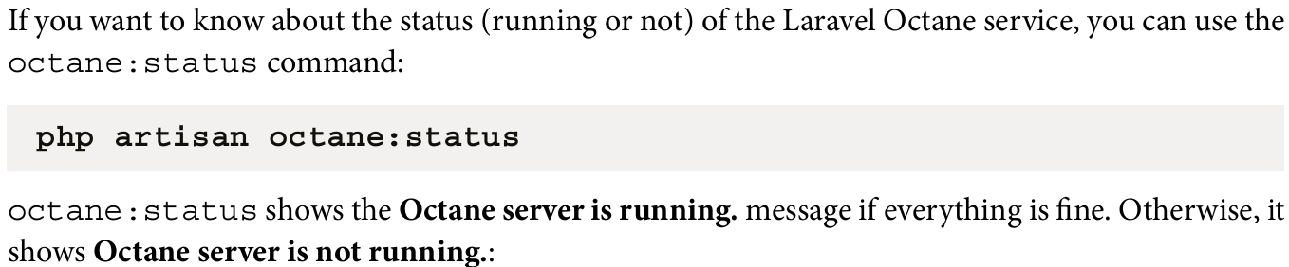

===============================================================
Listening events
Laravel Octane internally defines some events for notifying and managing when something happens, such as the worker starting, a request being received, and so on. In a framework, if you can produce some events, as a developer, you need a mechanism to listen for when an event occurs. The Laravel framework provides the developer with a mechanism to define and create events and a mechanism to listen (a listener). The listener in Laravel can execute a function defined by the developer.
===============================================================
Looking into the Laravel Octane config file (config/octane.php) in the listener section, you will see that the defined events are as follows: WorkerStarting, RequestReceived, RequestHandled, RequestTerminated, TaskReceived, TaskTerminated, TickReceived, TickTerminated, OperationTerminated, WorkerErrorOccurred, and WorkerStopping.
===============================================================



