To enable HTTPS, HTTP/2, and HTTP/3, apply these modifications instead:
services:
laravel.test:
ports:
- '${APP_PORT:-80}:80'
- '${VITE_PORT:-5173}:${VITE_PORT:-5173}'
- '443:443'
- '443:443/udp'
environment:
SUPERVISOR_PHP_COMMAND: "/usr/bin/php -d variables_order=EGPCS /var/www/html/artisan octane:start --host=localhost --port=443 --admin-port=2019 --https"
XDG_CONFIG_HOME: /var/www/html/config
XDG_DATA_HOME: /var/www/html/data
*********************************************************
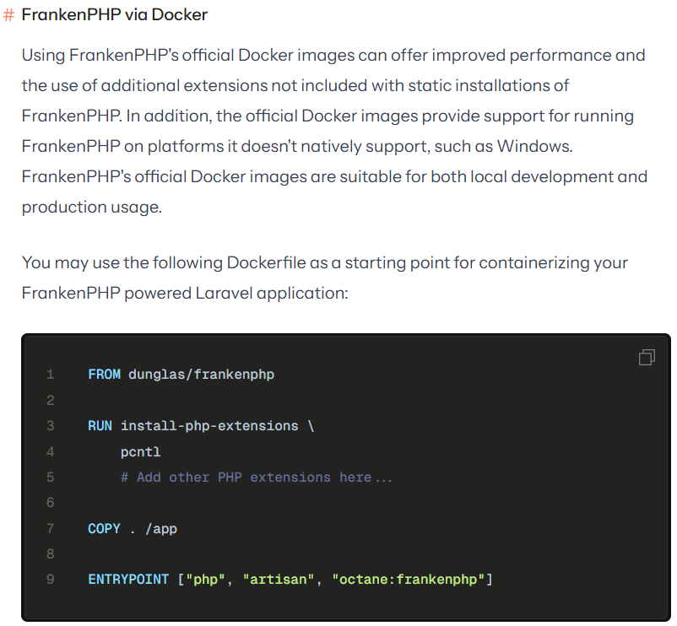
*********************************************************
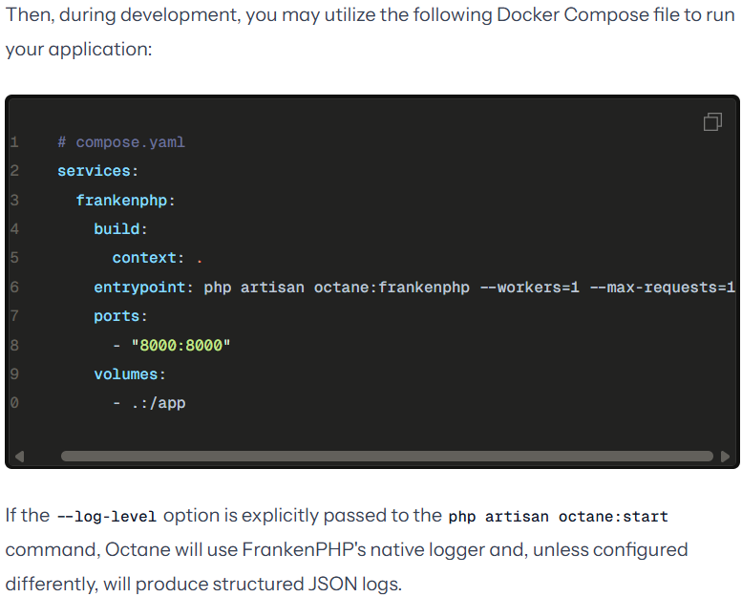
*********************************************************
php artisan octane:start --server=frankenphp --caddyfile=/path/to/your/Caddyfile
*********************************************************
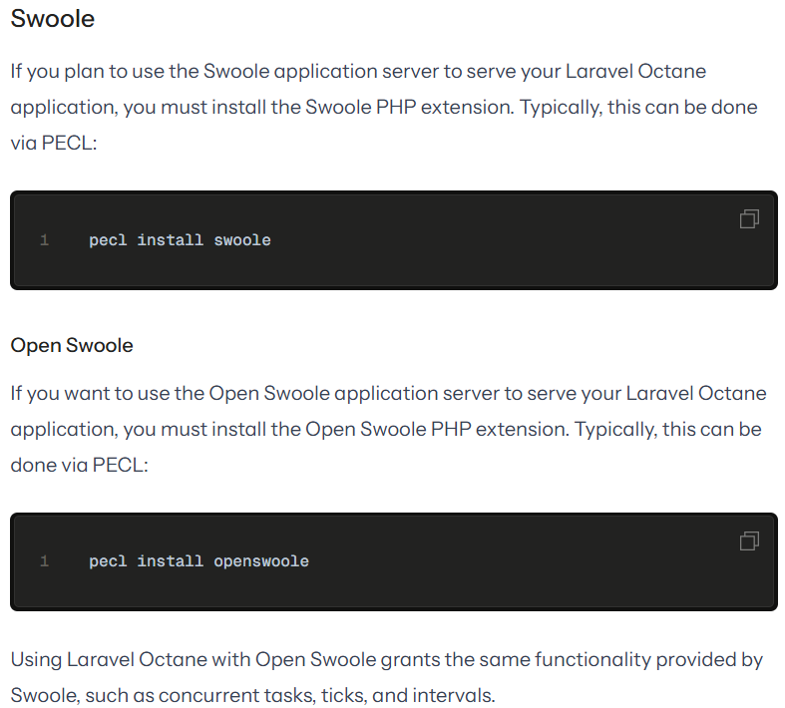
*********************************************************
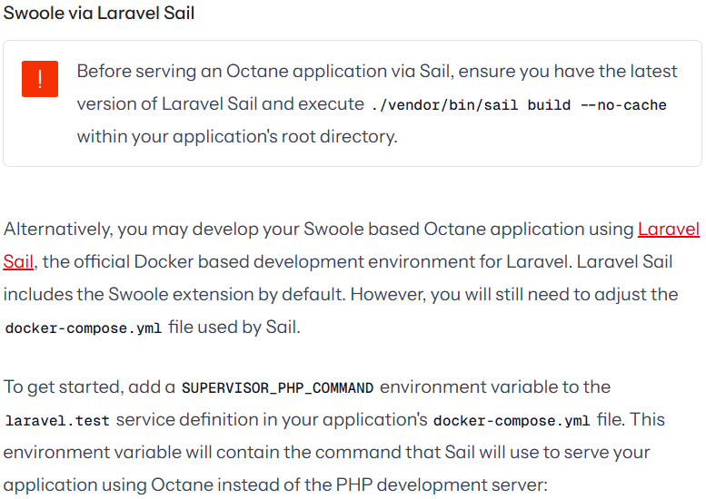
services:
laravel.test:
environment:
SUPERVISOR_PHP_COMMAND: "/usr/bin/php -d variables_order=EGPCS /var/www/html/artisan octane:start --server=swoole --host=0.0.0.0 --port='${APP_PORT:-80}'"
*********************************************************



