The styles alert-component in tailwindcss:
import { useState, type ReactNode } from "react";
import { AlertType } from "../constant";

type Props = {
title: string;
children: ReactNode;
type: AlertType;
closeable?: boolean;
onClose?: () => void;
}

const Alert = ({
title,
children,
type = AlertType.information,
closeable = false,
onClose,
}: Props) => {
const [visible, setVisible] = useState<boolean>(true);

if (!visible) {
return null;
}

function handleClose() {
setVisible(false)
if(onClose){
onClose()
}
}

return (
<div className={
`border inline-flex flex-col rounded-md border-gray-400 p-3 text-center
${type === AlertType.warning ? 'text-amber-300' : 'text-blue-600'}
bg-transparent`
}>
<div className="mb-1 flex items-center">
<span
role="image"
aria-label={type == AlertType.warning ? "Warning" : "Information"}
className={`w-7`}
>
{type == AlertType.warning ? "⚠️" : "ℹ️"}
</span>
<span className="font-bold">{title}</span>
{closeable && (
<button
aria-label="Close"
onClick={() => handleClose() }
className="ml-auto flex h-6 w-6 cursor-pointer items-center
justify-center border-none bg-transparent p-0"
>
<span role="image" aria-label="Close">
❌
</span>
</button>
)}
</div>

<div className="ml-7 pr-5 text-black">{children}</div>
</div>
);
};

export default Alert;
**********************************************************************
Tailwind doesn’t add all its CSS classes – that would produce a massive CSS file! Instead, it only adds the CSS classes used in the app.
**********************************************************************
Client Components can only be synchronous – RSCs can be asynchronous or synchronous.
--------------------------------------------------------------------------------------------------
RSCs is accessing a database on the server. Client Components can’t access server resources directly.
**********************************************************************
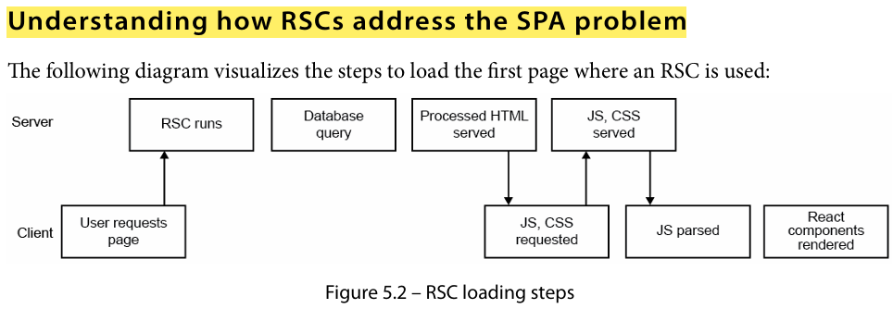
**********************************************************************
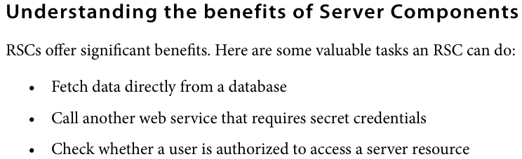
**********************************************************************
To create next.js app: npx create-next-app@latest
**********************************************************************

