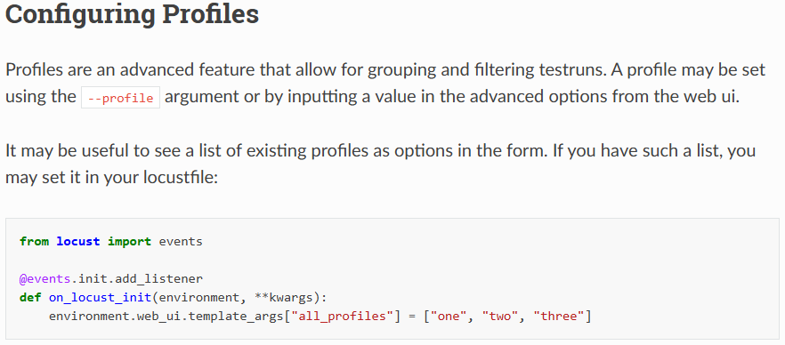
==============================================
For custom arguments: https://docs.locust.io/en/stable/extending-locust.html#custom-arguments
==============================================

